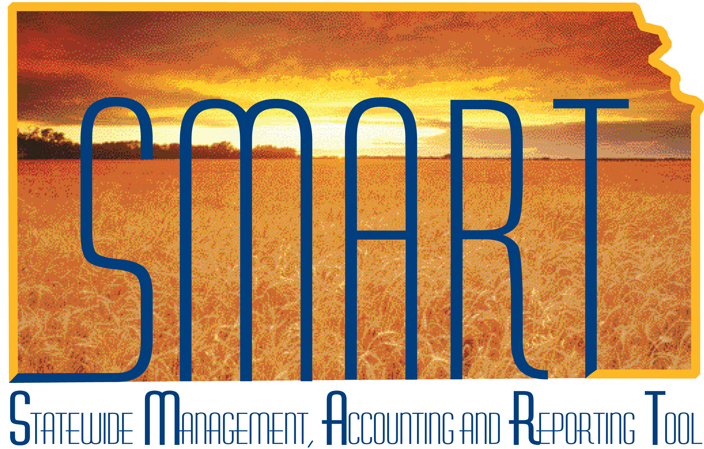
Participant Guide –
SAP310: Vendor Processing

State of Kansas
TABLE OF CONTENTS

Course Overview 4
Course Objectives 4
Agenda 4
Lesson 1: Vendor Processing Overview 5
Objectives 5
Topic 1: Vendor Processing Key Terms and Concepts 5
Topic 2: Vendor Security Access Roles in SMART 7
Topic 3: Vendor Business Process Flows in SMART 8
Topic 4: Integration between Vendors, Accounts Payable, and Purchasing modules 9
Lesson Review 10
Lesson 2: How to Use Existing Vendor Information in SMART 11
Objectives 11
Topic 1: Verify Existing Vendor Information in SMART 11
Topic 2: Edit or Inactivate Existing Vendor Information in SMART 12
Topic 3: Search for Existing Vendor Record in SMART 12
Search for Vendor by Name 13
Search for Vendor by Address 14
Search for Vendor by Withholding Tax ID Number 15
Topic 4: Review Existing Vendor Record in SMART 16
Summary Page 16
Identifying Information Page 17
Address Page 18
Contacts Page 20
Location Page 21
Location Page - Payables Link 23
Location Page - Procurement Link 25
Location Page – Sales/Use Tax Link 25
Location Page - 1099 Link 26
Custom Page 27
Lesson Review 27
Lesson 3: Enter New Vendor Information into SMART 28
Objectives 28
Topic 1: Vendor Information - Statewide Standards in SMART 28
Topic 2: Summary Page 28
Topic 3: Identifying Information Page 33
Topic 4: Address Page 43
Topic 5: Contacts Page 54
Topic 6: Location Page 58
Topic 7: Payables Link and Payables Options Page 64
Topic 8: Procurement Link and Procurement Options page 70
Topic 9: 1099 Link and Withholding Vendor Information page 72
Topic 10: Vendor Conversation Page 94
Topic 11: Vendor Contact Page 96
Lesson Review 97

Course Overview

Course Objectives
Upon completion of the course, participants are able to:
- Explain the vendor business processes
- Describe how vendor processing integrates with other functions in SMART
- List the roles involved in vendor processing
- Search for an existing vendor in SMART
- Enter a new vendor, and enter new information for an existing vendor in SMART
- Request an update to a existing vendor information in SMART

Agenda
Today, we will cover the following topics:
- Vendor Processing in SMART – State of Kansas overview
- Search for an existing vendor in SMART
- Enter new vendor information in SMART
- Request updates or changes to existing vendor information in SMART

Lesson 1: Vendor Processing Overview

Objectives
Upon completion of this lesson, participants are able to:
- Define basic vendor processing terms and concepts
- List the SMART security access roles involved in the vendor process and describe the tasks that each role performs
- Explain the business process flow for vendor information within SMART
- Explain how vendor processing integrates with Accounts Payable and Purchasing modules in SMART

Topic 1: Vendor Processing Key Terms and Concepts
- Vendor – Any person or company from whom the State of Kansas purchases goods or services, including state agencies, sub-recipients, and sub-grantees.
In SMART, a Vendor profile is created to store and manage all the information relating to the vendor.
Vendor records in SMART are STATEWIDE records, they are not Agency specific. This means that ALL Agencies have access to and can use vendor information.
Note. As a general rule, Agency employees are not included in the SMART vendor table for expense payment purposes. However, Regent employees are included in the SMART vendor table.
- Vendor Name – Legal or full name of the vendor. This information is sourced from the Form W-9 which is provided to the Agency by the vendor.
- Taxpayer Identification Number (TIN) - A tax processing number issued by the Internal Revenue Service (IRS) to a vendor. When entering a new vendor in SMART, the State of Kansas requires the vendor’s taxpayer identification number (TIN), TIN type, withholding entity, and address sequence to be entered.
- IRS - Form W-9 – Form W-9 is a form used by the Internal Revenue Service (IRS). Form W-9 requests the name, address, and taxpayer identification information of a taxpayer (usually in the form of a Social Security Number or Employer Identification Number. Either number is considered a Taxpayer Identification Number or TIN as it is commonly called).
Agencies are responsible for obtaining a CURRENT Form W-9 from a vendor prior to setting up a new vendor in SMART.
Note: Form W-9 is not sent to the IRS, it is maintained by each State Agency at their Agency office. If the Central Processing office needs to review a Form W-9 for a vendor, they will request that the Agency send them a copy of the form.
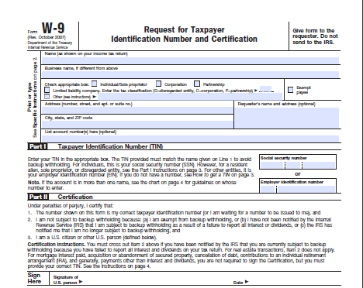
Figure 1. IRS Form W-9
- State of Kansas - DA-130 Form - Authorization for Electronic Deposit of Vendor Payment. Use this form to submit vendor bank account information to the Central processing office.
To obtain a copy of the DA-130 Form please contact Accounts and Reports by phone: (785) 296-7917.
The use of the DA-130 Form is covered later in this course.
- State of Kansas - DA-184 Form - Authorization For Direct Deposit of Employee Pay and or Employee Travel .
Regents - Use the DA-184 Form to submit Regent Employee Information to the Central processing office.
Locate this form: http://www.da.ks.gov/ar/pm/Forms/Default.htm
The use of the DA-184 Form is covered later in this course.
- State of Kansas - TM-21 Form. Use the TM-21 Form to request changes to an existing vendor file in SMART.
Submit the form to the Central processing office by emailing it to: mailto:Arvendor@da.ks.gov
Locate this form: http://www.da.ks.gov/ar/forms/default.htm
The use of the TM-21 Form is covered later in this course.

- IRS - Form 1099
Form 1099 is used by the Internal Revenue Service (IRS) and is used in the United States income tax system to prepare and file an information return to report various types of income other than wages, salaries, and tips.
Examples of reportable transactions are amounts paid to independent contractors.
If a Form 1099 is returned (due to address or TIN # discrepancies) to the State, the vendor file is closed in SMART by the Central Vendor Processor until a CURRENT Form W-9 is obtained from the vendor, and is then verified by the IRS.
Additional information about Form 1099 and reporting requirements is covered later in this course.
- ACH - Automated Clearing House (ACH). Automated Clearing House (ACH) is an electronic network for financial transactions in the United States. ACH processes large volumes of credit and debit transactions in batches. ACH credit transfers include direct deposit payroll and vendor payments.
In the State of Kansas, an ACH payment is a payment made by the State of Kansas directly into a vendor’s bank account. No live system check is generated when using the ACH payment type. The use of ACH payments is covered later in this course.

Topic 2: Vendor Security Access Roles in SMART
Role | Description
Agency Vendor Processor | This role is responsible for entering and saving new vendor information in SMART. This role cannot edit or modify existing vendor information in SMART.
Central Vendor Processor | This role is responsible for approving new vendors and maintaining all vendor information in SMART. This role, which is performed centrally, is the only role that has access to modifying existing vendor information in SMART.

Topic 3: Vendor Business Process Flows in SMART
- When an agency is preparing to enter vendor information into SMART, they need to gather all required information that needs to be entered prior to using SMART:
    - Basic business information for the vendor
    - Mailing address
    - Location information
    - Procurement defaults
    - Payment options and information
    - Vendor’s TIN Number
- Vendor records are created for Statewide use, they are not Agency specific records. This allows all State Agencies to access and use all vendor records in SMART.
- There is no formal systematic workflow or approval process associated with the Vendor module in SMART. Therefore Agencies may add and save vendor information, but they cannot edit or modify existing vendor information in SMART. All edits and changes must be completed by the Central Processing Office.
- The following graphic highlights the business process for an Agency to enter vendor information in SMART:
Figure 2. Business Process to Enter Vendor Information in SMART
- A vendor record is not available for use, and is visible to an Agency with an “Unapproved” status until it has been approved by the Central Processing office. It is important to understand that SMART does not send email notifications to Agencies once a vendor has been “Approved”. Once the vendor is “Approved” by the Central Processing office, the vendor record then becomes available for use by ALL Agencies within SMART.
- The following graphic highlights the processing of vendor information in SMART:
Figure 3. Vendor Processing in SMART

Topic 4: Integration between Vendors, Accounts Payable, and Purchasing modules
- The Accounts Payable and the Purchasing modules in SMART share the vendor file information which is stored in the Vendor module in SMART
- Vendor information must be added by an Agency and approved by Central in SMART before it can be used on a transaction in the Purchasing or Accounts Payables modules within SMART
- Vendor data is defaulted directly into purchase orders, vouchers, and payments which reference the vendor (using the 10 digit Vendor ID number assigned to the vendor by SMART – not the vendor TIN number)

Lesson Review
In this lesson, you learned how to:
- Define SMART basic vendor processing terms and concepts
- Identify SMART security roles and tasks associated with Vendor entry in SMART
- Describe the business process for SMART vendor information processing
- Explain the integration of vendor information with the Accounts Payable and Purchasing modules in SMART

Lesson 2: How to Use Existing Vendor Information in SMART

Objectives
Upon completion of this lesson, you will be able to:
- Describe the importance of verifying if vendor information exists in SMART prior to adding new vendor information
- Request an update or modification to existing vendor information in SMART
- Request the inactivation of existing vendor information in SMART
- Search for a vendor that has previously been entered into SMART
- Review existing SMART vendor information

Topic 1: Verify Existing Vendor Information in SMART
- Important! Prevent Duplicate Vendor Entries in SMART!
A common issue with vendors in SMART is the duplication of existing vendor information being entered into SMART by Agency Vendor Processors.
The State of Kansas expects all Agency Vendor Processors to verify that the vendor information does NOT already exist in SMART PRIOR TO entering any new or additional vendor information into SMART. This process involves a manual review of ALL existing vendor information in SMART before adding any new vendor information.
It is important to understand that Agency staff are NOT able to edit existing vendor information in SMART, they may only add new vendor information in SMART. Edits to existing vendor information are performed by the Central Agency Vendor Processor and must be submitted using a TM-21 Form.
Important! Prevent Duplicate Vendor Address Entries in SMART!
If an existing address in SMART is incorrect, please do NOT add a new address to correct the existing address in the vendor file. Please submit a TM-21 form to have the Central Vendor Processor edit the EXISTING address we have on file for the vendor. This prevents duplication of efforts and data in SMART. Thank you.
SMART users with the Agency Vendor Processor role or the Vendor Viewer role are able to select the “View All” link to view a history of all vendor addresses or locations. It is important to understand that SMART will allow only one address for each specific effective date.

Topic 2: Edit or Inactivate Existing Vendor Information in SMART
Use the TM-21 Form to request changes to, or in-activations of, existing vendor information in SMART.
Click this link to access the TM-21 Form: http://www.da.ks.gov/ar/forms/default.htm.
Submit the completed TM-21 form to the Central processing office by emailing it directly to: mailto:Arvendor@da.ks.gov.
The Central Agency Processor reviews the changes and either completes or denies them. Please understand that there is NO formal workflow process in the Vendors module in SMART. This means that you will NOT receive an email notification advising you that the vendor changes have been completed or denied as requested. You will need to check the vendor files in SMART to determine if, and when, the changes you submitted have been processed. For vendor inactivation requests, the Central Agency Processor changes the Status of inactivated vendors from “Active” to “Denied” in SMART.

Topic 3: Search for Existing Vendor Record in SMART

Use the Review Vendors page to locate existing vendor information in SMART prior to entering new vendor information into SMART. Enter the desired Search Criteria and click the Search button to display the search results grid at the bottom of the Review Vendors page.
Note: Use the SEARCH button, hitting the enter key does not work on this page!

Page name | Navigation
Review Vendors | Vendors>Vendor Information>Add/Update>Review Vendors

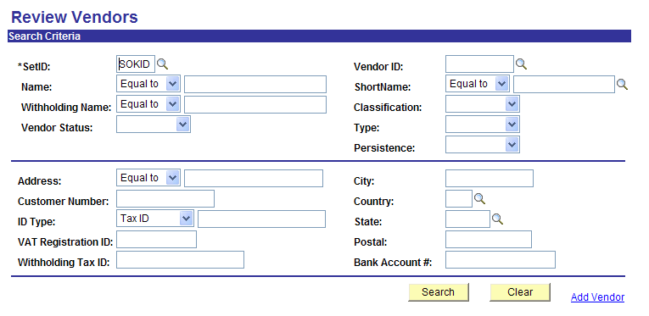
Figure 2.1. Review Vendors Page

Search for Vendor by Name
  - Select “Contains” in the dropdown box for Name
  - Type in part of the Vendor Name
  - Click on the “Search” button
  - Review the Search Results at the bottom of the page
  - Locate the desired result and click the icon
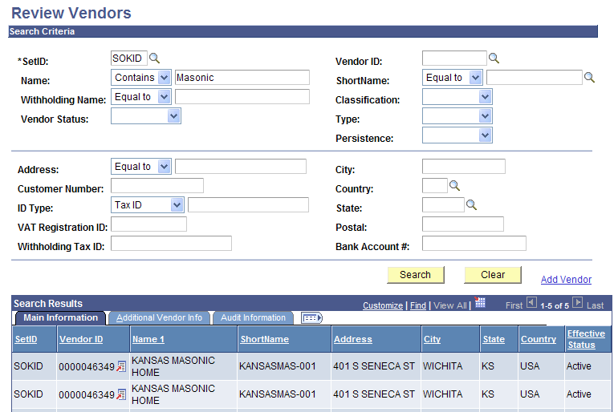
Figure 2.2. Review Vendors Page – Search by Name

Search for Vendor by Address
  - Select “Contains” in the Address dropdown box
  - Type in part of the address
  - Click the “Search” button
  - Review the Search Results at the bottom of the page
  - Locate the desired result and click the icon
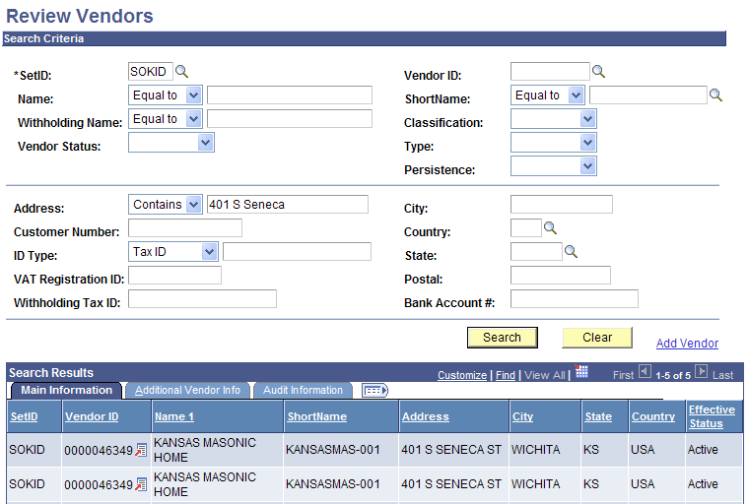
Figure 2.3. Review Vendors Page – Search by Address

Search for Vendor by Withholding Tax ID Number
  - Enter the Withholding Tax ID number in the Withholding Tax ID field
  - Click the “Search” button
  - Review the Search Results at the bottom of the page
  - Locate the desired result and click the icon
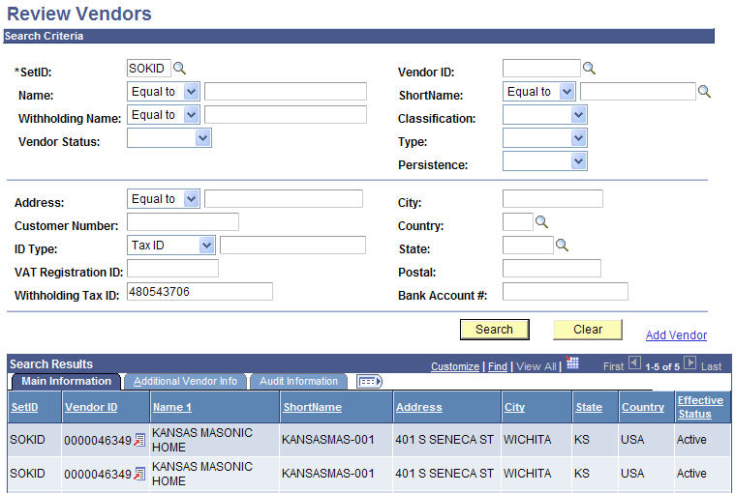
Figure 2.4. Review Vendors Page – Search by Withholding Tax ID
Clicking the (View Related Links) icon opens this screen:

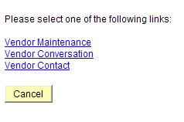
Figure 2.5. Existing Vendor link options
Select the Vendor Maintenance link to open the vendor record in a new window.

Topic 4: Review Existing Vendor Record in SMART

Use the vendor information pages to review existing information for a vendor in SMART. This topic provides a general overview of each of the pages used to store vendor information in SMART. The creation of a new vendor and the entry of data into these fields will be covered later in this course.

Summary Page
The Summary page contains an overview of the key information for a vendor in SMART.

Page name | Navigation
Summary | Vendors > Vendor Information > Add/Update > Review Vendors > (Enter Search Criteria) > Search Results > Click the (View Related Links) icon > Click the Vendor Maintenance link > Click the Summary Tab page

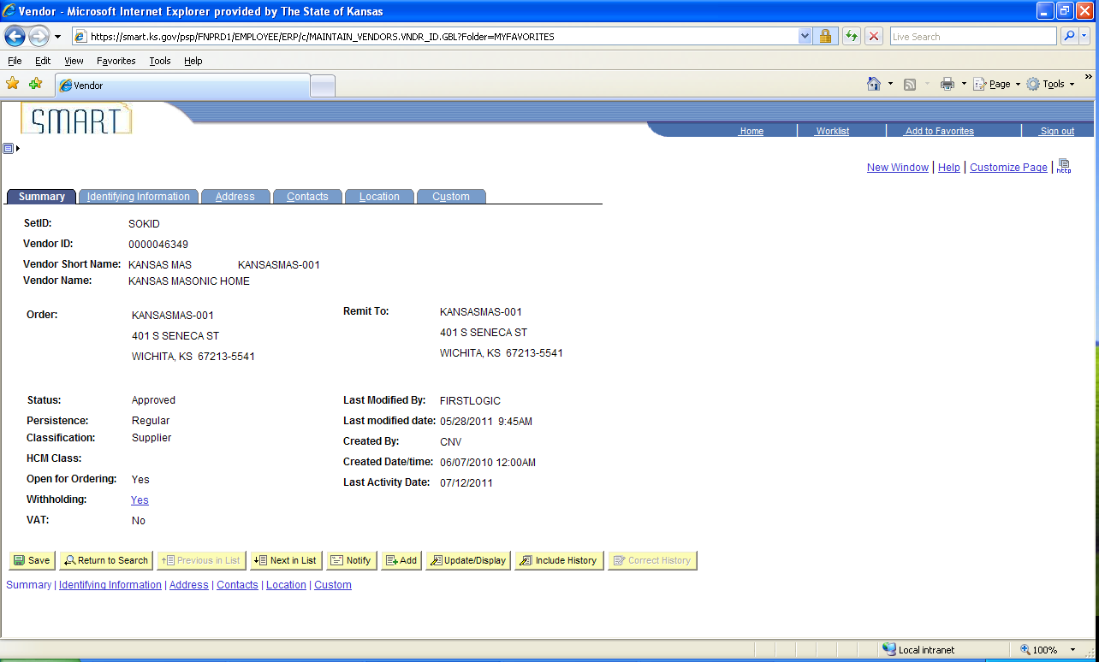
Figure 2.6. Vendor Summary Page

Identifying Information Page
The Identifying Information page lists additional vendor information including the Vendor Name, the Vendor Short Name, Vendor ID number, Vendor Status, and Withholding checkbox.

Page name | Navigation
Identifying Information | Vendors > Vendor Information > Add/Update > Review Vendors > (Enter Search Criteria) > Search Results > Click the (View Related Links) icon > Click the Vendor Maintenance link > Click the Identifying Information Tab

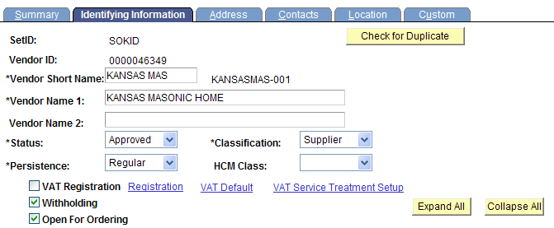
Figure 2.7. Vendor Identifying Information Page (Detail)
If you select a vendor that shows “Duplicate Vendor” in the Vendor Name 1 field, use only the vendor number given to find the new vendor record. DO NOT include the asterisk and number following it when using the vendor number.
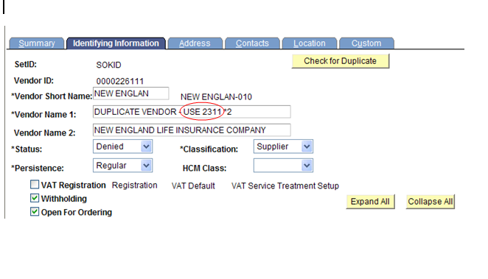
Figure 2.8. Example of a Duplicate Vendor Record (Detail)

Address Page
The Address page lists all address information for a vendor in SMART. Use the View All link to view all addresses for the vendor. The Phone Information section contains payment location information for the vendor.

Page name | Navigation
Address | Vendors > Vendor Information > Add/Update > Review Vendors > (Enter Search Criteria) > Search Results > Click the (View Related Links) icon > Click the Vendor Maintenance link > Click the Address Tab > Click the View All link

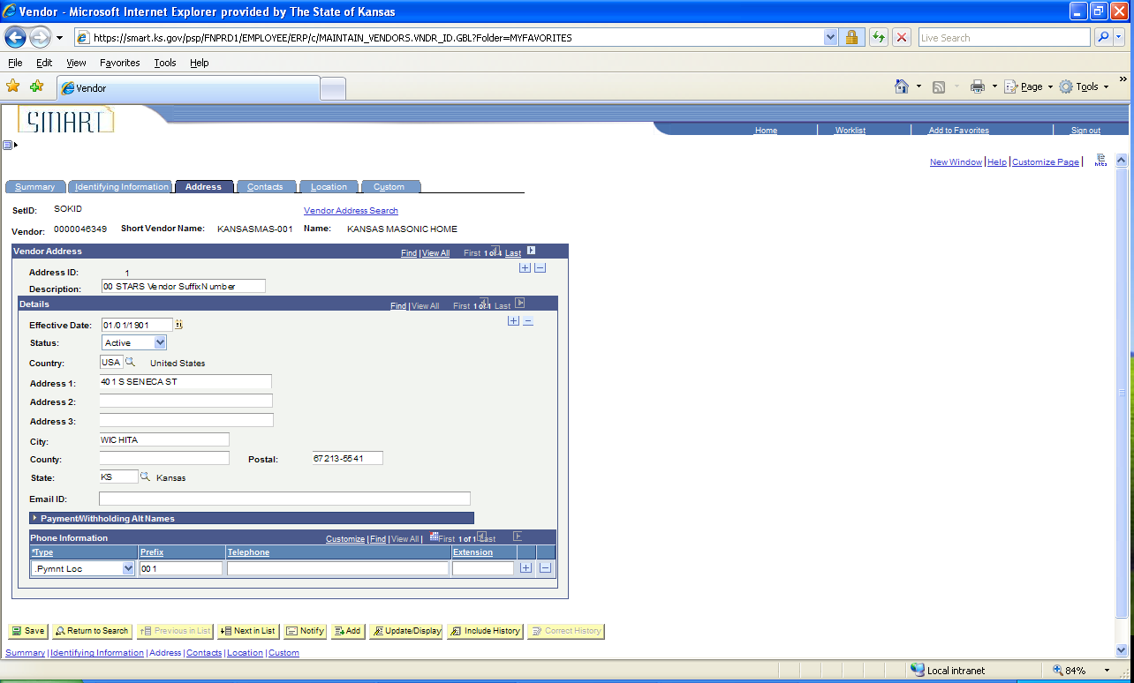
Figure 2.9. Vendor Addresses Page

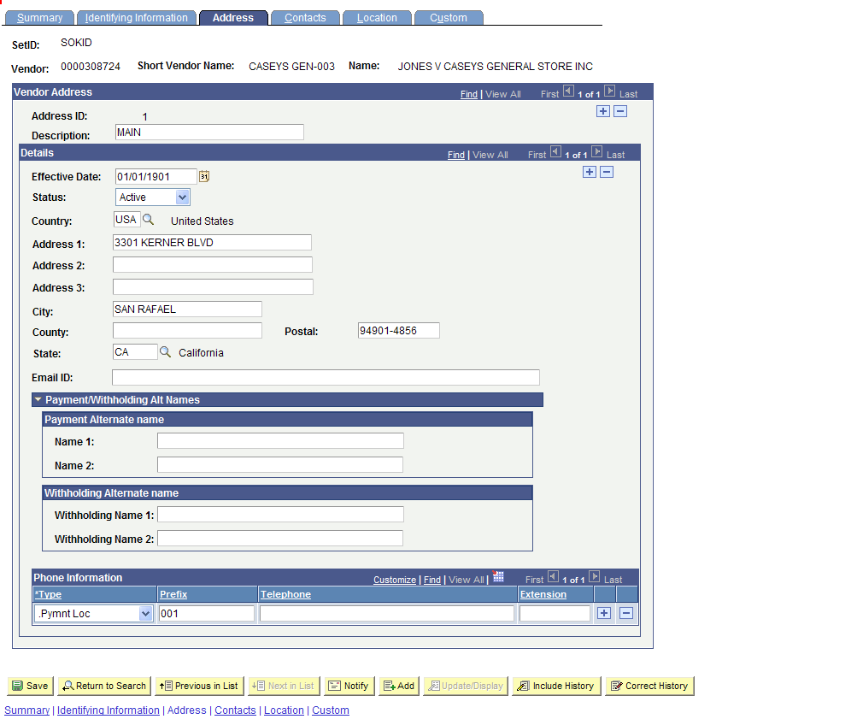
Figure 2.10. Vendor Addresses Page (Detail)

Contacts Page

The Contacts page stores the contact information for the contacts at the vendor.

Page name | Navigation
Contacts | Vendors > Vendor Information > Add/Update > Review Vendors > (Enter Search Criteria) > Search Results > Click the (View Related Links) icon > Click the Vendor Maintenance link > Click the Contacts Tab > Click the View All link

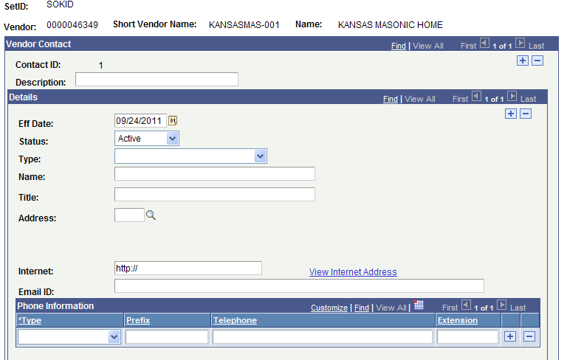
MAIN
Figure 2.11. Contacts Page

Location Page
The Location page contains the vendor payment information, vendor bank account information, Withholding information, and business procurement card information for the vendor.

Page name | Navigation
Location | Vendors > Vendor Information > Add/Update > Review Vendors > (Enter Search Criteria) > Search Results > Click the (View Related Links) icon > Click the Vendor Maintenance link > Click the Location Tab > Click the View All link

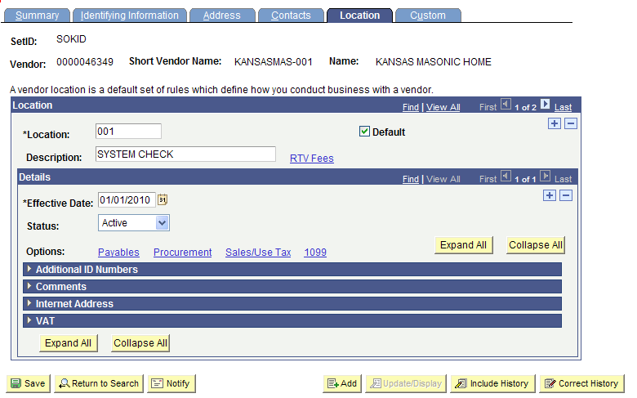
Figure 2.12. Vendor Location Page

Figure 2.13. Vendor Location Page (Detail)

Location Page - Payables Link

Clicking the Payables link on the Location page opens the Payables Options page. The Payables Options page contains the Additional Payment Information and the Vendor Bank Account Options.

Page name | Navigation
Payables Options | Vendors > Vendor Information > Add/Update > Review Vendors > (Enter Search Criteria) > Search Results > Click the (View Related Links) icon > Click the Vendor Maintenance link > Click the Location Tab > Click the Payables Link

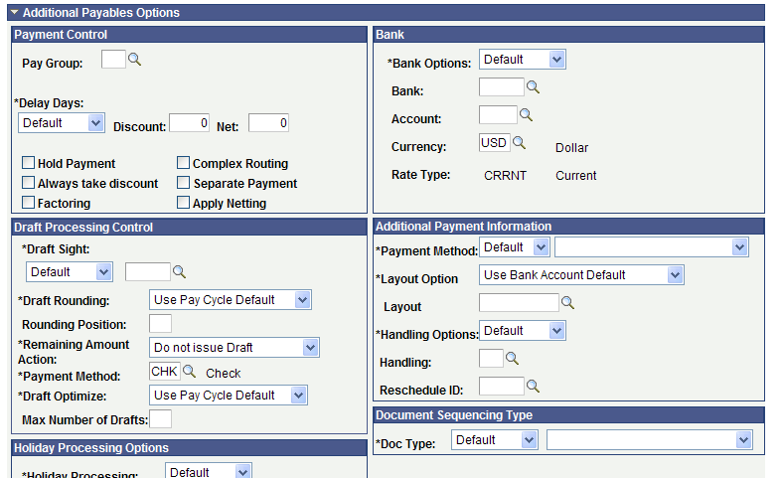
Figure 2.14. Payables Options Page – top of page
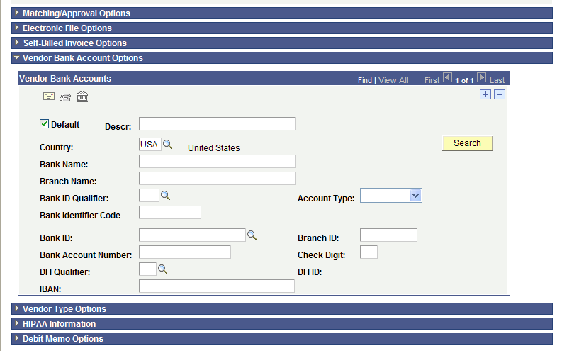
Figure 2.15. Payables Options Page – Vendor Bank Account Options

Location Page - Procurement Link

Clicking the Procurement link on the Location page opens the Procurement Options page which contains the Procurement Card Information for the vendor. If a vendor accepts business procurement cards as a method of payment, the Accepts Procurement Card as payment method checkbox is selected.

Agencies change the default *ProCard Dispatch Option from Default to Contact Cardholder.

Page name | Navigation
Procurement Options | Vendors > Vendor Information > Add/Update > Review Vendors > (Enter Search Criteria) > Search Results > Click the (View Related Links) icon > Click the Vendor Maintenance link > Click the Location Tab > Click the Procurement Link

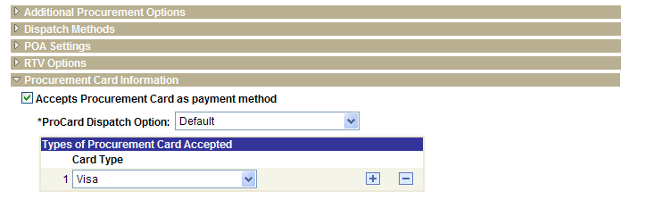
Figure 2.15. Procurement Options Page (Detail)

Location Page – Sales/Use Tax Link
The State of Kansas is not using the Sales/Use Tax Link.

Location Page - 1099 Link

Click the 1099 link on the Location page to open the Withholding Vendor Information page. The Withholding Vendor Information page is used to store the 1099 Withholding and/or Reporting information for a vendor.
Withholding information is covered in depth in Lesson 3 of this training course.

Page name | Navigation
Withholding Vendor Information | Vendors > Vendor Information > Add/Update > Review Vendors > (Enter Search Criteria) > Search Results > Click the (View Related Links) icon > Click the Vendor Maintenance link > Click the Location Tab > Click the 1099 Link

- Withholding Vendor Information
  - Both sections, 1099 Information and 1099 Reporting Information, must be completed
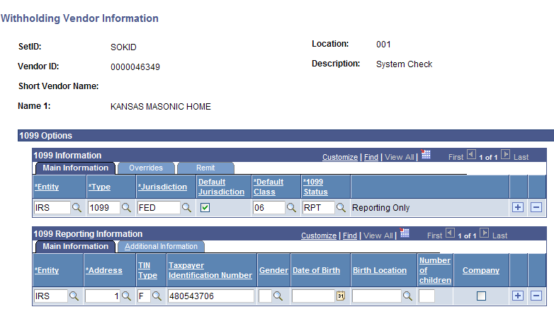
Figure 2.16. Withholding Vendor Information

- Non-Withholding Vendor Information
  - Only the bottom section, 1099 Reporting Information, must be completed
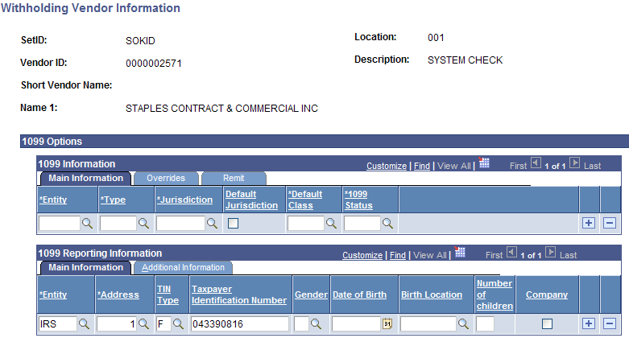
Figure 2.17. Non-Withholding Vendor Information

Custom Page
The State of Kansas is not using the Custom Page.

Lesson Review
In this lesson you learned:
- The importance of verifying if vendor information exists in SMART prior to adding new vendor information
- How to request an update or modification to existing vendor information in SMART using the TM-21 form
- How to request the inactivation of existing vendor information in SMART using the TM-21 form
- To search for a vendor that has previously been entered into SMART using different search options
- How to navigate to and review existing vendor information in SMART

Lesson 3: Enter New Vendor Information into SMART

Objectives
Upon completion of this lesson, you will be able to:
- Define the key terms and concepts used in the entry of vendor information in SMART
- Navigate to and use the vendor pages in SMART to enter vendor information

Topic 1: Vendor Information - Statewide Standards in SMART
- Vendor information is entered using ALL CAPS in SMART
- A vendor must be in an Approved status before you are able to use that vendor on a purchase requisition, purchase order, voucher, or payment in SMART.
- Do NOT edit Statewide Contract Vendors. Contact the Department of Administration, Central Processing office PRIOR to editing an EXISTING STATEWIDE Contract vendor. Eg: Staples

Topic 2: Summary Page
The Summary Page is a view only page that contains an overview of the key information for a vendor. The following topics will teach you how to enter the data into the remaining vendor pages.

Page name | Navigation
Summary | Vendors > Vendor Information > Add/Update > Find An Existing Value > Enter Search Criteria > Click the Search button > Summary Tab

Figure 3.1. Summary Page

Fields | Description
SetID | SOKID = State of Kansas ID. All vendor records in SMART are Statewide vendors, not Agency specific vendors.
Vendor ID | Contains the 10 digit Vendor ID number assigned to the vendor in SMART. Each vendor is assigned a unique 10 digit vendor ID number in SMART.
Vendor Short Name | Each vendor is assigned a 10 character Vendor Short Name in SMART.
Vendor Name | Contains the legal or full name of the vendor which is sourced from the Form W-9 or the Form W-8 when the vendor is originally set up in SMART.
Order | Contains the vendor’s Address information. This information is sourced from the vendor Address page in SMART.
Remit To | Contains the vendor’s Location information. This information is sourced from the vendor Location page in SMART.
Status | Displays the current status of the vendor according to the SMART vendor statuses. The Statuses available include Approved, Denied, Inactive, To Archive, and Unapproved.  SMART Vendor Status Definitions:  - Approved – For Central Vendor Processors, SMART automatically assigns a status of Approved to the vendor when entering a new vendor. SMART does not recognize a vendor as being in an Approved Status unless an authorized Accounts Payable or Purchasing user enters or approves it.  A vendor must be in an Approved status before vouchers, purchase requisitions, or purchase order transactions, can be created for the vendor in SMART.  - Denied - Central Vendor Processors may change the vendor Status to Denied. Once a vendor has been assigned a Denied Status, SMART users are unable to enter any transactions for the vendor in SMART. Duplicate vendors in SMART will be changed to a Denied Status.  - Inactive – Central Vendor Processors may inactivate a vendor. Once a vendor has been assigned an Inactive Status, SMART users are unable to enter any transactions for the vendor in SMART.  - To Archive – A Central Vendor Processor may select the To Archive Status. Once the To Archive Status has been selected, SMART users cannot enter any new transactions for this vendor; and the vendor is purged from SMART.  - Unapproved – Only a user with a Central Vendor Processor role may Unapprove a vendor. Once a vendor has been assigned an Unapproved Status in SMART, users cannot use that vendor for any transactions in SMART.  A new vendor created by an Agency and saved in SMART is saved with an Unapproved status, and is unavailable for use until the vendor record has been reviewed and Approved by a Central Vendor Processor.
Persistence | Denotes the frequency of transactions the vendor has with the State of Kansas.  SMART Vendor Persistence Definition:  Regular –You can create an unlimited number of vouchers for this vendor.  Agencies: Use only the REGULAR persistence. Do not use any other Persistence options.
Classification | The field that denotes the SMART Classification of a vendor, including Attorney, Employee, Medical, or Supplier.  Note: Most State vendors are Suppliers. Regent employees are the only Agency employees entered into SMART as vendors. Regent employees are entered with the Classification of “Supplier”, NOT “Employee”.  Regents do NOT have to complete a Form W-9 for a new individual employee, however, the Regent must supply a DA-184 form or a DA-130 form for the new employee to the Central Vendor Processing office.  HCM (Human Capital Management): Note to Agencies:  For existing vendors in SMART with the HCM Classification: Agencies may use the existing vendor record as it is in SMART. The agency MUST NOT make any changes to the existing vendor record.  It is important to know that if you are using an existing vendor in SMART which has an HCM classification, and you are sending the vendor a payment check; if the check gets returned for any reason, the check may not be returned to your agency as you might expect. The check may be returned to the Department of Administration, Payroll Services staff instead of your agency.  Question: I need to make a change to a vendor with an HCM Classification. How do I do this?  Answer: Changes are MUST NOT be made to existing vendors with an HCM Classification in SMART. Your Agency must either use a different existing vendor record in SMART, or ADD A NEW vendor record in SMART (please check that the vendor record does not already exist before adding a new vendor record – thank you!)
HCM Class  (Human Capital Management) | Agencies: The HCM option is not for Agency use. It is to be used only by Department of Administration, Payroll Services staff.
Open for Ordering | When selected, this checkbox indicates that purchase requisitions and purchase orders (POs) may be created for this vendor in SMART Purchasing.
Withholding | The Withholding Field indicates whether a vendor is considered to be eligible for 1099 withholding, or not. Information about 1099 withholding for vendors is covered later in this course.
VAT | The State of Kansas is not using the VAT option in SMART.
Last Modified By | This field contains the name of the user or process that last modified the vendor record in SMART (most recently).
Last modified date | This field contains the date and time that the vendor record was last modified in SMART (most recently).
Created By | This field contains the name of the SMART user that originally created the vendor record in SMART.  Note: The value CNV indicates that the vendor record was migrated from the State of Kansas’ prior operating system (STARS) into SMART.
Created Date/time | This field contains the date and time that the vendor record was originally created in SMART
Last Activity Date | This field contains the date and time that the vendor record was last changed or processed in SMART. The Last Activity Date includes both manual changes and automated batch processes that occur on a vendor record.
Save button | The Save button is used to Save any changes that you have made to a vendor record in SMART. If you do not use the Save button, you may lose any changes that you have made to the vendor record.
Return to Search button | Clicking the Return to Search button returns you to the previous vendor search criteria or vendor search results page in SMART.
Notify button | Agencies: Do NOT use the Notify button. The Notify functionality is not operational (functional) in the Vendor module in SMART.
Previous in List button | Click this button to navigate to the prior record in the list of search results.
Next in List button | Click this button to navigate to the next record in the list of search results.
Add button | Clicking the Add button enables a user to create a new vendor record.  Hint: If you have made changes to a vendor record, ensure you use the Save button to save the changes to that vendor record PRIOR to clicking the Add button. If you do not click the Save button, any changes you made to the current vendor record will be lost. The Add button transfers you to a new blank vendor record page.
Update/Display button | Agencies – Do NOT use this button. It is for Central use only.
Include History button | Agencies – Do NOT use this button. It is for Central use only.
Correct History button | Agencies – Do NOT use this button. It is for Central use only.
Summary link | This link is not operational on the Summary page, as you are already on the Summary page in SMART.
Identifying Information link | Use the Identifying Information link to navigate to the vendor Identifying Information page in SMART
Address link | Use the Address link to navigate to the vendor Address page in SMART
Contacts link | Use the Contacts link to navigate to the vendor Contacts page in SMART
Location link | Use the Location link to navigate to the vendor Location page in SMART
Custom link | Agencies: Do NOT use the Custom link. The State of Kansas is not using the vendor Custom page in SMART.
New Window link | Use the New Window link to open a new (additional) window containing SMART.
Help link | Use the Help link to access and use the SMART UPK’s (User Productivity Kits – computer based training tool).
Customize Page link | Agencies: Do not use the Customize Page link. The State of Kansas is not using the Customize Page link in SMART.
http icon | Agencies: Do not use the http icon link. The State of Kansas is not using the http functionality in SMART.
Home link | Use the Home link to return to SMART’s main home page and main left navigation menu.
Sign out link | Use the Sign out link to sign out of the current session of SMART (to log out of SMART).

Topic 3: Identifying Information Page
When you are preparing to enter a new vendor into SMART, you need to gather all of the information for the vendor before beginning to create the new vendor in SMART. This information includes (but is not limited to):
  - Identifying information, including status, classification, and other basic business information that tells you what kind of vendor you are entering
  - Physical addresses for the vendor
  - Procurement defaults that define your relationship with your vendor, and tell SMART how to handle voucher errors and approvals
  - Payment options that establish defaults for payment processing, such as Automated Clearing House (ACH). For ACH, you send all applicable payments in one file to your financial institution. If the financial institution is a member of a clearinghouse, then the clearinghouse sends the payments to the vendor’s bank for payment.

Page name | Navigation
Identifying Information | Vendors > Vendor Information > Add/Update (Find An Existing Value - Enter Search Criteria and Search) > Search Results > Select the desired result > Click the Identifying Information Tab

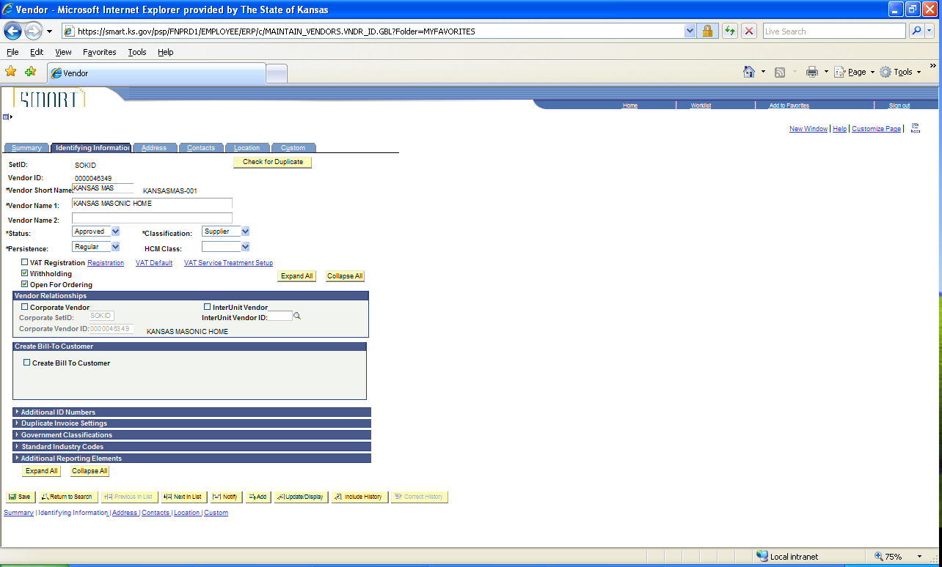
Figure 3.2. Vendor Identifying Information Page
Figure 3.3. Example of a Vendor Identifying Information Page (Detail)
Fields | Description
Vendor Short Name | Use the Vendor Short Name field to enter in the short vendor name. The Vendor Short Name field should be entered as:  Use ALL CAPS to enter the information.  Individuals: The first 10 characters of the Last name, COMMA, followed by as many characters of the first name as possible.  Example: JENNOLD,BAILE  Agencies: Do NOT use any spaces or special characters when entering a Vendor Short Name for an Individual in SMART.  Companies: First10 characters of the business name, excluding The, and, etc.  Example: The Kansas Registery is entered as KANSASREGISTE  DBA: ‘Doing Business As’ – Enter the DBA name in the Vendor Short Name field.
Vendor Name 1 | Use the Vendor Name 1 field to enter the legal or full name of the vendor which is sourced from the IRS Form W-9. You may use spaces in the vendor’s name when entering data in this field.  Use ALL CAPS to enter the information
Vendor Name 2 | There are two lines for the vendor name (Vendor Name 1 and Vendor Name 2), in case you are dealing with divisions, subsidiaries, or other complex organization entities that require detailed identification. You may use spaces in the vendor’s name when entering data in this field.  If a vendor is a DBA (Doing Business As), enter the DBA name into the Vendor Name 2 field (and in the Vendor Short Name field).  Use ALL CAPS to enter the information  Note: It is important to know that when a check is printed, the Vendor Name 2 name will be included on the same line as the Vendor Name 1.  For example: Vendor Name 1 field = Joe Green. Vendor Name 2 field = Joe’s AC Repair. In this case, the check will print out as ‘Joe Green Joe’s AC Repair’, appearing on the first line of the printed check.
Status | Agencies = Unapproved Status. When an Agency first creates a Vendor record and Saves the record, SMART assigns an Unapproved status to the record.  The Central Vendor Processor reviews the Unapproved vendor records on a daily basis and either Approves or Denies the vendor record.  Once the Central Vendor Processor changes the Status to Approved, you will be able to use the vendor record in SMART.  Note: There is NO email notification sent to an Agency to let them know that a vendor record has been either Approved or Denied. The Agency needs to manually monitor the Status of the vendor in SMART.
Classification | Use the Classification drop down list to select the desired Classification type for the vendor. Valid options include: Attorney, Employee, Medical, or Supplier.  Classification Definitions:  Attorney: Select the Attorney Classification when establishing an Attorney as a vendor.  Note: Do not use the Attorney option if you are not actually paying the attorney.  For example: If you are paying an individual care of an attorney, do not select the Attorney option.  Employee: Agencies – do not use this option.  Medical: Select the Medical Classification when establishing a medical vendor.  Supplier: Use the Supplier option for all other types of vendors. Regents: Please use the Supplier option to set up your employees.  HCM: Agencies – Do NOT select this option!  This option is used only by Department of Administration, Payroll Services staff for remittance purposes. Vendors with the HCM Classification must NOT be changed in SMART by Agencies.  All checks issued to SMART vendors with the HCM Classification are returned directly via Central Mail to the Department of Administration, Payroll Services staff.  If you need to use a different address for the vendor, first search for the vendor to ensure the vendor does not already exist under a different vendor number (which does not have an HCM Classification). If the vendor does not exist under a different Vendor ID number, then set up a new vendor with the desired Classification (do NOT use the HCM option).  Alternatively, if the vendor already exists under a different Vendor ID number, then add a new address to the existing vendor record (without the HCM Classification).
Persistence | Use the Persistence drop down list to select the “Regular” option.  Agencies – Do NOT use any other drop down list option.
HCM Class | Agencies – do NOT use this field. This field is used only by Department of Administration, Payroll Services staff.
VAT Registration checkbox | The State of Kansas is not using the VAT functionality in SMART. Agencies – do not use this field.
Registration link | The State of Kansas is not using the VAT functionality in SMART. Agencies – do not use this field.
VAT Default link | The State of Kansas is not using the VAT functionality in SMART. Agencies – do not use this field.
VAT Service Treatment Setup | The State of Kansas is not using the VAT functionality in SMART. Agencies – do not use this field.
Withholding checkbox | Select the Withholding checkbox for all U.S. based vendors, EXCEPT non-legal corporations and non-medical corporations. Please ensure the Withholding checkbox is selected for individuals.  Select the Withholding checkbox, then click on the Location Tab, click the 1099 link and add the Withholding information. Save the vendor file.  Note: SMART will not allow you to Save the vendor file if you do not have the Withholding checkbox on the Identifying Information page selected AND the information in the 1099 Withholding information page completed BEFORE clicking the Save button.  SMART requires you to enter the 1099 Withholding information PRIOR to the Vendor Bank Account Information on the Location Tab if you are setting up an ACH payment method for a vendor. More information about this process is covered in the Location Tab topic later in this course.
Open for Ordering checkbox | When selected, this checkbox indicates that purchase requisitions and purchase orders (POs) may be created for this vendor in SMART Purchasing.  Defaults as selected – Keep the default selection – do NOT deselect the Open for Ordering checkbox.
Expand All button | Use the Expand All button to open all sections on the Identifying Information page.
Collapse All button | Use the Collapse All button to collapse (close or minimize) all sections on the Identifying Information page.

Vendor Relationships Section – The State of Kansas is not using this section

Create Bill To Customer Section - The State of Kansas is not using this section

Page name | Navigation
Identifying Information | Vendors > Vendor Information > Add/Update (Find An Existing Value - Enter Search Criteria and Search) > Search Results > Select the desired result > Click the Identifying Information Tab  Expand the Additional ID Numbers collapsible section

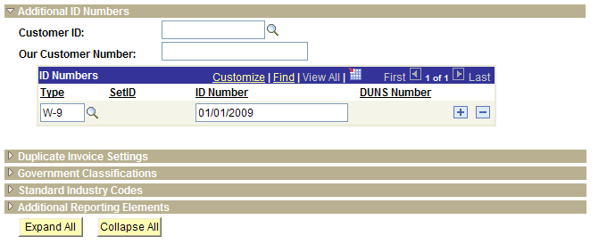
Figure 3.4. Vendor Additional ID Numbers Page
Fields | Description
Customer ID | If this vendor is also a customer in the SMART Accounts Receivable module, enter the valid Customer ID
Our Customer Number | Agencies: Do NOT enter the vendor’s TIN in the ‘Our Customer Number’ field.
Type | Note. For State of Kansas, use W-9. Enter the date the W-9 was obtained in the ID Number field.

Use the Government Classifications section to optionally track government-reporting information for this vendor. Vendors receive certain classifications of certification, such as small business or woman-owned, from various government sources.
Page name | Navigation
Identifying Information | Vendors > Vendor Information > Add/Update (Find An Existing Value - Enter Search Criteria and Search) > Search Results > Select the desired result > Click the Identifying Information Tab  Expand the Government Classifications collapsible section

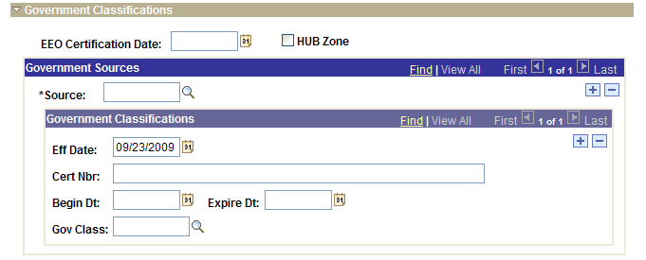
Figure 3.5. Vendor Government Classifications Page
Fields | Description
Source | Enter the vendor's certification source
Cert Nbr (certificate number) | Enter the number of the certificate that your vendor received from this source, verifying that the vendor is qualified for this government classification
Gov Class | Enter the type of government classification for which your vendor qualifies

Depending on your agency’s reporting requirements, you can apply Standard Industry Classification (SIC) codes as part of your vendor header or on your vendor Location tab. If you are not doing government reporting, you may choose to define these numbers at the vendor location only.
Page name | Navigation
Identifying Information | Vendors > Vendor Information > Add/Update (Find An Existing Value - Enter Search Criteria and Search) > Search Results > Select the desired result > Click the Identifying Information Tab  Expand the Standard Industry Codes collapsible section

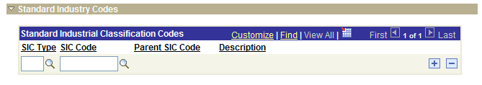
Figure 3.6. Vendor Standard Industry Codes Page
Fields | Description
SIC (Standard Industry Code) Type | Select the appropriate type for your vendor
SIC Code | In accordance with the SIC Type that you select, SMART provides an appropriate list of SIC Codes. Select a code for the vendor.  Based on the SIC information that you select, SMART populates the Parent SIC Code field and the Description field.

The Additional Reporting Elements section enables you to enter information required for Federal Procurement Data Systems reporting.

Page name | Navigation
Identifying Information | Vendors > Vendor Information > Add/Update (Find An Existing Value - Enter Search Criteria and Search) > Search Results > Select the desired result > Click the Identifying Information Tab  Expand the Additional Reporting Elements collapsible section

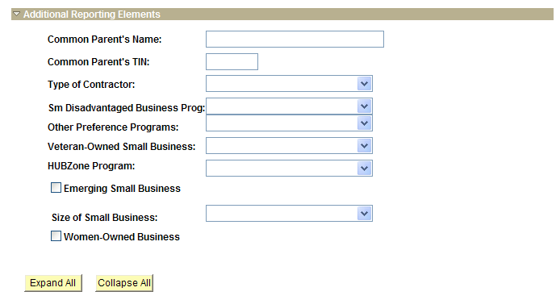
Figure 3.7. Vendor Additional Reporting Elements Page

Fields | Description
Sm Disadvantaged Business Prog (small disadvantaged business program) | Select a small disadvantaged business program.  A Small Disadvantage Business (SDB) program provides business development and federal contracting opportunities for small disadvantaged businesses that would not otherwise qualify for such programs. An SDB enables small businesses to compete in the federal contracting arena and helps expose them to a wider range of subcontracting opportunities that are typically available for large firms only. Programs of this nature are intended to help federal agencies achieve the government-wide goal of 5 percent SDB participation in prime contracting.
Veteran-Owned Small Business | Select a veteran-owned small business program.  The veteran-owned small business program provides veteran-owned small businesses maximum practical opportunity to participate in the performance of contracts and subcontracts awarded by any federal agency.
HUBZone Program (historically underutilized business zone program) | Select a HUB Zone program.  The HUB Zone Empowerment Contracting program provides federal contracting opportunities for qualified small businesses located in distressed areas.
Emerging Small Business | Select if the vendor qualifies as an emerging small business.
Size of Small Business | If you selected the Emerging Small Business check box, select the applicable business size for this small business from the available options.
Women-Owned Business | Select if this vendor qualifies as a women-owned business.

Topic 4: Address Page
- Agencies use the Address Page only to VERIFY EXISTING vendor address information
OR to add NEW vendor information.
- Agencies - Do NOT add a NEW address to correct an EXISTING vendor address in SMART!
- Agencies are unable to edit existing vendor address information in SMART.
- If you need to edit, delete, or modify existing vendor address information, please submit a TM-21 form to the Central Vendor Processor.

Edit, Delete, or Modify Existing Vendor Address Information in SMART

- Use the State of Kansas TM-21 Form to request changes or deletions of existing vendor address information in SMART.
- Locate this form: http://www.da.ks.gov/ar/forms/default.htm.
- Submit the completed TM-21 form to the Central Vendor Processor by emailing it to: mailto:Arvendor@da.ks.gov

Approved vs. Unapproved Vendors

It is important to understand that vendors are Statewide records, they are not Agency specific. It is also important to understand that changes to existing vendor address, location, or banking information, (and saving that information) automatically causes SMART to change the vendor Status to “Unapproved”.
When a vendor is in an “Unapproved” status, no State Agencies are able to use that vendor (until it has been reviewed and “Approved” by a Central Vendor Processor). The Central Vendor Processor runs a report in SMART each morning that provides a list of all vendors with an “Unapproved” status. The Central Vendor Processor reviews each vendor individually and either changes the vendor Status from “Unapproved” to “Approved” or “Denied”.
If your Agency needs to update vendor information and use the vendor immediately, please complete a TM-21 form and email the form and request for an immediate vendor review to the Central Vendor Processor at: mailto:Arvendor@da.ks.gov

Effective Dates

Use the Address page to enter NEW address information for a vendor. In SMART, vendor information is effective dated.
New Vendor Information for a NEW vendor is added accepting SMART’s default Effective Date of 01/01/1901.
Note: Updates to incorrect existing vendor information are made by the Central Vendor Processor who enters an effective date of today’s date (the current date).
If you are adding NEW address information to an EXISTING vendor, then accept the SMART default date of <today’s date>.

Order of Vendor Information Data Entry

When creating a new vendor in SMART, the Address information MUST be entered PRIOR to the Location Tab (Payment) information. If you attempt to Save a vendor record without having completed the data entry of vendor information in the correct order, SMART will not allow you to Save the vendor information (SMART will provide you with an error message).

Address Validation – State of Kansas Business Process

Addresses should be entered into SMART as “postal correct”. Agencies MUST validate an address format as ‘postal correct’ and accurate BEFORE entering the vendor address into SMART on the Address page. Use the USPS postal website to validate vendor address information PRIOR to entering the address into the vendor Address page. Use the address format from the USPS website as the source for address information to be entered into SMART. The website address for the USPS Zip Code Lookup page is: http://zip4.usps.com/zip4/.
Important! If your Agency neglects to enter a vendor’s address correctly into SMART, the nightly address validation process (called First Logic) may automatically deny the incorrect address entry, thereby automatically changing the vendor’s Status to “Inactive” in SMART.
Agencies are unable to use vendors with an “Inactive” Status in SMART.
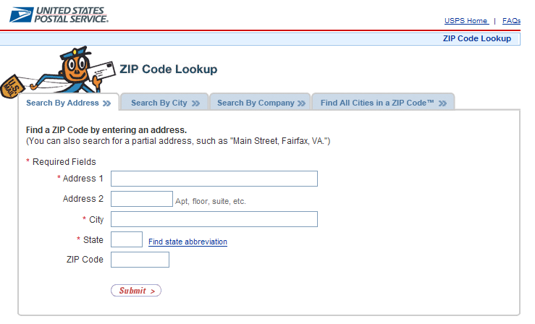
Figure 3.8. United States Postal Service – Zip Code Lookup (Vendor Address Verification tool)
Use this website to verify Canadian Addresses: http://www.canadapost.ca/cpotools/apps/fpc/business/findByCity
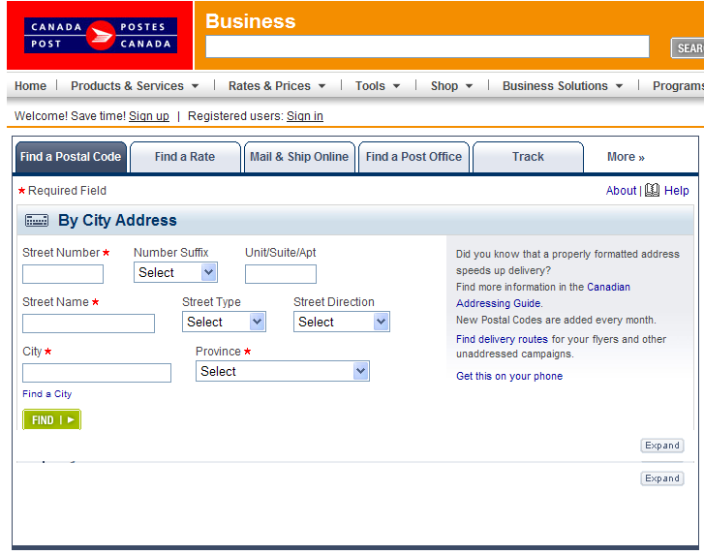
Figure 3.9. Canadian Postal Service – Look Up By City Address (Vendor Address Verification tool)

Page name | Navigation
Address | Vendors > Vendor Information > Add/Update (Find An Existing Value - Enter Search Criteria and Search) > Search Results > Select the desired result > Click the Address Tab

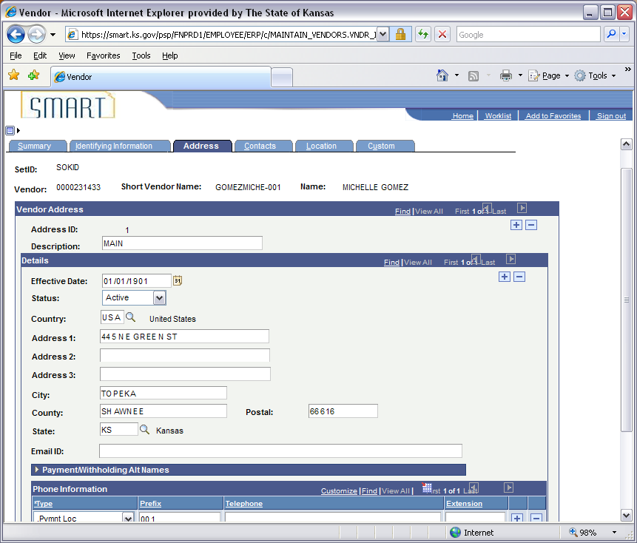
Figure 3.10. Vendor Address Page

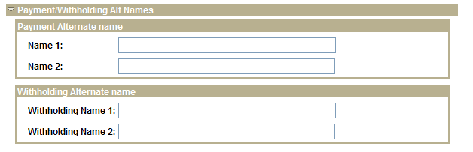
Figure 3.11. Address Page Detail – Payment/Withholding Alt Names Section (Expanded)

Fields | Description
Vendor Address  Address ID | SMART automatically assigns an Address ID to each address for the vendor.
Vendor Address  Description | Use the Description field to enter in a Description that will help distinguish this address from any of the other addresses in SMART for this vendor.  For example: MAIN, or CORP ADDR.  Agencies: Please do not add actual address information, TIN #’s, payment methods (check or ACH), or personal information in this field.  Note: For EXISTING vendors that were converted from STARS (the State of Kansas’ prior accounting computer system), the Description begins with two characters representing the STARS suffix number.  Example: 46 STARS Vendor Suffix Number, then the address information follows.
Vendor Address  + button | Use this ‘+’ button to add an additional address for the vendor.
Vendor Address  - button | Agencies – Do NOT use this button. It is for Central use only.  Submit a TM-21 Form to the Central Vendor Processor.
Details  Effective Date | Accept the SMART default date of 01/01/1901 for a NEW vendor address on a NEW vendor.  Accept the SMART default date of <today’s date> for a NEW address being added to an EXISTING vendor.  Agencies – do NOT change the default date.
Details  Status | Valid values for this field include: Active and Inactive.  Agencies – Select the Active status (default value) to indicate that the address is a valid and active address for the vendor.  Do NOT use the ‘Inactive’ status. This is used only by the Central Vendor Processors.  Note: Any address that does not pass the First Logic address verification nightly batch process in SMART, is automatically changed to an Inactive status. Any vendor with an Inactive status must be reviewed and changed to an Active status by a Central Vendor Processor before the vendor is able to be used by an Agency.
Details  Country | Use the drop down list to locate and select the correct Country code.
Details  Address 1 | After verifying the correct address on the USPS website, enter the vendor address information.  Use ALL CAPS to enter the address information.
Details  Address 2 | After verifying the correct address on the USPS website, enter the vendor address information.  Use ALL CAPS to enter the address information
Details  Address 3 | The Vendor Address 3 field should NOT be used for “real” address information. The Vendor Address 3 field is used to enter and store a vendor’s Medicaid Provider number.  Agencies: Do NOT enter vendor address information in the Address 3 field.  Enter the vendor’s Medicaid provider number in the Address 3 field (if applicable).  Use ALL CAPS to enter the information.
Details  City | After verifying the correct address on the USPS website, enter the vendor’s City.  Use ALL CAPS to enter the information
Details  County | If known, enter the vendor’s County.  Use ALL CAPS to enter the information
Details  Postal | After verifying the correct address on the USPS website, enter the vendor zip code (postal code), including the + 4 zip.
Details  State | Use the drop down list to locate and select the correct State code.
Details  Email ID | Enter the email address that relates to this Address for the vendor.
Details  + button | Use the ‘+’ button to add (create) new Address information for the vendor.
Details  - button | Agencies – Do NOT use this button. It is for Central use only.  Submit a TM-21 Form to the Central Vendor Processor.
Payment Alternate name  Name 1 | If information is entered in the Payment/Withholding Alternate Names section, SMART overrides the name that you specified on the vendor Identifying Information page. This feature may be useful if a vendor does business under a different name.  For example: ‘Smith Consulting’ may be the vendor name, but the vendor requests to receive payments and report 1099 Withholdings under the name of ‘Joe Smith’.  Agencies: Enter an alternate name for the vendor to be used on checks.  Do NOT put an Agency’s Account Number in this field!  Use ALL CAPS to enter the information.
Payment Alternate name  Name 2 | Agencies: Enter an alternate name for the vendor to be used on checks.  Do NOT put an Agency’s Account Number in this field!  Use ALL CAPS to enter the information.
Withholding Alternate name  Withholding Name 1 | Enter an alternate name for the vendor to be used for 1099 reporting.  Use ALL CAPS to enter the information.
Withholding Alternate name  Withholding Name 2 | Enter an alternate name for the vendor to be used for 1099 reporting.  Use ALL CAPS to enter the information.
Phone Information  ‘*Type’ | The ‘*Type’ field is NOT used to store or record vendor phone information.  The ‘*Type’ field is used by the State of Kansas to store payment location information for the vendor.  Agencies: Use the ‘*Type’ drop down listing to choose the option of “.Pymnt Loc”.  Do NOT choose any other option from the drop down listing.  When adding a NEW vendor, the Address must be related to the Location number (sourced from the Location Tab page). The Location code in SMART is used to map the payment methods of the vendor.  Each additional address for the vendor will be added to a Location based on the vendor’s choice of payment method (sourced from the Location Tab page).  Additional Vendor Payment Location information is covered in the Location Page topic.
Phone Information  Prefix | The ‘Prefix’ field is NOT used to store or record vendor phone information.  The ‘Prefix’ field is used by the State of Kansas to store the Payment Location code for the vendor.  Agencies: Use the ‘Prefix’ field to manually enter the desired Payment Location code.  The Payment Location code is sourced from the Location Tab > Location Section > *Location field.  For example: If the vendor only has one payment method, the Location code (which is entered into the Prefix field on the Address Page) will be ‘001’.  The Prefix field on the Address Tab is used to keep track of Vendor Payment Method information for each vendor address, thereby indicating which address location code the vendor’s payment should be remitted (sent) to.  If there are two Addresses for one vendor Location (payment method), then each Address must be mapped to the correct Location code (sourced from the Location Tab page – based on vendor’s preference for payment method). Either ‘001’ or ‘002’ – based on the vendor’s preference of what type of payment they want to receive for each address.  For Agencies that use Interfaces to upload information into SMART: It is important that you select the correct Location code in the Prefix field, as this is the field that determines the method of payments made to your vendors.  Additional Payment Location information is covered in the Location Page topic.
Phone Information  Telephone | Enter the contact telephone number for this vendor address. Telephone information is entered in the format of: xxx/xxx-xxxx.
Phone Information  Extension | Enter the telephone extension number for this vendor address (if applicable).
Phone Information  + button | Use the ‘+’ button to add a contact telephone number for this vendor address.
Phone Information  - button | Agencies – Do NOT use this button. It is for Central use only.  Submit a TM-21 Form to the Central Vendor Processor.

Add a New Address to an Existing Vendor

- Locate and select the Existing Vendor in SMART using the Review Vendors page
- Select the Address Tab
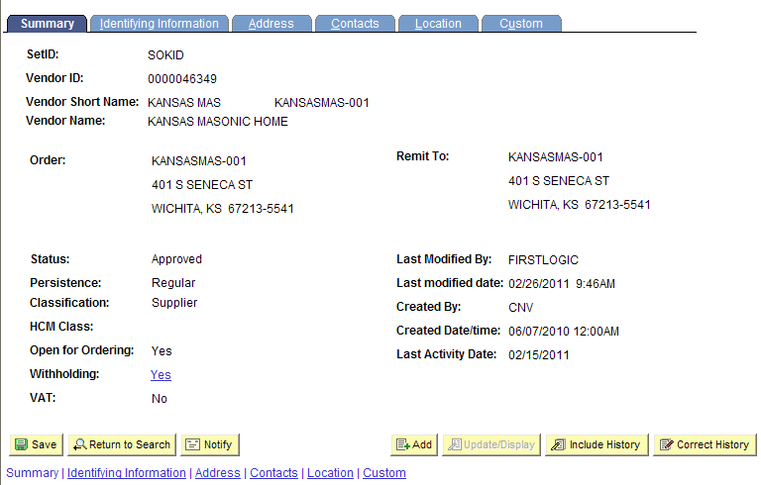
Figure 3.12. Vendor Address Page

- Address ID: 1 is brought up. Click on the “+” button to add the new address information.
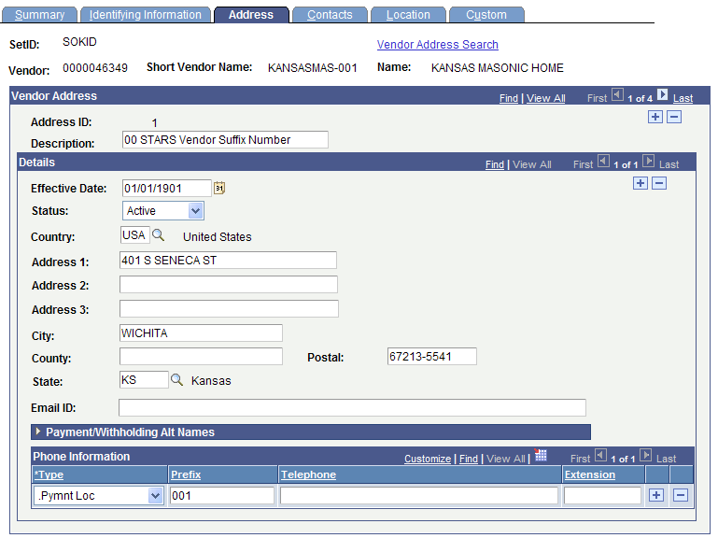
Figure 3.13. Vendor Address – + button (To add a new vendor address)
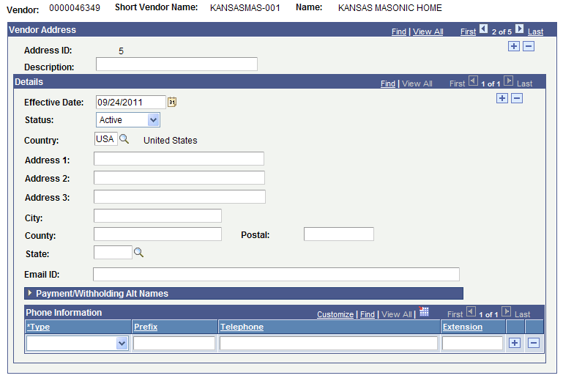
Figure 3.14. Vendor Address page – Details (Complete tp add a new vendor address)
- Add a Description. Example: Main, Corporate, Topeka etc.
- Effective Date: Accept the default date of <today’s date> – Do NOT change this date.
- Enter the validated address information, using ALL CAPS in the Address 1 and Address 2 fields.
- Enter the Medicare number for the vendor in the Address 3 field (if applicable)
- Phone Information, *Type: Select the ‘.Pymnt Loc’ option from the drop down list
- Phone Information, Prefix: Enter the Location code. Example: 001, or 002
(This information is sourced from the Location Tab and represents how the vendor is paid - either by SYSTEM Check or ACH. You need to map the address to the vendor’s preferred method [correct location] for payment)
- Click the Save button (bottom left corner of the page) to save your changes to the vendor record.

Topic 5: Contacts Page
The Vendor Contact Page is a tool that is provided to keep track of contacts within a vendor. An unlimited number of vendor contacts and their roles can be entered for each vendor so you can easily determine whom to contact with questions. You can also use this information to determine the business reason why a contact might want to talk to you before you return their call.
The Vendor Contact page is optional for Agencies to use.
Page name | Navigation
Vendor Contact | Vendors > Vendor Information > Add/Update (Find An Existing Value - Enter Search Criteria and Search) > Search Results > Select the desired result > Click the Contacts Tab

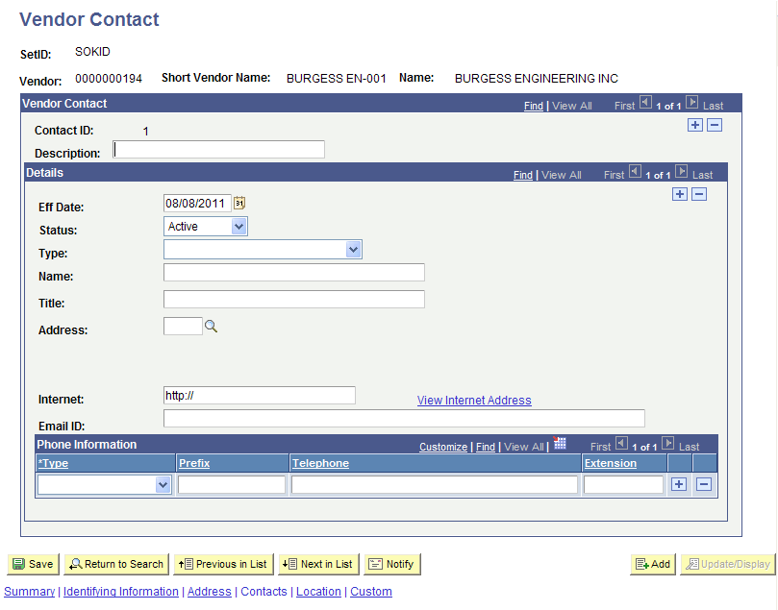
Figure 3.15. Contacts Page – Vendor Contact Details
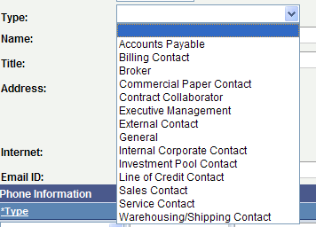
Figure 3.16. Contacts Page – Vendor Contact Details – Type (Detail)
Fields | Description
Vendor Contact  Contact ID | SMART auto numbers each Contact with a Contact ID number when you first enter and save contact information.
Vendor Contact  Description | Use this free form field to enter a business description for the Contact person at the vendor.
Vendor Contact  + button | Use the + button to add a new contact record.
Vendor Contact  ‘-‘ button | Agencies – Do NOT use this button. It is for Central use only.  Submit a TM-21 Form to the Central Vendor Processor.
Details  Eff Date | The Eff (Effective) Date field defaults with the SMART system date of 01/01/1901.  Agencies - Do NOT change the default date.
Details  Status | Use the drop down listing to select the Status of the contact:  Active: Select the Active status to indicate that this contact is a current and active contact at the vendor.  To Inactivate a vendor record: Submit a TM-21 Form to the Central Vendor Processor.
Details  Type | Select the appropriate type for the contact at the vendor. Select a value from the drop down list.  Values include: Accounts Payable, Billing Contact, Broker, Commercial Paper Contact, Contract Collaborator, Executive Management, External Contact, General, Internal Corporate Contact, Investment Pool Contact, Line of Credit Contact, Sales Contact, Service Contact, or Warehouse/Shipping Contact.
Details  Name | Enter the name of the contact person in this field.  Enter in the format of: First name Last name
Details  Title | Enter the job title of the contact person in this field.  This is a free text field.
Details  Address | Select the desired address from the available options in the Lookup list. Click the Lookup (magnifying glass) icon to access the list and make your selection.
Details  Internet | Enter the internet (website URL) address for the company or contact in this field.
Details  View Internet Address Link | This link is not operational in SMART. Please do NOT use this link.
Details  Email ID | Use this field to manually enter the contact’s email address. This is a free text field.
Details  + button | Click the + button to add a new record.
Details  ‘-‘ button | Agencies – Do NOT use this button. It is for Central use only.  Submit a TM-21 Form to the Central Vendor Processor.
Phone Information  Type | Use the ‘Type’ field to select the desired telephone Type. Select one from the following list of values:  Business, Campus, Cellular, Dormitory, FAX, Home, Main, Other, Pager 1, or Pager 2.
Phone Information  Prefix | Agencies: Please do NOT use the Prefix field.
Phone Information  Telephone | Use the Telephone field to enter in the contact phone number for the vendor.  The phone number is entered in the format of:  xxx/xxx-xxxx
Phone Information  Extension | Use the Extension field to enter in the desired phone extension number (if applicable).
Phone Information  + button | Use the + button to add a phone number.
Phone Information  ‘-‘ button | Agencies – Do NOT use this button. It is for Central use only.  Submit a TM-21 Form to the Central Vendor Processor.

Topic 6: Location Page
- Agencies use the Location Page only to VERIFY EXISTING vendor payment/banking information
OR to add NEW vendor payment/banking information.
- Agencies - Do NOT add NEW payment/banking information to correct existing vendor payment/banking information in SMART.
- Agencies are unable to edit existing vendor payment/bank account information in SMART.
- If you need to edit, delete, or modify existing vendor payment/banking information, please submit either a completed DA-130 form or a completed DA-184 form to the Central Vendor Processor.

Location – Definition

In the SMART Vendor module, a vendor address is a mailing address. A location is the payment/banking information for the vendor.
There is one vendor location for each bank account/payment method for the vendor. Locations are assigned location code numbers sequentially, starting with 001,002, 003, etc.
Each vendor has Location code ‘001’ as its default Location code number. If a vendor uses the same bank account/payment method across its business, only one location is entered in SMART.
Note: Location 001 is NOT always a SYSTEM CHECK. If the vendor was set up initially with ACH as a method of payment, then Location 001 will be ACH and not SYSTEM CHECK.
For example: Company ABC has offices in Kansas City, Chicago, and St. Louis. Each office has different bank accounts/payment methods. In this case, you need to set up the vendor with three different location codes (that is, three sets of rules), one for each office.
If all three offices use exactly the same bank account/payment method, you set up only one location code for the vendor.
When setting up a NEW vendor or vendor Location, ensure that the addresses from the Address page are mapped to the correct location code number.

Edit, Delete, or Modify Existing Vendor Address Information in SMART

- Use either the State of Kansas DA-130 Form or the DA-184 Form to request changes or deletions of existing vendor payment/banking information in SMART.
- State of Kansas - DA-130 Form - Authorization for Electronic Deposit of Vendor Payment. Use this form to submit vendor bank account information to the Central processing office. To obtain a copy of the DA-130 Form please contact Accounts and Reports by phone: (785) 296-7917.
- State of Kansas - DA-184 Form - Authorization For Direct Deposit of Employee Pay and or Employee Travel . Regents – Please use the DA-184 Form to submit Regent Employee Information to the Central processing office. Locate this form: http://www.da.ks.gov/ar/pm/Forms/Default.htm.
- Submit the completed DA-130 Form or the completed DA-184 Form to the Central Vendor Processor by emailing it to: mailto:Arvendor@da.ks.gov

Approved vs. Unapproved Vendors

It is important to understand that vendors are Statewide records, they are not Agency specific. It is also important to understand that changes to existing vendor address, location, or banking information, (and saving that information) automatically causes SMART to change the vendor Status to “Unapproved”.
When a vendor is in an “Unapproved” status, no State Agencies are able to use that vendor (until it has been reviewed and “Approved” by a Central Vendor Processor). The Central Vendor Processor runs a report in SMART each morning that provides a list of all vendors with an “Unapproved” status. The Central Vendor Processor reviews each vendor individually and either changes the vendor Status from “Unapproved” to “Approved” or “Denied”.
If your Agency needs to update vendor information and use the vendor immediately, please complete DA-130 Form or a DA-184 Form and email the form with a request for an immediate vendor review to the Central Vendor Processor at: mailto:Arvendor@da.ks.gov

Effective Dates

Use the Location page to enter NEW vendor payment/banking information. In SMART, vendor information is effective dated.
New Vendor Information for a NEW vendor is added accepting SMART’s default Effective Date of 01/01/1901.
Note: Updates to existing vendor information are made by the Central Vendor Processor who enters an effective date of today’s date (the current date).
If you are adding NEW information to an EXISTING vendor, accept the SMART default Effective Date of <today’s date>.

Order of Vendor Information Data Entry

When creating a new vendor in SMART, the Address information MUST be entered PRIOR to the Location Tab (Payment) information. If you attempt to Save a vendor record without having completed the data entry of vendor information in the correct order, SMART will not allow you to Save the vendor information (SMART will provide you with an error message).
Page name | Navigation
Location | Vendors > Vendor Information > Add/Update (Find An Existing Value - Enter Search Criteria and Search) > Search Results > Select the desired result > Click the Location Tab

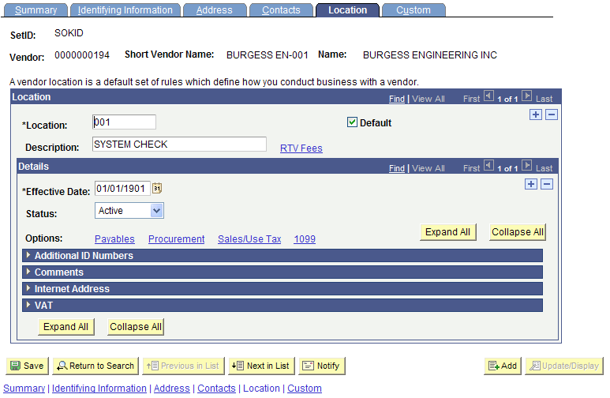
Figure 3.17. Location Page – Vendor Location Details

Fields | Description
Location  *Location | There is one vendor location for each bank account/payment method for the vendor.  Note. These are Statewide locations (not per Agency)  Locations should be assigned location code numbers sequentially, starting with 001,002, 003, etc.  Each vendor MUST have one Location code marked as its default Location.  If a vendor uses the same bank account/payment method across its business, only one location is entered in SMART.  If a vendor uses multiple bank accounts/payment methods, multiple locations are entered into SMART.
Location  Default Checkbox | The State of Kansas is using this field for SHARP remittance payments to SMART. The Default Checkbox in the Location section is used to select the correct Location code (and ultimately the correct payment method, and address, for the vendor).  The Default Checkbox MUST BE SELECTED to deliver the AP module functionality (processes).  The selection of the Default Checkbox allows this Location Code to be used in conjunction with the Address Location.
Location  + button | Use the + button to add a NEW Location (banking/payment method) for the vendor.
Location  ‘-‘ button | Agencies – Do NOT use this button. It is for Central use only.  Submit a TM-21 Form to the Central Vendor Processor to have a vendor Location removed.
Location  Description | If the vendor desires to receive a paper check, enter the value of “SYSTEM CHECK” in the Description field.  If the vendor desires an ACH (Automated Clearing House) payment (direct bank account deposit), enter the value of “ACH ******XXXX”, where ‘XXXX’ represents the last four digits of the vendor’s bank account number.  If there is no banking information that needs to be entered in the Description field, please enter the value of “SYSTEM CHECK’. This prompts SMART to generate and print a paper check for the vendor.  WIR – Indicates a wire payment. This option is used primarily by HCM vendors.  Agencies – Please contact the Department of Administration PRIOR to selecting this option for a new vendor, to determine if this is an appropriate selection for the vendor record. Thank you.
Location  RTV Fees Link | The State of Kansas is not using this link.
Details  Effective Date | Accept the SMART default date of 01/01/1901 for a NEW vendor location on a NEW vendor.  Accept the SMART default date of 01/01/1901 for a NEW location being added to an EXISTING vendor.  Agencies – do NOT change the default date.
Details  Status | Active: Select the Active Status to indicate that the Location information is effective and active for the vendor.  Inactive: To Inactivate a Location’s Status, please complete and submit either a DA-130 Form or a DA-184 Form to the Central Vendor Processor.
Details  + button | Click the + button to add a new set of details for the vendor.
Details  ‘-‘ button | Agencies – Do NOT use this button. It is for Central use only.  Submit a TM-21 Form to the Central Vendor Processor.
Details  Expand All Button | Click the Expand All button to open (expand) all the sections on the Location Page.
Details  Collapse All Button | Click the Collapse All button to close (collapse) all the sections on the Location Page.
Details – Options  Payables Link | Click the Payables Link to open the Payables Options page.  The use of the Payables Options page is covered later in this course.
Details – Options  Procurement Link | Click the Procurement Link to open the Procurement Options page.  The use of the Procurement Options page is covered later in this course.
Details – Options  Sales/Use Tax Link | The State of Kansas is not using the Sales/Use Tax functionality in SMART.  Please do NOT use this link.
Details – Options  1099 Link | Click the 1099 Link to open the Withholding Vendor Information page.  The use of the Withholding Vendor Information page is covered later in this course.
Details – Options  Additional ID Numbers Section | The State of Kansas is not using this section.  Please do NOT use this section.
Details – Options  Comments Section | The State of Kansas is not using this section.  Please do NOT use this section.
Details – Options  Internet Address Section | The State of Kansas is not using this section.  Please do NOT use this section.
Details – Options  VAT Section | The State of Kansas is not using the VAT functionality in SMART.  Please do NOT use this section.

Topic 7: Payables Link and Payables Options Page
Use the Payables Options page to define the vendor location’s invoicing and remitting addresses for the Location. Additional sections on this page are used to enter the vendor’s ACH and bank account information.
Page name | Navigation
Payables Options | Vendors > Vendor Information > Add/Update (Find An Existing Value - Enter Search Criteria and Search) > Search Results > Select the desired result > Click the Location Tab > Click the Payables Link

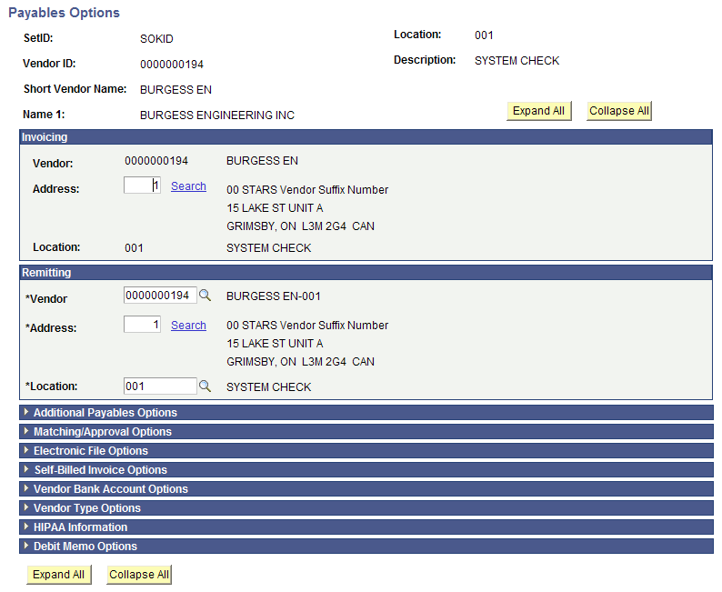
Figure 3.18. Payables Options page

Fields | Description
Expand All button | Click the Expand All button to open (expand) all sections on the Payables Options page.
Collapse All button | Click the Collapse All button to close (collapse) all sections on the Payables Options page.
Invoicing Section | The State of Kansas is not using the Invoicing section.  Agencies: Please do NOT use this section.
Remitting Section | The State of Kansas is not using the Remitting section.  Agencies: Please do NOT use this section.
Additional Payables Options section | Click the Expand Section button (triangle button to the left of the title) to open the section.  This section contains the Additional Payables Options information for the vendor.  The use of the Additional Payables Options section is covered later in this course.
Matching/Approval Options section | The State of Kansas is not using this section.
Electronic File Options section | The State of Kansas is not using this section.
Self Billed Invoice Options section | The State of Kansas is not using this section.
Vendor Bank Account Options section | Click the Expand Section button (triangle button to the left of the title) to open the section.  This section contains the Vendor Bank Account Options information for the vendor.  The use of the Vendor Bank Account Options section is covered later in this course.
Vendor Type Options section | The State of Kansas is not using this section.
HIPPA Information section | The State of Kansas is not using this section.
Debit Memo Options section | The State of Kansas is not using this section.

Additional Payables Options Section

Use the Additional Payables Options section to set up ACH payment information for this vendor.
Page name | Navigation
Additional Payables Options | Vendors > Vendor Information > Add/Update (Find An Existing Value - Enter Search Criteria and Search) > Search Results > Select the desired result > Click the Location Tab > Click the Payables Link > Click the Expand Section button (triangle to the left of the title) for the Additional Payables Options section

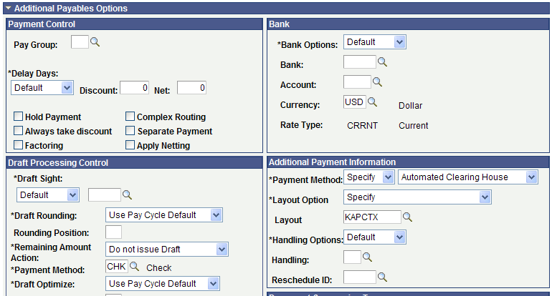
Figure 3.19. Additional Payables Options Section

Fields | Description
Payment Control Section | The State of Kansas is not using this section.
Bank Section | The State of Kansas is not using this section.
Draft Processing Control | The State of Kansas is not using this section
Additional Payment Information  Payment Method – First Drop Down List | Select the “Specify” option.
Additional Payment Information  Payment Method - Second Drop Down List | Select the “Automated Clearing House” option.
Additional Payment Information  Layout Option | The State of Kansas is not using this field.
Additional Payment Information  Layout | The State of Kansas is not using this field.  DO NOT CHANGE THE LAYOUT OPTION!
Additional Payment Information  Handling Options | The State of Kansas is not using this field.
Additional Payment Information  Handling | The State of Kansas is not using this field.
Additional Payment Information | The State of Kansas is not using this field.
Reschedule ID | The State of Kansas is not using this field.
Holiday Processing Options Section | The State of Kansas is not using this section.
Document Sequencing Type Section | The State of Kansas is not using this section.

Vendor Bank Accounts Section
Use the Vendor Bank Accounts section to enter the vendor’s bank account information. Use the DA-130 Form and/or a Voided check (for individuals) from the vendor to enter the information in this section.
Note: The Agency is responsible for adding electronic deposit information when you are adding a NEW vendor. The DA-130 Form must be completed and emailed to the Central Vendor Processor once you have set up the new vendor in SMART.
Only Central Vendor Processors are able to make changes to an existing vendor record in SMART. If you need to make changes to a vendor’s banking information, or if you need to cancel authorization for an electronic deposit to a vendor, you must complete a new DA-130 Form and submit it via email to the Central Vendor Processor.
Page name | Navigation
Vendor Bank Accounts | Vendors > Vendor Information > Add/Update (Find An Existing Value - Enter Search Criteria and Search) > Search Results > Select the desired result > Click the Location Tab > Click the Payables Link > Click the Expand Section button (triangle to the left of the title) for the Vendor Bank Accounts section

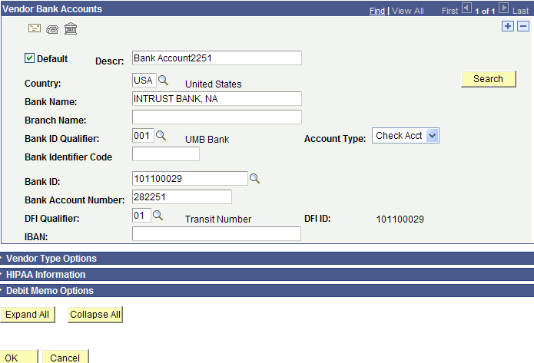
Figure 3.20. Vendor Bank Accounts Section
Fields | Description
Envelope Button | Click the envelope button to open the Bank Address page. Use the Bank Address page to enter the address for the bank.
Telephone Button | Click the Telephone button to open the Phone Information page. Use the Phone Information page to enter the telephone information for the bank.
Routings (Building) Button | Click the Routings Button to open the Intermediary Bank Routings page. Use the Intermediary Bank Routings page to enter the Routing Information for the Bank account.
Default Checkbox | Agencies – Please do not use this.
Descr | Use the Descr field to enter a description for the bank account information.
Country | Enter the Country code into the Country field. Use the Lookup button if necessary to look up international country codes.
Bank Name | Use the Bank Name field to enter the name of the bank.  Use ALL CAPS to enter the bank name.
Branch Name | Use the Branch Name field to enter the branch name for the bank.  Use ALL CAPS to enter the branch name.
Bank ID Qualifier | Use the Lookup button to locate and select the correct Bank ID Qualifier from the available list of options in SMART.
Bank Identifier Code | Agencies – Please do not use this.
Bank ID | Use the Lookup button to locate and select the correct Bank ID from the available list of options in SMART (Bank ID number must match the Bank number on the voided check you received from the vendor)  Note: Once a Bank ID number is entered and saved, SMART masks the Bank ID number with a series of ***** for security purposes.
Bank Account Number | Use the Bank Account Number field to enter the vendor’s bank account number.  Note: Once saved, bank account numbers are masked for security purposes. Only the last 4 digits of the bank account number are able to be viewed by Agencies. The rest of the bank account number is masked with a series of *****.
DFI Qualifier | Use the Lookup button to locate and select the correct DFI Qualifier from the available list of options in SMART.
IBAN | Agencies – Please do not use this.
Account Type drop down list | Use the Account Type drop down list to locate and select the correct Account Type from the available list of options in SMART.
Branch ID | Agencies – Please do not use this.
Check Digit | Agencies – Please do not use this.
DFI ID | Agencies – Please do not use this.
Search button | Agencies – Please do not use this.
+ button | Please review ALL existing bank account records PRIOR to adding a NEW bank account for the vendor.  Click the + button to add a NEW bank account to the vendor.  Note: You must have a completed DA-130 Form/DA-184 Form and/or a voided check.
‘-‘ button | Agencies – Do NOT use this button. It is for Central use only.  Submit a TM-21 Form to the Central Vendor Processor to have a vendor’s bank account information removed/inactivated.
OK button | After you have completed entering the information on this page, click the OK button to save your changes.
Cancel button | If you do not want to save the changes you have made on this page, click the Cancel button to discard the changes you made.

Topic 8: Procurement Link and Procurement Options page

If the vendor agrees to accept business procurement cards (P-Cards) as a method of payment, use the Procurement Options page to enter the procurement card information for the vendor. Selecting this option and entering the procurement information allows you to pay the vendor using a business procurement card, rather than a check or an ACH payment.
Page name | Navigation
Procurement Options | Vendors > Vendor Information > Add/Update (Find An Existing Value - Enter Search Criteria and Search) > Search Results > Select the desired result > Click the Location Tab > Click the Procurement Link > Click the Expand Section button (triangle to the left of the title) for the Procurement Card Options section

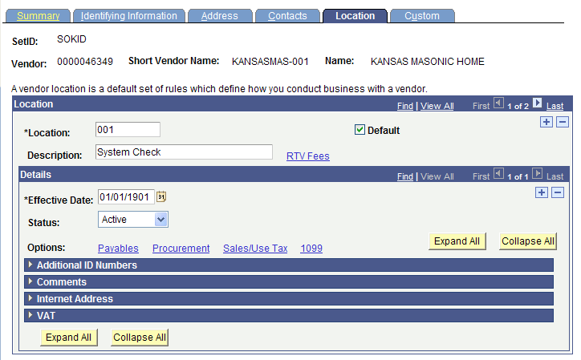
Figure 3.21. Vendor Location Tab – Procurement Link
- Select the Procurement Link on the Location Tab to open the Procurement Options page.
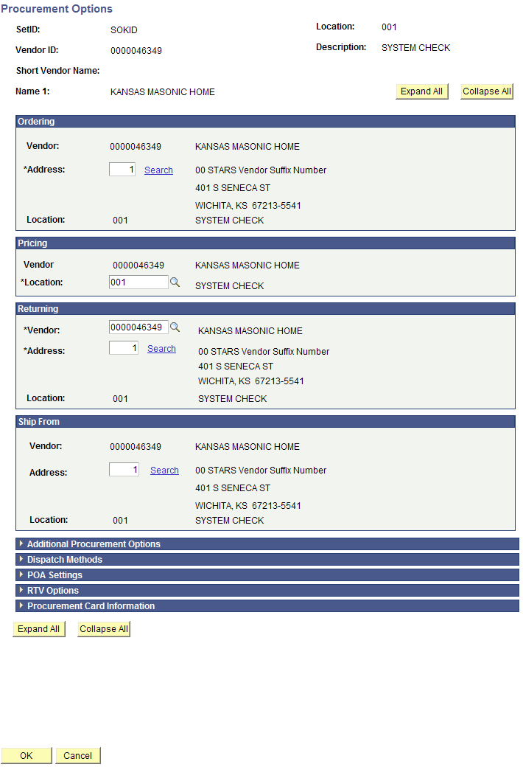
Figure 3.22. Vendor – Procurement Options Page
- Click on the Expand Section button (triangle to the left of the title) beside the Procurement Card Information section.

- Select the Accepts Procurement Card as payment method checkbox
  - Select “Contact Cardholder” from the *ProCard Dispatch Option drop down list
  - In the Types of Procurement Card Accepted, select “Visa” from the Card Type drop down list
  - Agencies – DO NOT enter any information in the Vendor Card Settings section!
  - Click the OK button at the bottom left of the screen to save your changes.
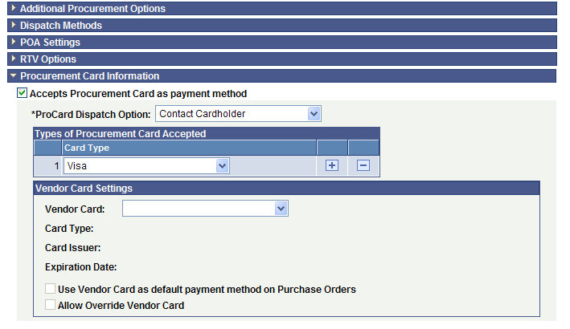
Figure 3.23. Procurement Options Page – Procurement Card Information Section

Topic 9: 1099 Link and Withholding Vendor Information page

1099 Information
What is a 1099? It is an informational return to report various type of income other than wages.
Melissa.Fuhrman@da.ks.gov is the 1099 Accountant for the State of Kansas. Melissa works for the Department of Administration, Central Office in Topeka.
The IRS requires the State of Kansas to issue 1099’s to reportable entities (vendors) for services, rentals, awards, certain type of grants, interest, dividends, and certain real estate purchases.

The State of Kansas, Department of Administration submits five types of 1099 Forms to the IRS:
- 1099-MISC: Services, rents, awards
- 1099-G: Governmental payments (tax refunds are the Dept of Revenue)
- 1099-INT: Interest
- 1099-DIV: Dividends
- 1099-S: Real estate
Two criteria must be met in order for 1099 reporting to occur for a vendor:
- The vendor must be subject to 1099 reporting
- The payment must be reportable
What vendors are NOT (currently) reportable?
- Corporations are NOT reportable UNLESS they provide medical or legal services
- Governments
- Tax Exempt Organizations
What is LLC?
LLC stands for Limited Liability Company. The federal government does not recognize an LLC as a classification for federal tax purposes. An LLC can be a corporation, partnership or sole proprietorship. The W-9 Form should indicate the Type of entity the vendor is.

Guide to completing the Withholding Vendor Information page

- SMART will not allow you to save a vendor record if you enter the ACH information in BEFORE entering the 1099 information. Ensure you complete the Address Tab before the Location Tab when setting up a new vendor record in SMART.
- Withholding Vendors
Complete the 1099 Information section AND the 1099 Reporting Information section.
Examples:
  - Medical Corporations
  - Attorneys
  - LLC – Limited Liability Company

- Non-Withholding Vendors
Complete only the 1099 Reporting Information section.
Examples:
  - Incorporated
  - Corporation
  - Foreign Vendors

FORM 1099 MISC - EXAMPLES OF REPORTABLE PAYMENTS
RENTS (Form 1099-MISC, Box 1) | NON-EMPLOYEE COMPENSATION
Office Space | (Form 1099-MISC, Box 7)
Parking Lot Space | Accountants/Auditors
Welfare Rental Assistance (to Landlords) | Advertising Services
Equipment | Appraisers
Surface Royalties | Architects
Real Property | Armored Car Services
Other Property | Attorneys* (who are not your employees)
 | (Includes Corporations)*
 | Auto Repair
ROYALTIES (Form 1099-MISC, Box 2) | Board Members
Literary rights | Chaplains
Copyrights | Cleaning Services
Publishing Licensing fees | Commercial Repairs – Hwy Vehicles
 | Computer Programming
 | Computer Repairs
OTHER INCOME (Form 1099-MISC, Box 3) | Construction Services
Awards (Nonemployee) | Consultants
Prizes (Nonemployee) | Contracted Repairs
 | Court Appointed Workers
 | Court Reporters
MEDICAL & HEALTH CARE SERVICES | Custodial / Maintenance
(Form 1099-MISC, Box 6, includes all payments | Design & Testing
to Medical Service Corporations) | Engineers
Ambulance Services | Evaluation Consultant
Dentists/Dental Services | Expert Witnesses
Doctors/Medical Services | Extermination Services
Hospitals** | Graphic Artist
(**except if tax exempt or owned/operated by a | Institution Contracts
governmental entity) | Janitorial Services
Lab Services | Keypunch Services
Optometrists | Landscapers, Locksmiths
Private Duty Nurses | Laundry Services
Psychiatrists, Psychologists | Maintenance Agreements
Rehabilitation Centers | Non-Employee Allowance
Therapists | Occasional Salaries & Wages (to Non-Employees)
Hospitalization | Parcel & Delivery Services
All payments to Medical Service Corporations | Photographers
 | Printing Services
 | Prison Labor Allowance
GROSS PROCEEDS PAID TO AN ATTORNEY | Professional Service Payments
(Form 1099-MISC, Box 14) | Protection Services
Gross proceeds paid to an attorney | Security Services
in connection with legal services. | Teacher/Instructor (Non-Employee)
 | Trash Removal
 | Working Interest - Oil and Gas Payments
FORM 1099-INT, 1099-DIV, 1099-G and 1099-S
EXAMPLES OF REPORTABLE PAYMENTS
INTEREST (Form 1099-INT, Box 1) |  | DIVIDENDS (Form 1099-DIV, Box 1)
Interest income |  | Distributions, such as dividends, capital gain distributions,
 |  | or nontaxable distributions, that were paid on stock,
 |  | and liquidation distributions.
TAXABLE GRANTS (Form 1099-G, Box 6) |  | PROCEEDS FROM REAL ESTATE (Form 1099-S, Box 2)
Taxable Grants |  | Gross Proceeds from the sale or exchange of real estate

SMART 1099 Account Code Guide

Note: Titles are presented as they appear in SMART (field length limits)

SMART Account | STARS Esobj | Title | 1099 TYPE | 1099 Class | Notes
523100 | 2310 | REPROGRAPHIC EQUIPMENT RENTAL | 1099 | 01
523200 | 2320 | BUILDING SPACE RENTAL | 1099 | 01
523300 | 2330 | EQUIPMENT RENTAL | 1099 | 01
523400 | 2340 | LAND RENTAL | 1099 | 01
523600 | 2360 | INFORMATION PROCESSING EQUIPMENT RENTAL | 1099 | 01
523700 | 2370 | INFORMATION PROCESSING SOFTWARE RENTAL | 1099 | 01
523900 | 2390 | OTHER RENTALS | 1099 | 01
524101 | 2410 | REPAIR AND SERVICE - PASSENGER CARS | 1099 | 07
524201 | 2420 | REPAIR AND SERVICE - OTHER SELF-PROPELLED EQUIP | 1099 | 07
524300 | 2430 | REPAIR AND SERVICE - MACHINERY,EQUIPMENT,FURNIT | 1099 | 07
524400 | 2440 | REPAIR AND SERVICE - BUILDINGS AND GROUNDS | 1099 | 07
524501 | 2450 | REPAIR AND SERVICE-HIGHWAYS AND BRIDGES (276, 7 | 1099 | 07
524700 | 2470 | INFORMATION PROCESSING EQUIPMENT REPAIR & SERVI | 1099 | 07
524800 | 2480 | INFORMATION PROCESSING EQPT SOFTWARE MAINT & SE | 1099 | 07
524900 | 2490 | REPAIR AND SERVICE - NOT OTHERWISE CLASSED | 1099 | 07
525120 | 2521 | HIRE OF CARS, PLANES, BUSES FOR IN-STATE TRAVEL | 1099 | 01 | Taxable if paid direct to vendor
525130 | 2531 | STATE CAR EXPENSE FOR IN-STATE TRAVEL | see note |  | Repairs are taxable if paid direct to vendor, supplies are not
525170 | 2571 | RAIL, PLANE, BUS FARES - IN-STATE TRAVEL | 1099 | 07 | Taxable if paid direct to vendor
525180 | 2581 | LODGING | 1099 | 01 | Taxable if paid direct to vendor
525190 | 2591 | NONSUBSISTENCE ITEMS FOR IN-STATE TRAVEL | see note |  | Taxable if paid direct to vendor; conference registration 1099 class 03
525220 | 2522 | HIRE OF CARS, PLANES, BUSES - OUT-OF-STATE TRAVEL | 1099 | 01 | Taxable if paid direct to vendor
525230 | 2532 | STATE CAR EXPENSE FOR OUT-OF-STATE TRAVEL | see note |  | Repairs are taxable if paid direct to vendor, supplies are not
525270 | 2572 | RAIL, PLANE, BUS FARES - OUT-OF-STATE TRAVEL | 1099 | 07 | Taxable if paid direct to vendor
525280 | 2582 | LODGING | 1099 | 01 | Taxable if paid direct to vendor
525290 | 2592 | NONSUBSISTENCE ITEMS FOR OUT-0F-STATE TRAVEL | see note |  | Taxable if paid direct to vendor; conference registration 1099 class 03
525320 | 2523 | HIRE OF CARS, PLANES, BUSES - INTERNATIONAL TRAVEL | 1099 | 01 | Taxable if paid direct to vendor
525330 | 2533 | STATE CAR EXPENSE FOR INTERNATIONAL TRAVEL | see note |  | Taxable if paid direct to vendor
525370 | 2573 | RAIL, PLANE, BUS FARES - INTERNATIONAL TRAVEL | 1099 | 07 | Repairs are taxable if paid direct to vendor, supplies are not
525380 | 2583 | LODGING | 1099 | 01 | Taxable if paid direct to vendor
525390 | 2593 | NONSUBSISTENCE ITEMS FOR INTERNATIONAL TRAVEL | varies |  | Taxable if paid direct to vendor
526200 | 2620 | HONORARIUMS | 1099 | 07 | in some cases could be class 03
526320 | 2632 | COMPUTER PROG AND DATA PROCESS-VENDORS O/T DISC | 1099 | 07
526330 | 2633 | DATABASE ACCESS FEES-VENDORS OTHER THAN DISC | 1099 | 07
526400 | 2640 | RECORDING FEES, SERVICING, AND COURT COSTS | 1099 | 07
526500 | 2650 | LABORATORY FEES | 1099 | 07
526700 | 2670 | BOARDING HOME PAYMENTS | 1099 | 01
526800 | 2680 | MAINTENANCE AND TUITION FOR REHABILITATION CLIE | 1099 | 07
526900 | 2690 | OTHER FEES | 1099 | 07
526910 | 2691 | CREDIT CARD FEES AND CHARGES | 1099 | 07
526920 | 2692 | BANK FEES CHARGED BY CONTRACTOR BANKS-REIM TREAS. | 1099 | 07
526960 | 2696 | E-CHECKS FEES AND CHARGES | 1099 | 07
526970 | 2697 | MILITARY ACTIVATION PAYMENT | 1099 | 03
527100 | 2710 | ARCHITECTS AND ENGINEERS | 1099 | 07
527200 | 2720 | ATTORNEYS AND LAWYERS | 1099 | 07
527300 | 2730 | PHYSICIANS AND MEDICAL ASSOCIATIONS | 1099 | 06
527400 | 2740 | HOSPITALS AND NURSING HOMES | 1099 | 06
527500 | 2750 | ADVERTISING AGENCIES | 1099 | 07
527600 | 2760 | VETERINARIANS | 1099 | 07
527700 | 2770 | LECTURERS, SPEAKERS AND ENTERTAINERS | 1099 | 07
527800 | 2780 | ACCOUNTANTS AND AUDITORS | 1099 | 07
527910 | 2791 | INFORMATION SYSTEMS CONSULTING FEES | 1099 | 07
527990 | 2700 | ADMINISTRATIVE SERVICES | 1099 | 07
527990 | 2790 | professional services | 1099 | 07
529200 | 2920 | LAUNDRY, DRY CLEANING AND TOWEL SERVICE | 1099 | 07
529500 | 2950 | NON-EMPL REWARDS,PREMIUMS & BOUNTIES-IRS REPORT | 1099 | 03
529500 | 2950 | NON-EMPL REWARDS,PREMIUMS & BOUNTIES-IRS REPORTABL | 1099 | 03
529500 | 2954 | NON-EMPL AWARDS,REWARDS,PREMIUMS &BOUNTIES-NOT IRS
542010 | 4200 | BUILDINGS AND IMPROVEMENTS | 1099 | 07
542090 | 4209 | BUILDINGS AND IMPROVEMENTS- NON-INVENTORY | 1099 | 07
543100 | 4310 | LAND AND INTEREST IN LAND | 1099S | 01 | Reportable if Agency is Closing Agent
543190 | 4319 | LAND AND INTEREST IN LAND - NON-INVENTORY | 1099S | 01 | Reportable if Agency is Closing Agent
544010 | 4450 | BLDGS & GRNDS- LAND IMPROVE (CAPITAL/INV) IRS | 1099 | 07
544090 | 4459 | BLDGS & GRNDS- LAND IMPROVE (CAPITAL/NONINV) IR | 1099 | 07
552040 | 5204 | INTEREST INCOME ON UNCLAIMED PROPERTY (670 ONLY | 1099I | 01
552050 | 5205 | DIVIDEND INCOME ON UNCLAIMED PROPERTY (670 ONLY | 1099D | 01
552060 | 5206 | ROYALTY INCOME ON UNCLAIMED PROPERTY (670 ONLY) | 1099 | 02
552400 | 5240 | WORKERS' COMPENSATION CLAIMS(AGENCY 173 & 331 ONLY |  |  | Not reportable
552400 | 5241 | GROSS PROCEEDS PAYMENTS TO ATTORNEYS FOR WORKERS | 1099 | 14 | Reportable
552700 | 5270 | CIVIL RIGHTS CONCILIATION CLAIMS | 1099 | 03
552700 | 5271 | GROSS PROCEEDS PAYMENTS TO ATTORNEYS FOR CIVIL | 1099 | 14
552800 | 5280 | PROMPT PAYMENT ACT INTEREST PENALTIES | 1099I | 01
552900 | 5290 | OTHER CLAIMS
552900 | 5291 | GROSS PROCEEDS PAYMENTS TO ATTORNEYS FOR OTHER | 1099 | 14
552900 | 5292 | OTHER CLAIMS - NON WAGE PAYMENTS | 1099 | 03
555100 | 5510 | DIRECT STATE WELFARE ASSISTANCE (AGY 039,629 ON | 1099 | 07
555100 | 5514 | STATE WELFARE ASSISTANCE-NOT SETOFF,NOT IRS REPORT |  | none
555110 | 5511 | DIRECT STATE WELFARE ASSISTANCE-SETOFF,NOT IRS REP |  | none
555110 | 5512 | STATE WELF ASST-SETOFF,IRS REP(171 & 629 ONLY) | 1099 | 07
555150 | 5515 | STATE WELF ASST-RENT,SETOFF,IRS REP(171 & 629 O | 1099 | 01
555160 | 5516 | STATE WELF ASST-MED&HLTH PAY IRS REP(039,171,35 | 1099 | 06
555200 | 5520 | DIRECT FED WELFARE ASST-AGY 039,171,629 ONLY | 1099 | 07
555200 | 5524 | FEDERAL WELFARE ASSISTANCE-NOT SETOFF,NOT IRS REPO
555210 | 5521 | FEDERAL WELFARE ASSISTANCE-SETOFF,NOT IRS REP
555210 | 5522 | FED WELFARE ASST-SETOFF,IRS REP(171, & 629 ONLY | 1099 | 07
555250 | 5525 | FED WELFARE ASST-RENT,SETOFF,IRS REP(171, 629 O | 1099 | 01
555260 | 5526 | FED WELF ASST-MED&HLTH PAY SETOFF IRS REP(039,1 | 1099 | 06
555850 | 5585 | HOUSING ASSISTNCE PAYMNTS-DEBT SETOFF IRS REPOR | 1099 | 01
555900 | 5590 | OTHER STATE SPECIAL GRANTS (206,300,350,629,683)
555900 | 5590 | OTHER SPECIAL GRANTS-IRS REPORTABLE | 1099G | 05
555900 | 5591 | OTHER SPECIAL GRANTS-IRS REPORTABLE | 1099G | 06
555900 | 5596 | OTHER SPECIAL GRANTS-IRS REP MED & HLTH PAYMENTS | 1099G | 06
559200 | 5920 | ROYALTY PAYMENTS | 1099 | 02
559400 | 5940 | KANSAS BREEDING DEVELOPMENT SUPPLEMENTS(553 ONL | 1099 | 03
559500 | 5950 | INT INCOME:APPL DEP REF(553),BUS TAX REF(565) O | 1099I | 01
559800 | 5980 | AGRICULTURAL CONSERVATION PROG PMTS(634 ONLY) | 1099G | 06

Page name | Navigation
Withholding Vendor Information | Vendors > Vendor Information > Add/Update (Find An Existing Value - Enter Search Criteria and Search) > Search Results > Select the desired result > Click the Location Tab > Click the 1099 Link > Withholding Vendor Information page

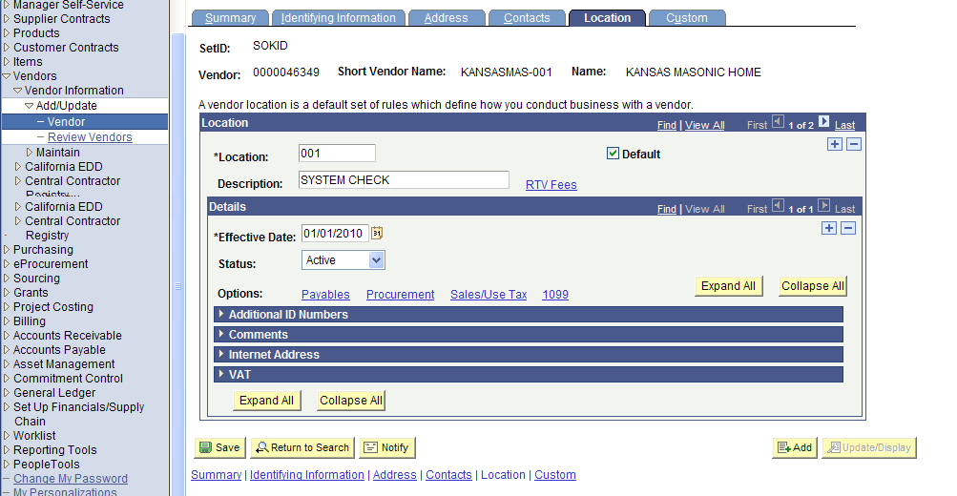
Figure 3.24. Vendor Location Tab – 1099 Link
Click the 1099 link on the vendor Location page to open the Withholding Vendor Information page.

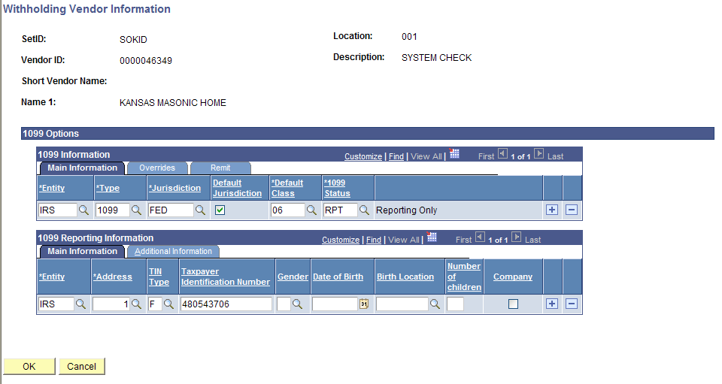
Figure 3.25. Withholding Vendor Information page
Important! You must check the Withholding checkbox on the vendor Identifying Information tab if the vendor is subject to 1099 reporting.
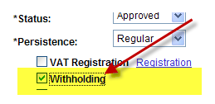
Figure 3.26. Vendor Identifying Information page – Withholding Checkbox
Important: You will receive a ‘fatal error’ message from SMART if….
You selected the Withholding checkbox on the Identifying Information tab, but you did NOT complete the information in the Withholding Vendor Information page, AND you try to Save the vendor record.
In this case, SMART will NOT allow you to save the vendor record; and you will have to enter ALL of the vendor information again!

1099 Types and Class Information
  - Each vendor Location needs at least one 1099 set up
  - The *Type and *Default Class will initially populate on a Voucher when it is created
  - Each Location should only have one *Type
  - When setting up the 1099 information for a vendor, set up all the *Default Classes you anticipate the vendor may use
Fields | Description
1099 Information Section  Main Information Tab  *Entity | Agencies: Select the ‘IRS’ option.  Agencies: Do NOT use any other option.
1099 Information Section  Main Information Tab  *Type | Select the correct Type of withholding. For each withholding type, there may be classes and categories associated with the type.  Values include: 1099, 1099D, 1099G, 1099I, and 1099S.
1099 Information Section  Main Information Tab  *Jurisdiction | Select the Withholding Jurisdiction for this type of withholding
1099 Information Section  Main Information Tab  Default Jurisdiction Checkbox | Indicate which jurisdiction is the default by selecting the check box in that jurisdiction's row. You can select more than one row as the default jurisdiction.
1099 Information Section  Main Information Tab  *Default Class | Select one of the following withholding classes for the type of withholding:  Reportable:  - 01 Rental  - 02 Royalties  - 03 Prizes, Awards, other  - 06 Medical, including medical laboratory service  - 07 Services including legal  - 14 Gross Proceeds:  - Payments made to an attorney as part of a legal settlement or court order.  - Gross proceeds may be issued in the names of the attorney and the client.  - Gross proceeds may include an amount for the attorney’s services.  -If you can determine the amount of attorney fees included in the gross proceeds, report the fee in box 7 and nothing in box 14.  Agencies – Do NOT select any of the other values from the list.  Not Reportable:  - Examples: Commodities and refunds
1099 Information Section  Main Information Tab  *1099 Status | Select the withhold status for this withholding class combination and vendor location. Select the RPT – Reporting Only option.
1099 Information Section  Main Information Tab  + button | Click the + button to add a NEW *Type for the vendor
1099 Information Section  Main Information Tab  ‘-‘ button | Agencies – Do NOT use the – button. This button is for use by the Central Vendor Processor only.  Submit a TM-21 Form to the Central Vendor Processor to have vendor information removed.
1099 Information Section  Overrides Tab | Agencies – Do NOT use the Overrides Tab. The State of Kansas is not using this functionality.
1099 Information Section  Remit Tab | Agencies – Do NOT use the Remit Tab. The State of Kansas is not using this functionality.
1099 Reporting Information  Main Information  *Entity | Agencies: Select the ‘IRS’ option.  Agencies: Do NOT use any other option.
1099 Reporting Information  Main Information  *Address | Select the vendor's address from the addresses defined on the Vendor Information - Address page. The entity needs the vendor's address.  Note: The Address field defaults the value of “1”. Change the Address code if this is not correct.
1099 Reporting Information  Main Information  TIN Type | Select the Taxpayer Identification Number (TIN) type for the vendor from these options:  F = Federal Employer ID Number  S = Social Security Number
1099 Reporting Information  Main Information  Taxpayer Identification Number | Enter the vendor's valid 9 digit TIN for the withholding entity. If you enter any number with less, or more than, 9 digits, you will receive an error message and you will not be allowed to Save the vendor record.  For Foreign vendors, enter the word ‘FOREIGN’ in the TIN field. Foreign vendors are entered manually ONLINE in SMART only, they cannot be uploaded using an interface. Any ACH payments to FOREIGN banks are entered ONLINE only. If a foreign vendor does not have a TIN #/W-9 Form, please obtain a W-8 form to send to the Central Vendor Processor.  For Federal vendors, enter ‘FED’ in the TIN field  For all other types of vendors that do not meet one of the above TIN types criteria, enter ‘OTH’.  Note: For security purposes, SMART encrypts the entire TIN number with “*’s” when the TIN field contains 9 numeric characters.  SMART does not allow you to Save the vendor record if you attempt to enter anything else in the TIN field.
1099 Reporting Information  Main Information  Gender | Agencies – Do NOT use the Gender field. The State of Kansas is not using this field.
1099 Reporting Information  Main Information  Date of Birth | Agencies – Do NOT use the Date of Birth field. The State of Kansas is not using this field.
1099 Reporting Information  Main Information  Birth Location | Agencies – Do NOT use the Birth Location field. The State of Kansas is not using this field.
1099 Reporting Information  Main Information  Number of children | Agencies – Do NOT use the Number of Children field. The State of Kansas is not using this field.
1099 Reporting Information  Main Information  Company Checkbox | Agencies – Do NOT use the Company Checkbox. The State of Kansas is not using this checkbox.
1099 Reporting Information  Main Information  + button | Click the + button to ADD a new line of information.
1099 Reporting Information  Main Information  ‘-‘ button | Agencies – Do NOT use the – button. This button is for use by the Central Vendor Processor only.  Submit a TM-21 Form to the Central Vendor Processor to have vendor information removed.
1099 Reporting Information  Additional Information Tab | Agencies – Do NOT use the Additional Information tab. The State of Kansas is not using this tab.
OK button | Once you have added the information on the Withholding Vendor Information page, click the OK button to save your changes
Cancel button | If you do NOT want to save the information you added to the Withholding Vendor Information page, click the Cancel button to cancel the changes you made.

Adding a New Location:

- You can search for an existing vendor by Vendor ID, Name, or Withholding Tax ID
- Click the “SEARCH” button
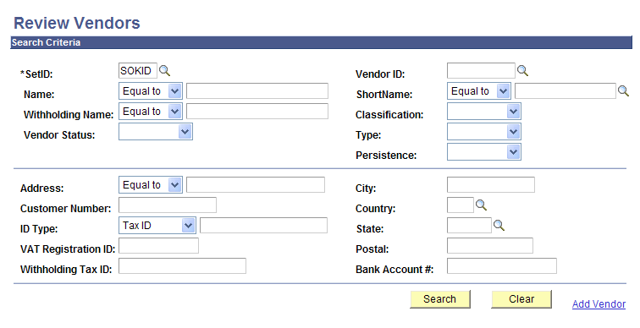
Figure 3.27. Review Vendor page

- The vendor record, Summary page is displayed. Select the Location Tab.

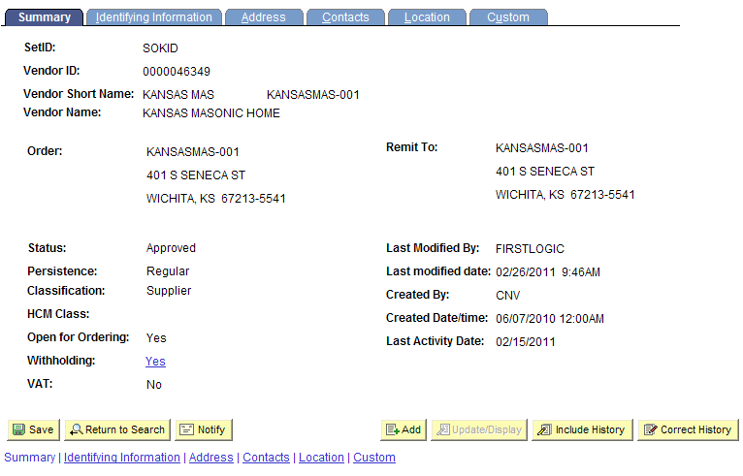
Figure 3.28. Vendor Page – Location Tab (Outlined)
- The Vendor Location page is displayed. Location 1 is displayed. Be sure to review all existing location records PRIOR to adding a NEW location !
- To ADD a new location, click on the “+” button.
  - If all addresses associated with the vendor require payments as “SYSTEM CHECK” (paper check), you do NOT need to add a new location.
  - If a vendor wants an ACH payment (direct bank account payment), and the existing record is only a “SYSTEM CHECK”, a new location needs to be set up.

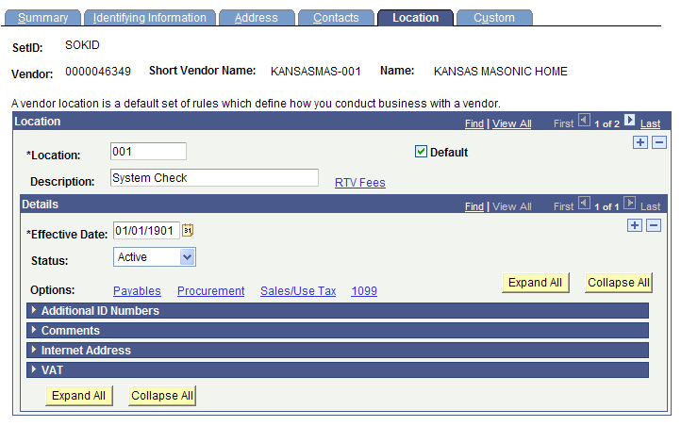
Figure 3.29. Location Page (Detail) – Add a New Location Button (Outlined)
- *Location: Enter desired location number. For example: ‘002’
- Description: Enter ‘ACH ****XXXX’ (where XXXX is the last 4 digits of the bank account number)
- Effective Date: <today’s date> (SMART default value)
- Click on the Payables Link
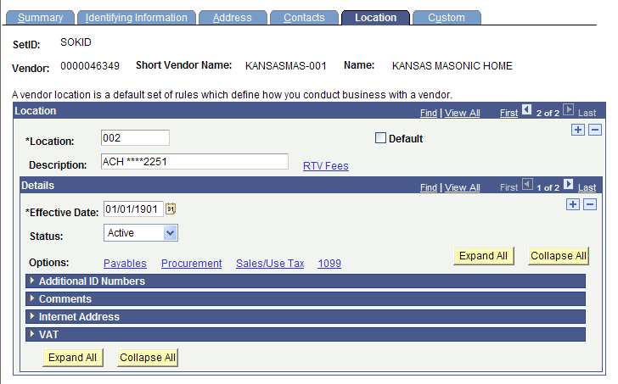
Figure 3.30. Location Page (Detail) – Add a new vendor location (data entry required)
- On the Payables Option page, click the Expand Section button (triangle button to the left of the title) for the Additional Payables Options section.

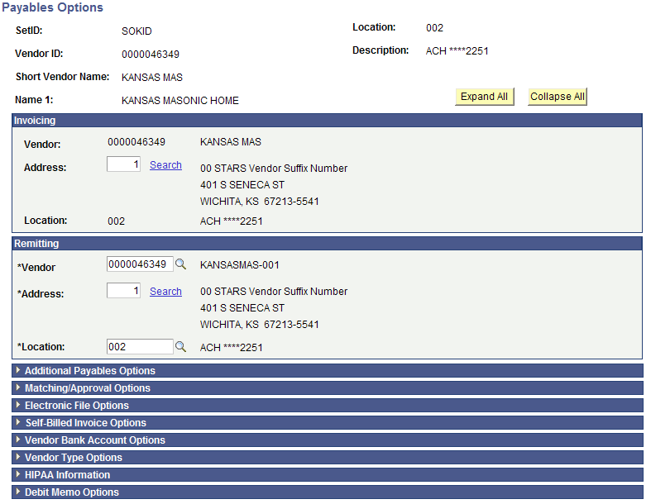
Figure 3.31. Payables Options page – Additional Payables Option section (Outlined)
- In Additional Payables Option under Additional Payment Information, select “Specify” and “Automated Clearing House” from the drop down boxes beside Payment Method.

Figure 3.32. Additional Payables Option - Additional Payment Information Section (Outlined)
- Click on the Expand Section button (triangle button to the left of the title) for the Vendor Bank Account Options section.
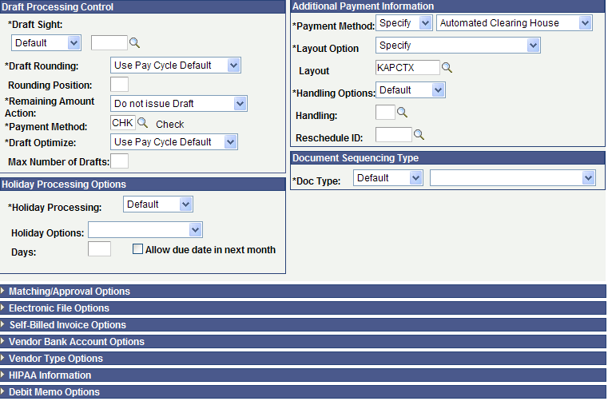
Figure 3.33. Payables Options page – Vendor Bank Account Options section (Outlined)
- Enter the Vendor Bank Account information from the DA-130 and the voided check (if obtained for an individual
Figure 3.34. Vendor Bank Accounts Section and OK button (Outlined)
- Click the OK button.
- Next, you need to complete the 1099 information. Click on the 1099 link.
Figure 3.35. Vendor Location Page – 1099 Link (Outlined)
- Refer to Topic 9 for completing 1099 information for a vendor.
- Save the vendor record before exiting the record
- Don’t forget to send the additional information Forms to the Central Vendor Processor via email !

Topic 10: Vendor Conversation Page

- You can view internal conversation information for a vendor that has previously been entered into SMART.
Note: Agency Vendor Processors can add conversations to vendor records. This is an optional use page for Agencies.
Page name | Navigation
Vendor Conversation | Vendors > Vendor Information > Maintain > Conversations

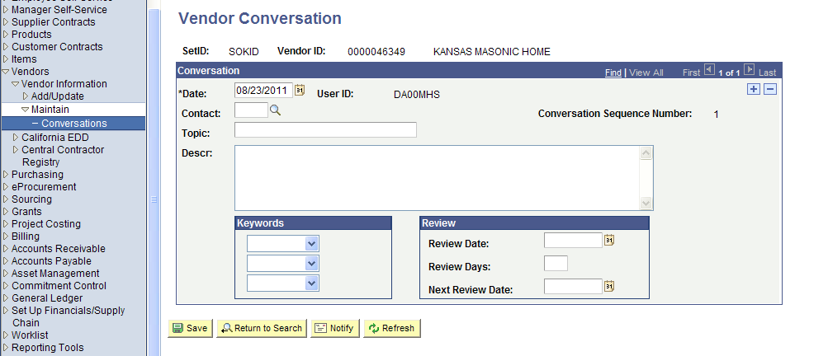
Figure 3.36. Vendor Conversation Page
Fields | Description
*Date | The current date (today’s date) automatically defaults in the *Date field.  Agencies: Do NOT change the default conversation date. Accept the default value of <today’s> date.
User ID | SMART automatically populates the User’s ID in the User ID field. This indicates which SMART user created the conversation note in SMART.
Contact | Enter the vendor Contact in the Contact field if applicable. If desired, click the Lookup button to locate a vendor Contact.
Conversation Sequence Number | SMART automatically adds the Conversation Sequence Number. Values begin at “1” and are added incrementally. Example: 1, 2, 3, and so on.
Topic | Maximum field length: 30 characters. Use the free text Topic field to enter a title for the topic of conversation.
Descr | Free text field. Use the Descr field to enter a brief summary of the conversation.
Keywords Section | Optional. You may assign up to three (s) keywords from the available list of keywords to each conversation note if desired.  Keyword options include:  1099, address, available, back order, bulk, buy out, conceal, confirm, contact, damage, dispute, duplicate, eft, estimate, freight, invoice, irate, late pay, late ship, lead time, lost pymt, name chg, order ad, other, overship, partial, price, product, quote, refund, remit add, restocking, ret/exch, returns, sales tax, satisfact, service, setoff, ship add, ship owner, shipment, short ship, shortage, stock fee, substitute, tax, tax exempt, terms, W9, warranty, and wrong.
Review Section  Review Date | Optional use field. Use the Review Date field to enter a review date in SMART. Please note that there is NO functionality associated with this feature in SMART.
Review Section  Review Days | Optional use field. Use the Review Days field to enter a number of review days in SMART. Please note that there is NO functionality associated with this feature in SMART.
Review Section  Next Review Date | Optional use field. Use the Next Review Date field to enter a next review date in SMART. Please note that there is NO functionality associated with this feature in SMART.
Save button | Use the Save button to save the conversation notes that you have entered. If you do NOT use the Save button, any notes you enter will NOT be saved.
Return to Search button | Use the Return to Search button to return to the search results screen (the search screen prior to this screen).
Notify button | The State of Kansas is not using the Notify functionality in this section of SMART.  Agencies: Do NOT use this Notify button.
Refresh button | Once you have entered and saved conversation notes, you may use the Refresh button to refresh the display of the Vendor Conversation page.

Topic 11: Vendor Contact Page

- Use the Vendor Contact page to view Vendor Contact information.
Note: This is an optional use page for Agencies. Agency Vendor Processors are unable to change any information on the Vendor Contact Page – this is a VIEW ONLY page.
- The information on the Vendor Contact page is sourced from the Contact tab in the Vendor record.
Page name | Navigation
Vendor Contact | Vendors > Vendor Information > Review Vendors > Enter search criteria > Click Search button > Search Results grid > Click the icon in the Vendor ID column > Click the Vendor Contact link > Opens a new window with the Vendor Contact page

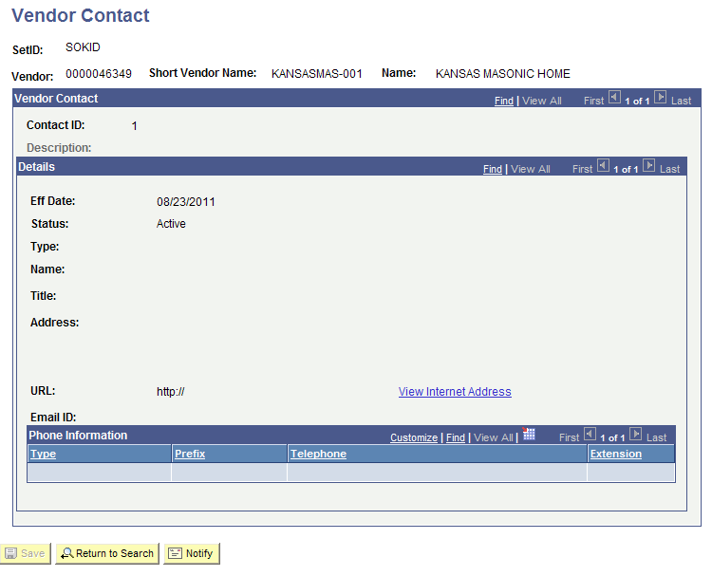
Figure 3.37 Vendor Contact Page

Lesson Review
In this lesson, you learned how to:
- Define the key terms and concepts used in the entry of vendor information in SMART
- Navigate to and use the vendor pages in SMART to enter vendor information
- Describe the concept and criteria associated with Withholding payments for vendors
- Explain the State of Kansas business processes associated with entering new vendor information
- Locate, complete, and submit the necessary forms and emails associated with vendor changes and updates

