Garnishment Information and Tips
Garnishment information is available to all payroll individuals with access to view a paycheck in SHaRP. The information can be used by agencies to help employees who have questions about their garnishments or need paychecks printed out with garnishment information on them. This is the same information available to the Department of Administration in regards to what an employee has on their paycheck related to garnishments.

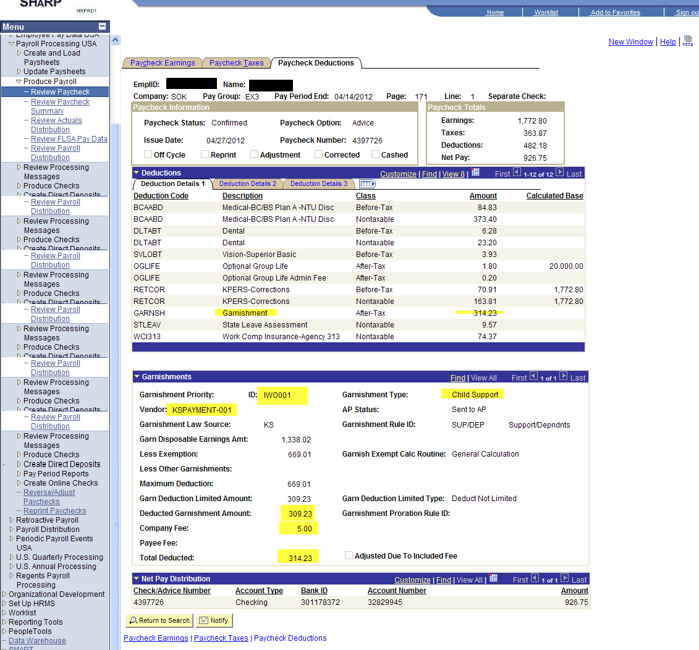

- The information is located at Payroll for North America\Payroll processing USA\Produce Payroll\Review Paycheck.
- Once you enter the EmplID and requested Pay Period End Date, go to the Paycheck Deductions tab and click on the blue line that says Garnishments. The box will open up and you can look at one garnishment at a time, or can click the View All button and see what was taken on different garnishments.
- Employees usually want to know what garnishments are taken, the amounts taken for each garnishment and where they are going. This box shows the Deducted Garnishment Amount, the amount of fee taken, if any, and also the Vendor the payment was remitted to.
- The amounts located in the Garnishment section will tie to the amounts in the Deductions section for the GARNSH deduction code.

