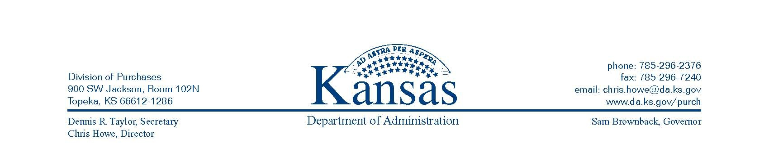

May 18, 2011

DIVISION OF PURCHASES MEMORANDUM 11-03

SUBJECT: Procedures for Processing Prior Authorization Requisitions

Agencies MUST submit a SMART Prior Authorization Purchase Requisition to the Division of Purchases for procuring goods or services when:
a) not on an established contract;
b) above the agency’s delegated authority; and
c) the competitive bid process is not appropriate.
The Prior Authorization Form, which must be attached to the SMART requisition, shall document the justification for the non-competitive transaction. The SMART requisition workflow process is the tool for routing prior authorizations and documenting Division of Purchases’ (DoP) approval for these procurements.

There are several Prior Authorization Requisition Types denoted by a code in SMART. All Prior Authorization requisitions, except those for Grant Sub-Recipients (GSR) and Utility Services (USR), require the Prior Authorization form to document justification for DoP approval. Below is a list of codes and their descriptions.

SMART Code | Type of PA Requisition | Definition | PA form required?
CCA | Consortium/Coop Agreement | Use when the agency wishes to purchase from an existing consortium or cooperative agreement. | Yes
COM | Compatible with Existing Equip | Use when compatibility with existing contractual services, supplies, materials or equipment is the overriding consideration | Yes
CSD | Computer Software or Maintenance from Developer | Use when purchasing computer software or maintenance from the developer when not available through another vendor. | Yes
DAR | Delegated Authority Request | Use when requesting one-time delegated purchasing authority up to a maximum of $25,000. | Yes
DOP | Director of Purchases | Use when, in the judgment of the director of purchases and the head of the acquiring state agency, not seeking competitive bids is in the best interest of the state. | Yes
EMR | Emergency Procurement | Use when an agency emergency requires immediate delivery of supplies, materials or equipment, or immediate performance of services. | Yes
GSR | Grants Sub-Recipients | Use when issuing a grant to a sub-recipient for encumbrance purposes. | No
IGP | Inter/Intra-Gov Procurements | Use when the agency wishes to purchase goods/services from another governmental entity. | Yes
LRE | Lab or Research Equipment/ Supplies | Use for chemicals and other material or equipment for use in laboratories or experimental studies which are best purchased without competition, or where rates are fixed by law or ordinance. | Yes
OCP | Off Contract Purchase Requests | Use when the agency wishes to purchase a contract item from a vendor other than the contracted vendor. | Yes
OEM | Original Equipment Manufacturer | Use when purchasing items that must be compatible with the original equipment manufacturer (OEM). | Yes
OKP | Only Known Provider | Use when the vendor is the only known provider and no competition exists. | Yes
PEP | Purchased for Evaluation Purpose | Use when the purchase is for evaluation purposes only. | Yes
PSC | Patented Specialized Consulting | Use for patented specialized consulting. | Yes
PSP | Professional Services Purchase | Use when the purchase is covered by the Professional Services Sunshine Act, KSA 75-37,130. | Yes
SCW | State Use Catalog Waiver Request | Use when the agency wishes to waive the requirement to use a State Use Vendor. | Yes
STX | Statutorily Exempt | Use when another statute authorizes another procedure or provides an exemption from seeking competition. | Yes
USE | Purchase of Used Equipment | Use when a used item becomes available and is subject to immediate sale. | Yes
USR | Utility Services | Use for utility services. | No

NOTE: Prior Authorization requisitions for Statutorily Exempt (STX) transactions must include the specific statute that exempts the procurement from the competitive bid process.

An overview for completing the Prior Authorization form follows:
- Thoroughly complete the Prior Authorization form available from the Division of Purchases Forms website: http://www.da.ks.gov/purch/Forms.htm .
- Include the total amount (which must match the SMART requisition amount).
- Include the Prior Authorization Code. This code must ALSO be included on the requisition in SMART.
- Add SMART Vendor ID, Vendor Name and Address.
- Respond to question regarding employment with State of Kansas.
- Provide justification by completing sections:
  - Description of Material or Service;
  - Document what makes this vendor uniquely qualified; and
  - Research conducted to insure no other competition exists.
- Include agency contact information.
If revisions are needed, thoroughly complete the “Revised Prior Authorization” section of the existing document attached to the approved requisition. A brief explanation for the need to revise the Prior Authorization must be included.
- Fax or e-mail the revised Prior Authorization to the applicable Division of Purchases’ Procurement Officer (typically the same one that approved the initial request, which can be found by drilling down to the ‘Approvals’ from the Manage Requisitions page).
- If approved, the signed document will be returned to the agency via fax or email.
- The agency’s Buyer MUST attach this document to the applicable SMART Purchase Order.

Note: The higher the dollar amount of the Prior Authorization transaction, the higher the expectation for complete and thorough documentation by the Division of Purchases.

Submitting Prior Authorization via SMART:
- Complete the SMART requisition, clearly identifying the goods or services being requested. If the Prior Authorization requisition is for a multi-year agreement or contract, the amount on the requisition must be for the ENTIRE agreement or contract period. The SMART requisition amount must equal the amount on the Prior Authorization document.
  - If the transaction is for Grant Sub-Recipients or Utility Services, the appropriate Prior Authorization Type code must be selected on the requisition, but the Prior Authorization form is not required.

  - If the transaction is for Statutorily Exempt goods or services, the agency must reference the specific statute that exempts the procurement from the competitive bid process.
- Indicate the Prior Authorization Type code on the SMART requisition Review and Submit page
- Attach the completed Prior Authorization form to the line item comment on the SMART requisition.
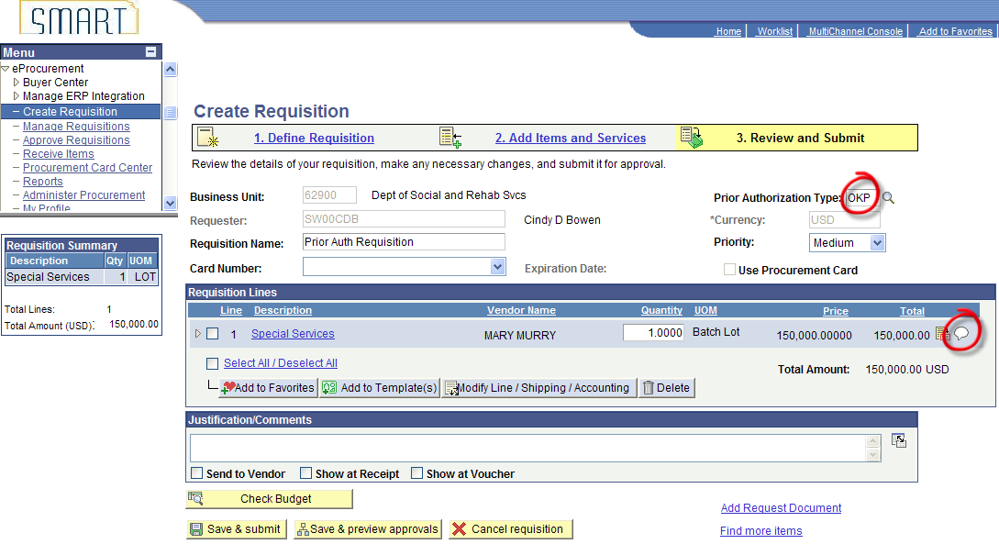

- Do not check the Send to Vendor checkbox, see below.
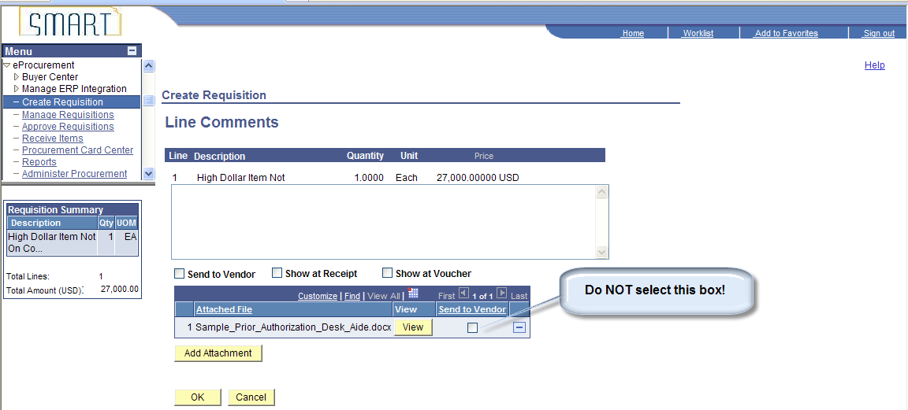

- Assure the requisition workflows to the agency’s purchasing or fiscal officer, as appropriate (Ad Hoc approver workflow may be necessary), see below:
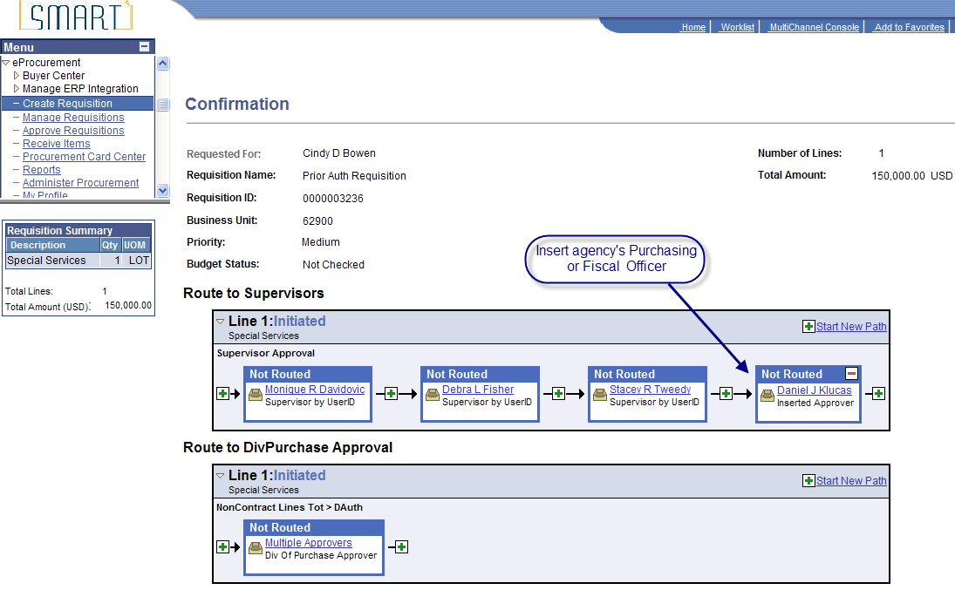

- Division of Purchases reviews the Prior Authorization document attached to the requisition.
- If justification is insufficient, the DoP Procurement Officer will deny the requisition and include comments as to why it was not approved. The requester is notified via e-mail that the requisition has been denied. The agency may edit the requisition with appropriate changes and re-submit it.
- If the justification is sufficient, the DoP Procurement Officer approves the SMART requisition.
- Once the requisition has been approved by the DoP Procurement Officer, SMART will source the requisition to a Purchase Order. The PO will be available in an open status to the agency’s Buyer specified on the requisition.
- If the Prior Authorization is for a one-time purchase requiring a single payment, the agency’s Buyer will approve and process the PO through the agency’s normal business process, regardless of dollar amount.
- If the Prior Authorization is for a purchase equal to or greater than $25,000 and requires multiple payments, a Supplier Contract must be created in SMART.
- If the Prior Authorization is for a purchase that requires payments in more than one fiscal year, a Supplier Contract must be created.
- If a Supplier Contract is created, a header comment must be added. The comment must include the Standard Comment of PA1 and indicate the SMART requisition ID for the approved Prior Authorization. Comments are added by clicking on the “Add Comments” link, see screenshot below.

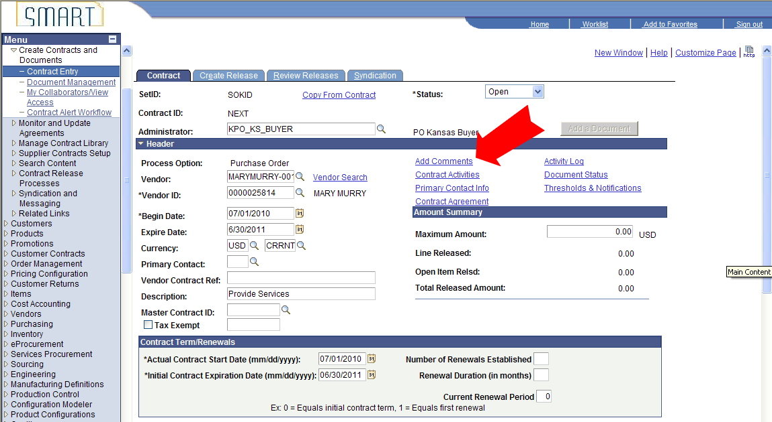

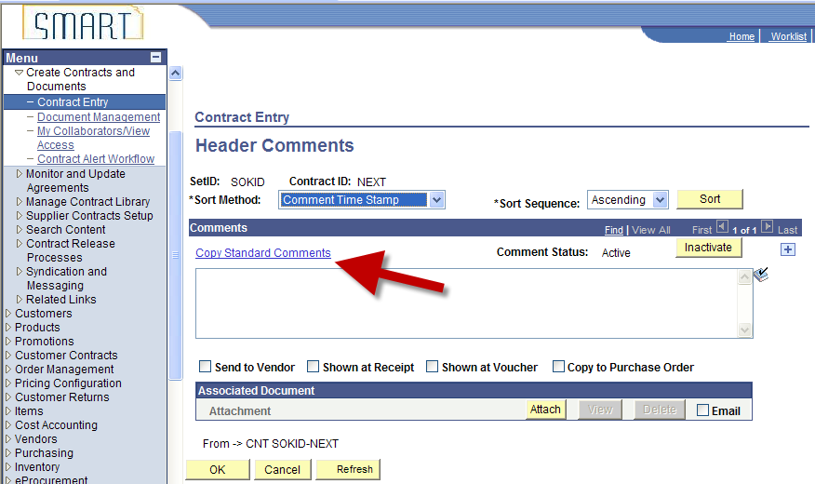

Clicking on the Copy Standard Comments link (above) opens the page below.
Under Action, select “Copy Comment”.
Under Comment Type, select “SCN”.
Under Comment ID, select “PA1”. Then click OK.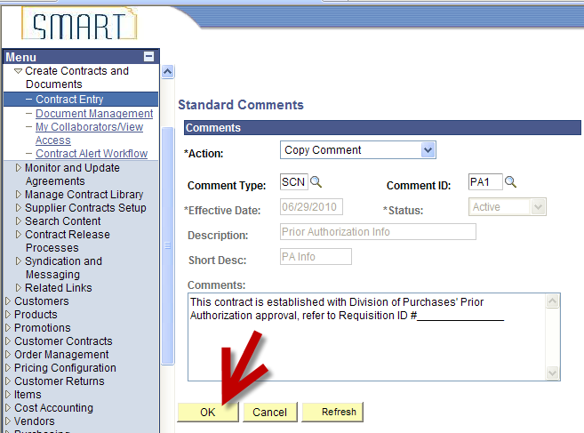

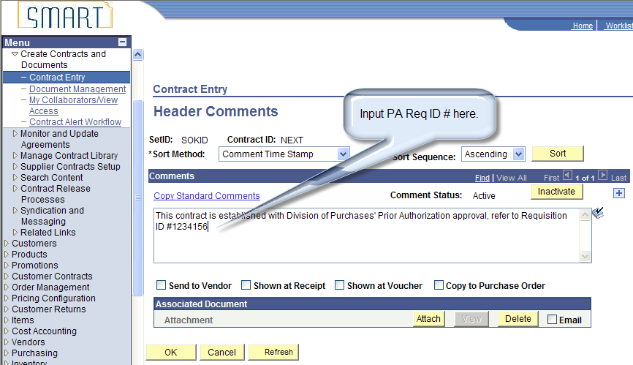
(Enter the applicable Requisition ID in the comment box.)

- Attach the contract document to the contract by clicking the Attach Button. Browse your local drive for the contract document, then upload the document.
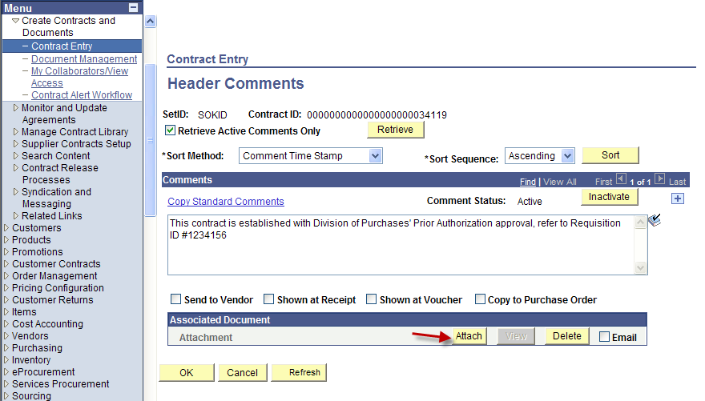

- Any contract equal to or greater than $25,000 must be approved by the DoP Procurement Officer via the contract’s “Notify” feature. Procedures are outlined in training course PO325 Entering Supplier Contracts, dated March 15, 2010, beginning on page 43.
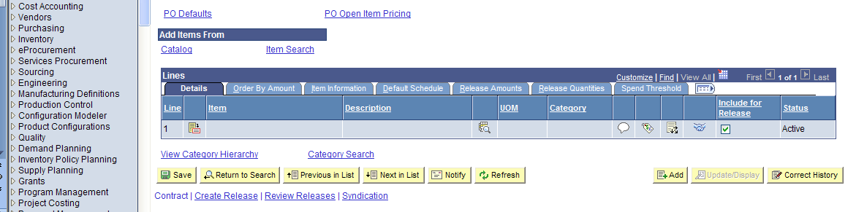

- Any contract less than $25,000 may be approved by the Agency Contract Processor IF the agency has received Prior Authorization approval through a SMART requisition and included the Standard Comment noted above.
- For multi-year contracts, once the Supplier Contract has been approved by the DoP Procurement Officer, the agency Buyer will need to reduce the PO line amount(s) to reflect the current fiscal year obligation.
- The PO line must reference the contract ID that was approved by the DoP Procurement Officer.
- To encumber funds in subsequent fiscal years, the agency Requisitioner will enter a requisition for that fiscal year’s obligation on the requisition line and indicate the applicable Contract ID. Once the requisition is approved by the final agency Approver, the requisition will source to a PO for the applicable Buyer to process.

Chris Howe
Director of Purchases

