Introduction To SHARP

Accessing SHARP
Procedure

In this simulation, you are going to learn how to sign in and out of SHARP.
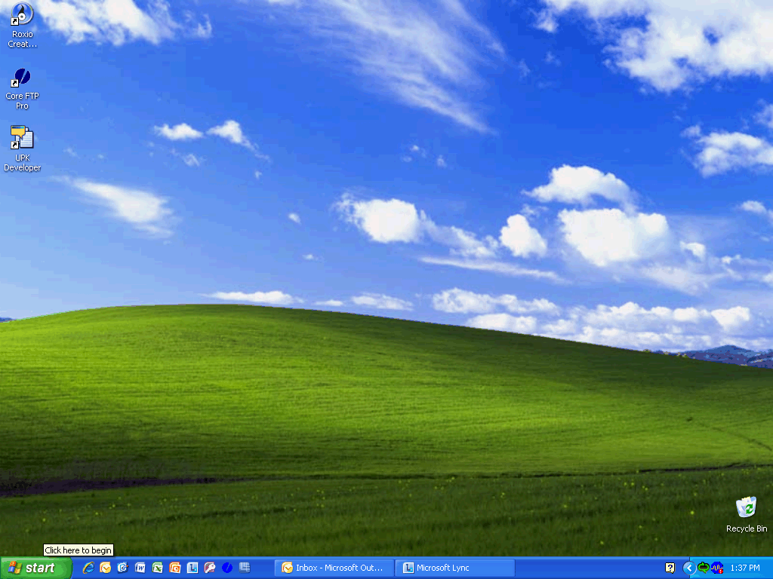

Step | Action
 | Click the start button.

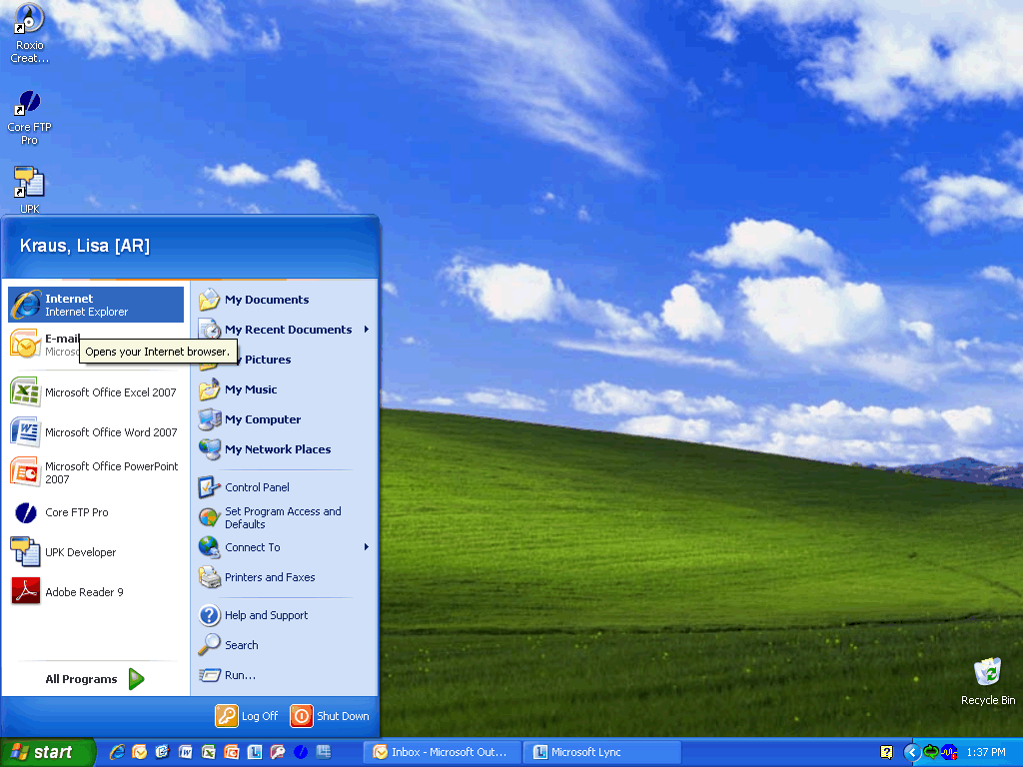

Step | Action
 | Click the Internet list item.

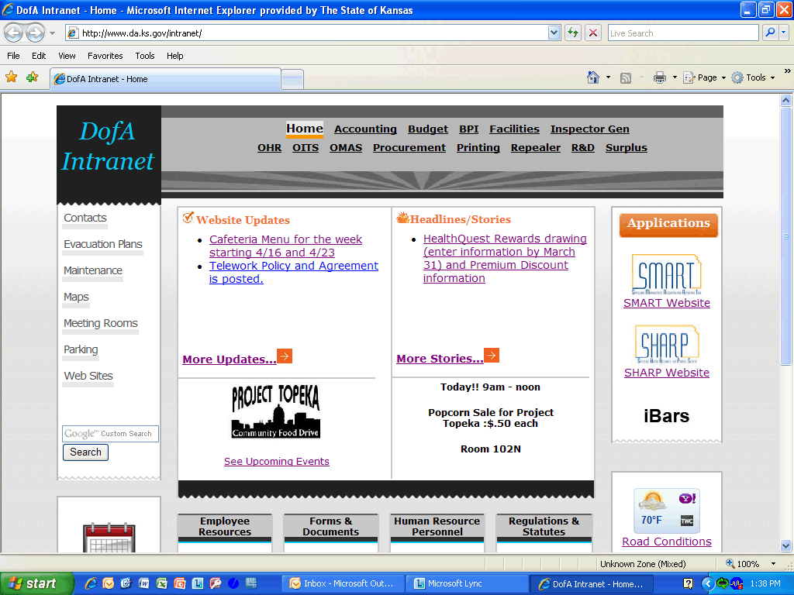

Step | Action
 | Enter the desired information into the field. Enter "https://sharp91.ks.gov/psp/HRPRD91/".

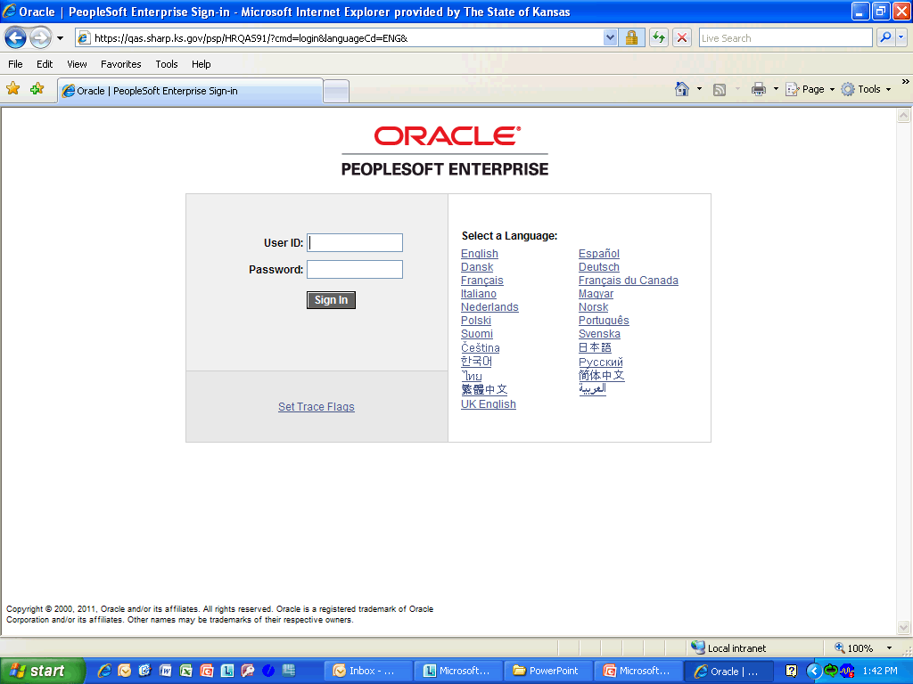

Step | Action
 | Enter the desired information into the User ID: field. Enter "DA00NEW".
Password: SHARP passwords must be changed every 30 days. A good password should:
1. Contain at least 8 characters (required)
2. Have at least one letter and one number (required)
3. Have at least one special character that is not a letter or number
4. Include at least one upper and one lowercase letter

The Password to enter for today is: "$Money99".

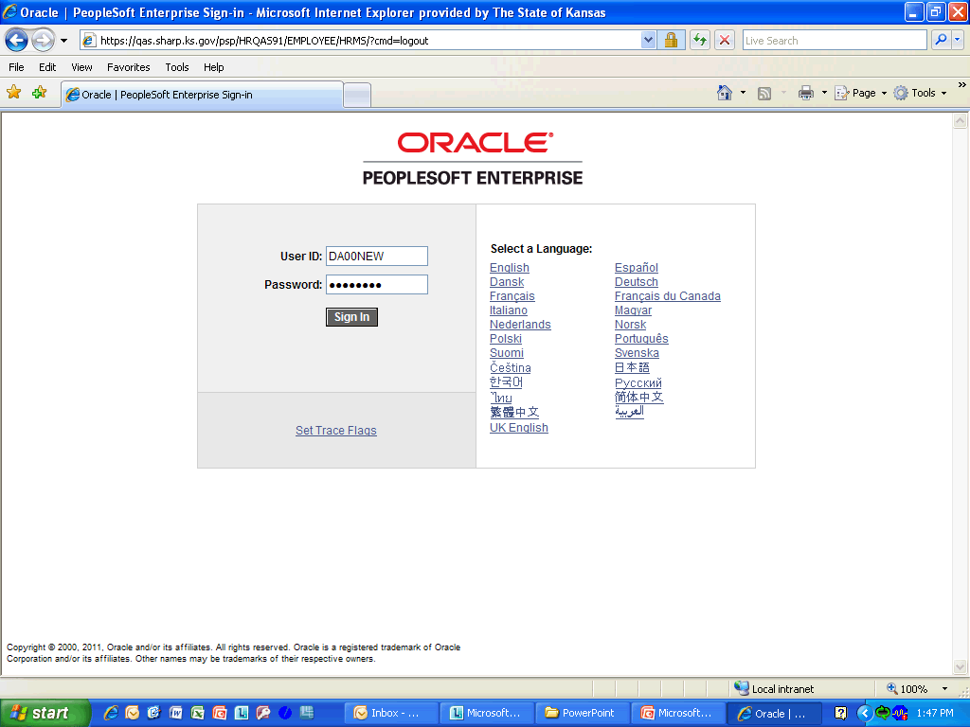

Step | Action
 | Click the Sign In button.

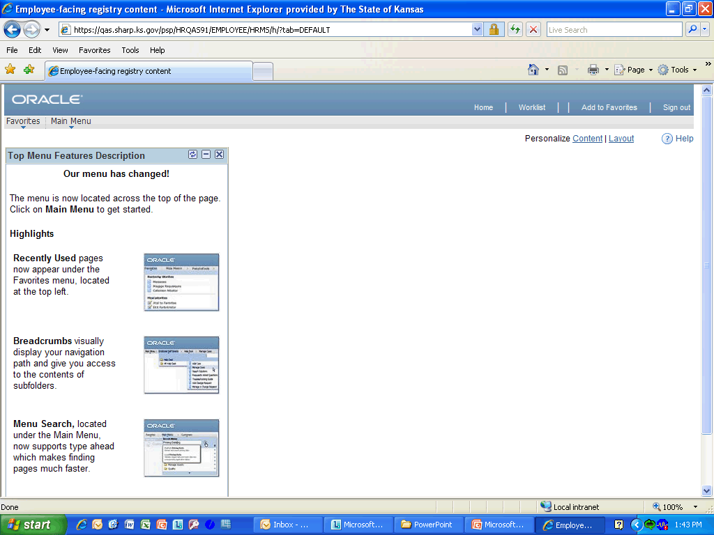

Step | Action
Now that you are logged into SHARP, you are going to see how easy it is to log out. For security reasons and to better utilize the system resources, it’s important that you always use the Sign Out link, instead of closing the browser window to sign out of SHARP.

Click the Sign out link to exit SHARP.
Congratulations! You have just completed Accessing SHARP.
End of Procedure.

