Payroll Commitment Accounting

Adding a Position Pool ID
Procedure

You are entering a simulation where you will follow step by step instructions on how to add a Position Pool ID into the SHARP system.
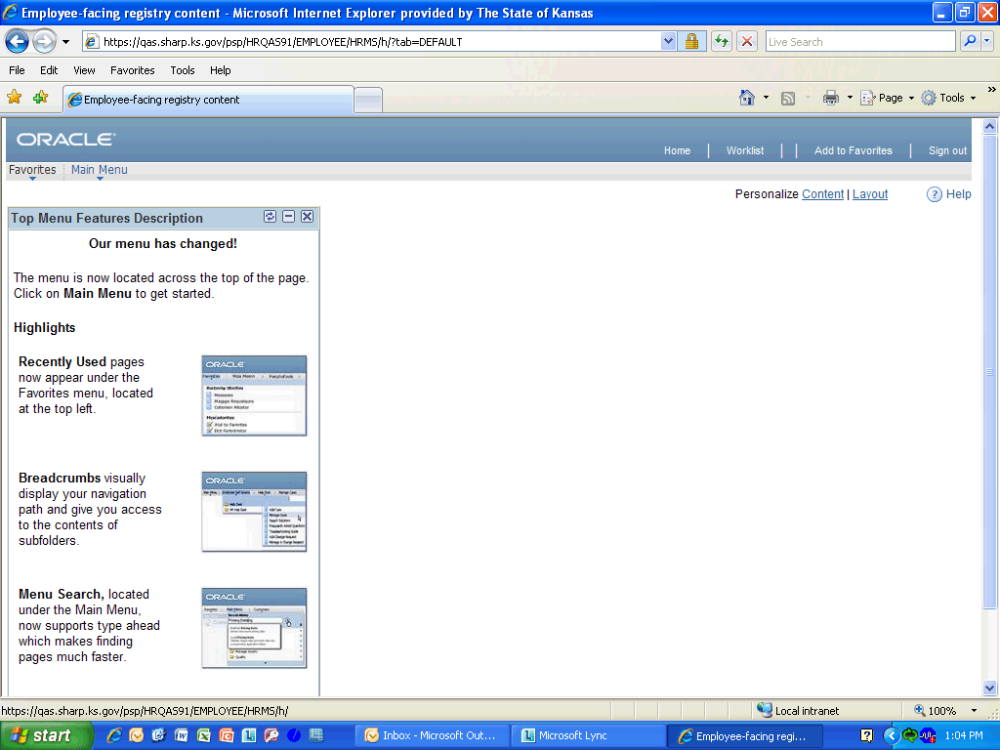

Step | Action
 | Click the Main Menu link.
 | Click the Set Up HRMS link.
 | Click the Product Related link.
 | Click the Commitment Accounting link.
 | Click the Budget Information link.
 | Click the Position Pool Table link.

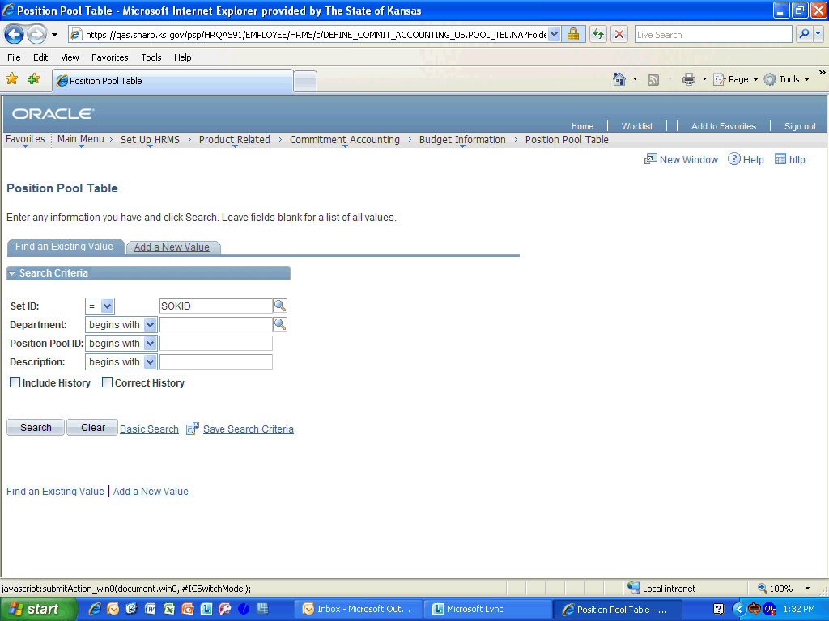

Step | Action
 | Click the Add a New Value link.
 | Enter the desired information into the Department field. Enter "1730101010".
 | Enter the desired information into the Position Pool ID field. Enter "055".
 | Click the Add button.
Enter the desired information into the Effective Date field. Enter "08/21/2011".
The Effective Date should by the first day of a pay period that has not yet been confirmed.
 | Enter a something that describes the Position Pool ID that you added into the Description field. Enter "Payroll Services".
 | Now enter an abbreviated description into the Short Description field. Enter "Payroll".
 | Click the Save button.
Congratulations! You have completed Adding a Position Pool ID into SHARP.
End of Procedure.

