Reporting

Downloading Reports Using Core FTP Pro
Procedure

For this scenario, you are asked to download the most recent KPAY710 report from your agency MVS mailbox using the Core FTP Pro software.
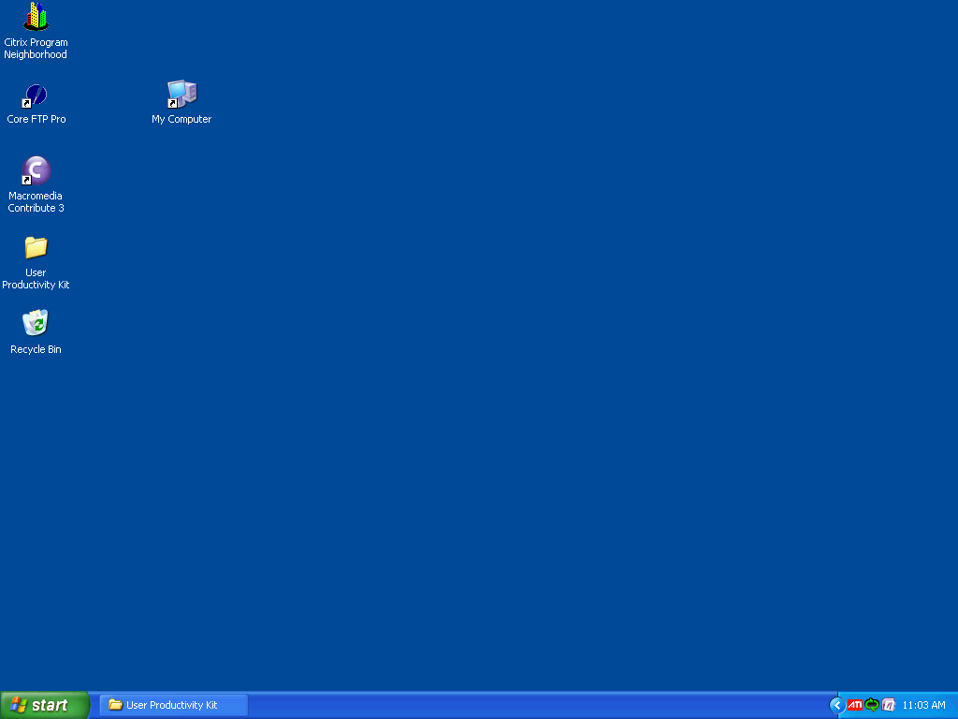

Step | Action
Double-click the Core FTP Pro icon.
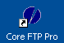

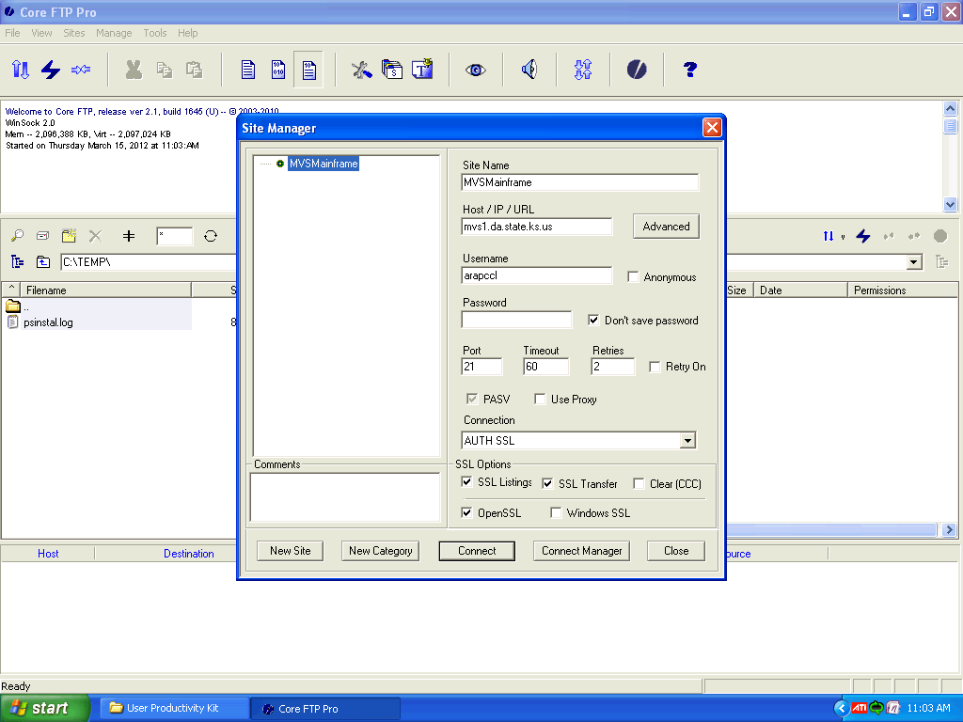

Step | Action
The Site Manager window opens.

Click in the Password field.
Enter your password into the field.

For this simulation, enter "training1".
 | Click the Connect button.
 | When the MVS mailbox (or the remote site) opens, you can see all of the files available to you in the right pane. The bottom status bar will also indicate it's "Ready".
It's often difficult to locate a specific report from the long list of reports in the mailbox. You can narrow down the list by entering a few beginning letters of your report name in the File Mask field, then press the Enter key to perform the search.

Click in front of (to the left of) the asterisk in the File Mask field.
The filter is case sensitive, so the letters entered must be in caps to locate the reports.

Press the [Caps Lock] key on the left of your keyboard.
Enter the first few letters of the desired report name into the field. For this simulation, we will download the most recent KPAY710 report.

Enter "KPAY" into the File Mask field.
 | Press [Enter] to start the search.

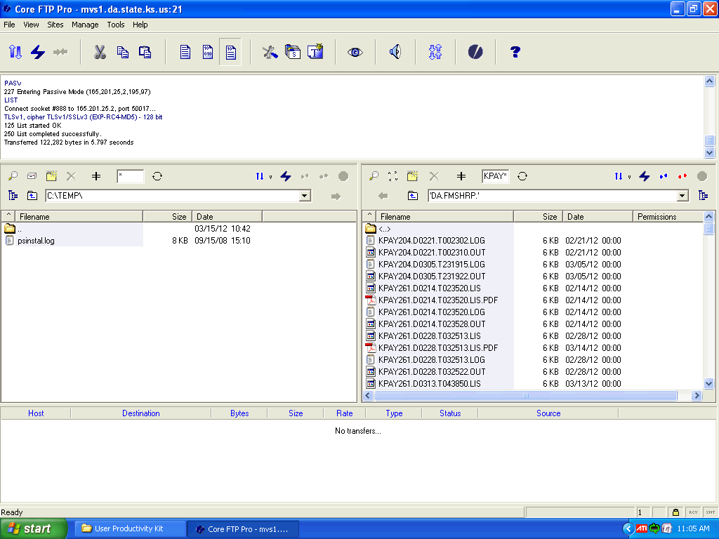

Step | Action
After filtering the list, the system will return only files named "KPAY...". You may need to scroll down to find the file you are looking for.

For this simulation, click on the right scroll bar.

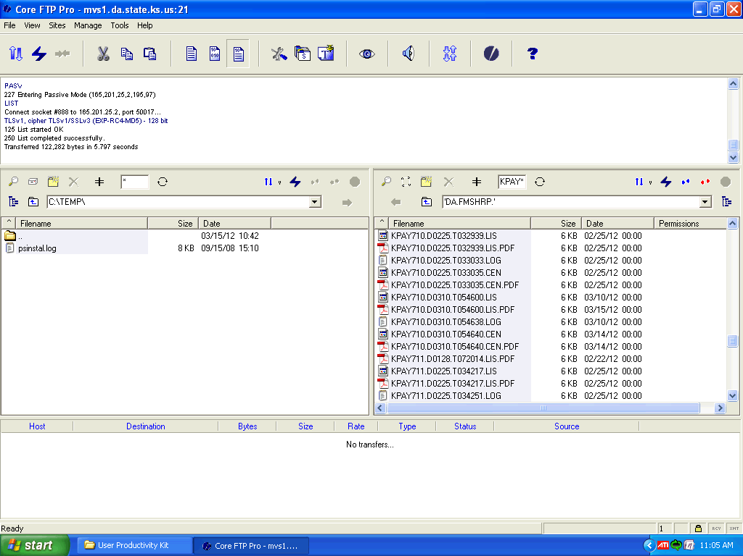

Step | Action
When you see the report you are looking for, click to select it.

For this simulation, click the KPAY710.D0310.T054600.LIS.PDF report.
 | With the selected report highlighted, click the Left Arrow button.
The report is transferred from the remote site (MVS mailbox) to your workstation (your local drive). With the correct software, you can view the downloaded report by double clicking the report name.

Double-click the KPAY710.D0310.T054600.LIS.PDF report in the local folder.
With the View radio button on,
click the OK button.

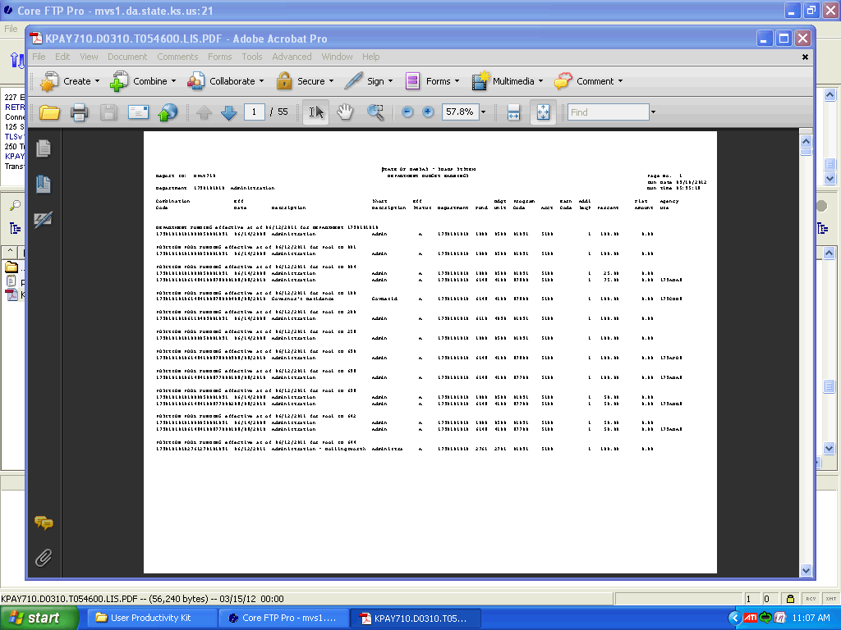

Step | Action
If the report is not legible, you can enlarge the print by clicking the + button or selecting a higher zoom percentage.

Click the Drop Down Arrow by the Percentage box.

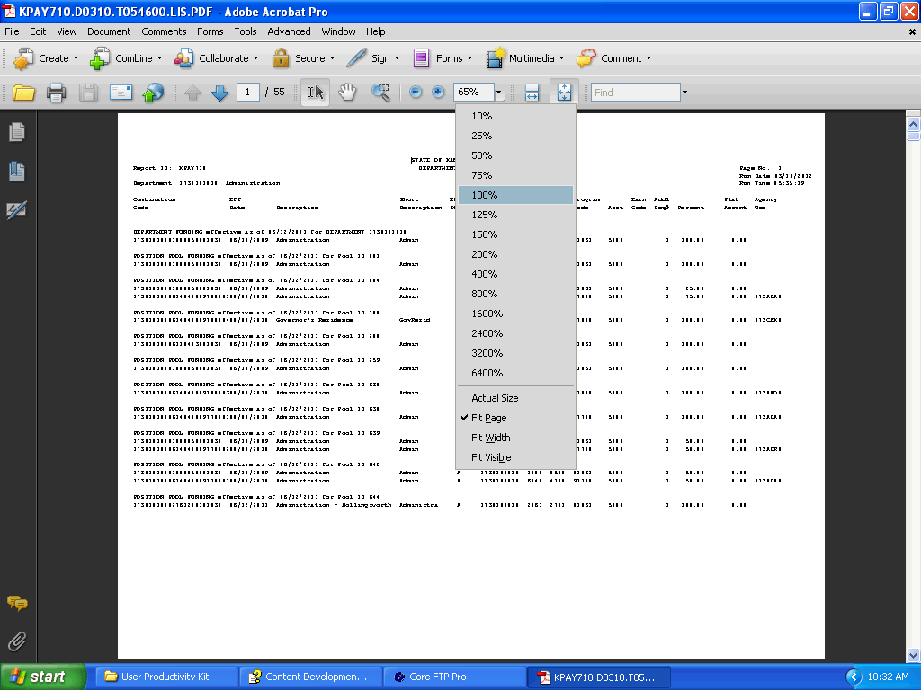

Step | Action
 | Click the 100% level.
The print is enlarged with the new setting. When you are done viewing the report, close the report.

Click the Close button.
Congratulations! You have successfully downloaded a report using the CoreFTP software!
End of Procedure.

