Payroll

Entering Additional Pay
Procedure

This simulation will show you the procedure for entering Employee's Additional Pay in the SHARP system. Here you will enter additional pay that is for a contractual obligation.
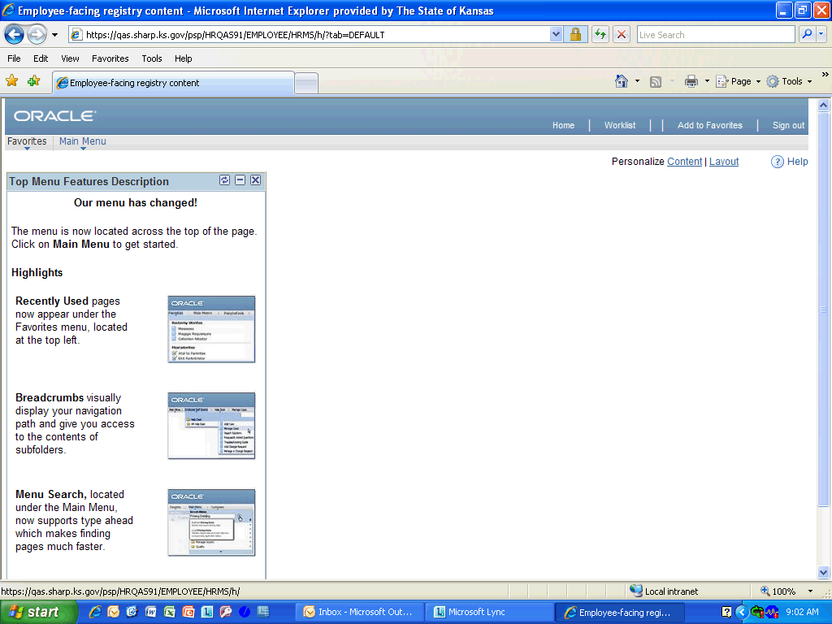

Step | Action
 | Click the Main Menu link.
 | Click the Payroll for North America link.
 | Click the Employee Pay Data USA link.

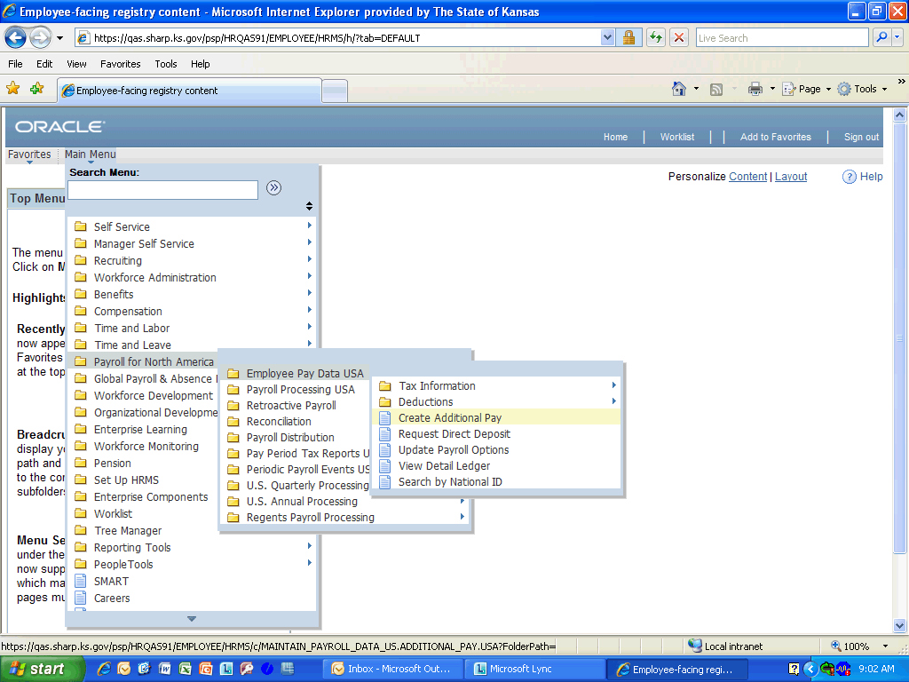

Step | Action
 | Click the Create Additional Pay link.

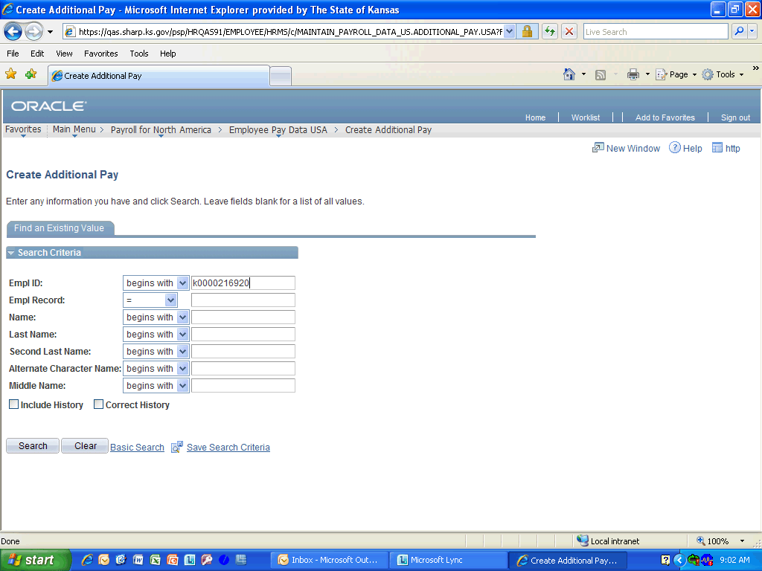

Step | Action
 | Enter the desired information into the Empl ID field. Enter "K0000216920".
 | Click the Search link.
 | Enter the desired information into the Earnings Code field. Enter "c".
 | Click the Look up Earnings Code (Alt+5) button.
 | Click the Contractual Pay button.
 | Enter the desired information into the Effective Date field. Enter "08/22/2011".
 | Enter the desired information into the Addl Seq Nbr field. Enter "1".
 | Click the Reason list.

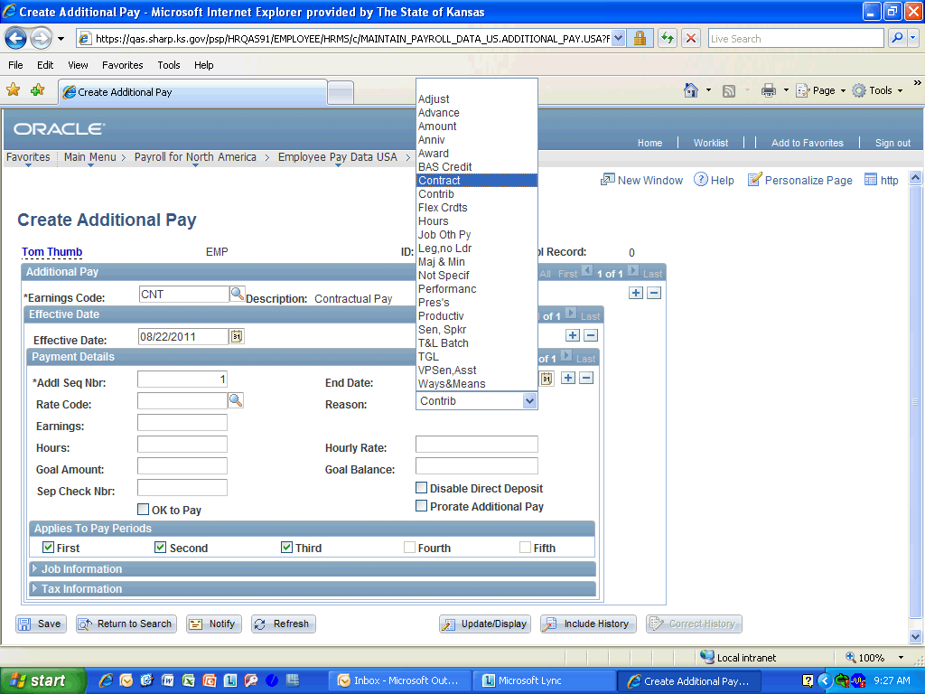

Step | Action
 | Select Contract from the list.

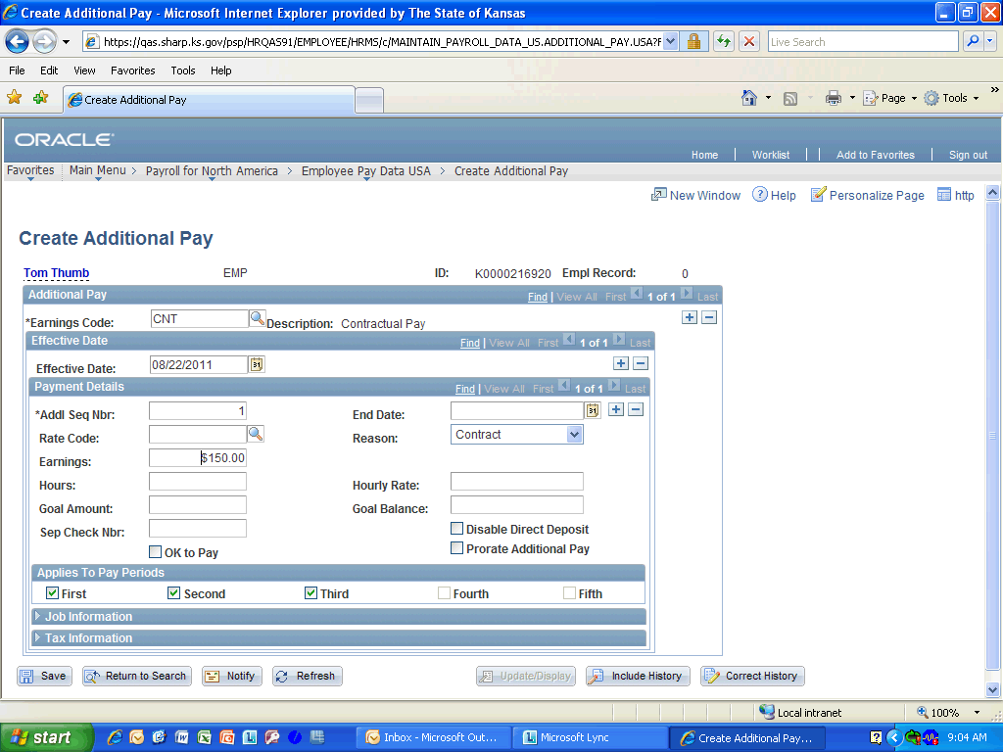

Step | Action
 | Enter the desired information into the Earnings field. Enter "150.00".
 | Click the OK to Pay option.
 | Click the Prorate Additional Pay option.

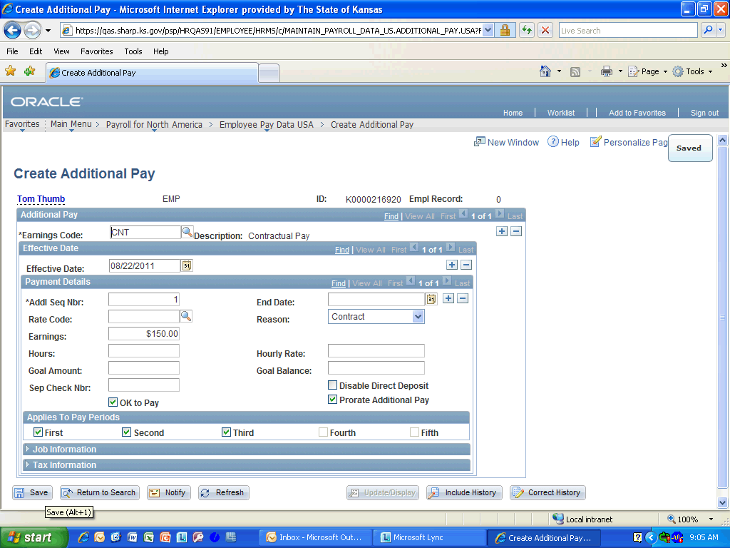

Step | Action
 | Click the Save button.
Congratulations! You have completed Entering Additional Pay.
End of Procedure.

