Payroll

Entering General Deductions
Procedure

For this simulation, you are going to follow step by step instructions for entering employee's general deductions. You will be entering two deductions. First you will entering an United Way Deduction and Fee. Finally you will enter a Learning Quest Deduction.
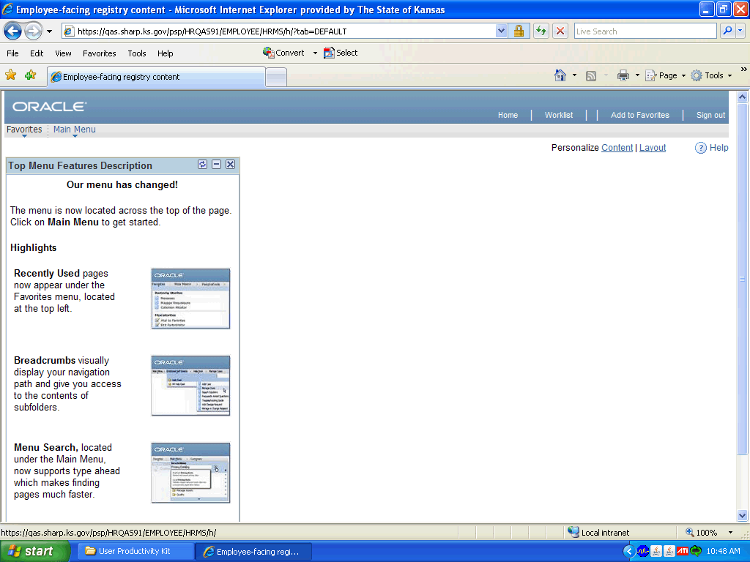

Step | Action
 | Click the Main Menu link.
 | Click the Payroll for North America link.
 | Click the Employee Pay Data USA link.
 | Click the Deductions link.

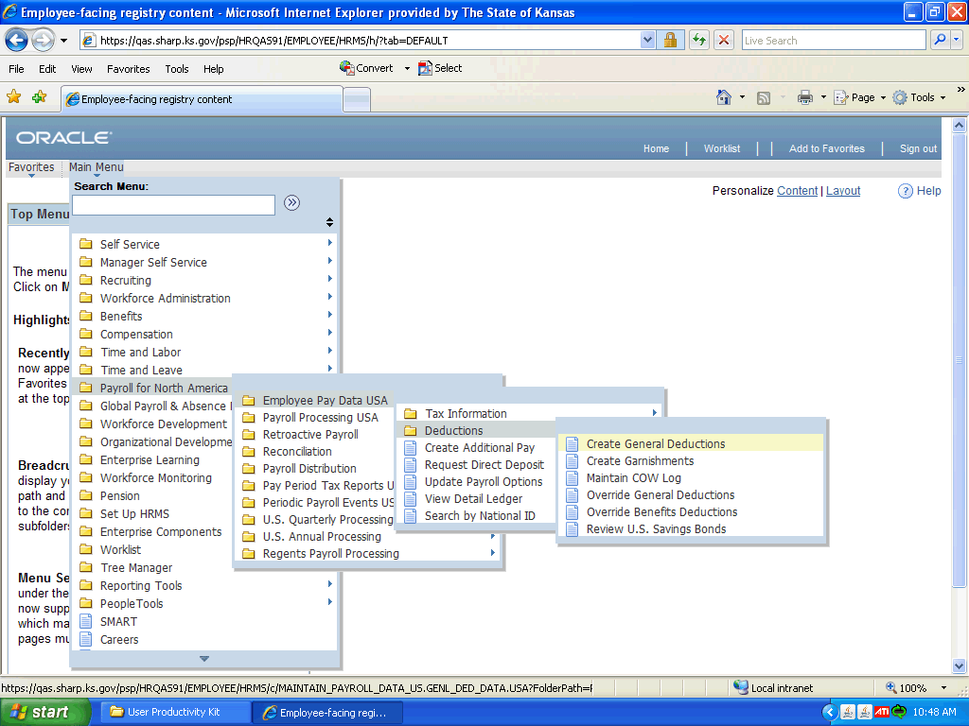

Step | Action
 | Click the Create General Deductions link.
 | Enter the desired information into the Empl ID field. Enter "K0000216920".
 | Enter the desired information into the Company field. Enter "SOK".
 | Click the Search button.
 | Enter the first letter of the code you are going to enter into the Deduction Code field. Enter "U", since you are going to be entering an United Way deduction.
 | Click the Look up Deduction Code (Alt+5) button.

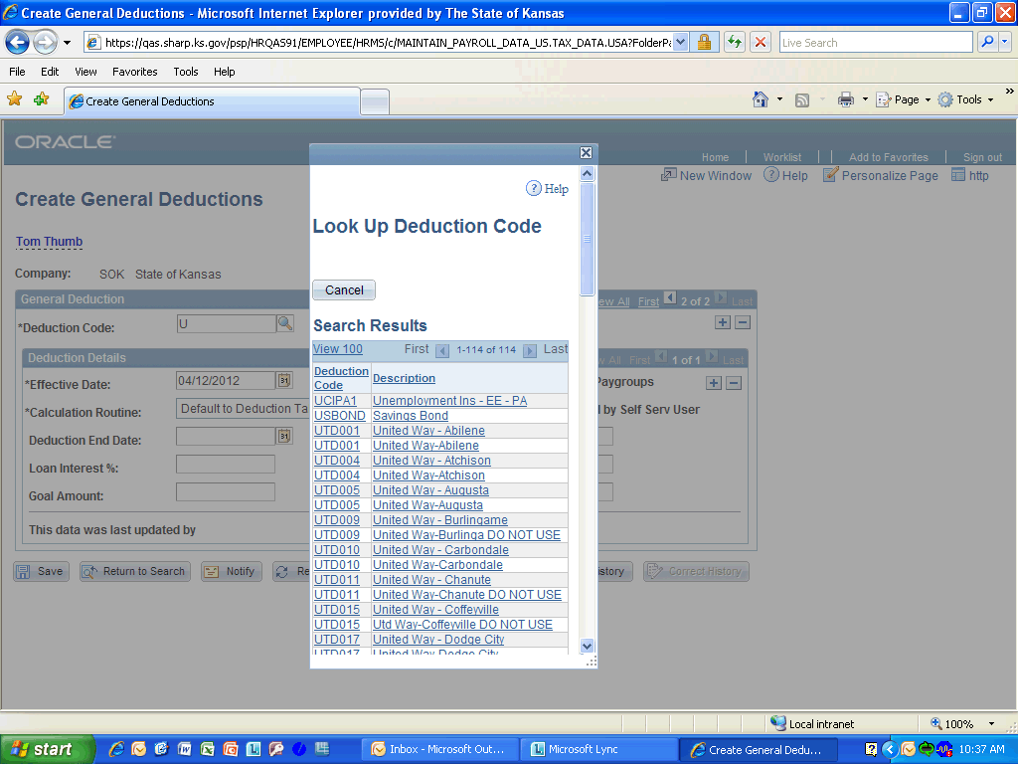

Step | Action
 | Press the left mouse button and drag the Scroll Bar down to the desired location.

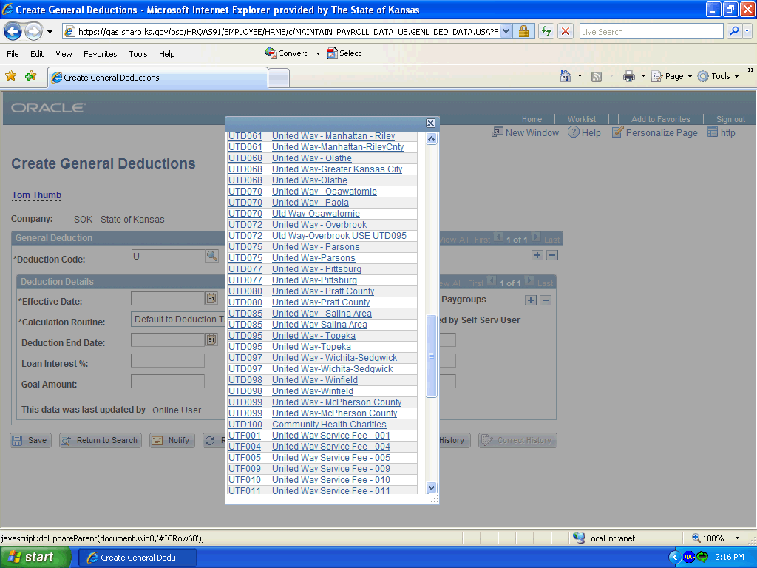

Step | Action
 | Scroll to the United Way - Topeka link and select it.

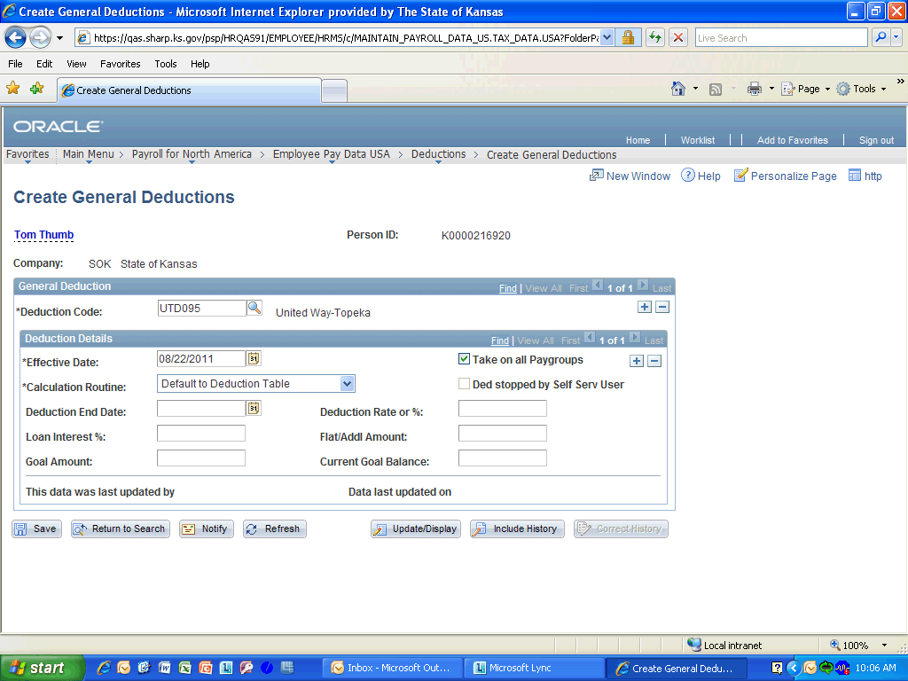

Step | Action
 | Enter the desired information into the Effective Date field. Enter "08/22/2011".
 | Select the desired type from the Calculation Routine field. We will choose Flat Amount.
 | Enter the desired information into the Deduction End Date field. Enter "12/25/2011". United Way Deduction should have the first day of the last pay period in the calendar year.
 | Enter the amount of the deduction into the Flat/Addl Amount field. Enter "4.94". The employee had chose to donate $5.00 a pay period to United Way. United Way deduction have to be split into two entries, the first is the amount minus $.06 fee that you will enter next.

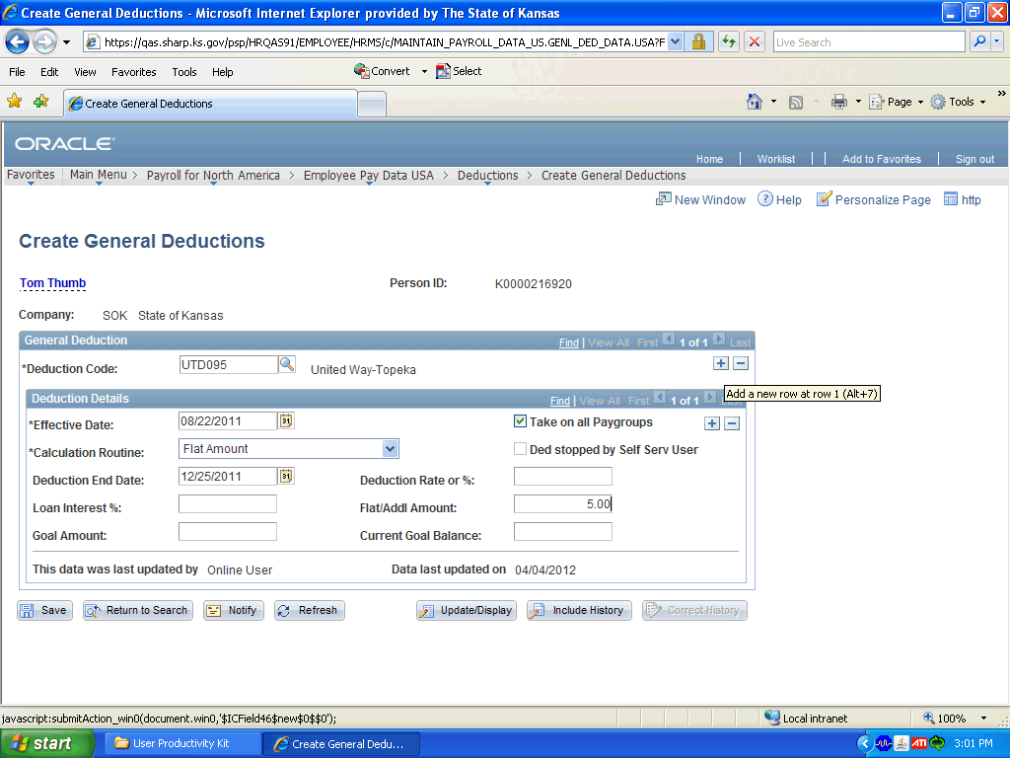

Step | Action
 | Click the Plus Sign to add an additional deduction.
 | Enter the desired information into the field. Enter "U".
 | Click the Look up Deduction Code (Alt+5) button.

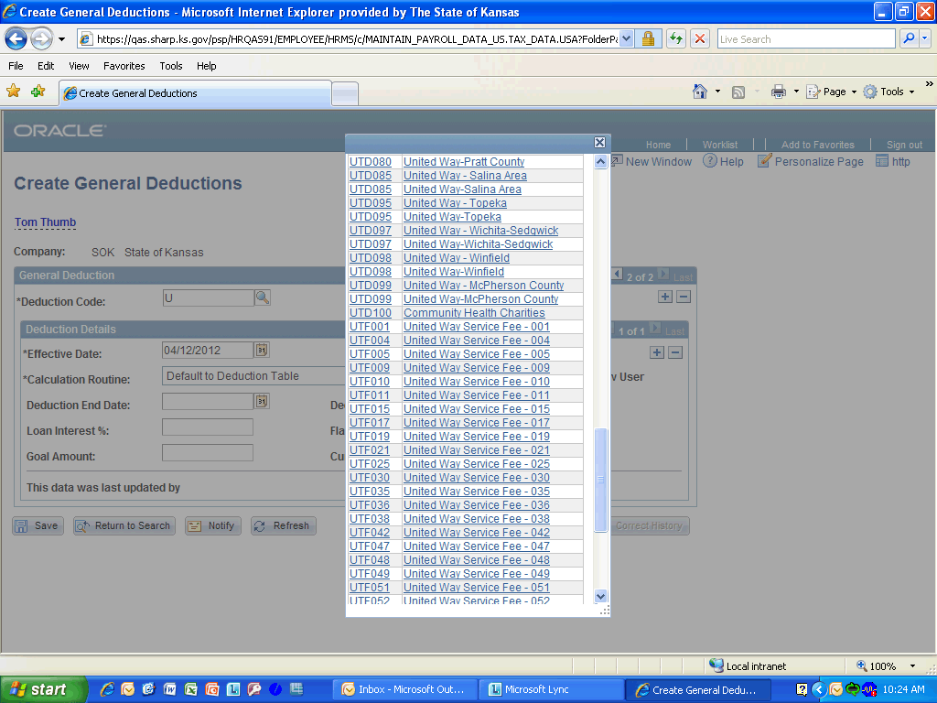

Step | Action
 | Press the left mouse button and drag the Scroll Bar down to the desired location.

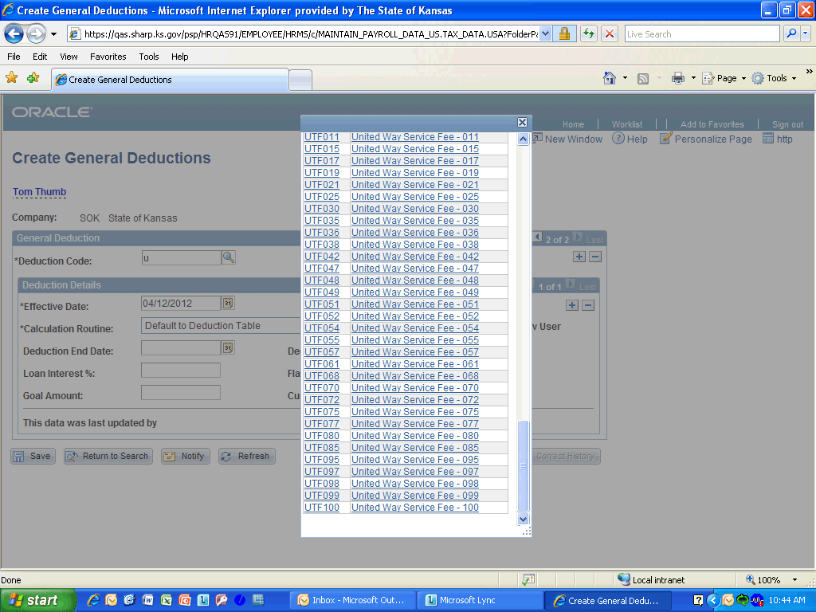

Step | Action
 | Click on the United Way Service Fee - 095.

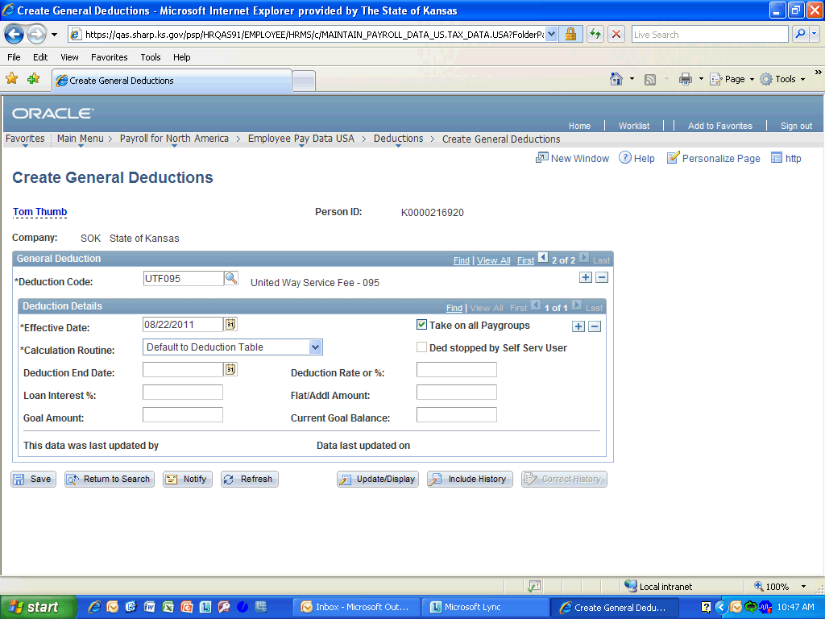

Step | Action
 | Enter the desired information into the Effective Date field. Enter "08/22/2011".

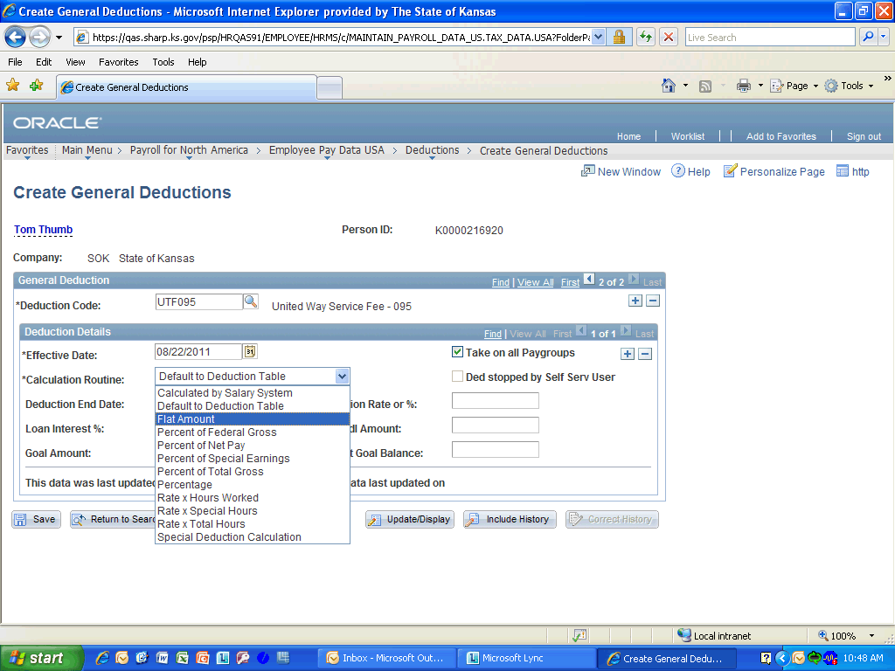

Step | Action
 | From the Calculation Routine drop-down list, select Flat Amount.

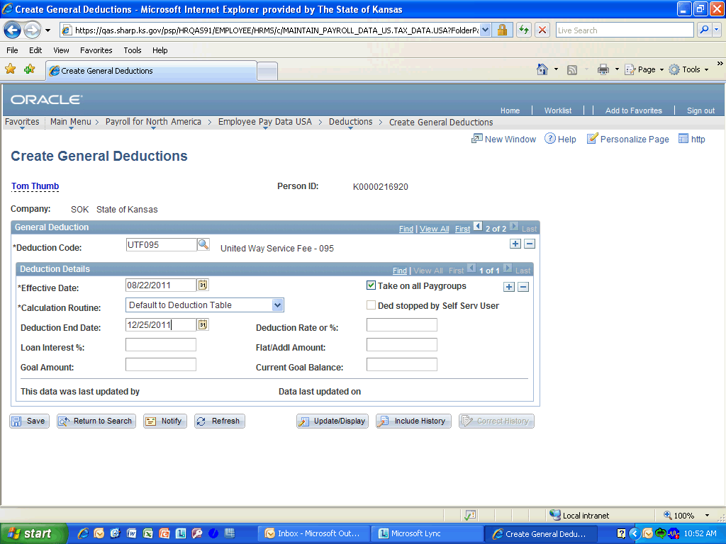

Step | Action
 | Enter the desired information into the Deduction End Date field. Enter "12/25/2011".

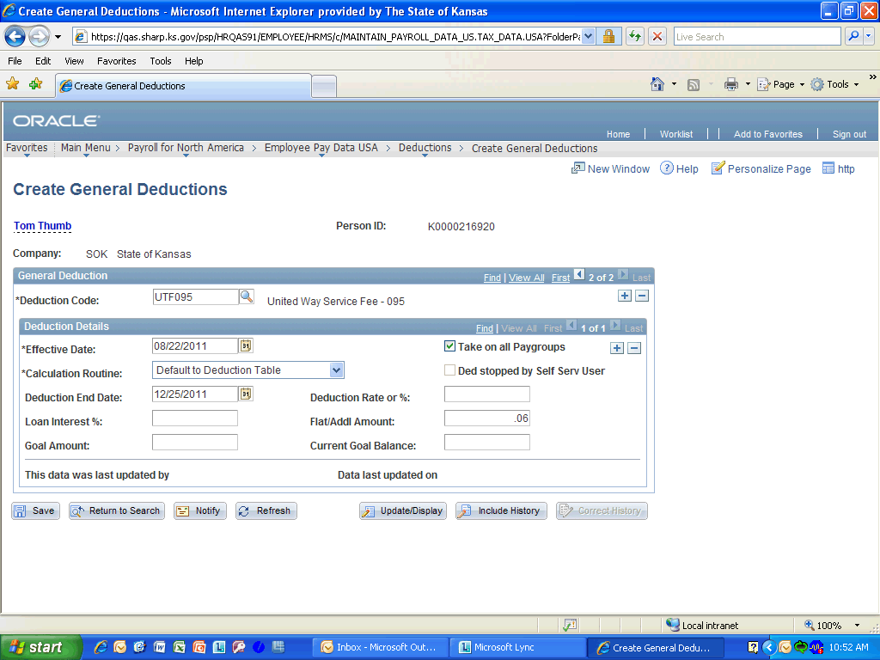

Step | Action
 | Enter the desired information into the Flat/Addl Amount field. Enter ".06".
 | Click the Plus Sign object.

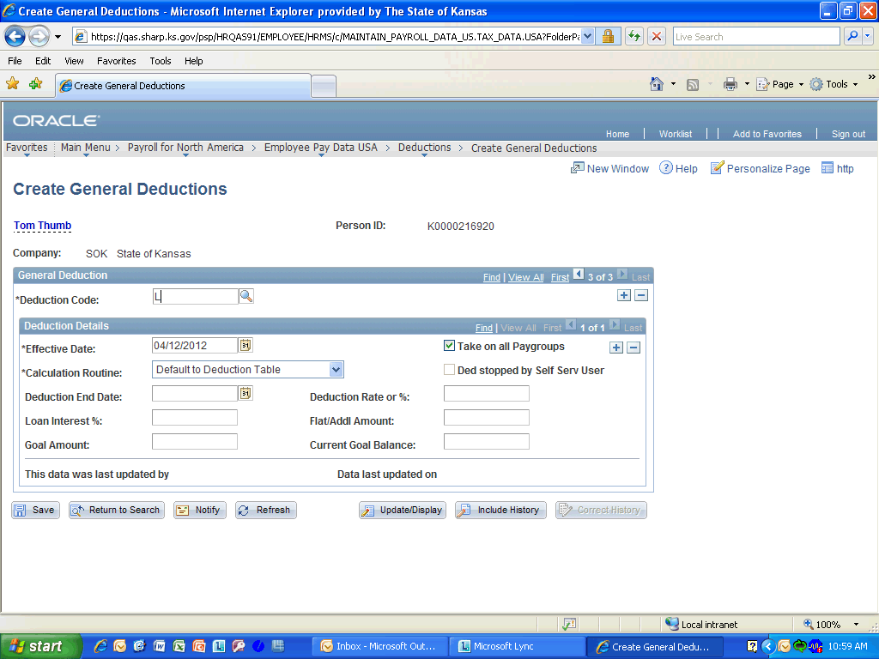

Step | Action
 | Enter the first letter of the next deduction that you are entering into the Deduction Code field. Enter "L", since you are adding a Learning Quest deduction.
 | Click the Look Up Deduction Code (Alt+5) button.
 | Click the Learning Quest link.
 | Enter the desired information into the Effective Date field. Enter "08/22/2011".
 | Click the Calculation Routine list and select Flat Amount.
 | Enter the desired information into the Flat/Addl Amount field. Enter "50.00".

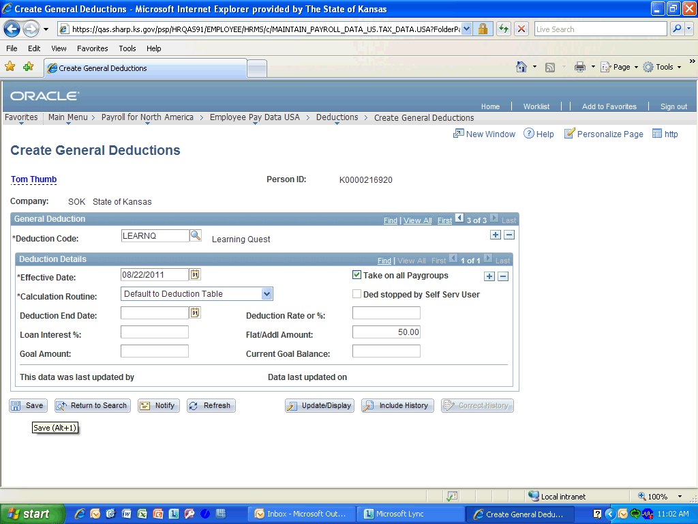

Step | Action
 | Click the Save button.
Congratulations! You have successfully completed Entering General Deductions.
End of Procedure.

