Payroll

Entering Maximum Arrears Payback
Procedure

You are about to follow step-by-step instructions for entering a Maximum Arrears Payback. The entire arrears payback will be collected from the employees next paycheck unless a maximum arrears payback is established before final pay confirmation of the first on-cycle or supplemental paycheck being issued to the employee after the arrearage occurred.
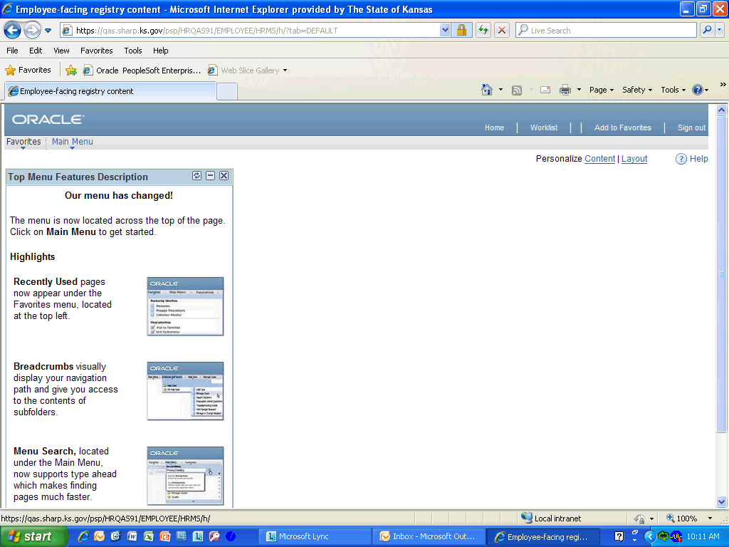

Step | Action
 | Click the Main Menu button.

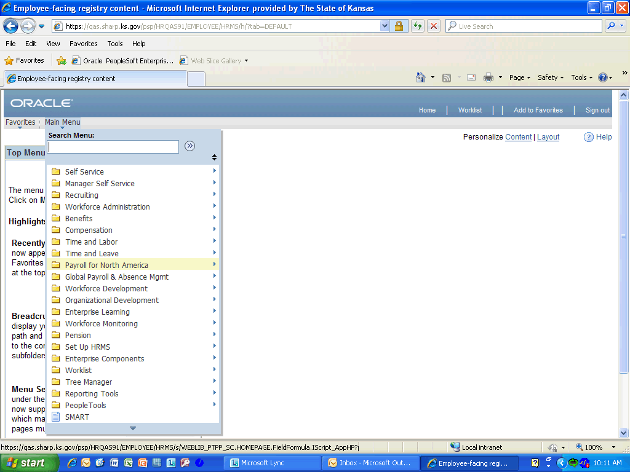

Step | Action
 | Click the Payroll for North America link.

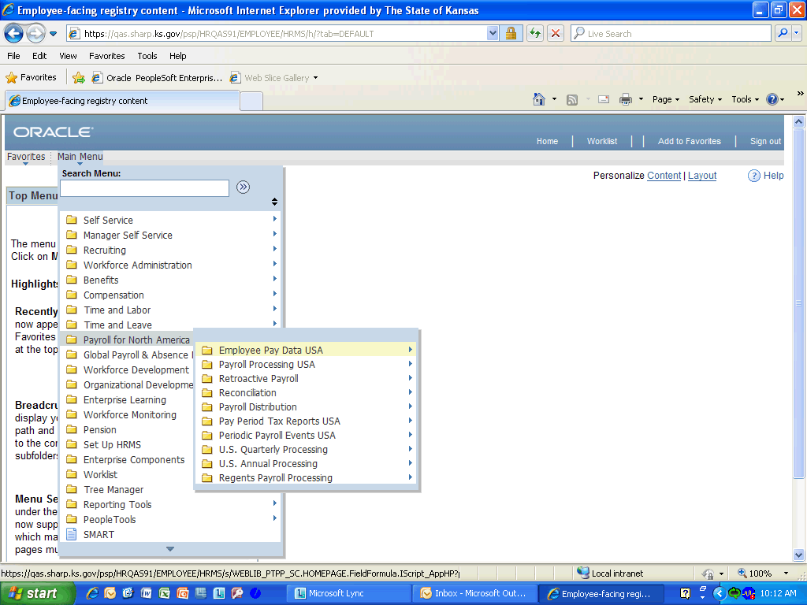

Step | Action
 | Click the Employee Pay Data USA link.

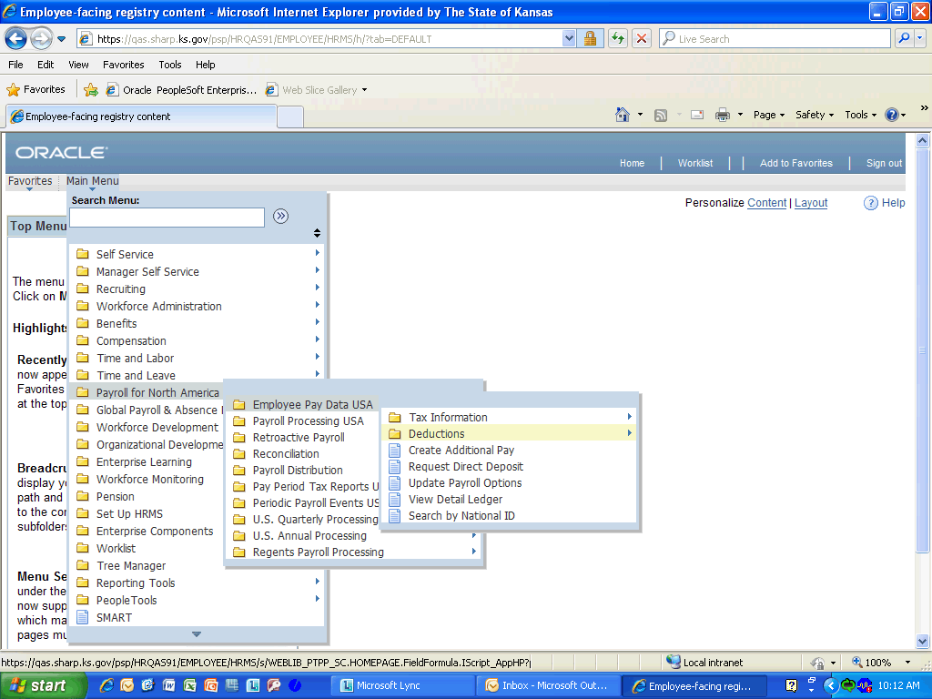

Step | Action
 | Click the Deductions link.

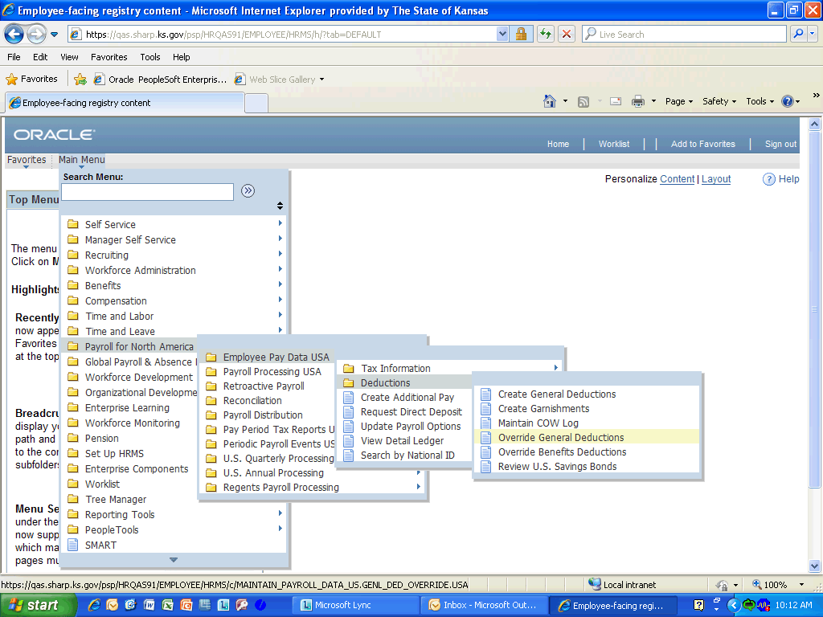

Step | Action
 | Click the Override General Deductions link.

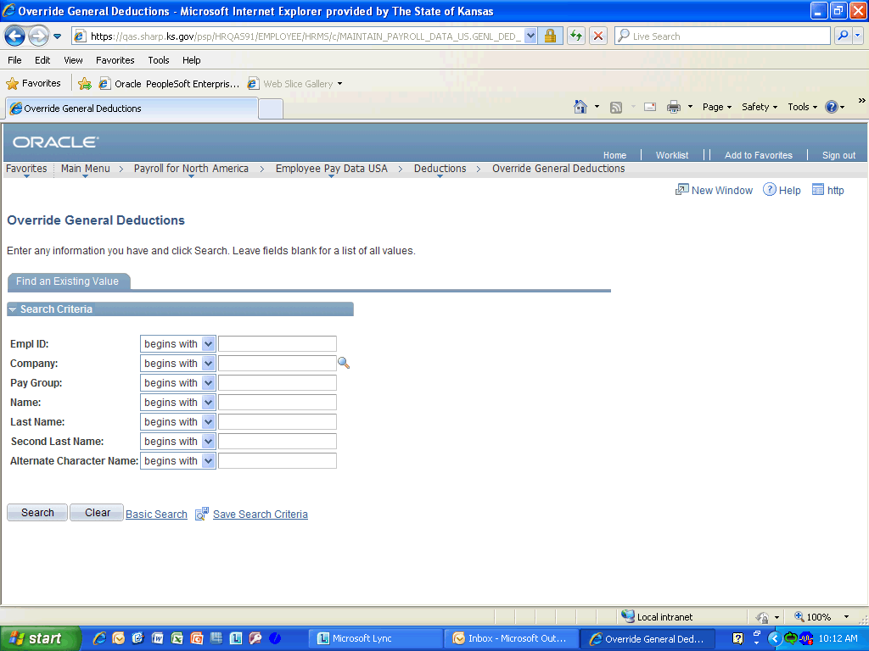

Step | Action
 | Enter the desired information into the Empl ID: field. Enter "K0000216920".

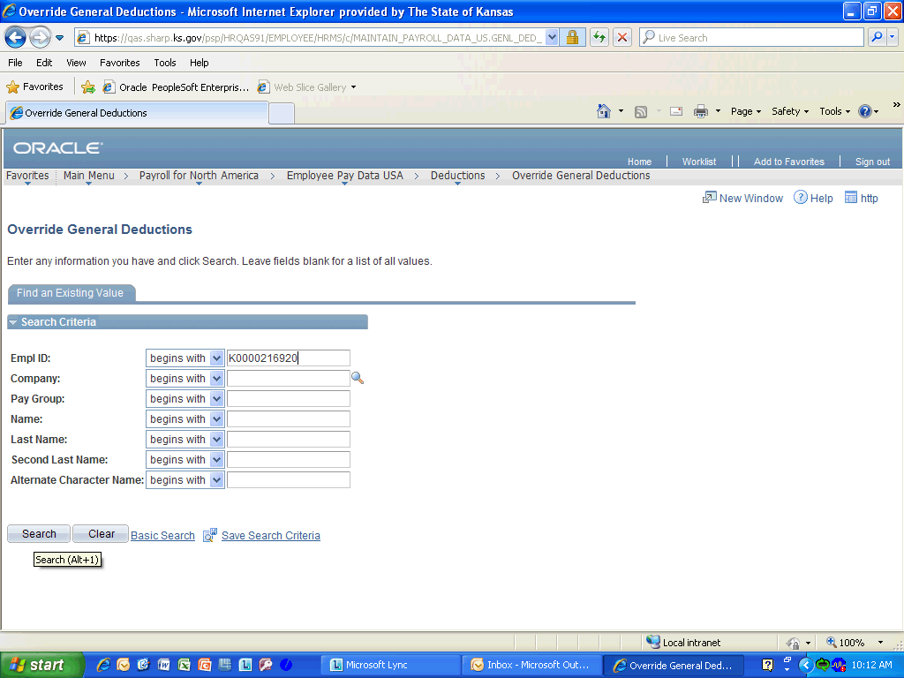

Step | Action
 | Click the Search (Alt+1) button.

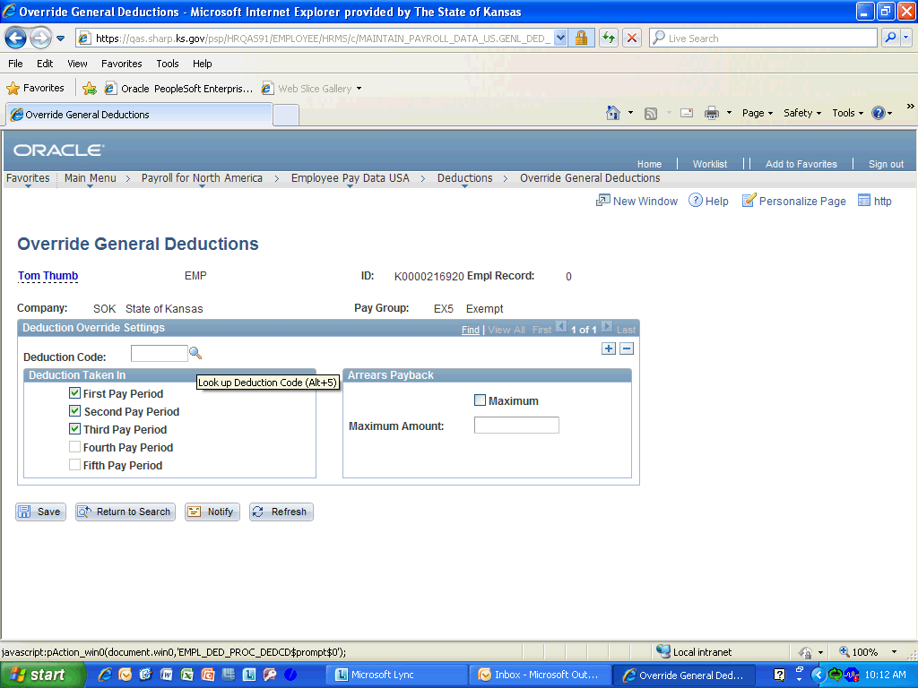

Step | Action
 | Click the Look up Deduction Code (Alt+5) list.

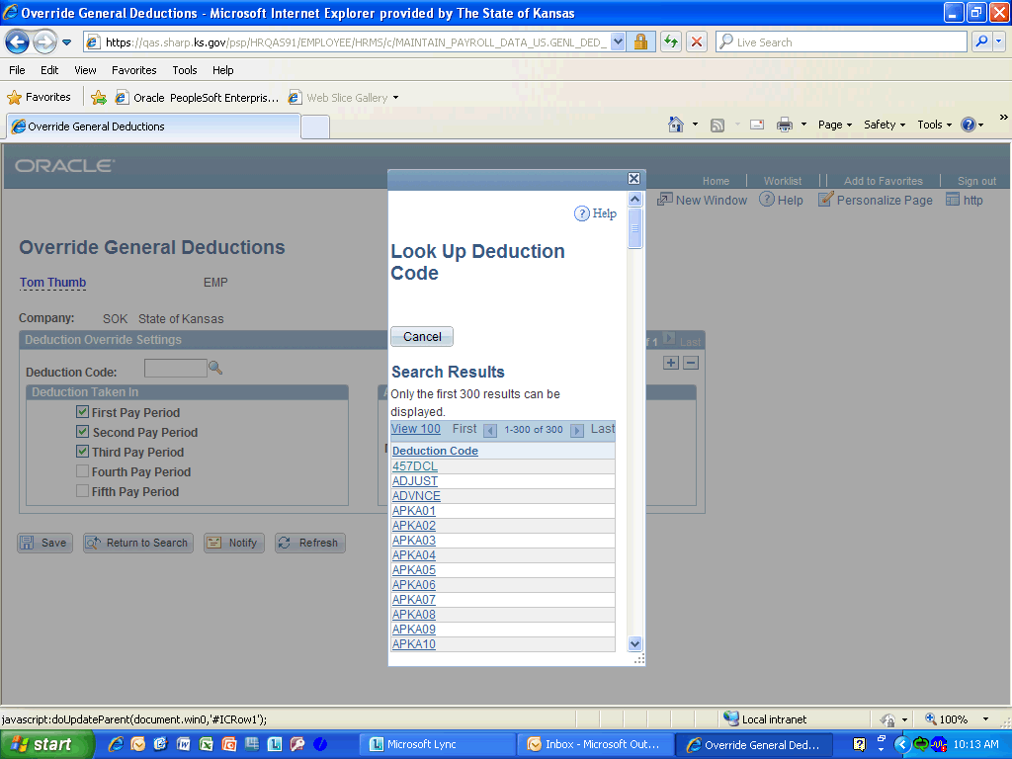

Step | Action
 | The maximum arrears payback must be entered separately for each plan type and deduction code, either ADVNCE or ADJUST. For this simulation, click the ADJUST link.

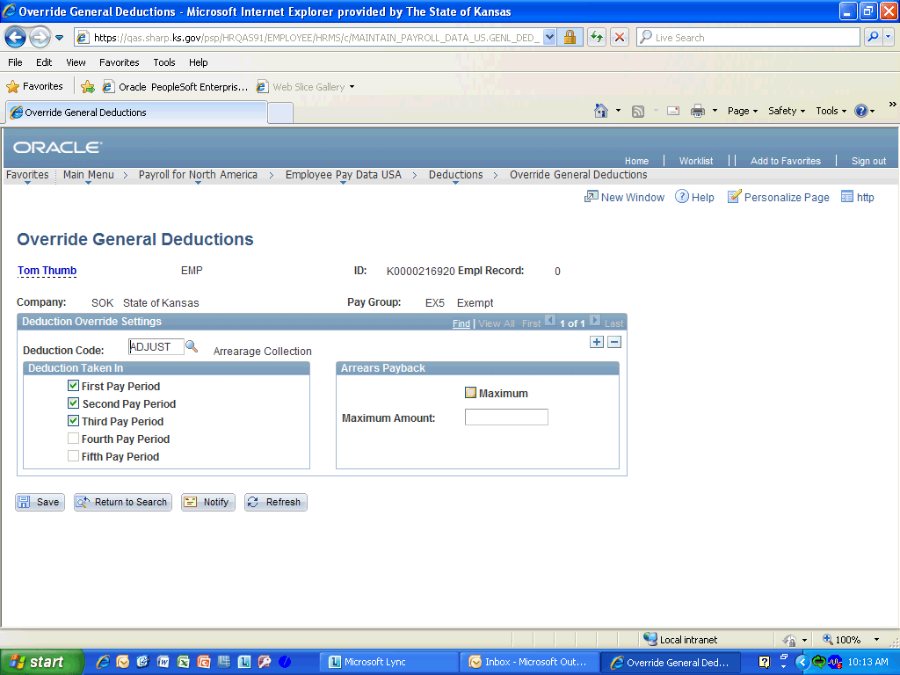

Step | Action
The maximum check box must be selected for a maximum arrears payback to work.
Click the Maximum option.

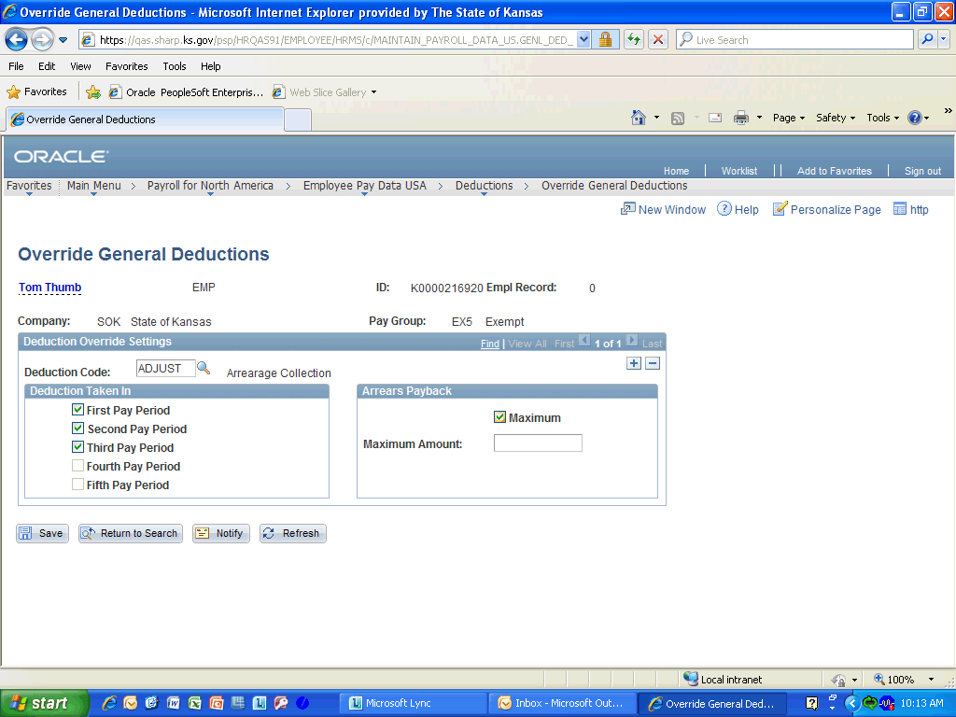

Step | Action
The maximum amount to come out of an employees paycheck for the arrearage is established here.
Enter the desired information into the Maximum Amount: field. Enter "25.00".

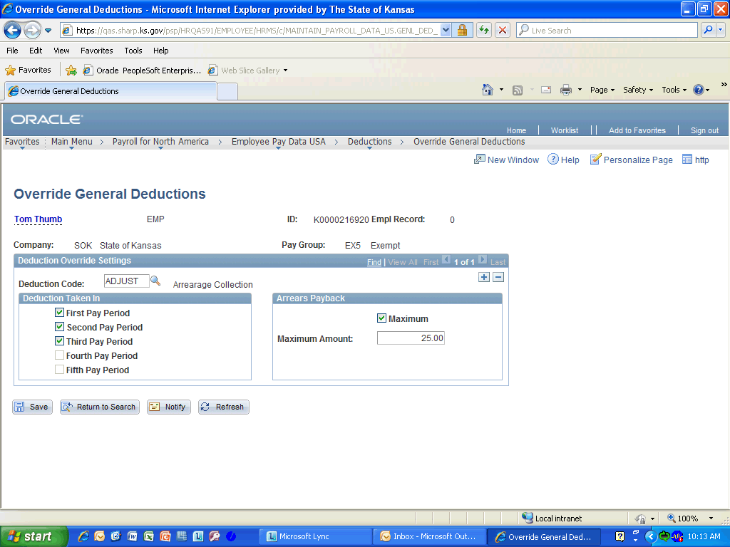

Step | Action
 | Click the Save (Alt+1) button.
Congatulations! You have completed entering Maximum Arrears Payback.
End of Procedure.

