Payroll

Entering a Paycheck Reprint
Procedure

You are about to follow step-by-step instructions for having a paycheck reprinted. Before entering the re-print request, you must gather the necessary information, ensure that it is eligible for an agency entered check reprint, and get approval from the State Treasurer's Office.
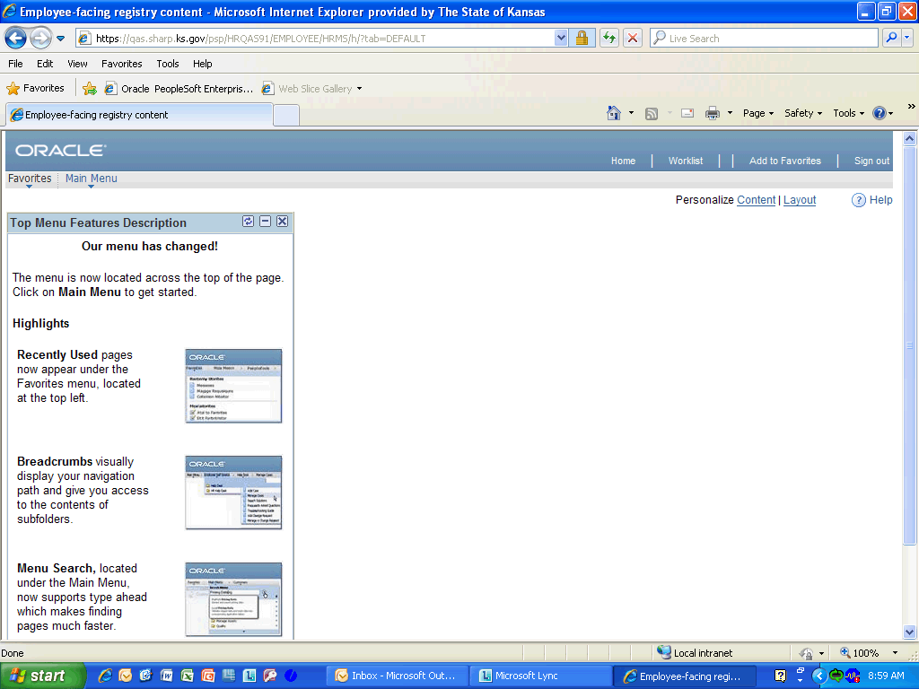

Step | Action
 | Click the Main Menu link.
 | Click the Payroll for North America link.
 | Click the Payroll Processing USA link.
 | Click the Produce Payroll link.

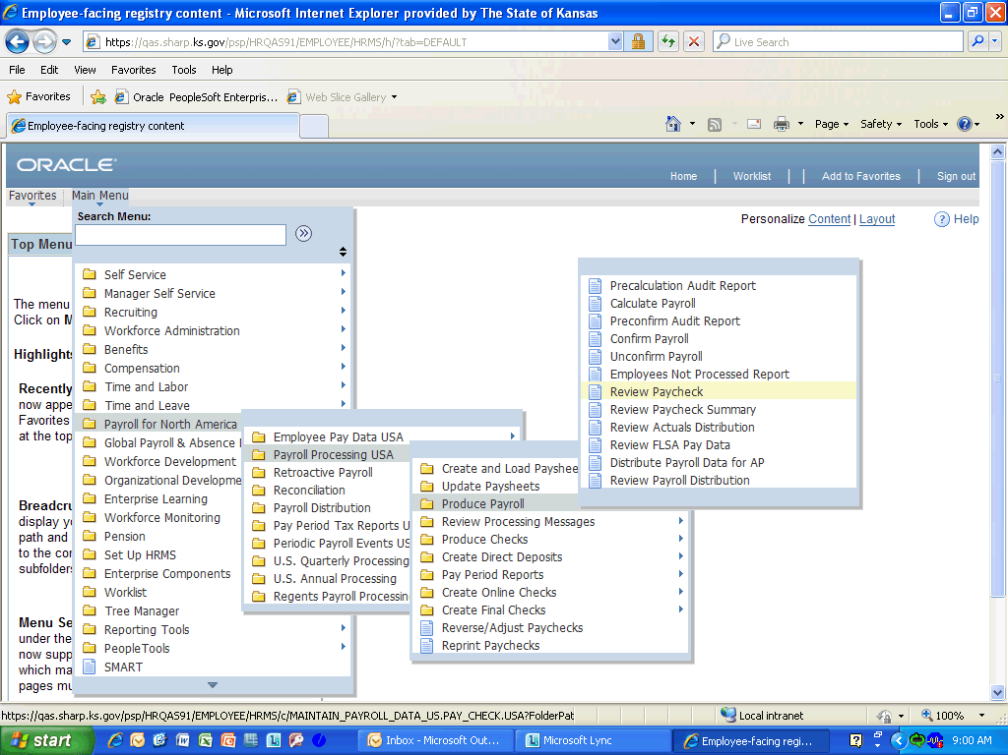

Step | Action
 | Click the Review Paycheck link.

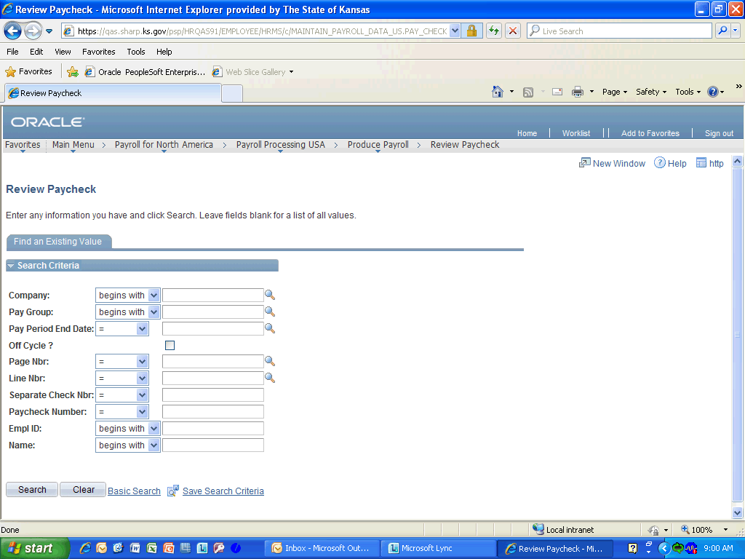

Step | Action
 | Enter the desired information into the Pay Period End Date: field. Enter "09/03/2011".
 | Enter the desired information into the Empl ID: field. Enter "K0000216920".
 | Click the Search (Alt+1) button.
 | Here is where the Issue Date and Paycheck Number can be found for the DA-6P form that needs filled out. After jotting these down, click in either area to move on.

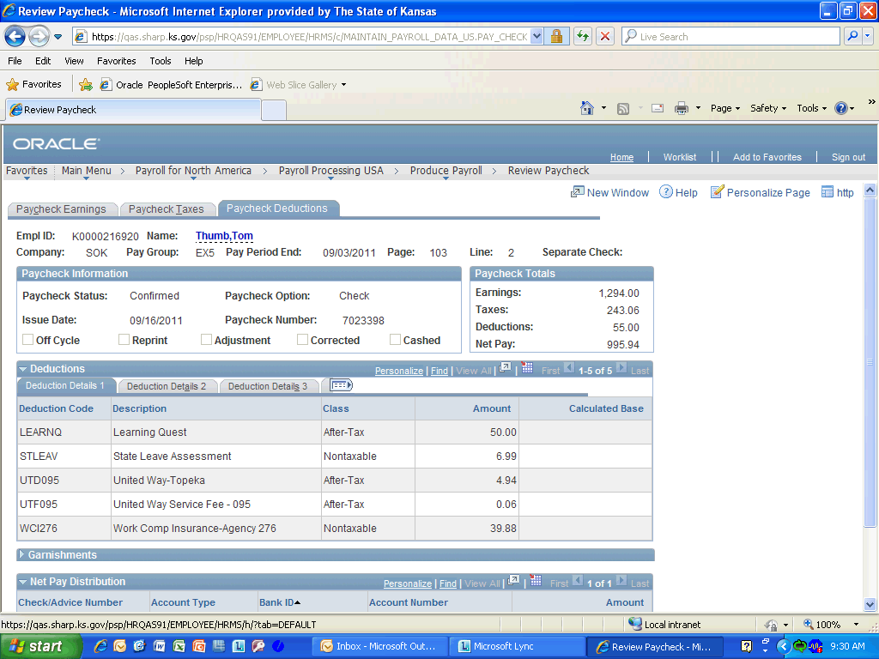

Step | Action
 | Click the Home link.

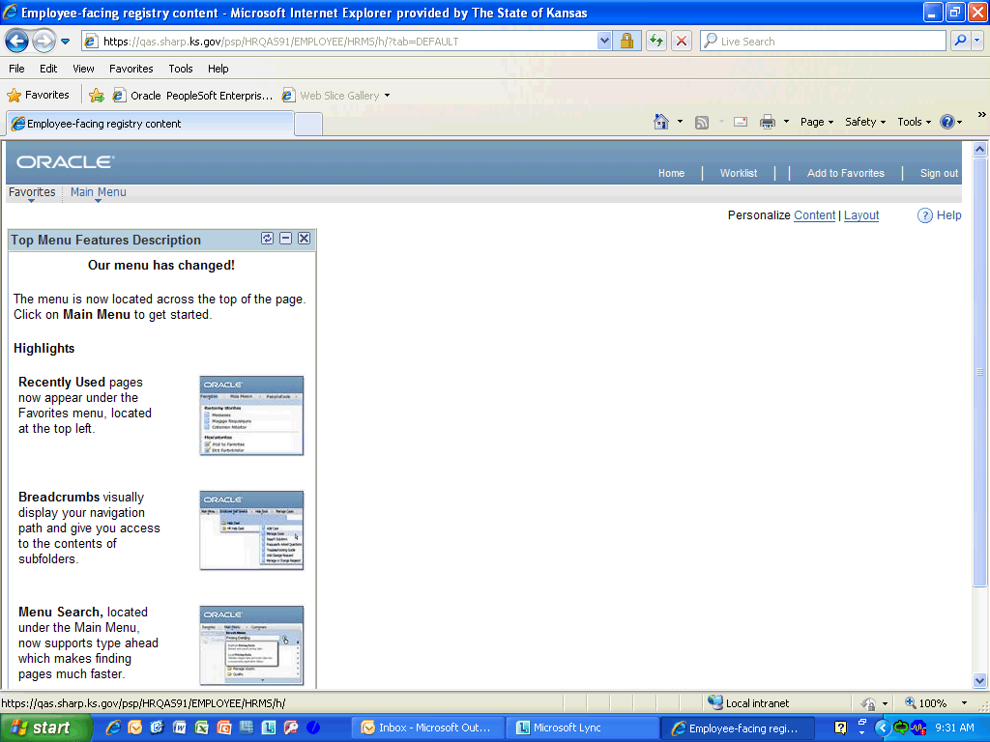

Step | Action
 | Click the Main Menu link.
 | Click the Workforce Administration link.
 | Click the Personal Information link.

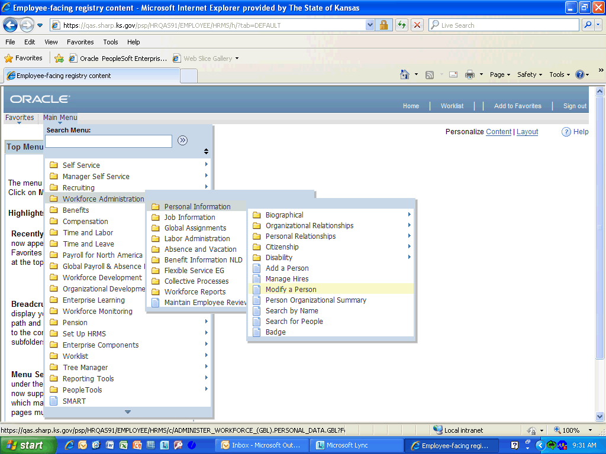

Step | Action
 | Click in the Modify a Person field.
 | Enter the desired information into the Empl ID field. Enter "K0000216920".
 | Click the Search button.
 | Click the Contact Information link.
Jot down the Address for this employee, it will be needed when filling out the DA-6P as well. If a paycheck was lost in the mail due to a CHANGE of ADDRESS, the reprint process CANNOT be used. A DA-180 will need to be processed centrally. Click anywhere on the address to continue.
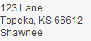
 | Click the Home link.

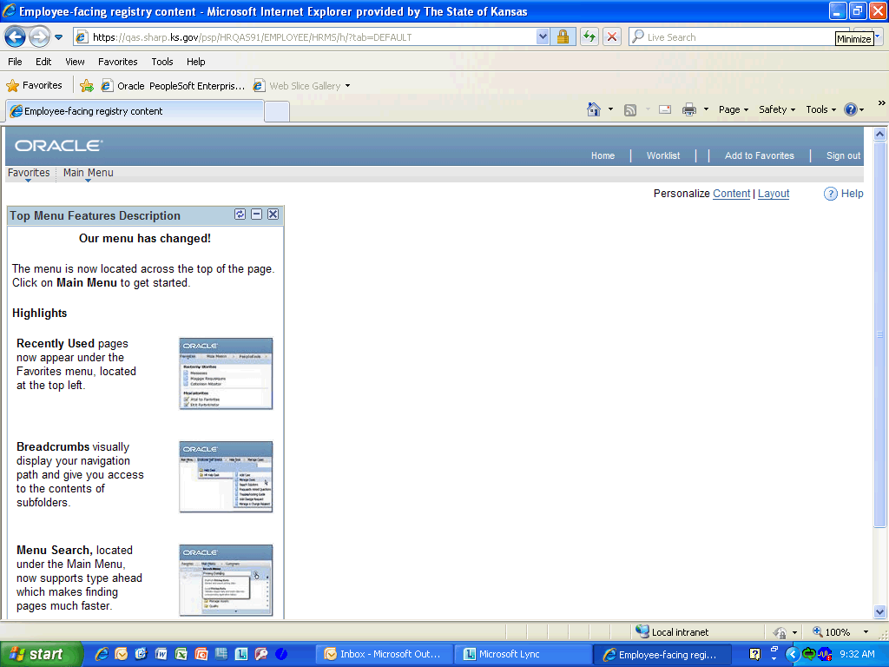

Step | Action
 | Click the Minimize button.

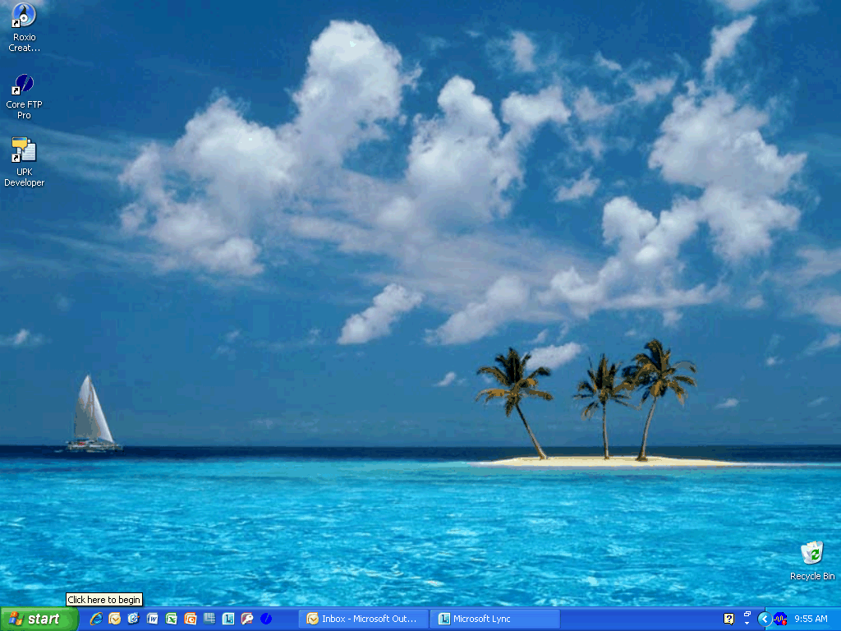

Step | Action
 | Click in the start button.
 | Click in the Internet Explorer link.
 | Enter the desired information into the Web Address field. Enter "http://www.da.ks.gov/sharp/".

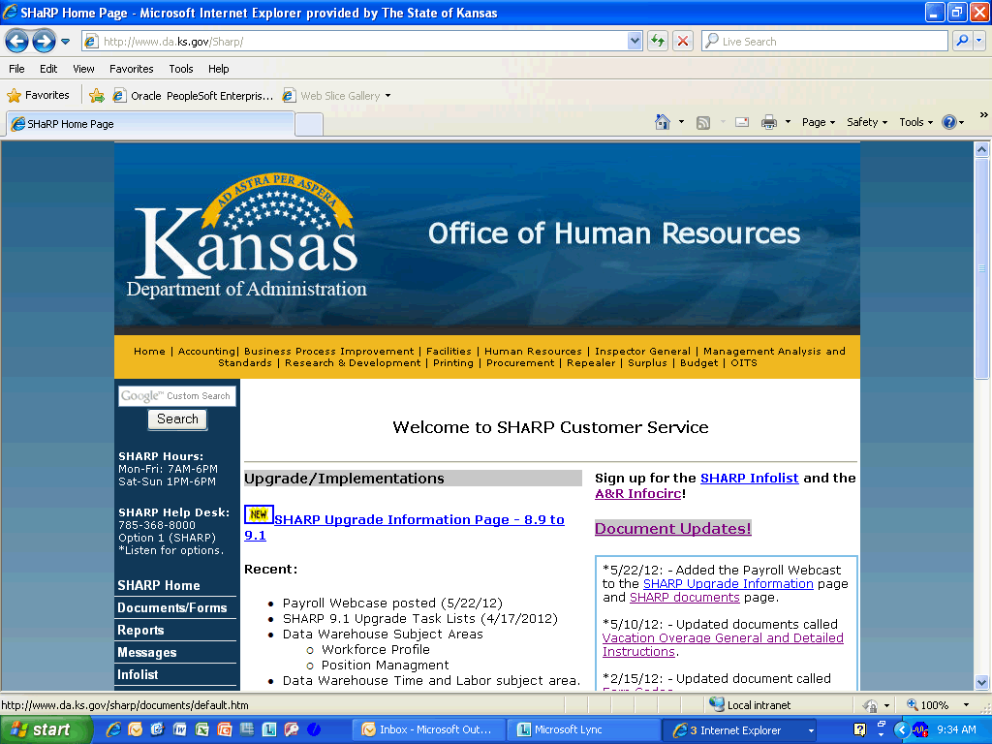

Step | Action
 | Click the SHARP documents link.

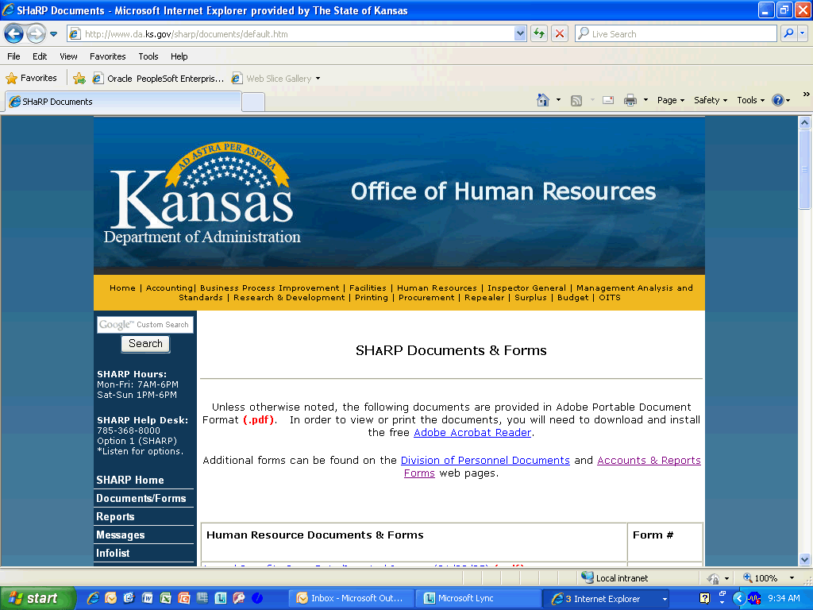

Step | Action
 | Click the Scrollbar and drag it down to the DA-6P form.

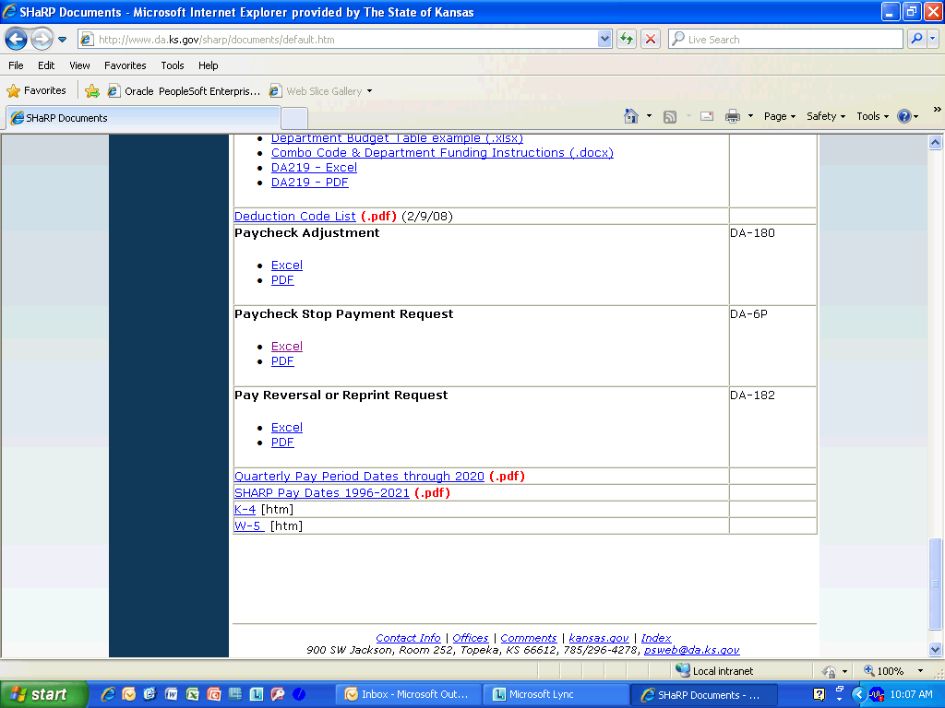

Step | Action
 | Click the DA-6P object.
 | Click the Excel link.

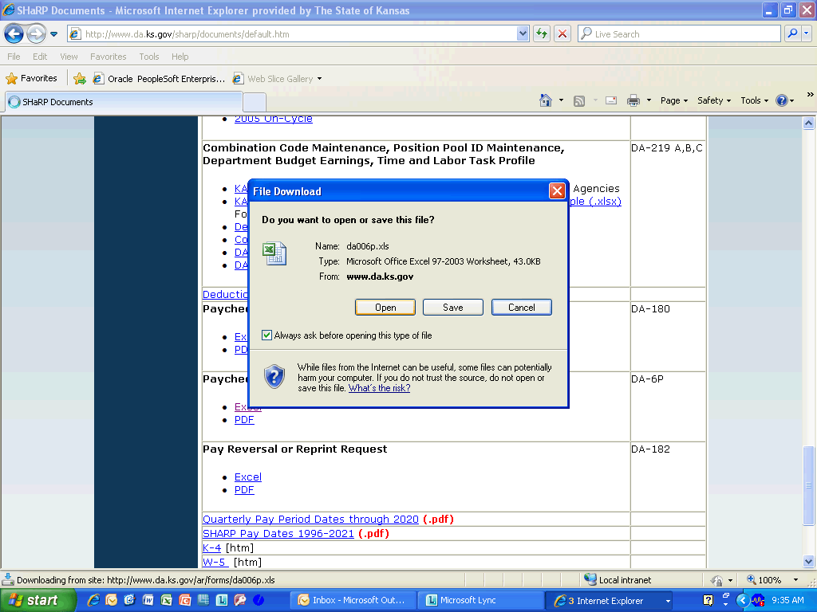

Step | Action
 | Click the Open button.
 | Fill in the top section of the DA006P form and fax it to the State Treasurer's Office at 785-296-2014 for approval to continue with the check reprint. Click in the highlighted section to continue.
 | Here is the DA-6P form filled out to send to the State Treasurer's Office. Click anywhere on the highlighted part of the DA06P form to continue.

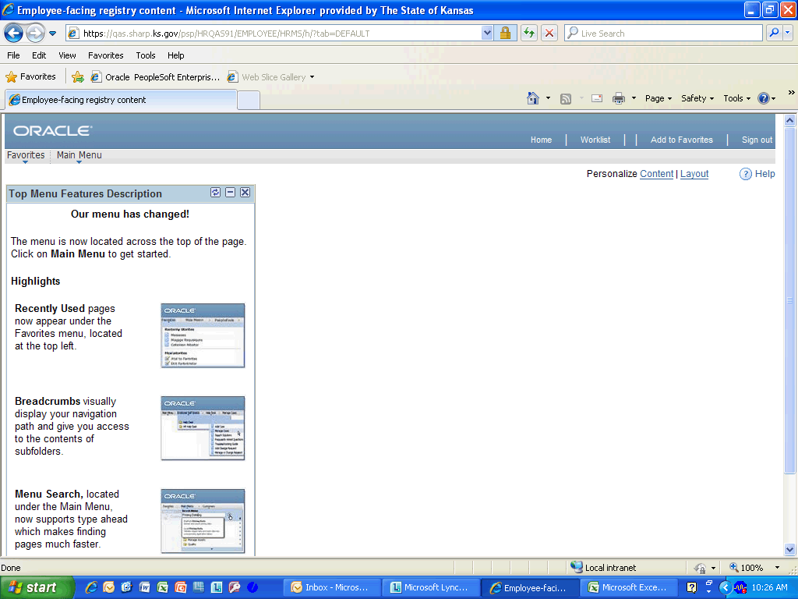

Step | Action
 | Click the Main Menu link.
 | Click the Payroll for North America link.
 | Click the Payroll Processing USA link.
 | Click the Reprint Paychecks link.

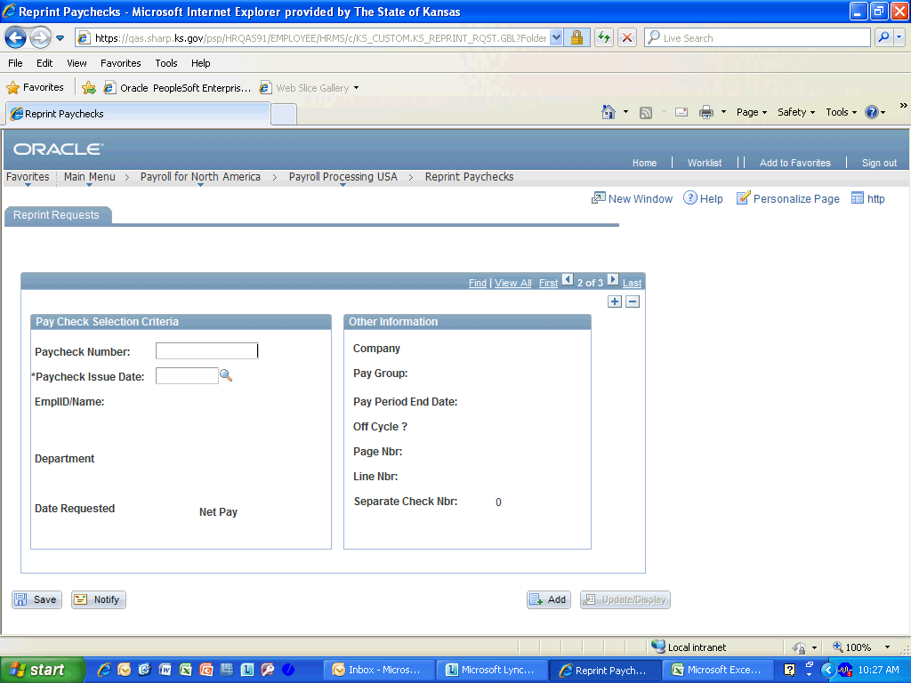

Step | Action
 | Click in the Add a new row at row 2 (Alt 7) button.
 | Enter the desired information into the Paycheck Number field. Enter "7023398".
 | Enter the desired information into the Paycheck Issue Date: Required field. Enter "09/16/2011".
 | Click the Save button.
Congratulations! You have completed Entering a Paycheck Reprint.
End of Procedure.

