Payroll

Entering an Employee's Direct Deposit
Procedure

For this simulation, you will follow the procedure for entering an employee's direct deposit information. The direct deposit will be split with a flat amount going into a checking account and the balance going into a savings account at two different entities.
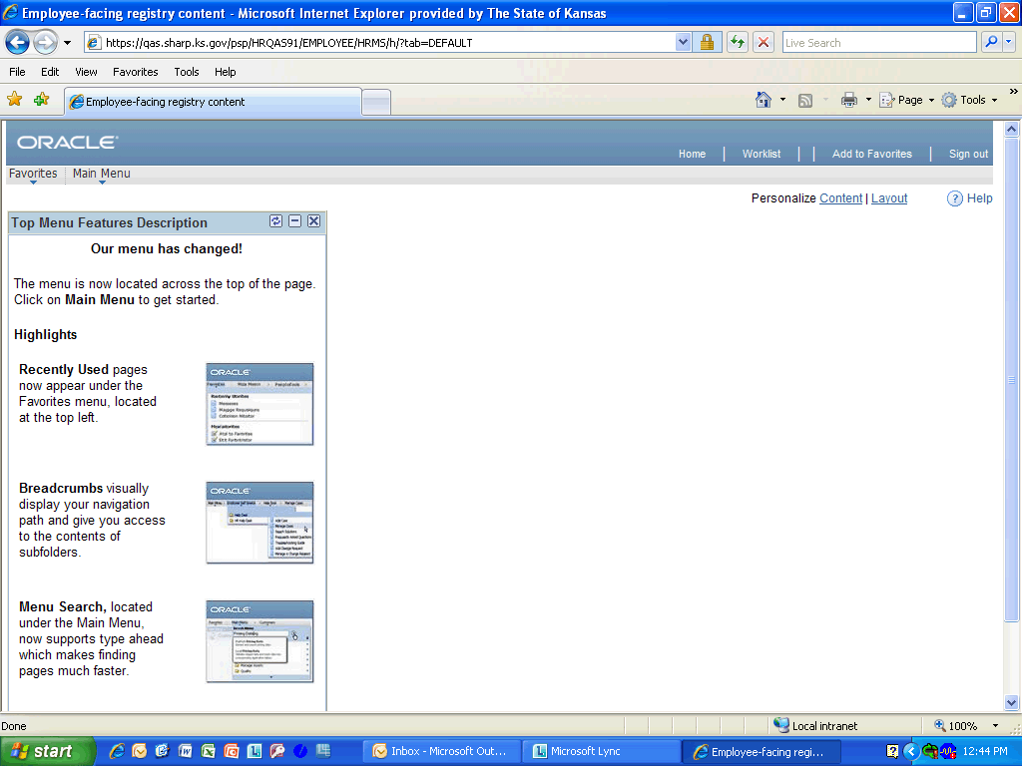

Step | Action
 | Click the Main Menu link.
 | Click the Payroll for North America link.
 | Click the Employee Pay Data USA link.

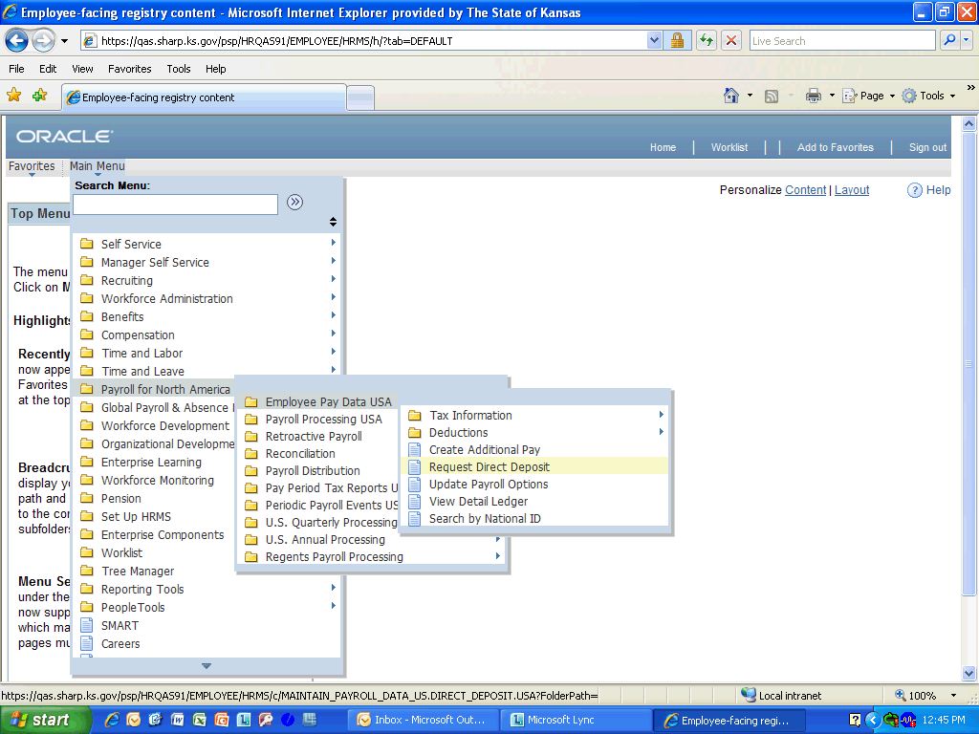

Step | Action
 | Click the Request Direct Deposit link.

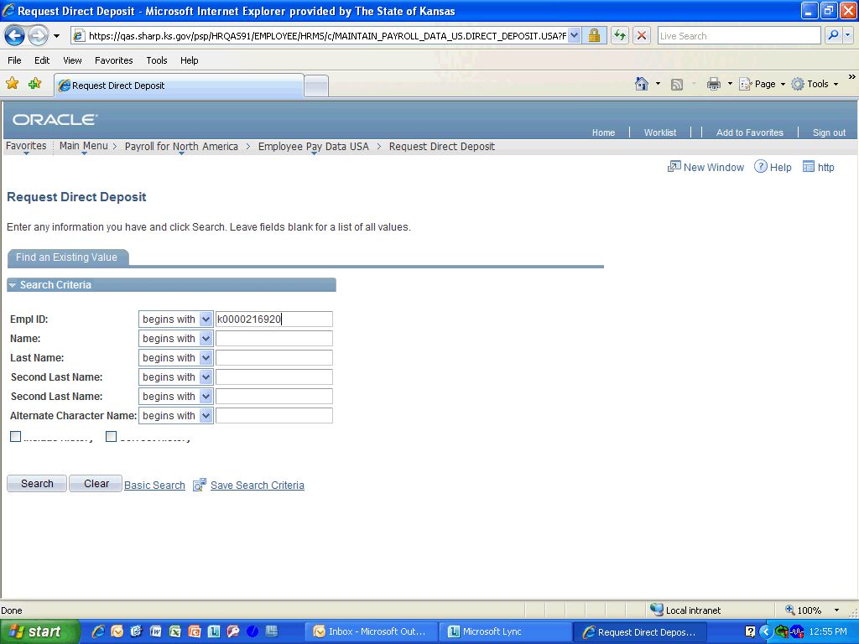

Step | Action
 | Enter the desired information into the Empl ID field. Enter "K0000216920".
 | Click the Search button.
 | Enter the desired information into the Effective Date field. Enter "08/22/2011".
 | Click the Active list.
 | Enter the Bank ID provided on the DA-184 and confirmed from a voided check or deposit slip. Enter "011000138".
 | Verify that the correct banking information has been pulled in. Click anywhere in the BANK OF AMERICA, N.A. selection to continue.
 | Click the Account Type list and select Checking.
 | Click in the Deposit Type field and select Amount.
 | Enter the desired information into the Net Pay Amount field. Enter "800.00".
 | Enter the desired information into the Priority field. Enter "1".
 | Enter the desired information into the Account Number field. Enter "123456789".

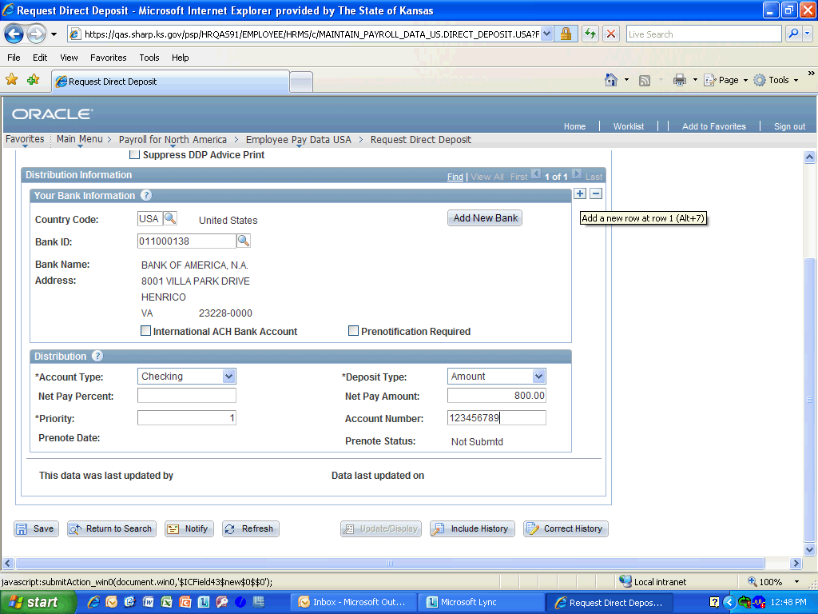

Step | Action
 | Click the Add a new row button.

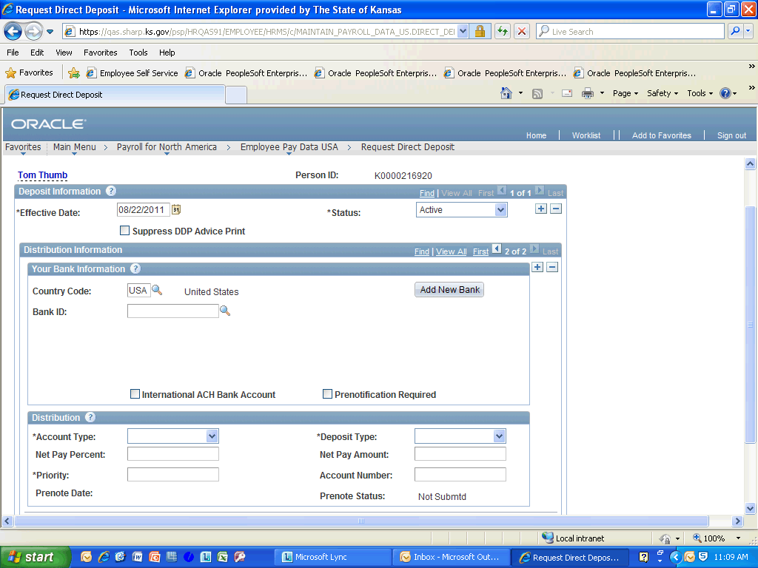

Step | Action
 | Enter the desired information into the Bank ID field. Enter "301179724".
 | Verify that the correct banking information has been pulled in by comparing the Bank Name and Address with the voided check or deposit slip provided with the DA-184. Click anywhere in the Employment Security Employees selection to continue.
 | Click in the Account Type field and select Savings.
 | Click in the Deposit Type field and select Balance.
 | Enter the desired information into the Priority field. Enter "2".
 | Enter the desired information into the Account Number field. Enter "987654321".
 | Click the Save button.
Congratulations! You have completed Entering an Employee's Direct Deposit.
End of Procedure.

