Introduction To SHARP

Navigating Around in SHARP
Procedure

You are about to enter a simulation that shows you the step by step instructions for navigating in SHARP.
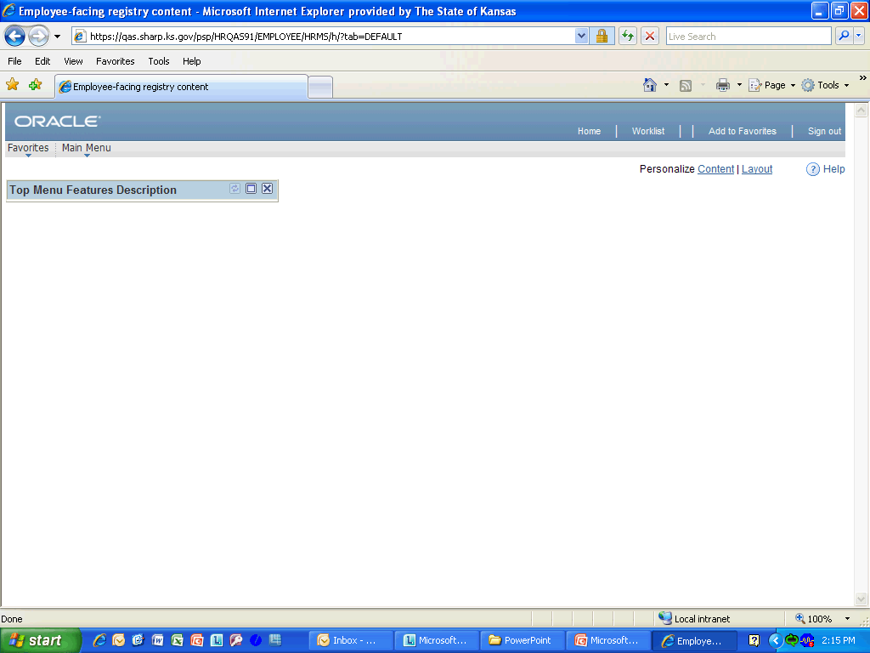

Step | Action
When you first log in you will see the Favorites link and Main Menu link are listed. You will have to click on them for them to display the contents.

Click either selection to continue.

Step | Action
The following links in SHARP are common to every page and can be found in the navigation header:
Favorites, Main Menu, Home, Worklist, Add to Favorites, and Sign Out.

Click anywhere in the selection to continue.

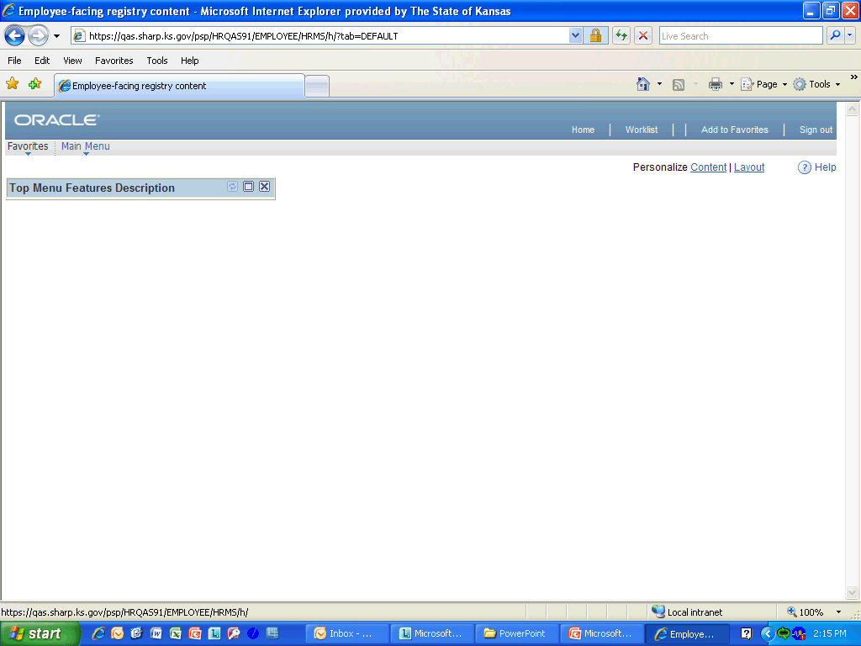

Step | Action
 | Click the Main Menu link.

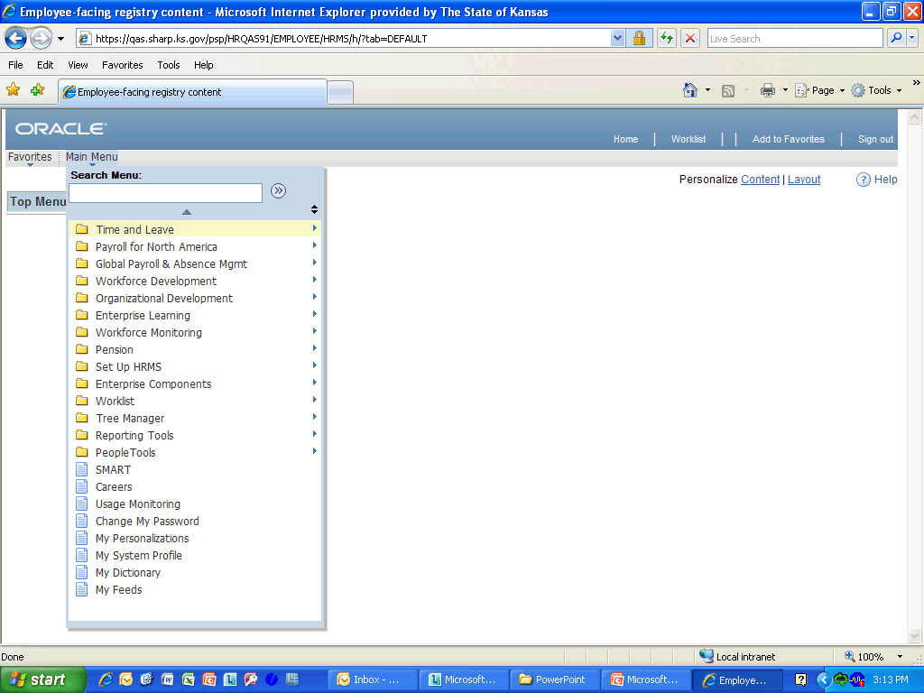

Step | Action
You can sort the menu by clicking the sort icon to toggle between alphabetic ascending, descending, and portal sequence number presentation of folders.

You can also quickly scroll through the menu items by using the up or down arrow at the top and bottom (not shown here) of the menu pane.

Click on either selection to continue.

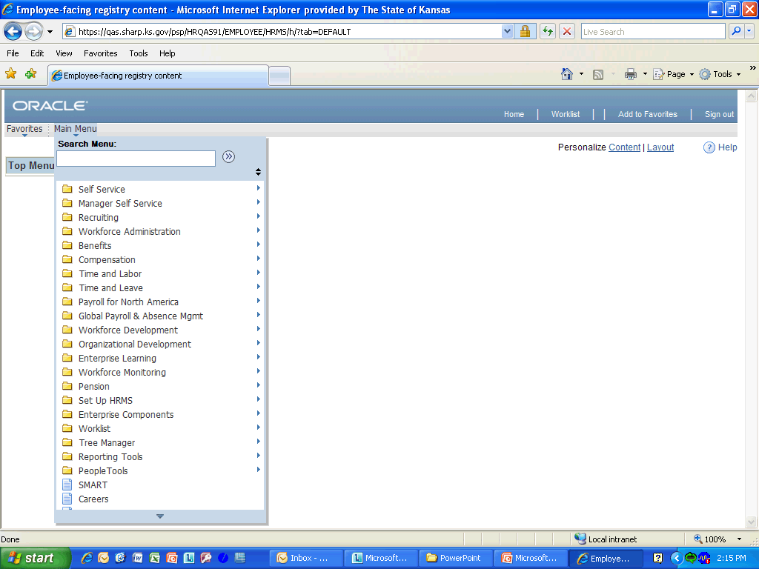

Step | Action
The menu page let will only show the items assigned to your security. By clicking on the menu item, it will take you to any area you wish to access.
Click any where in the selection to continue.
 | Enter into the Search Menu field whatever you are trying to find. For today you will enter "update employ".
The search index will generate matching entries as you type. When you see a match, select the item in the list.
Click anywhere within the selection to continue.

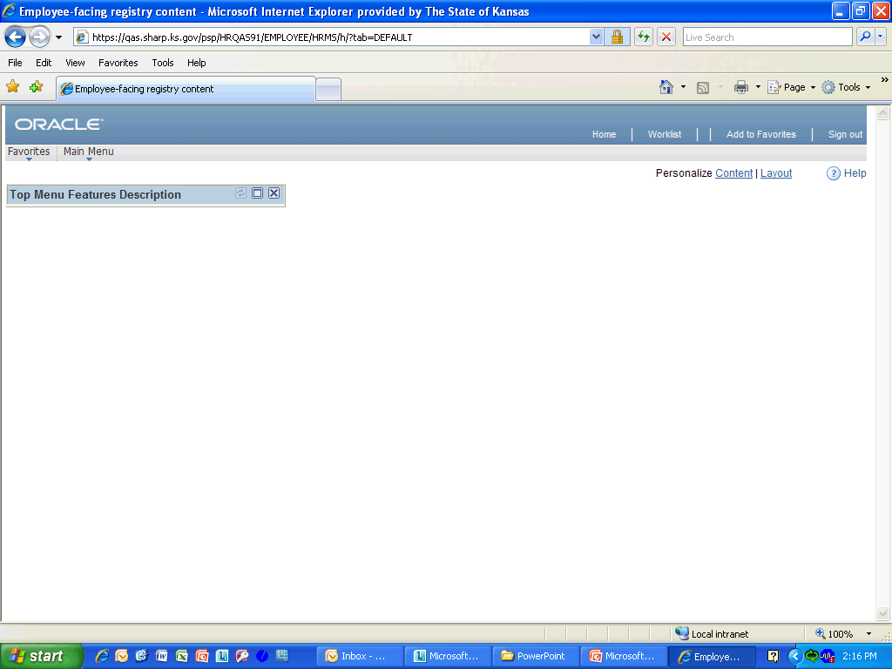

Step | Action
You can add any page to your Favorites list by clicking on the Add to Favorite link when you are at the page.

Click either selection to continue.

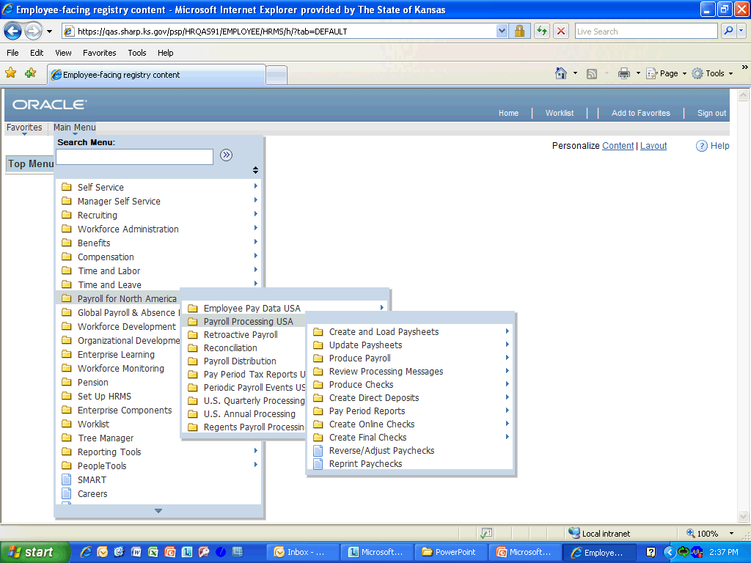

Step | Action
As you select (click) a menu item, the menu cascades to the right, revealing more components that you have access to view.

Click anywhere in the selection to continue.
Congratulations! You have completed Navigating Around in SHARP.
End of Procedure.

