Payroll

Requesting Online Checks
Procedure

For this simulation, you will follow step by step instructions for requesting an online check in the SHARP system. The online check will simulate a scenario where the employee's pay rate changes and he receives a bonus.
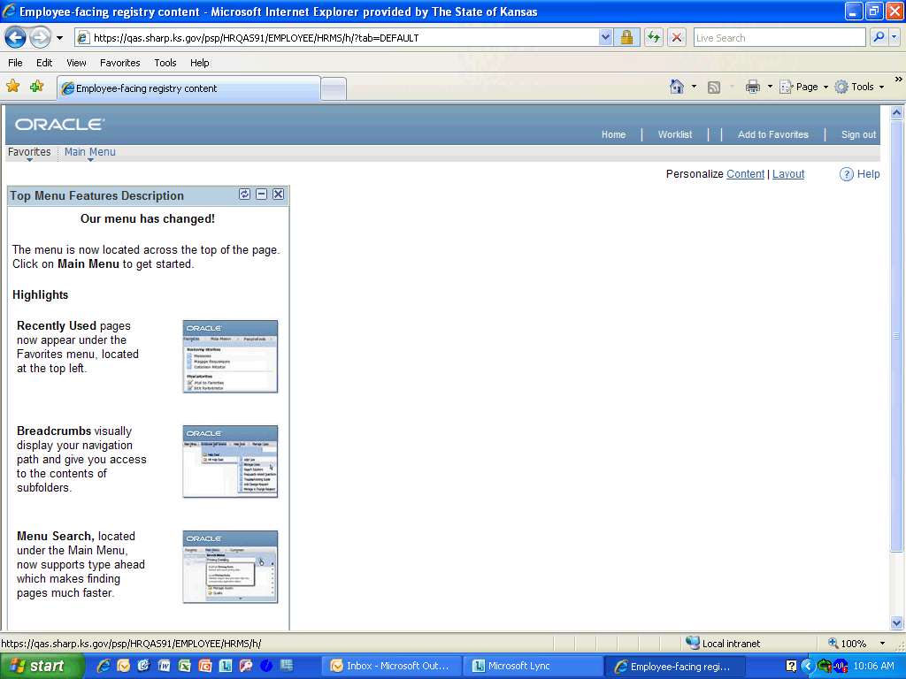

Step | Action
 | Click the Main Menu link.
 | Click the Payroll for North America link.
 | Click the Payroll Processing USA link.
 | Click the Create Online Checks link.

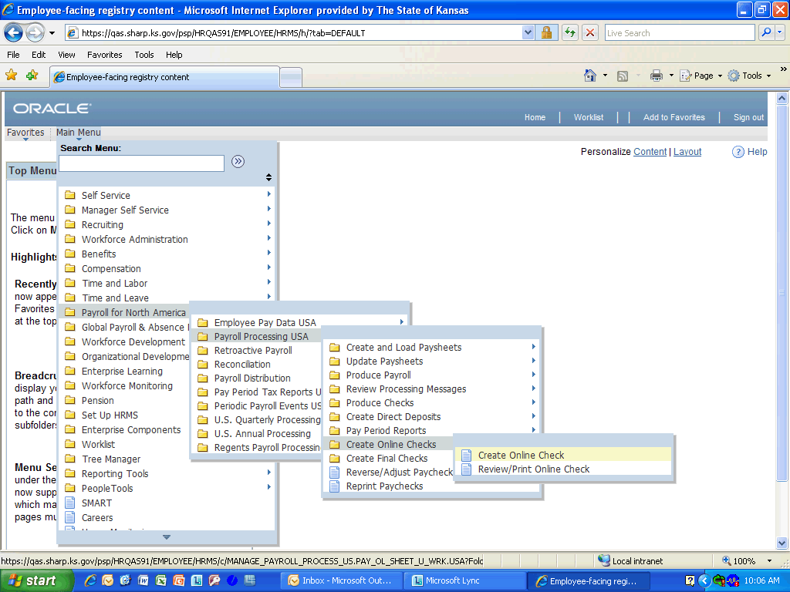

Step | Action
 | Click the Create Online Check link.

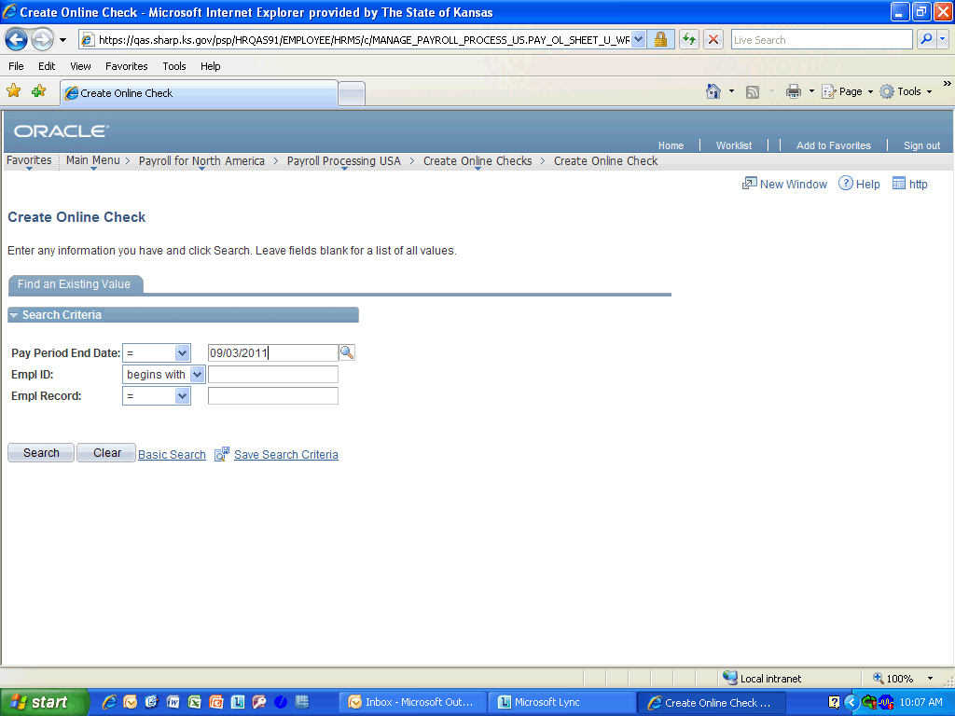

Step | Action
 | Enter the desired information into the Pay Period End Date field. Enter "09/03/2011".
 | Enter the desired information into the Empl ID field. Enter "K0000216920".
 | Click the Search button.
 | Click the Yes button.
 | Click the No button.
 | Click the Override Hourly Rate option.
 | Enter the desired information into the Hourly Rate field. Enter "20.00".
 | Enter the desired information into the Reg Salary field. Enter "1600.00".
 | Enter the desired information into the Code field. Here you will be entering a bonus, so enter "BON".
 | Enter the desired information into the Amount field. Enter "500.00".
 | Click the Add a new row option.
 | The Taxable Group Life earnings will need to be entered when doing an online check because the online check functionality does not calculate imputed income. Enter the earnings code for this into the Code field. Enter "TGL".
 | Enter the desired information into the Amount field. Enter ".94".
 | Click the OK to Pay button.
 | Click the Show next row button.
 | Make sure the OK to Pay option is selected on the second page. Also, notice the Other Earnings section includes the Additional Contractual Pay that was entered in an previous section.
 | Click the Save and Calculate button.
 | Click the Expand section object.
Review the information.
Click the Collapse section button again to remove it from display.

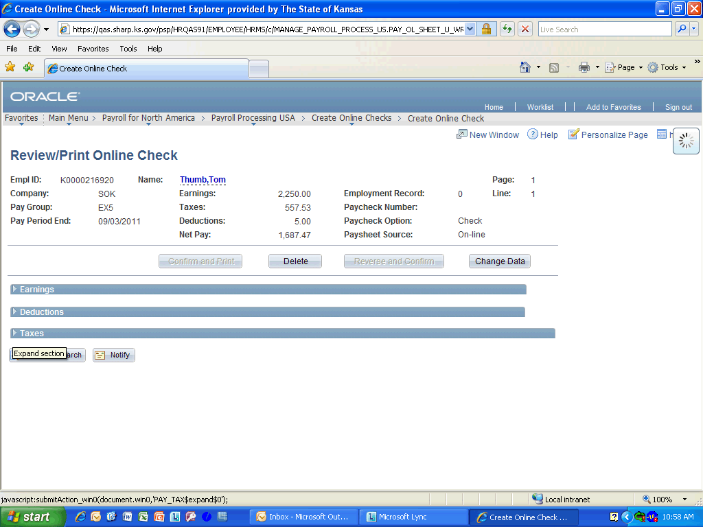

Step | Action
 | Click the Expand Section object.

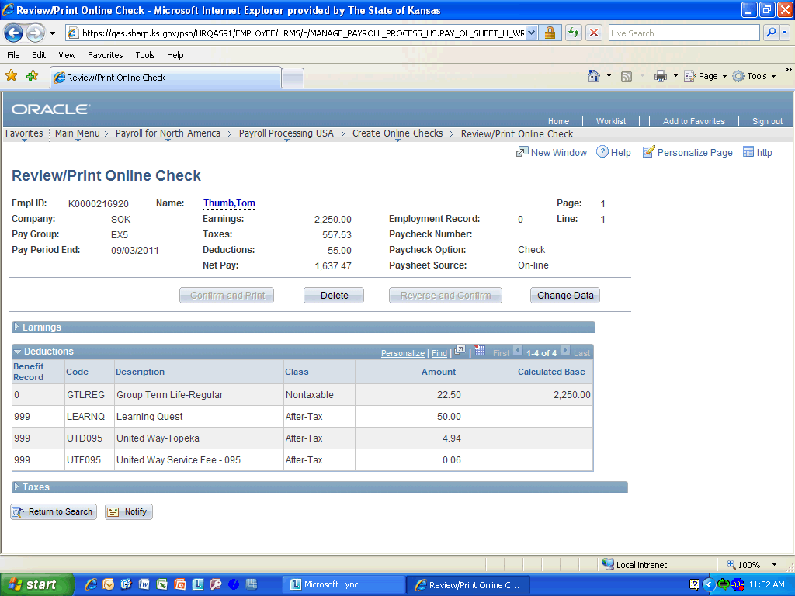

Step | Action
Review the information.
Click the Collapse section button.
 | Click the Expand section button.
 | Click the Collapse section button.

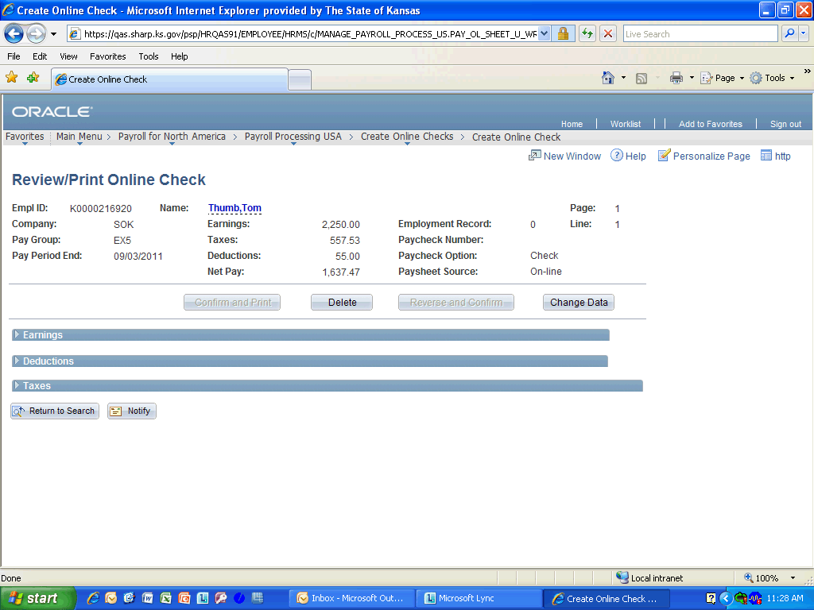

Step | Action
 | Click the Delete button.

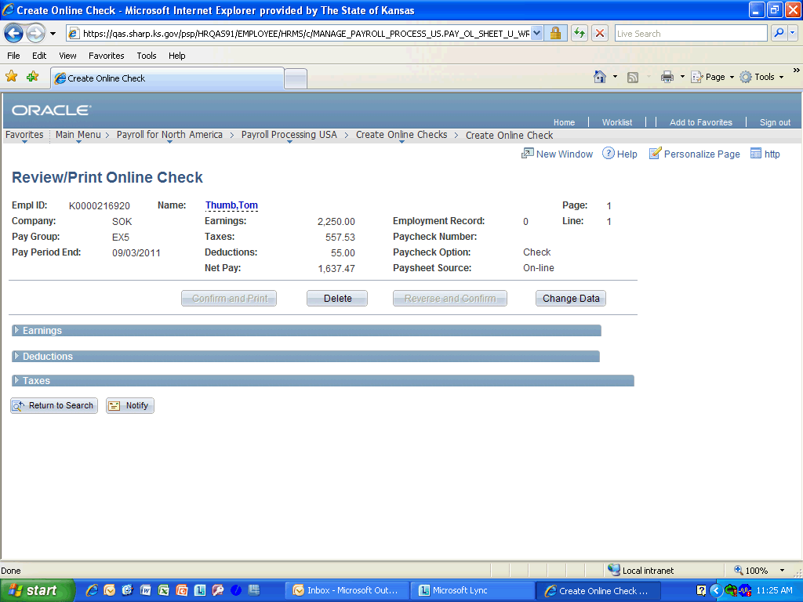

Step | Action
Congratulations! You have successfully completed Requesting Online Checks.
End of Procedure.

