Payroll

Requesting a Paycheck Adjustment
Procedure

You are about to enter a simulation where you will follow the step by step procedure for requesting a paycheck adjustment in the SHARP system. Remember that Agencies can enter online adjustments for only the three types mentioned in this CBT. The details for the specific adjustments are detailed in this CBT with references to related guides and other CBT with more specific information related to these adjustments. This simulation only shows the actual adjustment request that is common to all three.
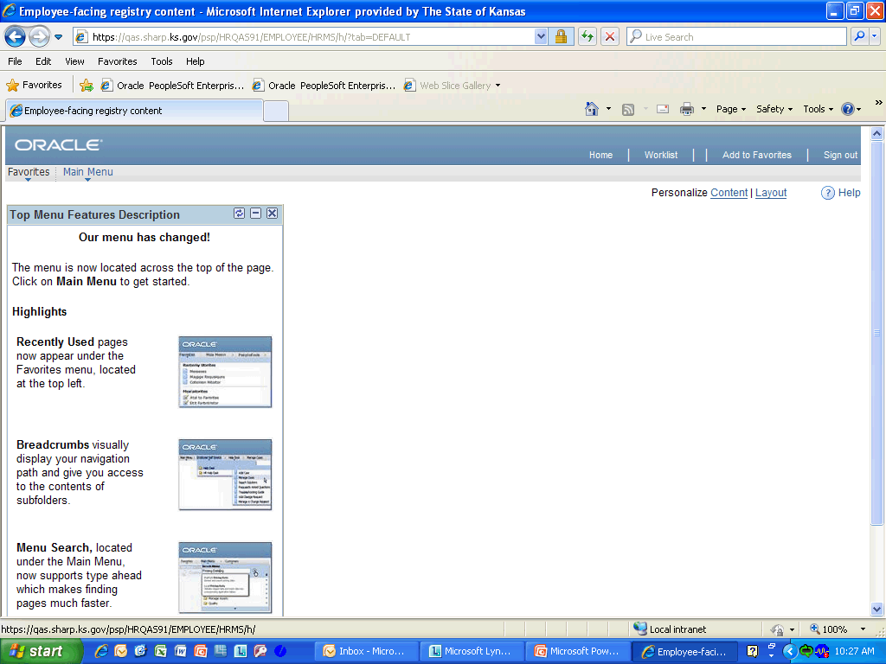

Step | Action
 | Click the Main Menu link.
 | Click the Payroll for North America link.
 | Click the Payroll Processing USA link.
 | Click the Reverse/Adjust Paychecks link.
 | Click the Add a New Value link.

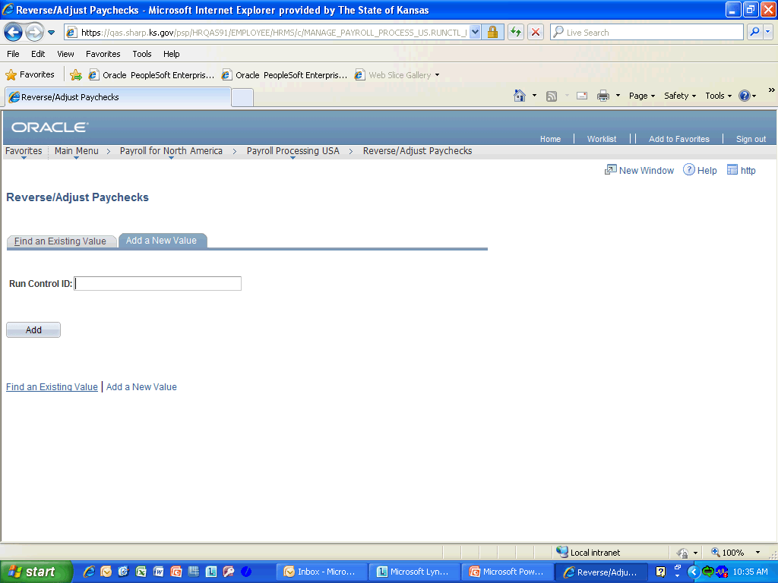

Step | Action
 | Enter the desired information into the Run Control ID field. Enter "ADJ-ALL".

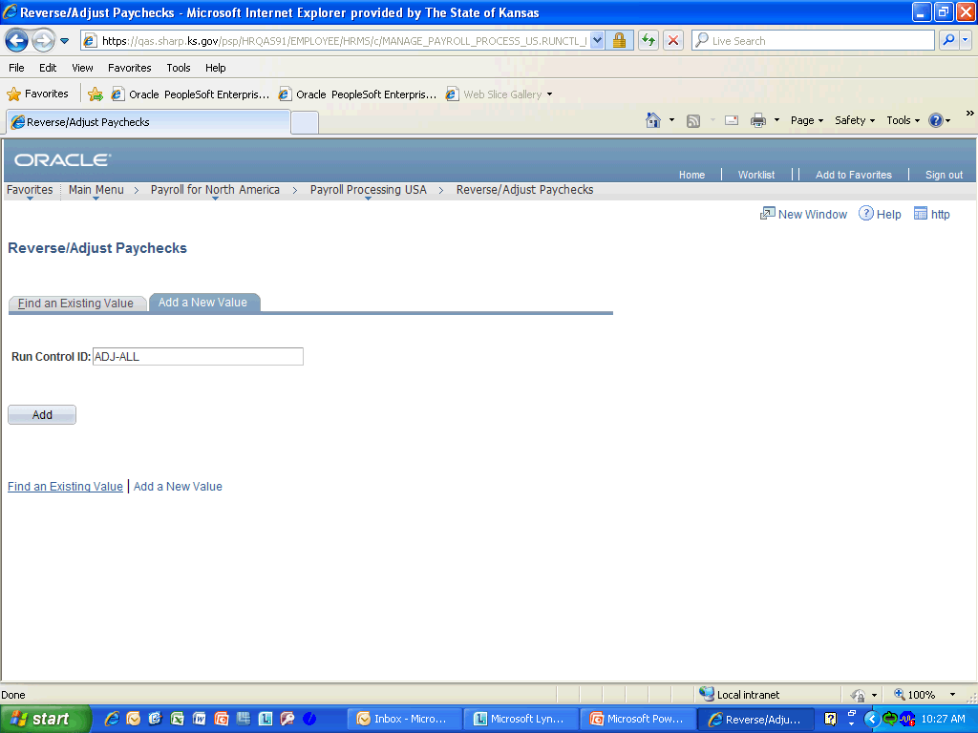

Step | Action
 | Click the Add (Alt+1) button.

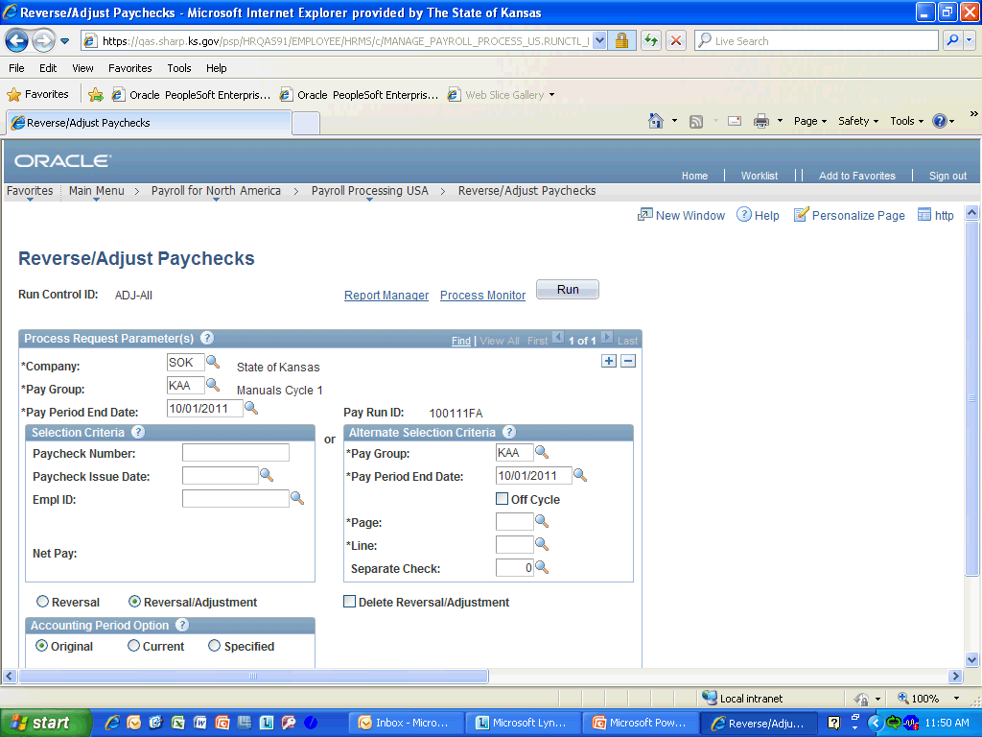

Step | Action
 | Company, Pay Group, and Pay Period End Date related to the next off-cycle will default in. However, the first time you set-up the Run Control ID for Reverse/Adjusting Paychecks, you will have to enter the information for the next off-cycle check. Click anywhere in the Process Request Parameter(s) area to continue.

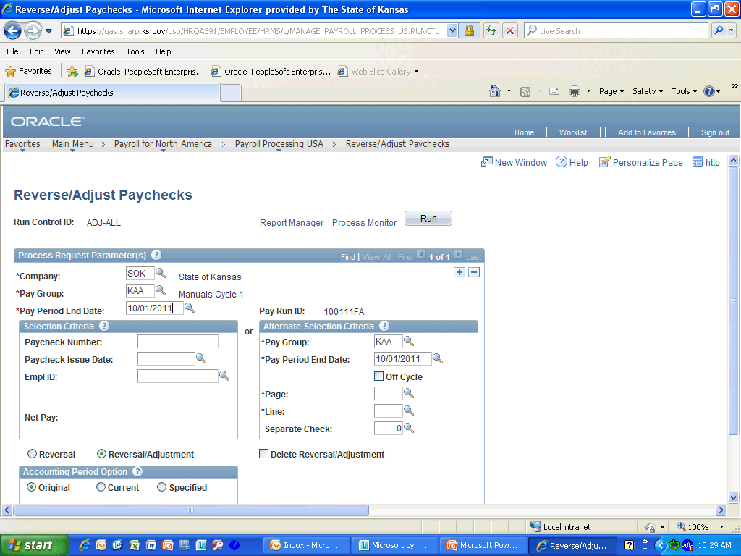

Step | Action
 | Enter the desired information into the Paycheck Number: field. Enter "7023431".
 | Enter the desired information into the Paycheck Issue Date: field. Enter "09/30/2011".

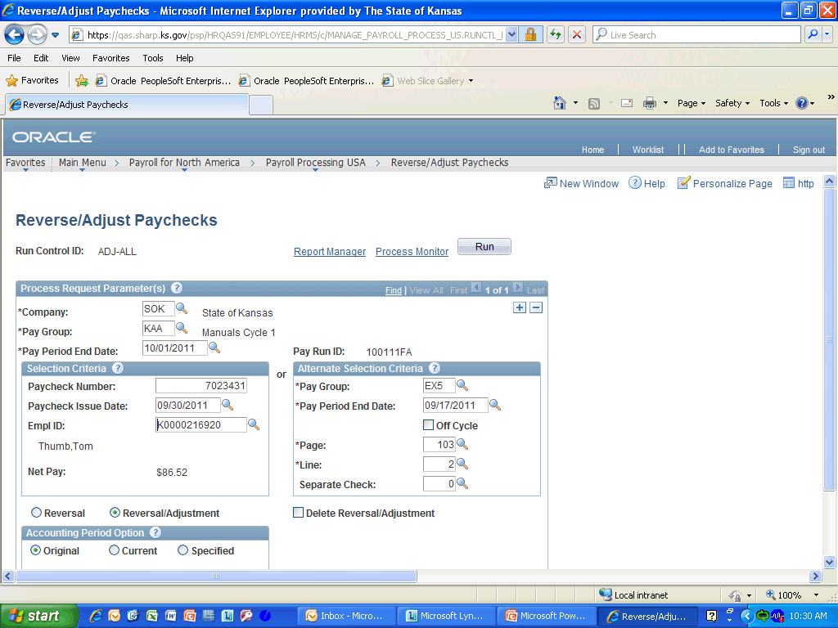

Step | Action
 | After the Paycheck Number and Paycheck Issue Date (of the paycheck to be adjusted) is entered in there fields, then when you tab out of the Paycheck Issue Date field, the paycheck details (Empl ID, Net Pay, Pay Group, Pay Period End Date, etc.) will populate. Verify the information is correct. Click anywhere in the Selection Criteria or Alternative Selection Criteria to continue.

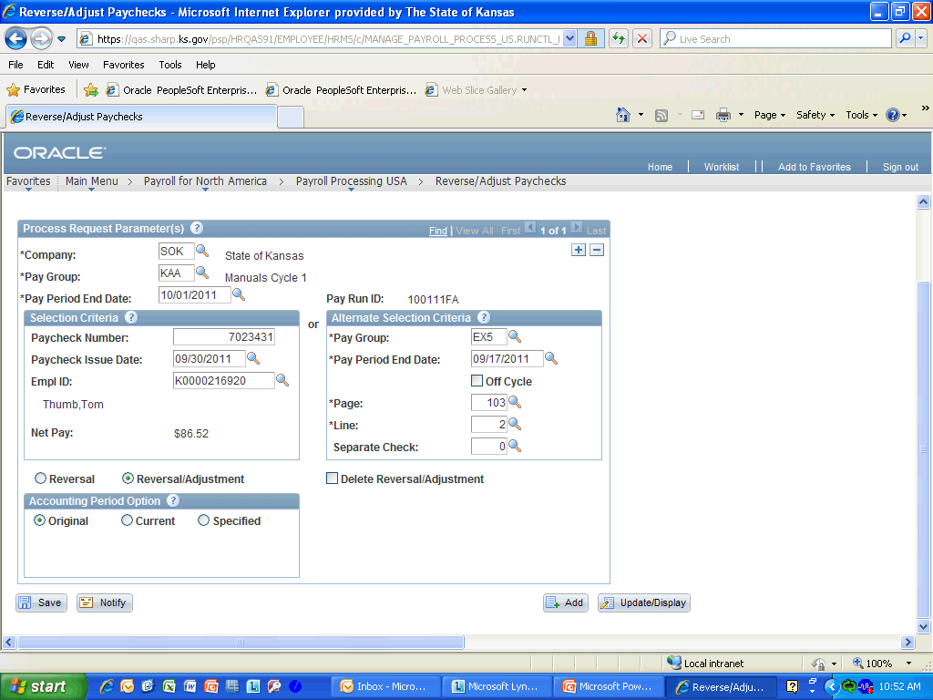

Step | Action
 | Make sure the Reversal/Adjustment radio button is selected for adjustments. Click anywhere in the Reversal/Adjustment object to continue.
 | If you have multiple rows of data, click the Add Row button for each additional row, then repeat the steps. You can wait until all rows have been entered or save after each one. Click the Save button.
Congratulations you have completed Requesting a Paycheck Adjustment in SHARP.
End of Procedure.

