Payroll

Requesting a Supplemental
Procedure

You are about to enter a simulation that takes you through the steps of processing a supplemental.
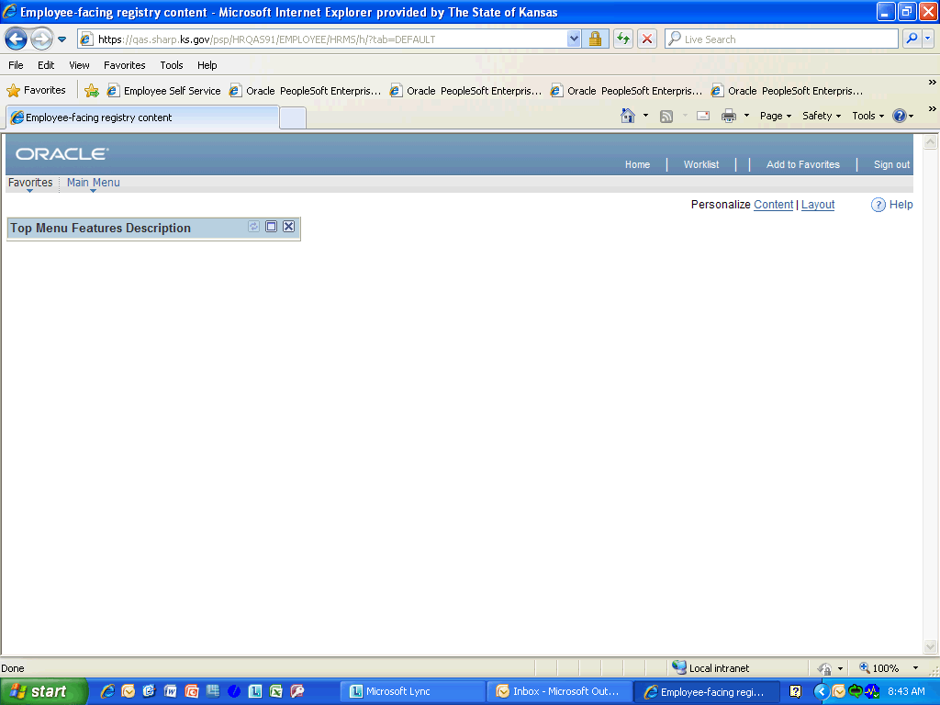

Step | Action
 | Click the Main Menu link.
 | Click the Manager Self Service link.
 | Click the Time Management link.
 | Click the Report Time link.
 | Click the Timesheet link.

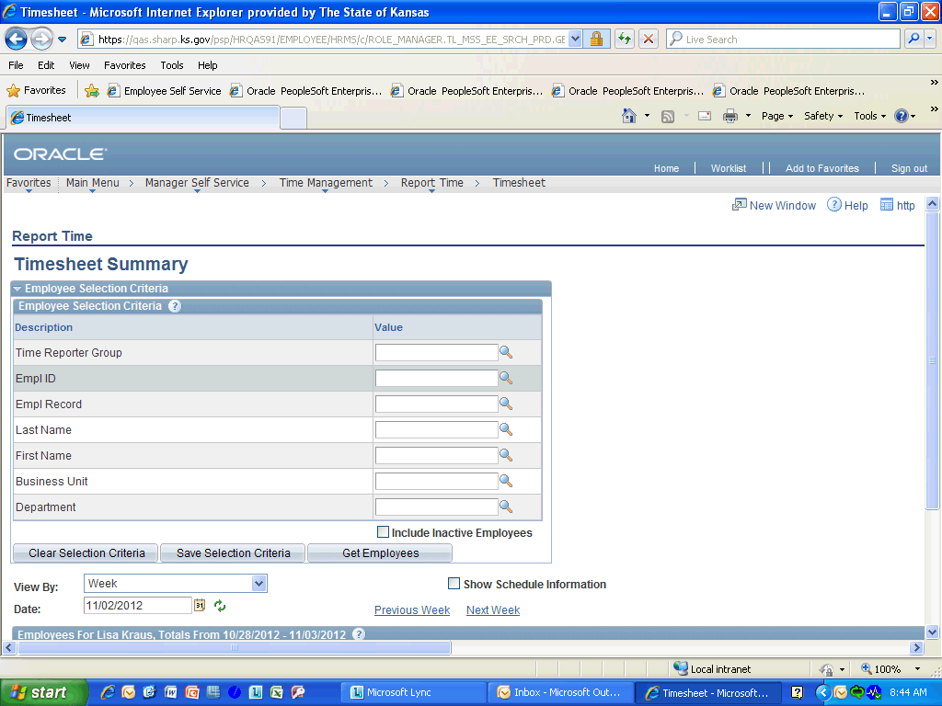

Step | Action
 | Enter the desired information into the Empl ID field. Enter "K0000216920".
 | Enter the desired information into the Date field. Enter "10/29/2011".
 | Click the Refresh Date button.

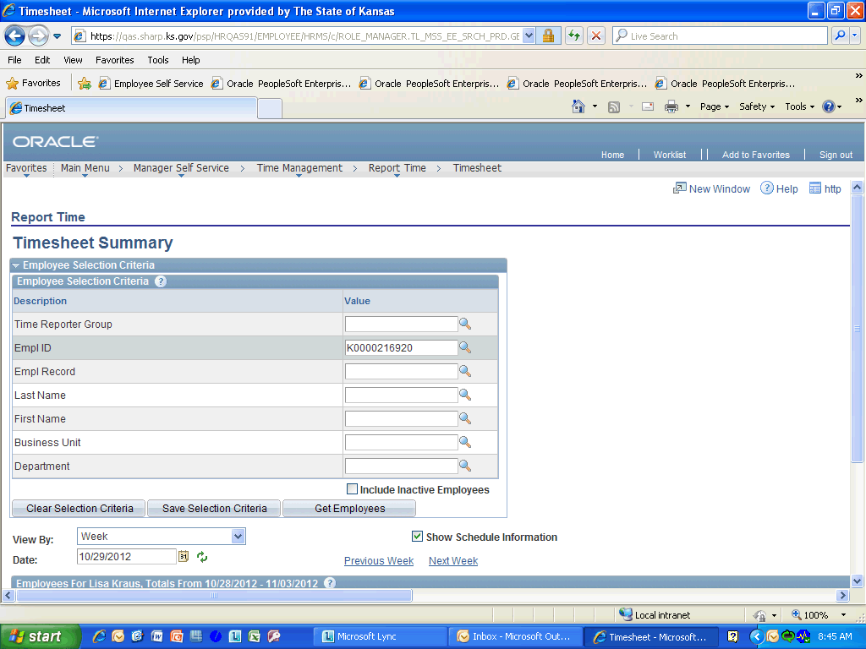

Step | Action
 | Click the Get Employees button.
 | Click the Tom Thumb link.
 | This is where the hours that need to be paid are entered. Click in the Selection to continue.

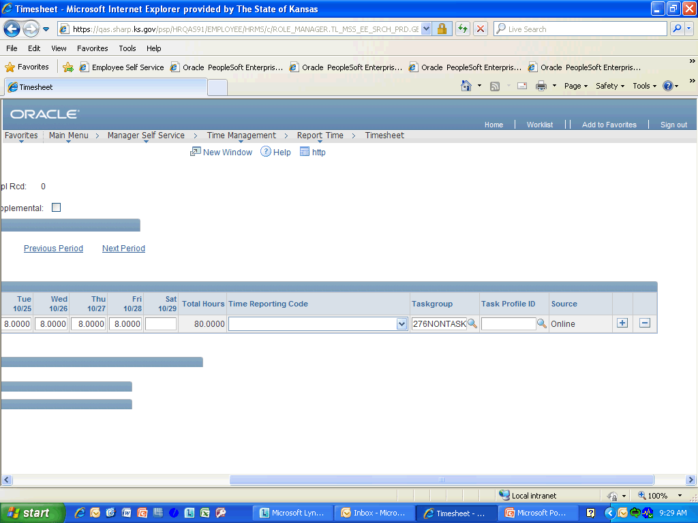

Step | Action
 | Click the Time Reporting Code look-up list.

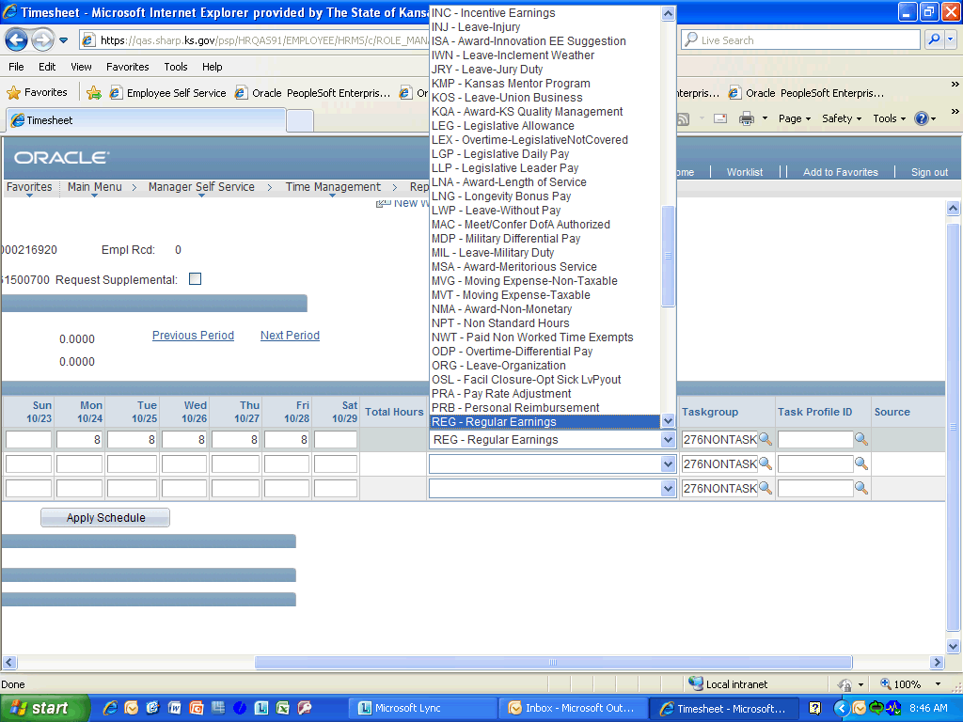

Step | Action
 | Select the type of hours you entered from the list. Click REG-Regular Earnings in the list to continue.
 | Select a Task Profile ID from the look-up list.

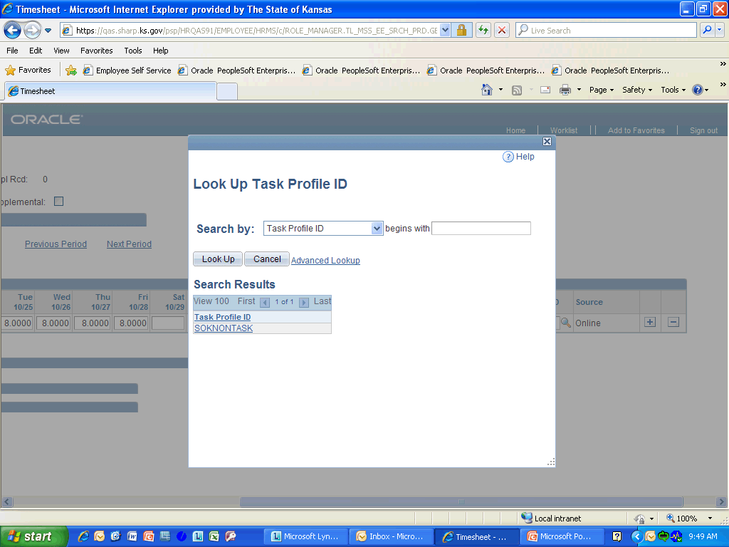

Step | Action
 | Click the SOKNONTASK link.

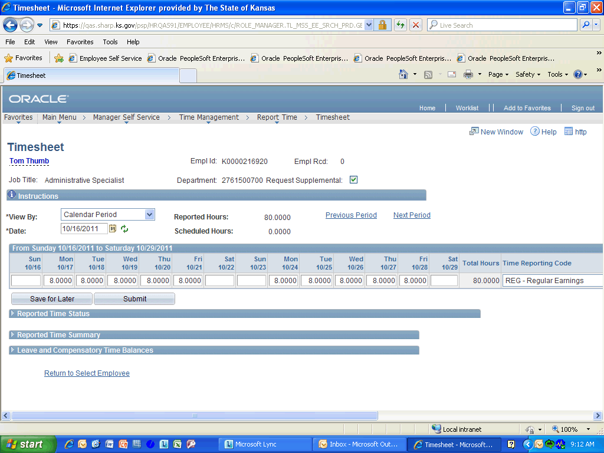

Step | Action
 | Click the Request Supplemental option.

Step | Action
 | Click the Submit button.
 | Click to expand the Reported Time Status titlebar.

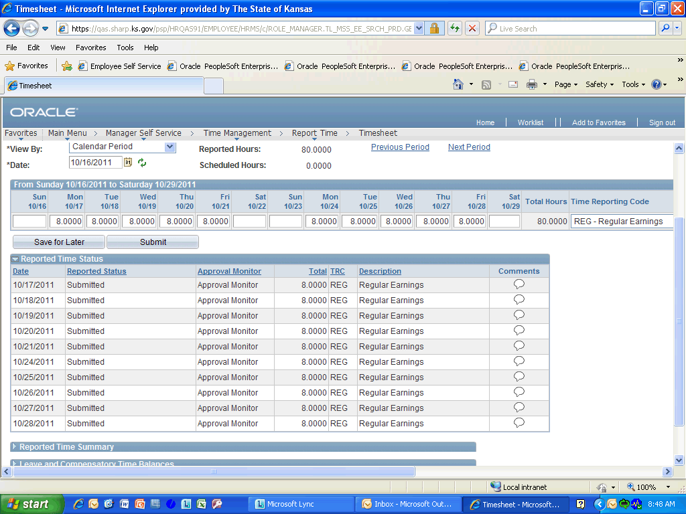

Step | Action
 | Depending on how approvals were set-up in your agency, there will be a Select column next to the Date column. If a Select column is present, all records will need to be selected and Approved for the Supplemental process to work. However, some agency have chosen for the approval to default in, making this step unnecessary. Click anywhere in the selection to continue.
Congratulations! You have completed Requesting a Supplemental.
End of Procedure.

