Reporting

Requesting an Agency Run Report
Procedure

For this simulation, you are asked to request an agency run report, the on-cycle PAY005, Cost Center report for the pay period ended 06/11/2011.
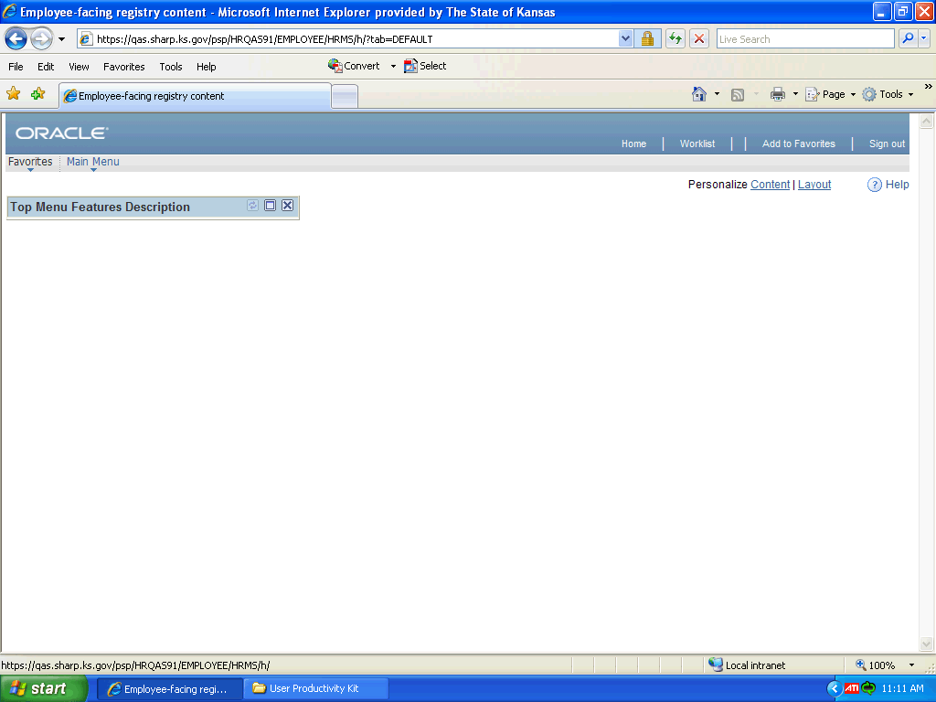

Step | Action
 | Click the Main Menu link.

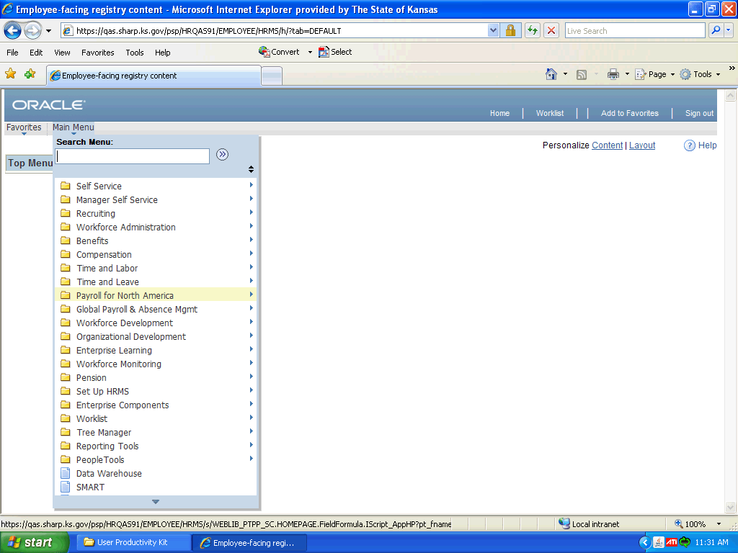

Step | Action
 | Click the Payroll for North America link.

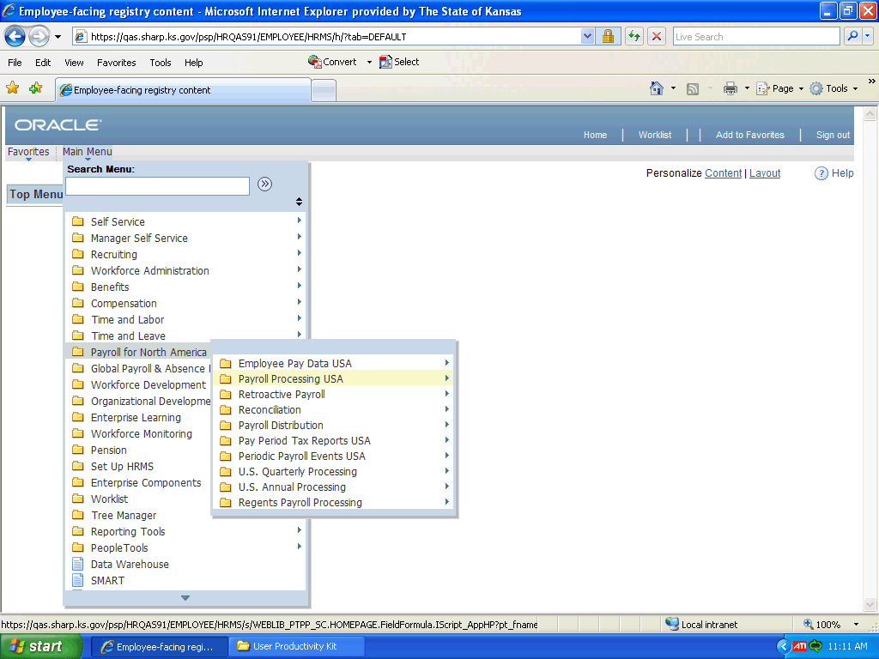

Step | Action
 | Click the Payroll Processing USA link.
 | Click the Pay Period Reports link.
 | Click the Cost Center link.

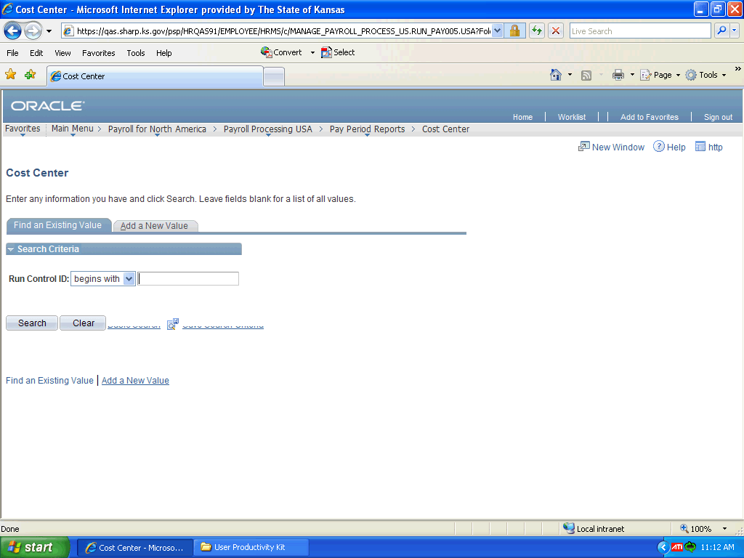

Step | Action
If you already have a run control ID set up for the report, you can click the Search button to find a listing of existing ID's to select from. To request the report for the first time, you will have to click the Add a New Value tab to add the Control ID.

Click the Add a New Value tab.
 | Click in the Run Control ID field.
The Run Control ID field is limited to 30 characters.

For this simulation, enter "Cost_Center".
 | Click the Add button.
The Pay Run ID is named by pay period end date in the MMDDYYCN format, where
C will be replaced by "O" for an on-cycle and "F" for an off-cycle payroll. N is the cycle number/ID, such as A, B, or C.

Click the Look Up button by the Pay Run ID field.

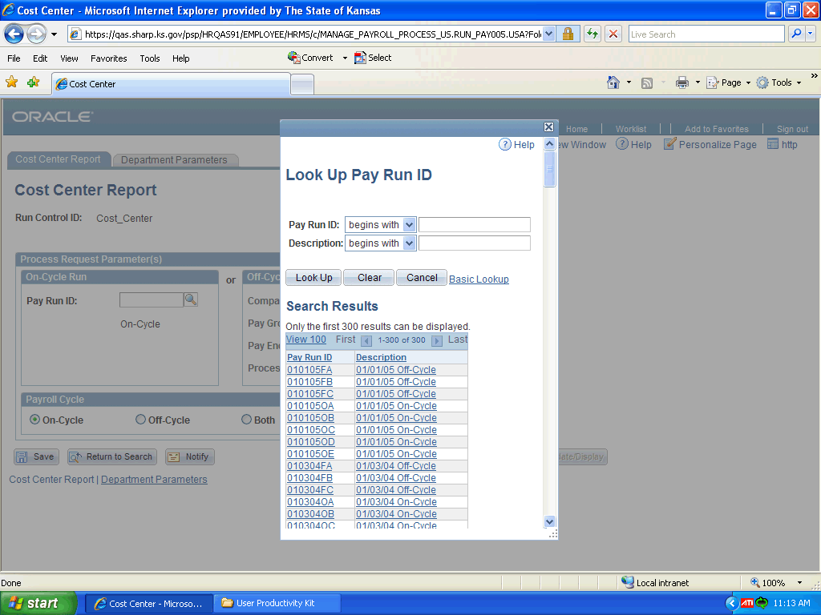

Step | Action
You can narrow down the Search Results by entering the month and date in the Pay Run ID field, then clicking the Look Up button.

Click in the Pay Run ID field.

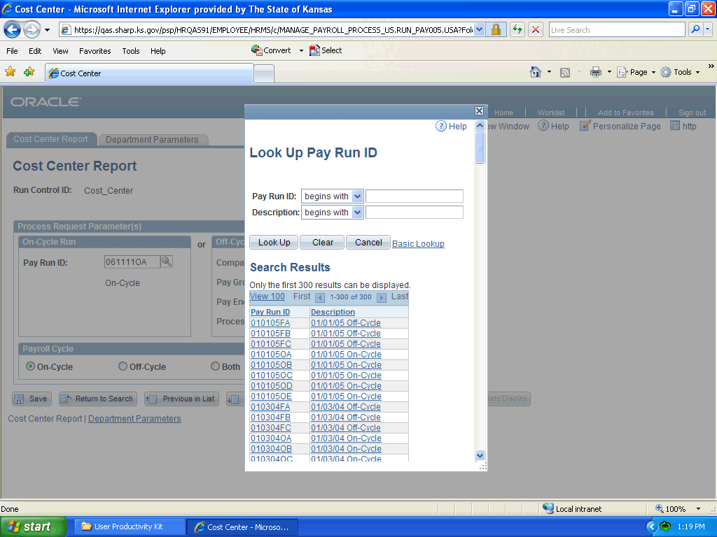

Step | Action
Enter the month and date (in MMDD format) into the Pay Run ID field.

For this simulation, enter "0611".
 | Click the Look Up button.
 | There is only one on-cycle payroll for each pay period. Click the 061111OA link.
 | If you want to save the Process Request Parameters for later use, you would click the Save button to save it. This step is optional.

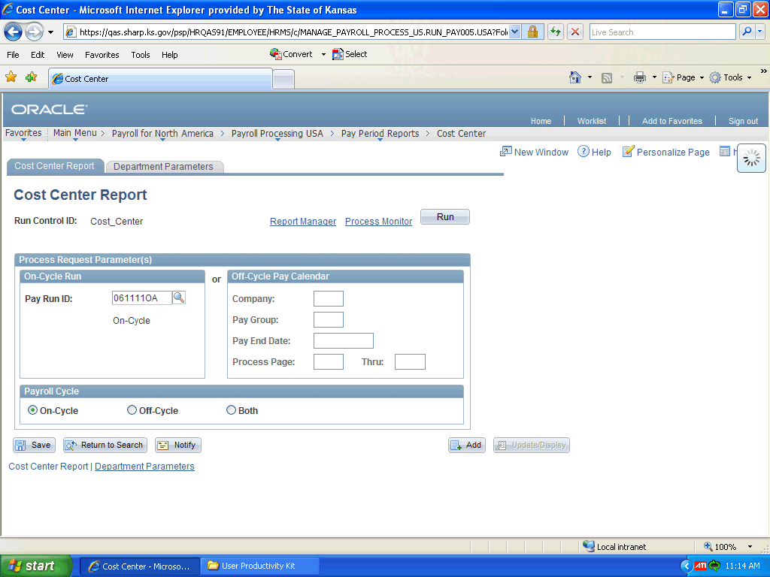

Step | Action
 | Click the Run button.
 | Your report should be selected on the Process Scheduler Request page. If your report Process Type is SQR Report, make sure the Server Name is PSUNX. Usually, Type should be Web and Format should be PDF.

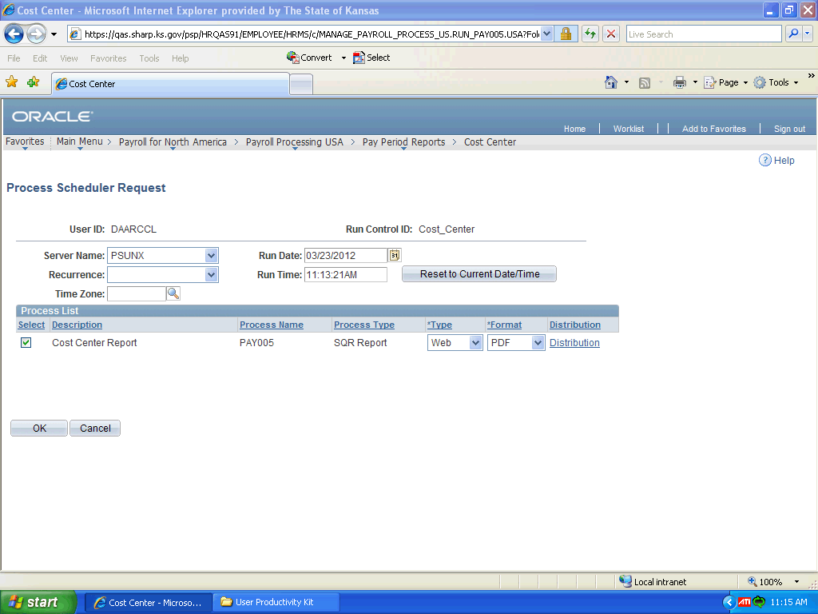

Step | Action
 | Click the OK button.

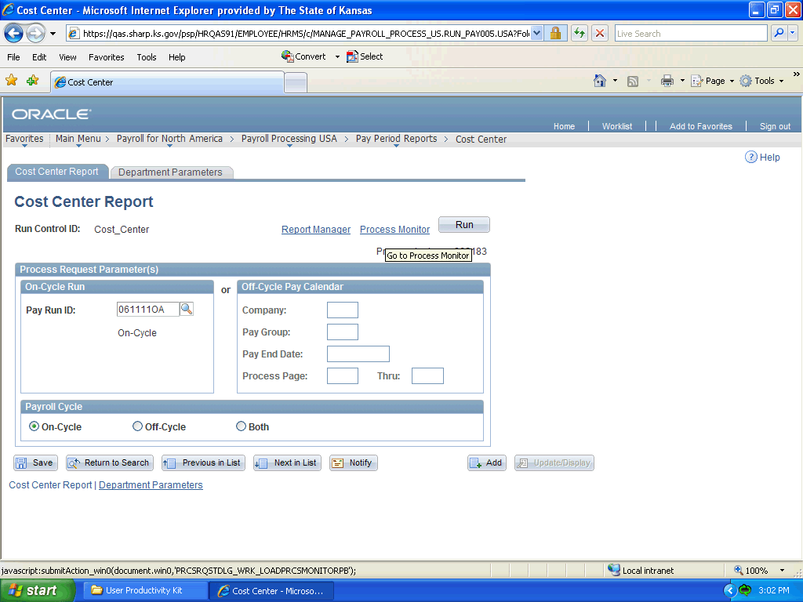

Step | Action
After clicking OK, the system will return you to the report Run Control ID page. This time you will click the Process Monitor link.

Click the Process Monitor link.
When you first arrive at the Process Monitor page, the report Run Status will be Processing and the Distribution Status will be N/A.

You can control how many days worth of reports to keep in the system by entering the desired number in the Last _ Days field.
You would want to click the Refresh button from time to time to check the report processing status.

Click the Refresh button.

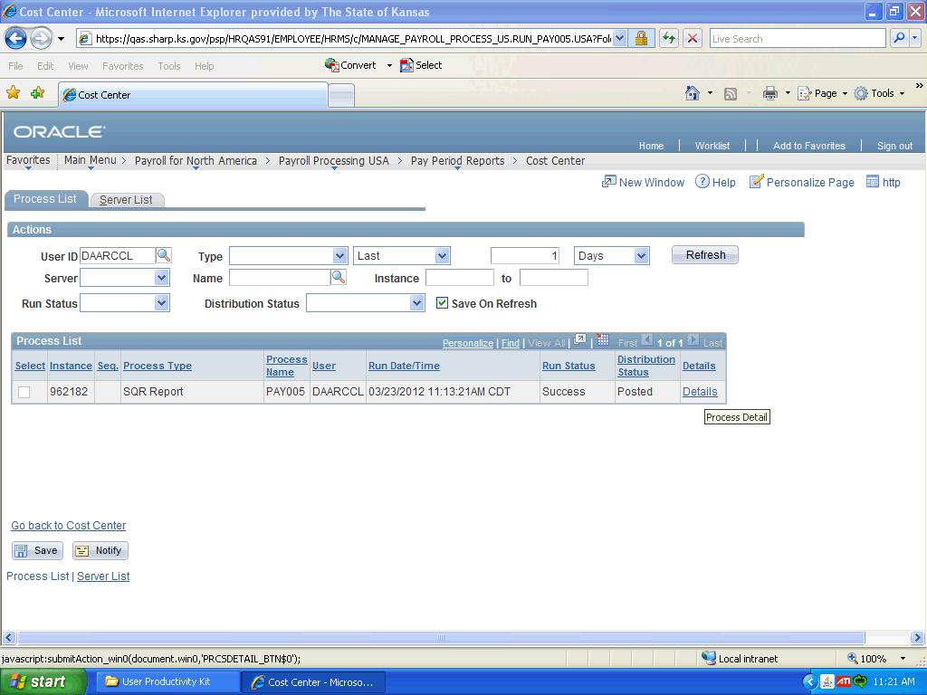

Step | Action
When the report is completed, the Run Status will be Success and the Distribution Status will be Posted.

Click the Details link.
 | On the Process Detail page, you can further manipulate the run process by clicking the appropriate button to Hold Request, Cancel Request, Delete Request, etc.

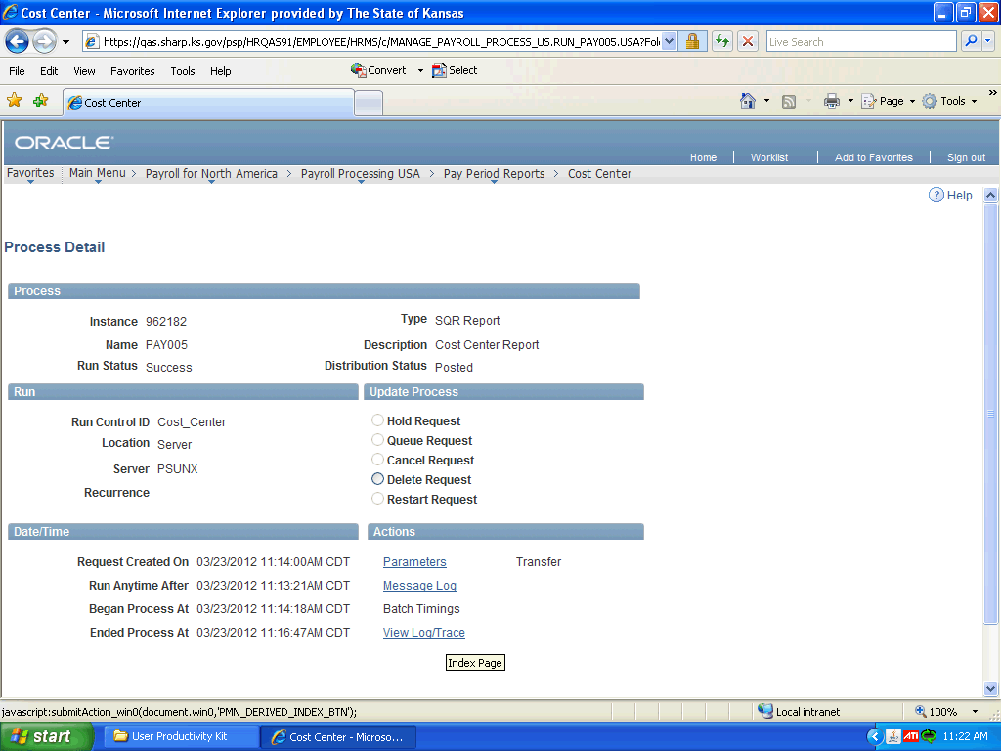

Step | Action
 | Click the View Log/Trace link.
The report file will have a .PDF extension.

Click the pay005_962182.PDF link.

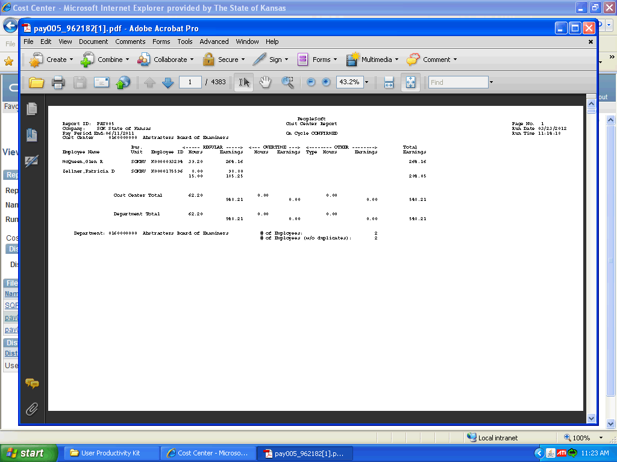

Step | Action
You can save the report to a desired location, or simply close the report after viewing.

Click the Close button to close the report.
 | End of Procedure.

