Payroll Commitment Accounting

Setting Up Department Default Funding
Procedure

You are about to enter a simulation that walks you through the step by step instructions for setting up default funding for a department.
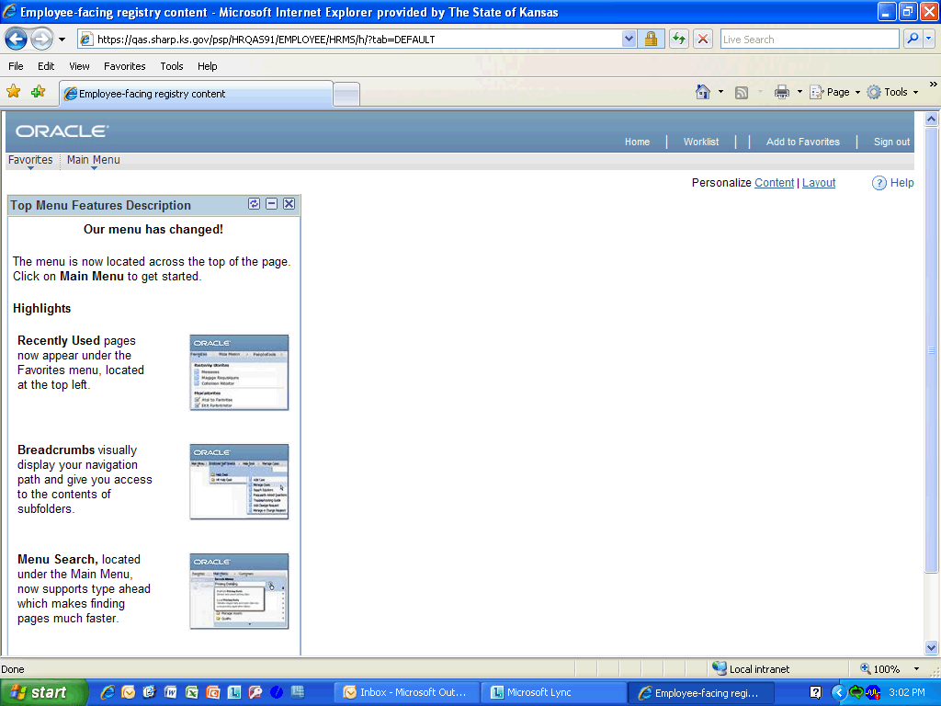

Step | Action
 | Click the Main Menu link.
 | Click the Set Up HRMS link.
 | Click the Product Related link.
 | Click the Commitment Accounting link.
 | Click the Budget Information link.
 | Click the Department Budget Table USA link.

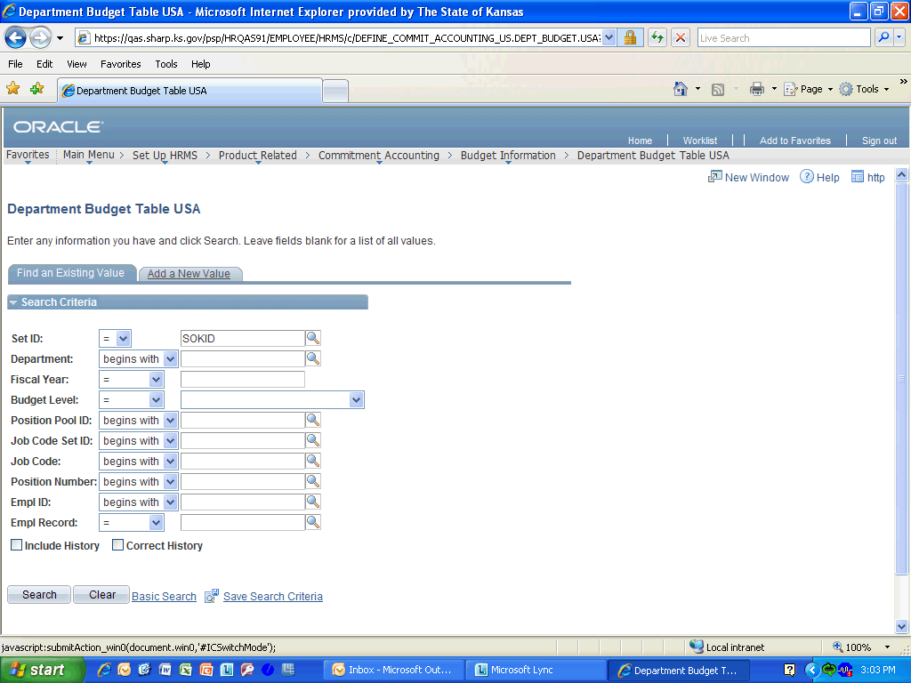

Step | Action
 | Click the Add a New Value object.
 | Enter the desired information into the Department field. Enter "1730101010".
 | Enter the desired information into the Fiscal Year field. Enter "2013".
 | Click the drop down for the Budget Level list.
 | Select Department from the list.
 | Click the Add button.

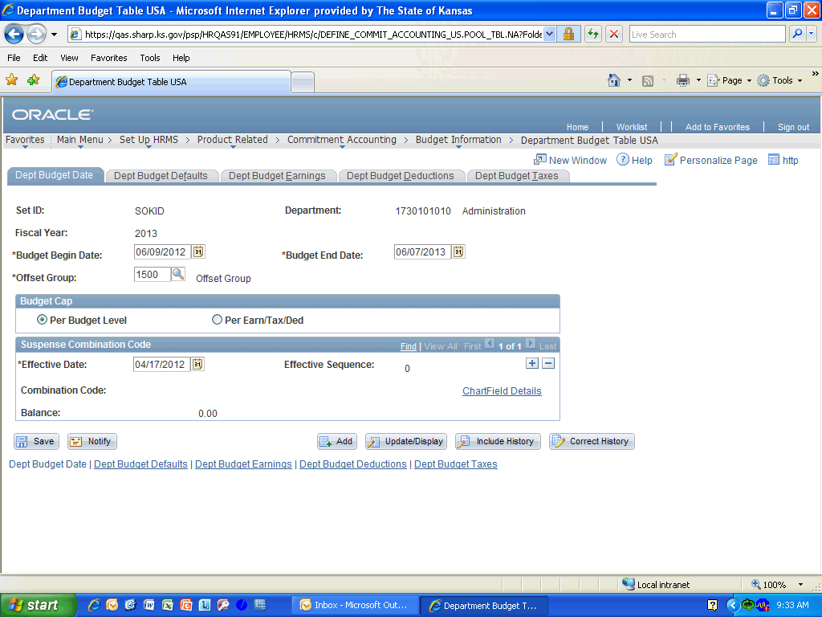

Step | Action
 | The Budget Begin Date and Budget End Date are inserted centrally and are the beginning and end dates of the fiscal year and should not be changed except when a new Department is being established. The Offset Group is for the offsetting accounting entries group for payroll expenses and you should use the default value of 1500.

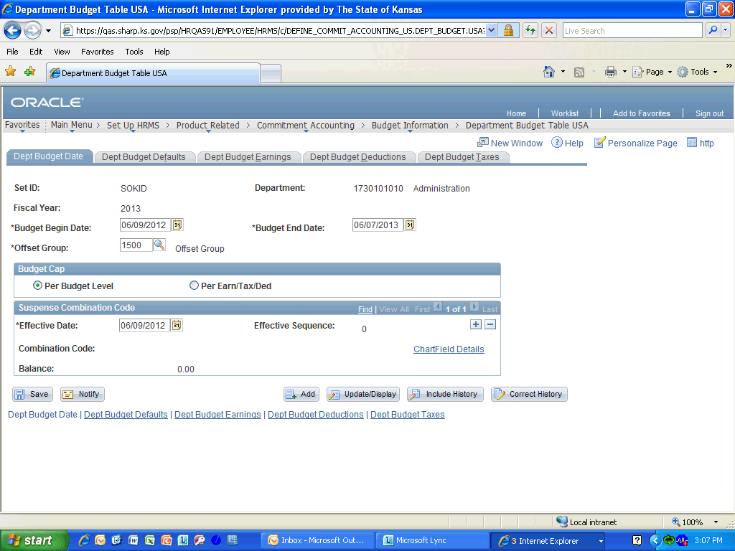

Step | Action
 | Enter the desired information into the Effective Date field. Enter "06/09/2012".

Step | Action
 | Click the ChartField Details link.

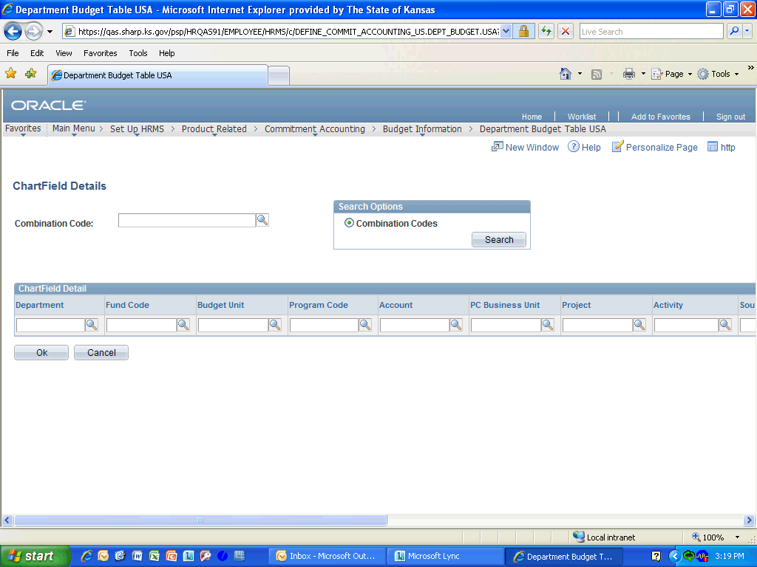

Step | Action
 | Enter the desired information into the Combination Code field. Enter "Suspense".

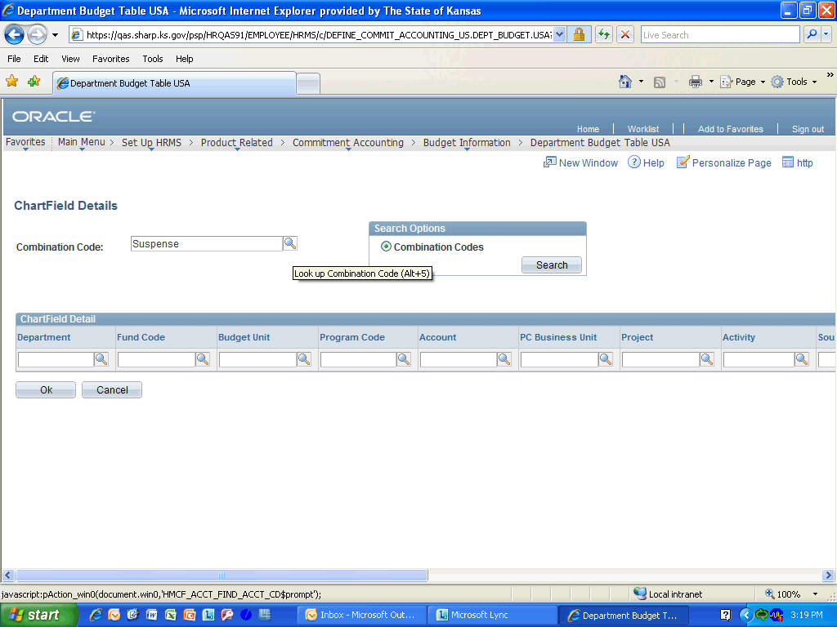

Step | Action
 | Click the Look up Combination Code (Alt+5) object.

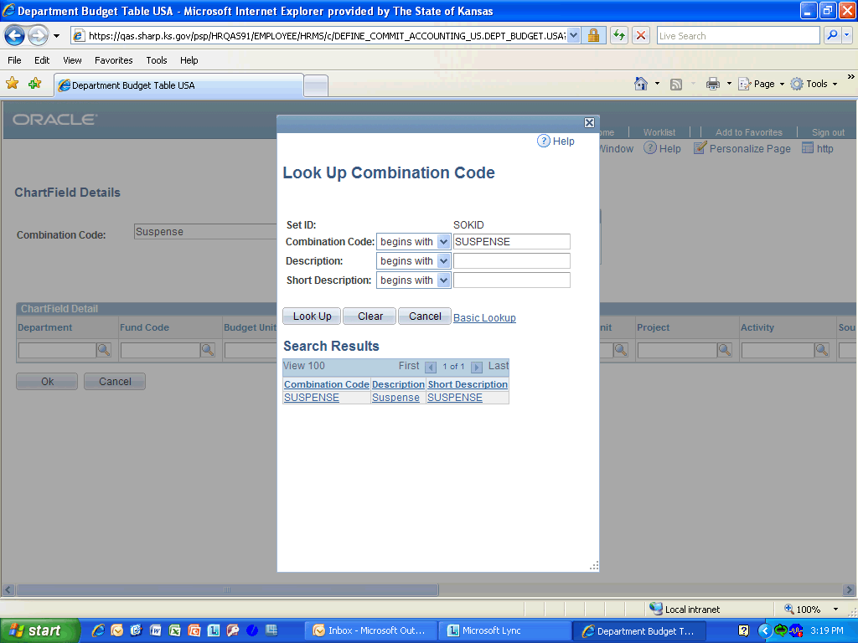

Step | Action
 | Click the SUSPENSE link.
 | Click the OK button.
 | Click the Dept Budget Defaults link.
 | The information on the Dept Budget Defaults tab is defaulted in and should not be changed
 | Click the Dept Budge Earnings tab.
 | Enter the desired information into the Effective Date field. Enter "06/09/2012".
 | Enter the desired information into the Sequence Number field. Enter "1".
 | Enter the desired information into the Funding End Date field. Enter "06/07/2013".
 | Click the Combination Code Description link.
 | Click the ChartField Details link.
 | Enter the desired information into the Combination Code field. Enter "173".

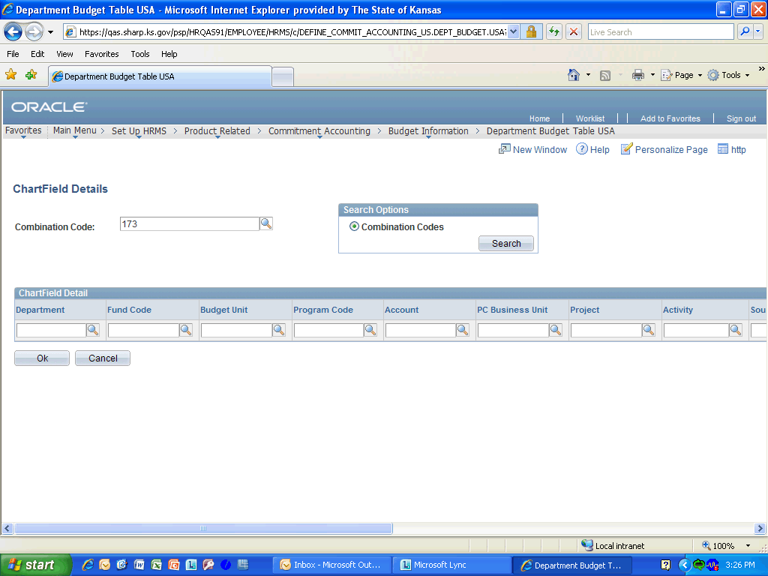

Step | Action
 | Click the Look up Combination Code (Alt+5) option.

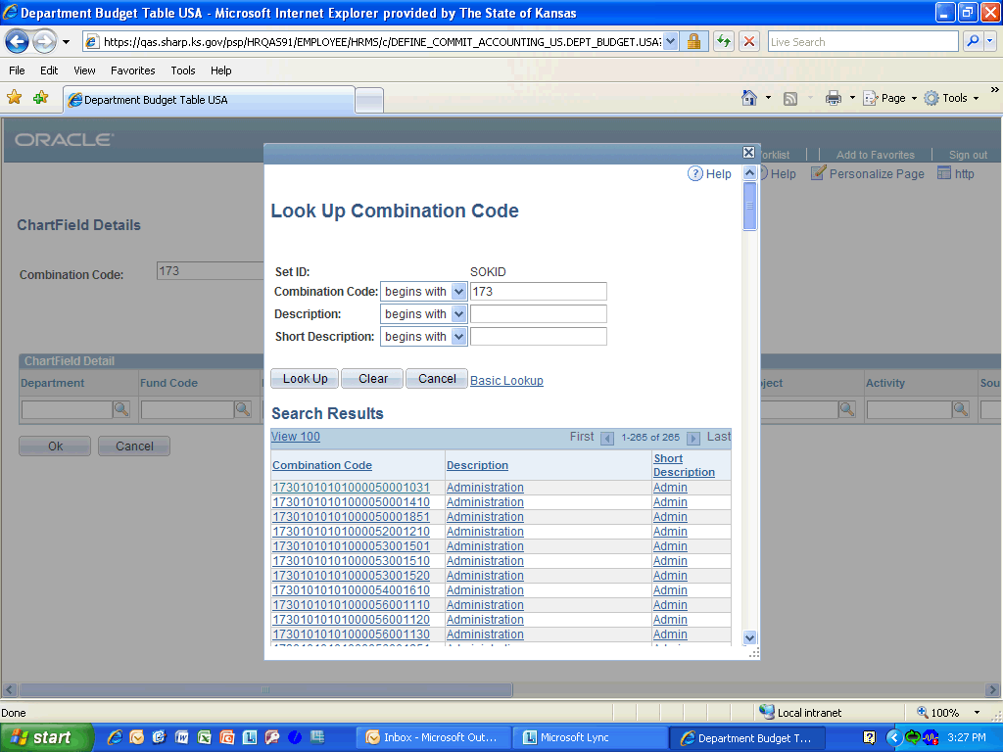

Step | Action
 | Click on the Scroll Bar and drag it down until you find the Combination Code you are looking for.

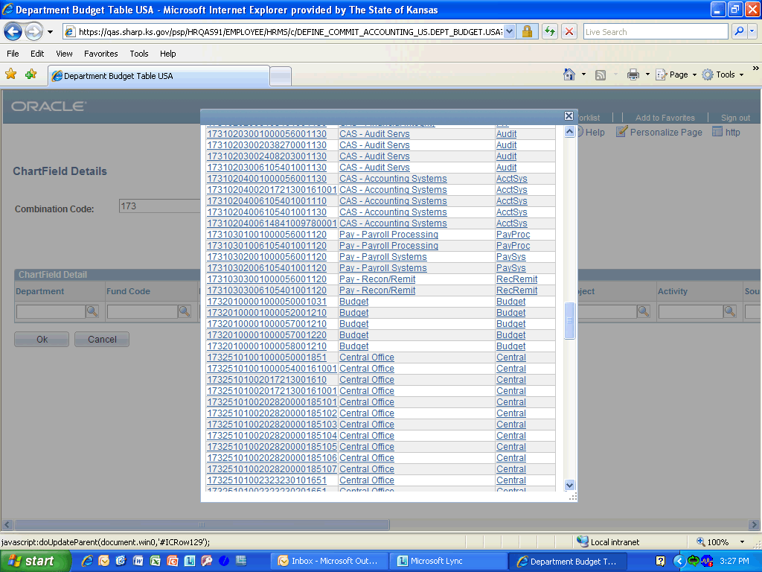

Step | Action
 | Click on the Pay - Payroll Systems link.
 | Click the Ok button.
 | Click the Combination Code Description tab.

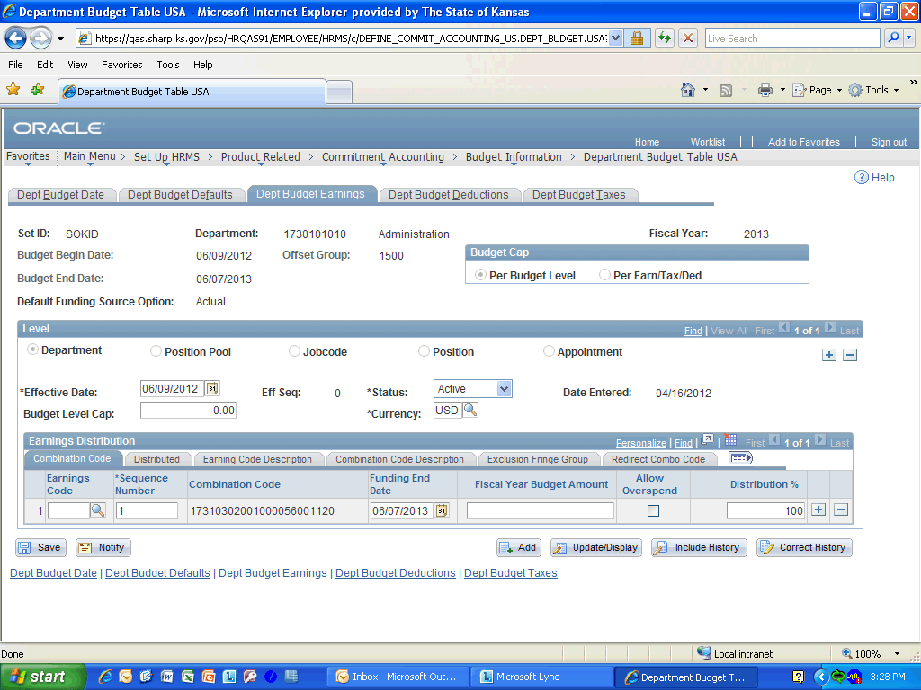

Step | Action
 | Enter the desired information into the Distribution % field. Enter "100".

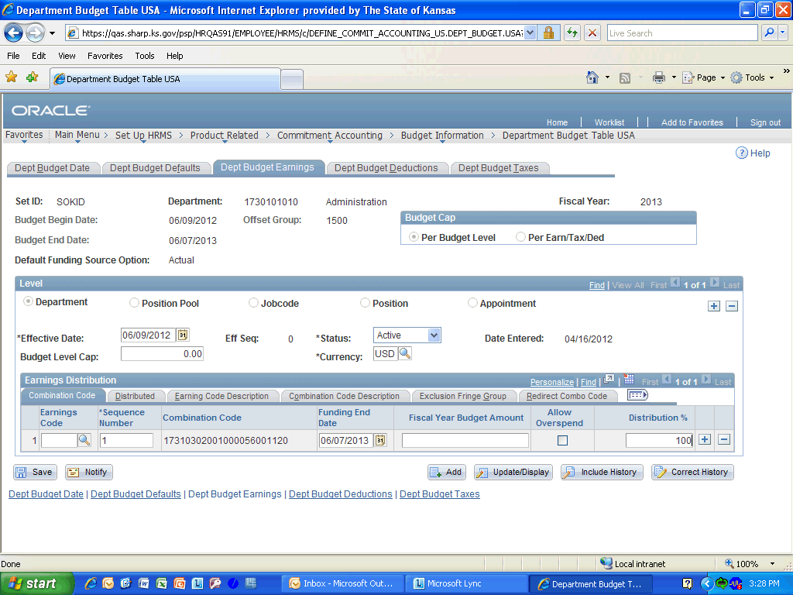

Step | Action
 | Click the Save button.
Congratulations! You have completed Setting Up Department Default Funding.
End of Procedure.

