Payroll Commitment Accounting

Setting Up Payroll Funding in SHARP
Procedure

You are about to enter a simulation that demonstrates how you can set up payroll funding in SHARP.
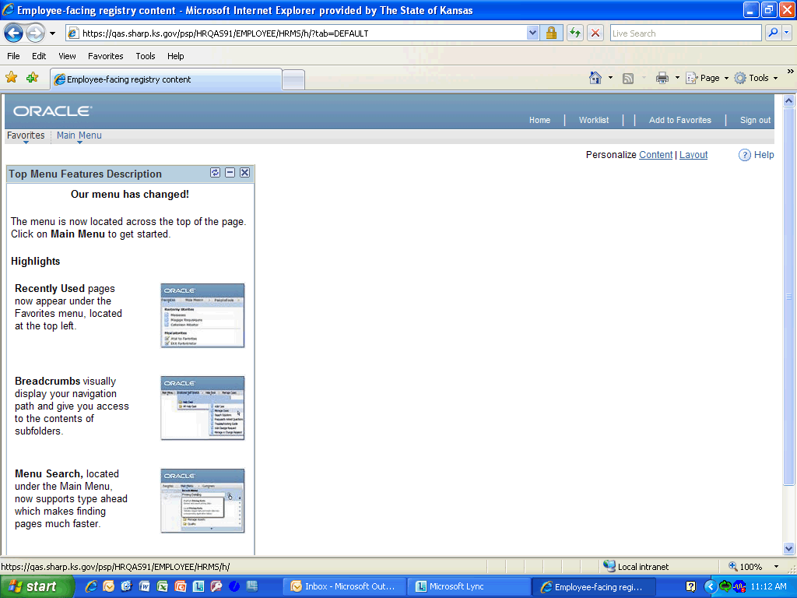

Step | Action
 | Click the Main Menu link.
 | Click the Set Up HRMS link.
 | Click the Product Related link.
 | Click the Commitment Accounting link.
 | Click the Budget Information link.
 | Click the Department Budget Table USA link.

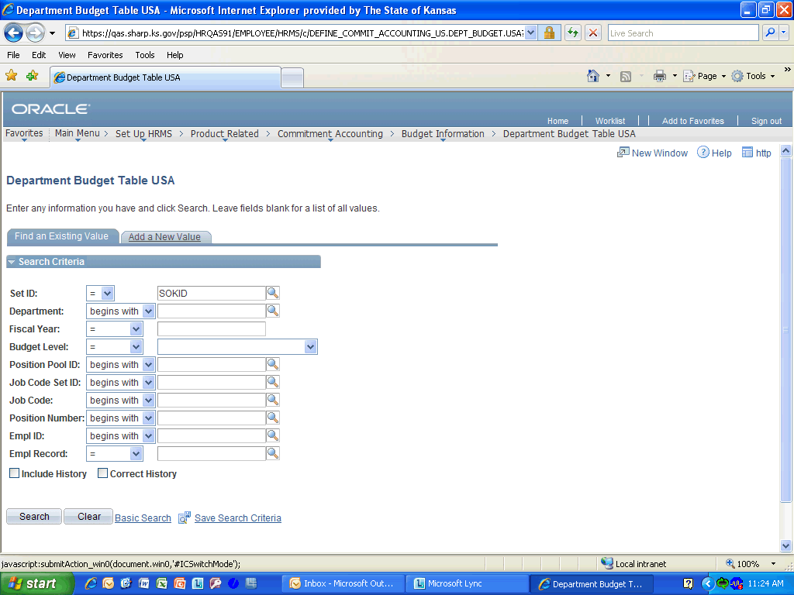

Step | Action
 | Click the Add a New Value link.
 | Enter the desired information into the Department field. Enter "1730101010".
 | Enter the desired information into the Fiscal Year field. Enter "2012".
 | Click the Budget Level list.
 | Click the Position Pool link.
 | Enter the desired information into the Position Pool ID field. Enter "055".
 | Click the Position Pool ID button.
 | Click any where in the Dept Budget Date area to continue.
 | Click the Dept Budget Earnings link.
 | Enter the desired information into the Effective Date field. Enter "08/21/2011".
 | Enter the desired information into the Sequence Number field. Enter "1".
 | Enter the desired information into the Funding End Date field. Enter "06/11/2012".
 | Click the Combination Code Description link.
 | Click the ChartField Details link.
 | Enter the desired information into the Combination Code field. Enter "173".
 | Click the Look up Combination Code (Alt+5) button.

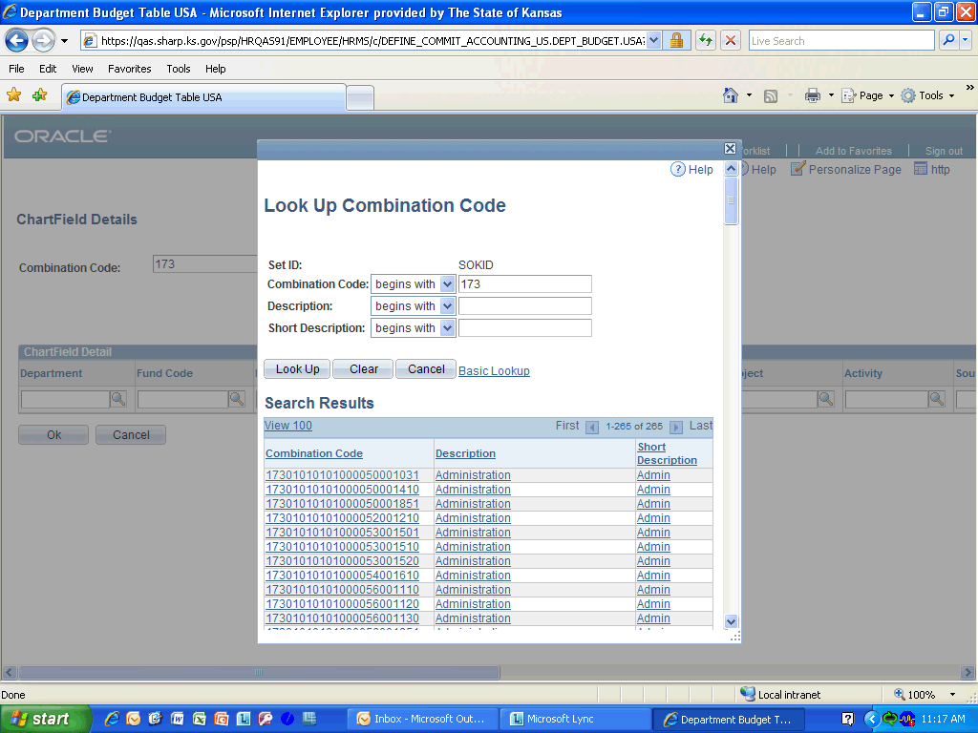

Step | Action
 | Click the Scroll Bar and drag it down to the Combination Code you need.
 | Click the Pay - Payroll Systems link.

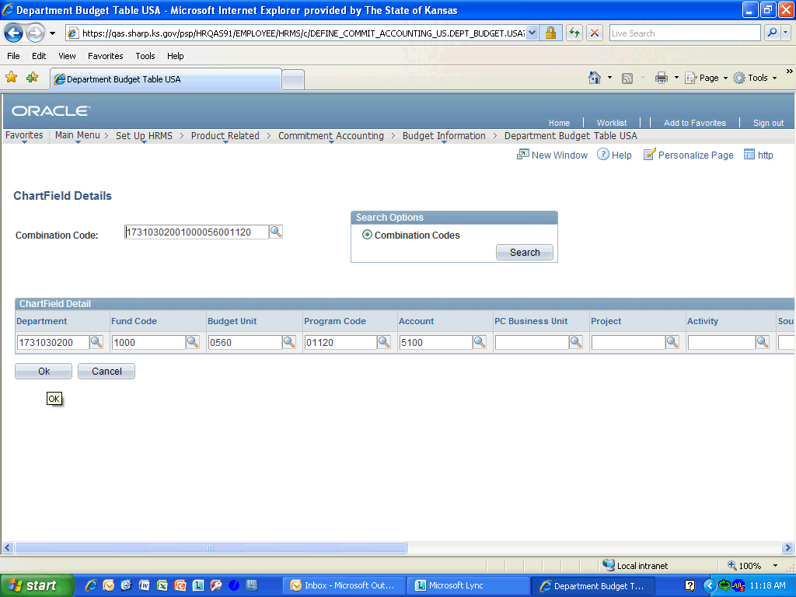

Step | Action
 | Click the Ok button.
 | Click the Add a new row button.

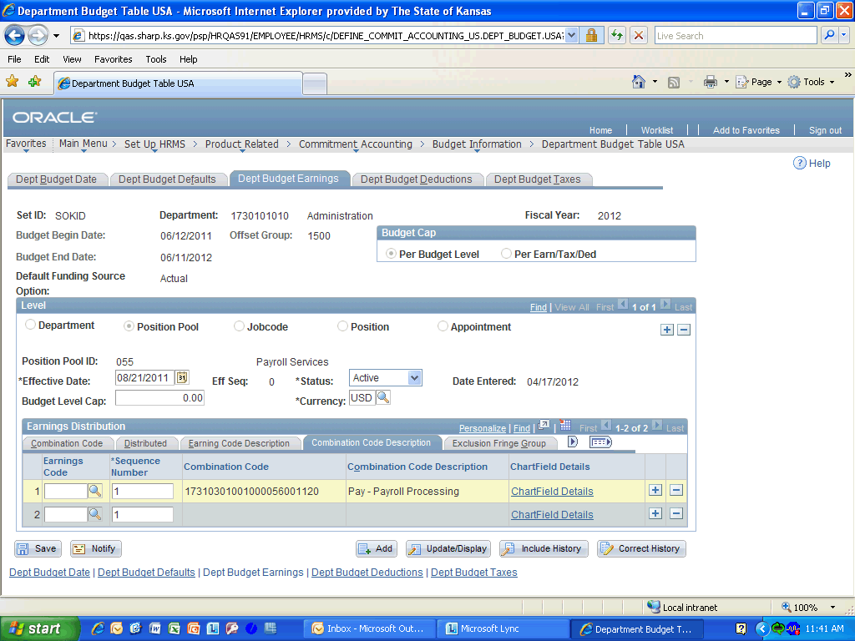

Step | Action
 | Enter the desired information into the Sequence Number field. Enter "1".

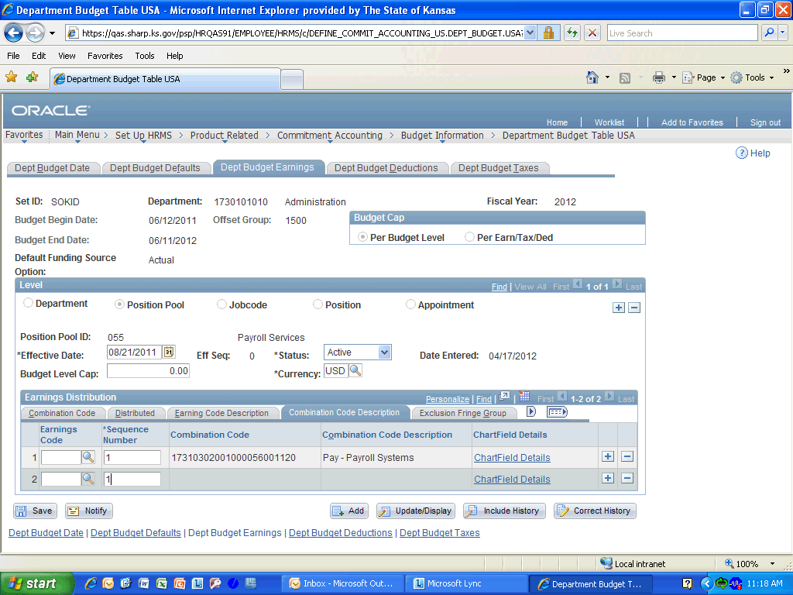

Step | Action
 | Click the ChartField Details link.
 | Enter the desired information into the Combination Code field. Enter "173".
 | Click the Look up Combination Code (Alt+5) button.

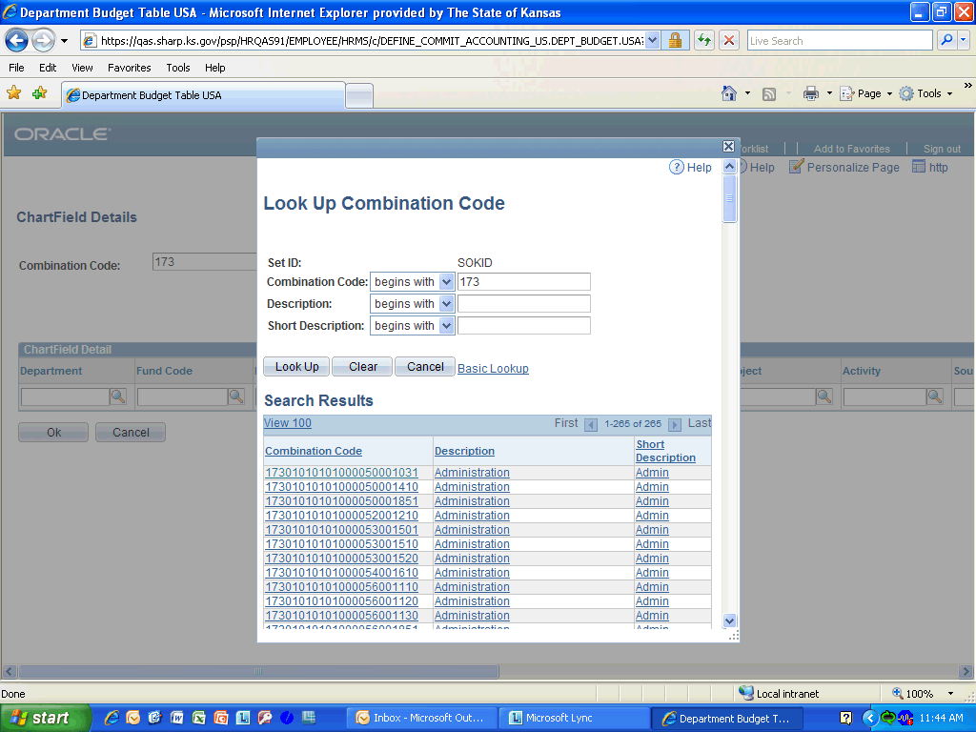

Step | Action
 | Click the Scroll Bar and drag it down to the Combination Code you want.
 | Click the Pay - Payroll Systems link.

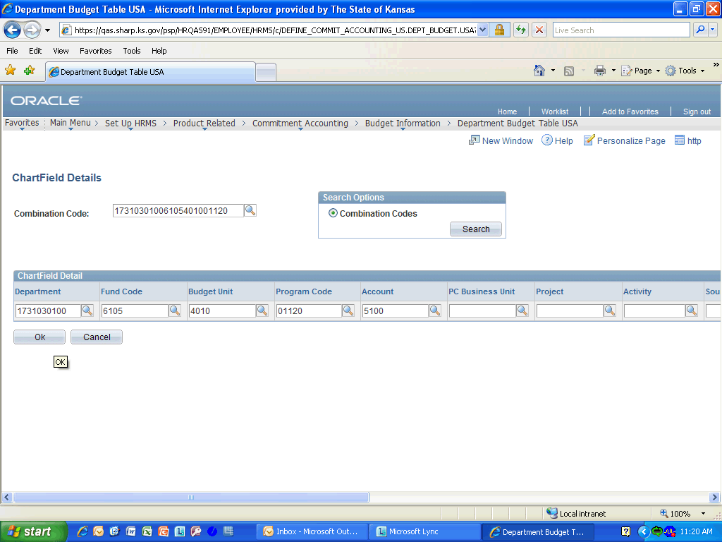

Step | Action
 | Click the Ok button.

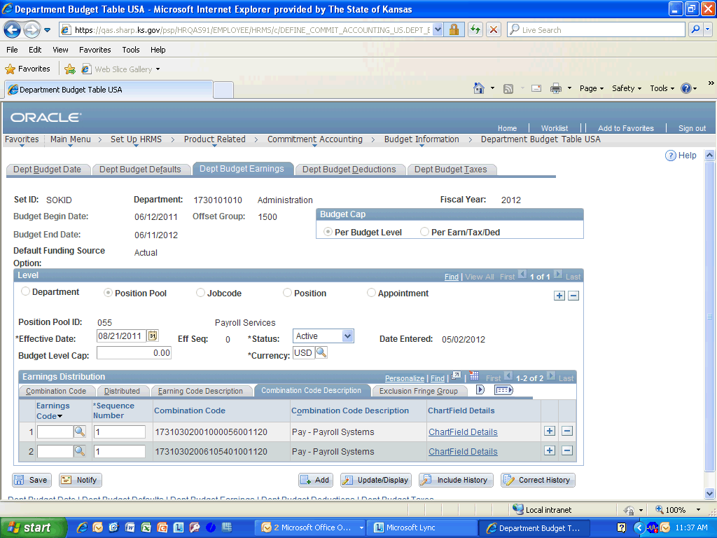

Step | Action
 | Click the Combination Code link.

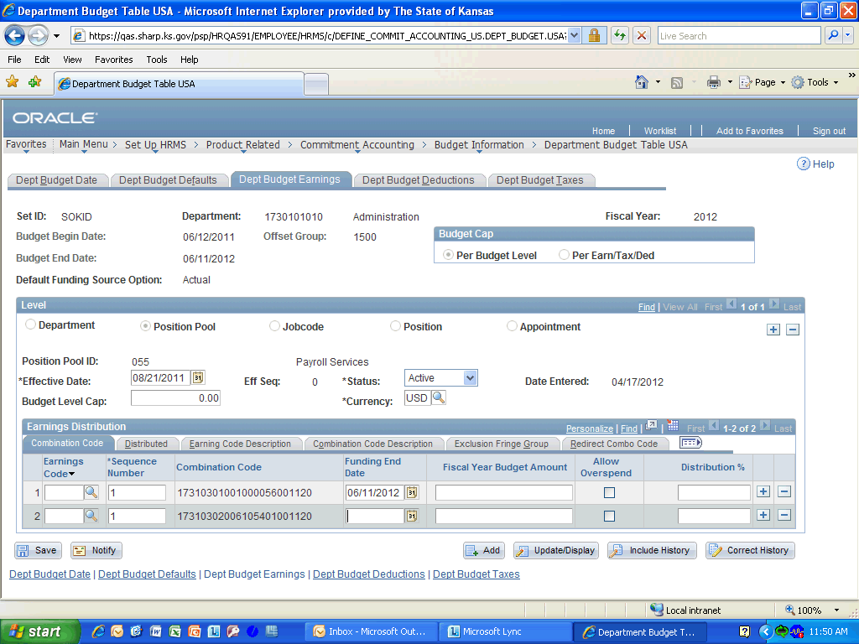

Step | Action
 | Enter the desired information into the Funding End Date field. Enter "06/11/2012".
 | Enter the desired information into the Distribution % field. Enter "50".
 | Enter the desired information into the Distribution % field. Enter "50".
 | Click the Save button.
Congratulations! You have completed Setting Up Payroll Funding in SHARP.
End of Procedure.

