Payroll

Updating Employee Tax Data
Procedure

For this simulation, you are going to follow step by step instructions on updating an employee's payroll tax data. You will first update the employee's federal tax data and then the employee's state tax data.
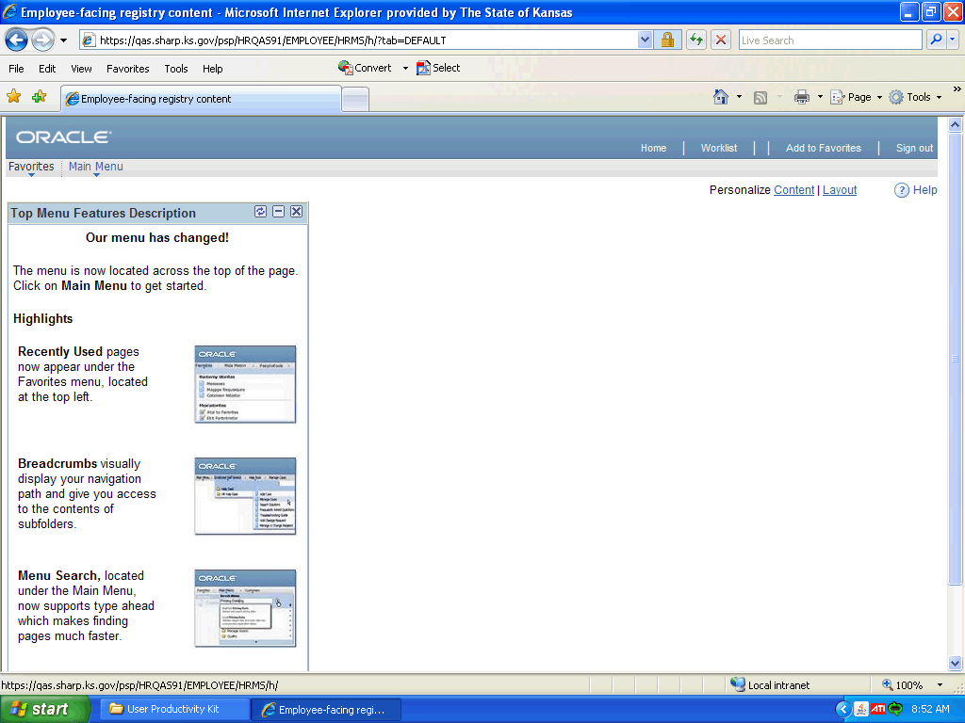

Step | Action
 | Click the Main Menu link.
 | Click the Payroll for North America link.

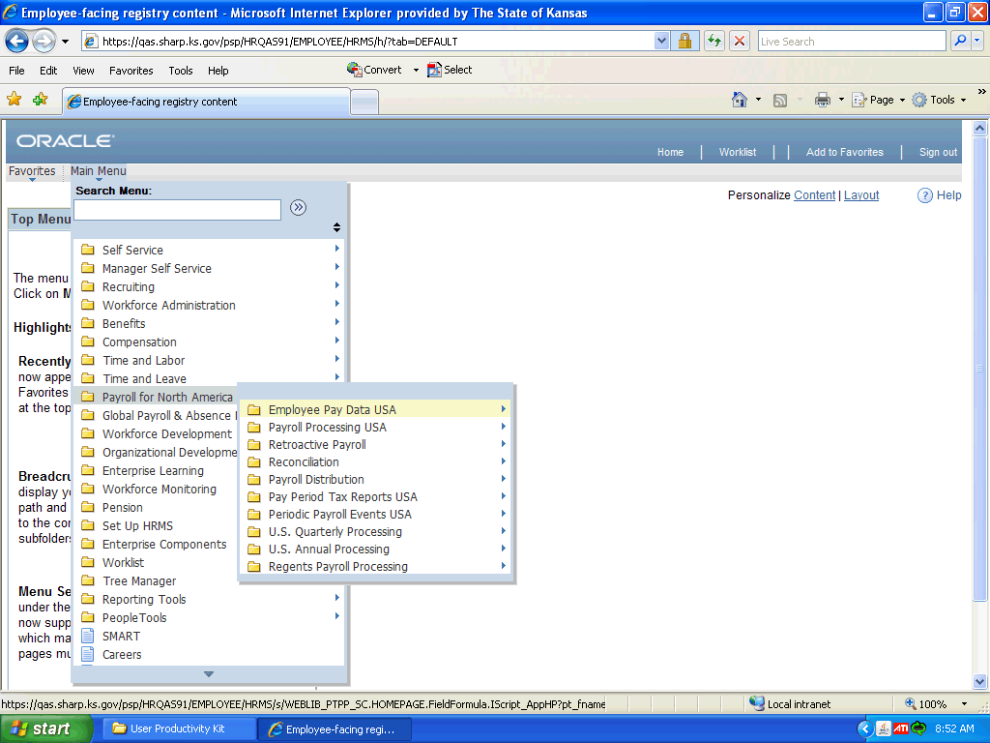

Step | Action
 | Click the Employee Pay Data USA link.

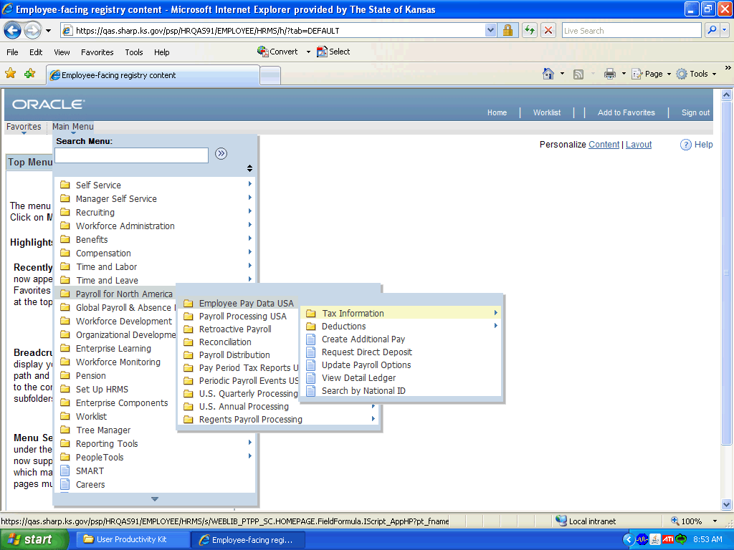

Step | Action
 | Click the Tax Information link.

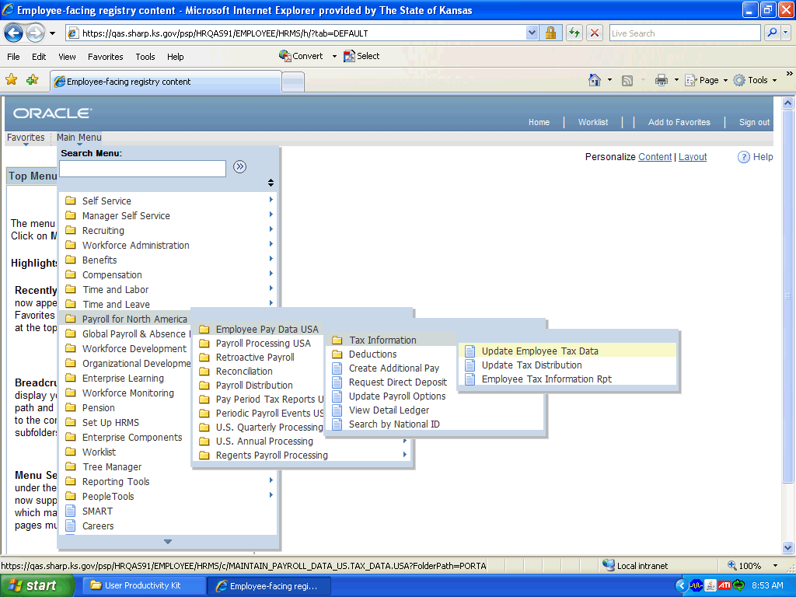

Step | Action
 | Click in the Update Employee Tax Data field.

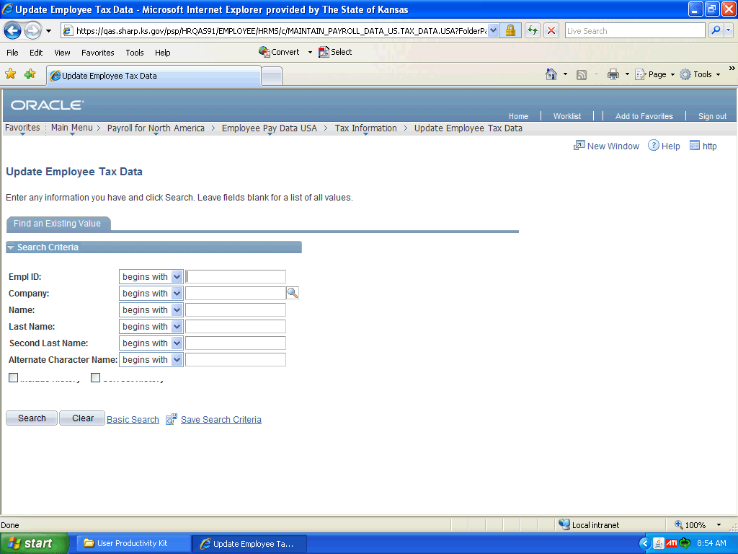

Step | Action
 | Click the Employee ID box.

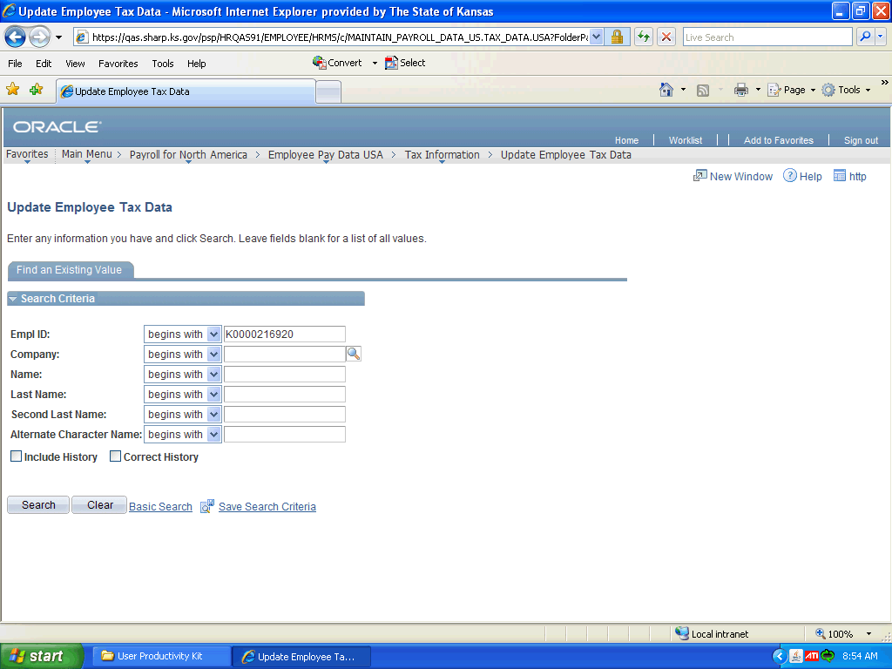

Step | Action
 | Enter the desired information into the Empl ID field. Enter "K0000216920".
Enter the desired information into the Company field. Enter "SOK" for the State of Kansas
.
 | Click the Search button.
 | Click the Add a new row at row 1 (Alt+7) button.
 | Enter the new Effective Date. Enter "08/22/2011".

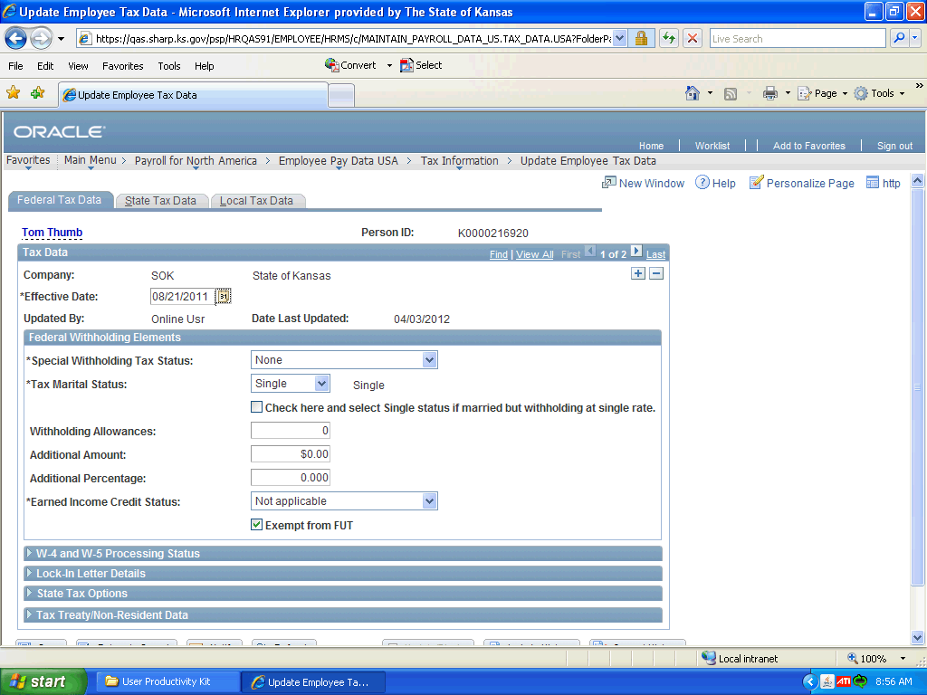

Step | Action
 | Click the drop-down arrow for the Special Withholding Tax Status.

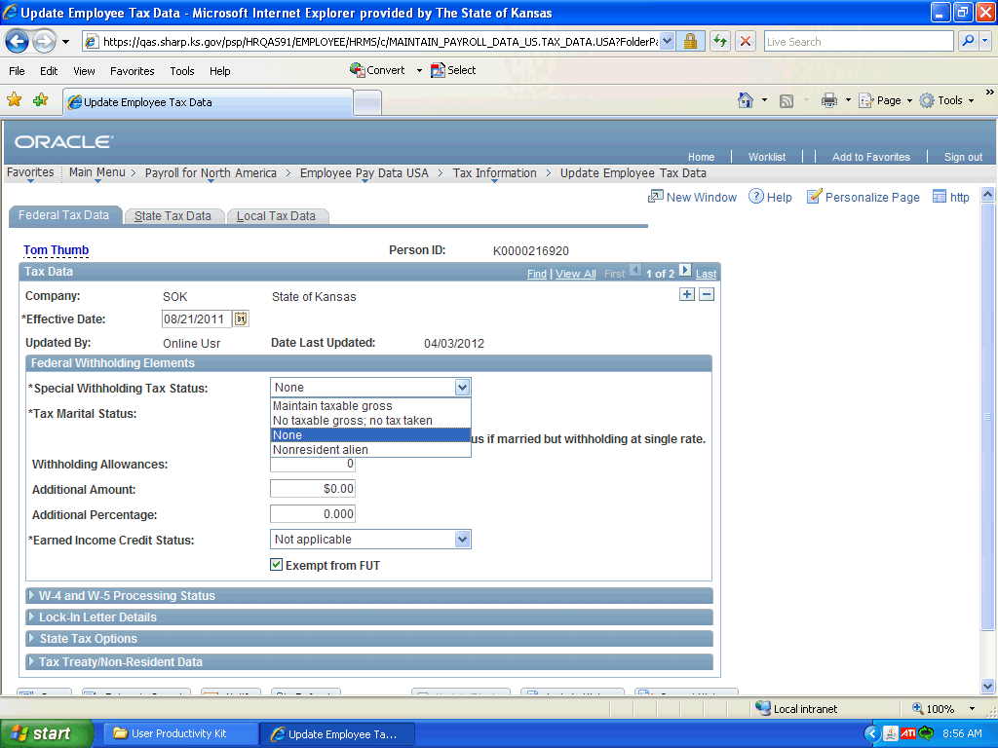

Step | Action
 | Select the correct Special Withholding Tax Status from the list. Usually the selection is the default of None.
 | Select the correct Tax Marital Status list. Here you are going to select Single.
 | Select the check box Check here and select Single status if married but withholding at single rate.

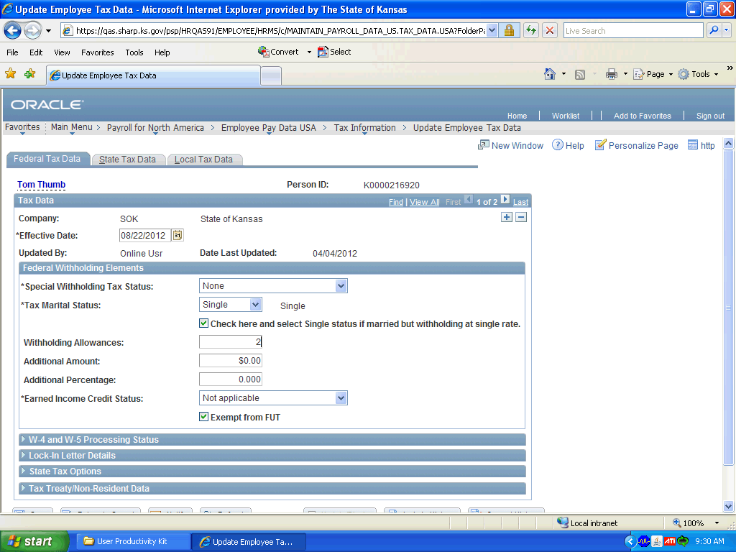

Step | Action
 | Enter the correct number of Withholding Allowances. Enter "2".

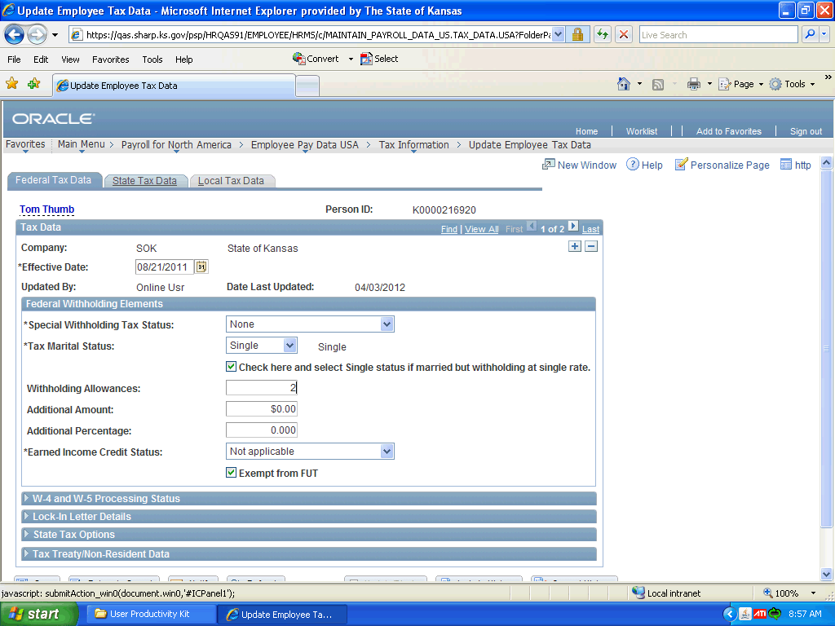

Step | Action
 | Select the tab State Tax Data.

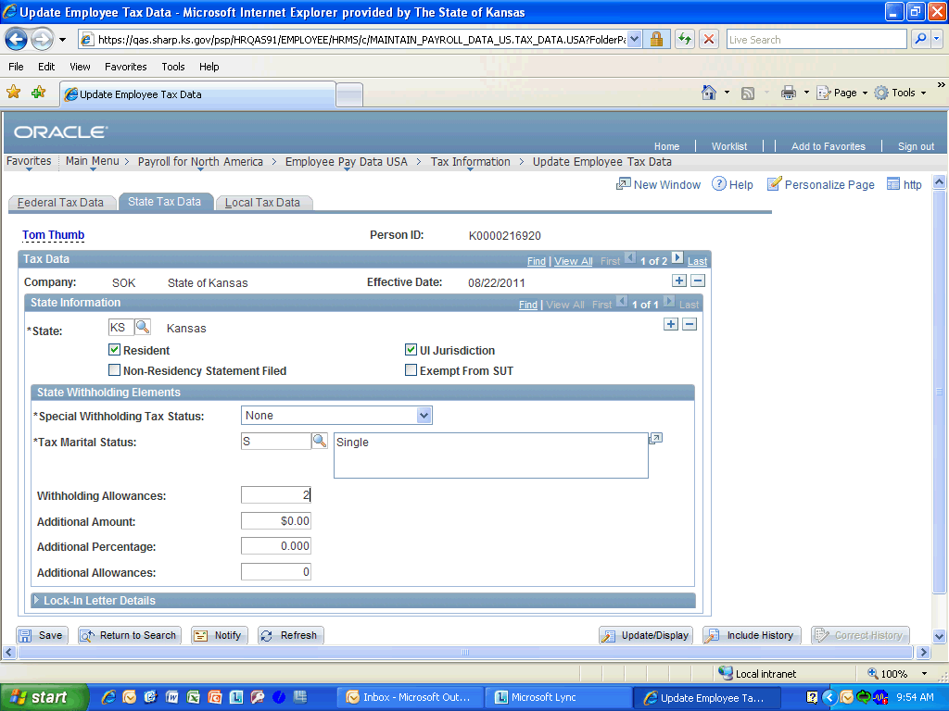

Step | Action
 | Enter the desired information into the Withholding Allowances field. Enter "2".

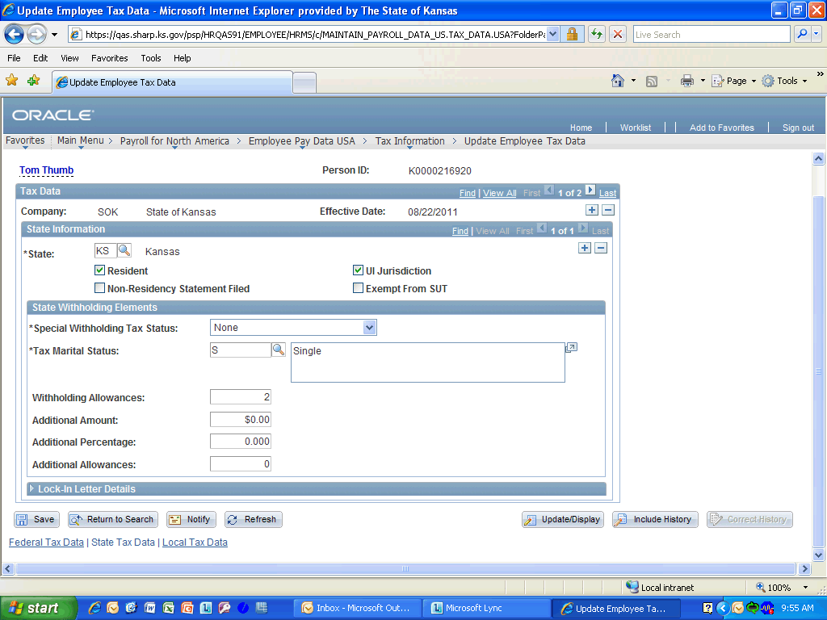

Step | Action
 | Click the Save button.
Congratulations! You have successfully completed Updating Employee's Tax Data.
End of Procedure.

