Introduction To SHARP

Using the Different Page Controls in SHARP
Procedure

There are many types of Page Controls that are used in SHARP. This simulation will show you some of them and explain how they might be used.
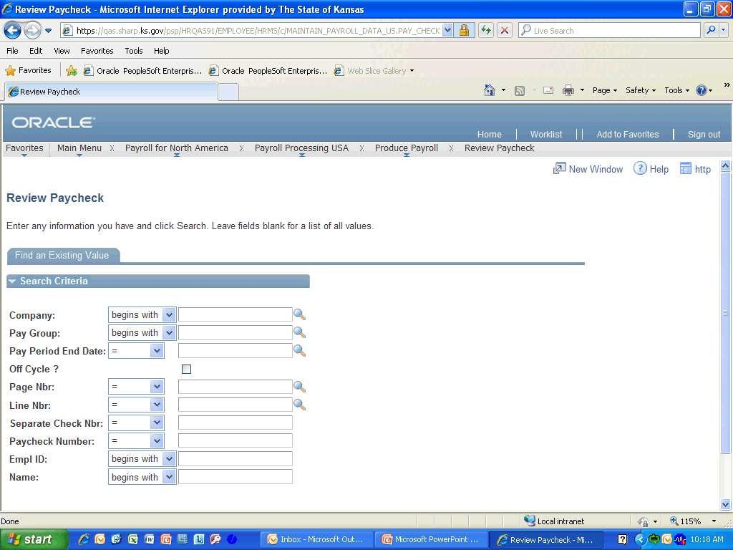

Step | Action
Under the Navigation Header is the Pagebar. The New Window link here is used to create a new SHARP session. This should be used instead of opening a new one from the browser to to look-up other information contained within SHARP. The HELP link is currently not used. To copy this page’s URL to the clip board, click the http icon.

Click any where on the Pagebar menu bar to continue.
The Tab Names at the top are the same as the Shortcut Names at the bottom as you will see in the next frame.

Click the Tab Names section to continue.
Here are the Shortcut Names at the bottom of the page. You can use either the Tab Names at the top or the Shortcut Names at the bottom to move between pages within a component.

Click anywhere in the Shortcut Names section to continue.
You can use the Collapse Section button (down arrow) and the Expand Section button (right arrow) to show or hide a section in the page.

Click in the Expand or Collapse Section button to continue.
Here you can see that selecting the Expand and Collapse Section Buttons has changed the view of the page.

Click anywhere in the Earnings or Special Accumulators Section to continue.

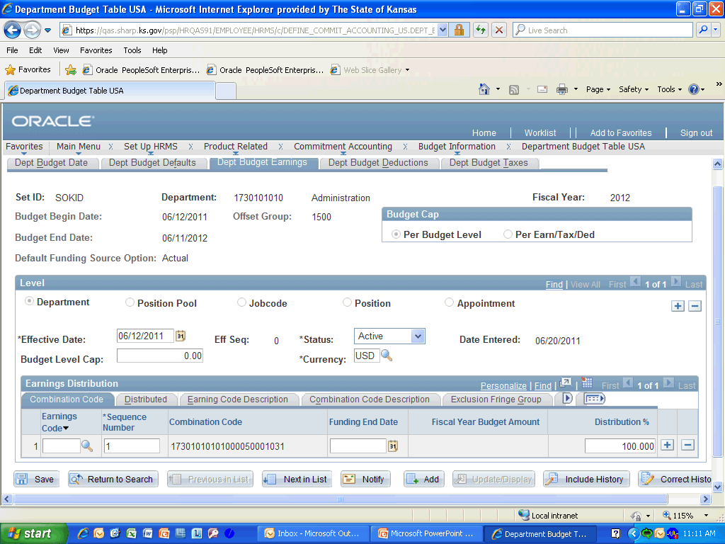

Step | Action
The Radio Buttons are used to quickly select from the choices as you can see under the Budget Cap Section. The Navigation Bar consist of a right and left arrow to move between records, a Find Hyperlink to look-up information, and a View All Hyperlink to see all the rows within the data area. The + and - buttons are used to Add Rows and Delete Rows within the data area. The Date Prompt Button brings up a calender to help you select the correct date for effective dating rows. The Drop Down List Box allows you to select from pre-determined data records. The Lookup Button is used to look-up data that is available for your selection. Fields marked by an asterisk are required. If you try to save before entering data into a required field, the field will turn red and an error message will appear. Other Fields are optional and appear the same without an asterisk by them.
Click anywhere on one of the Page Controls to continue.
The Zoom Button(button with diagonal arrow) allows you to magnify the display of the record you are viewing. In this case, you would be magnify the Earnings Distribution Section. The Download Button(grid like button) allows you to export the data to Excel for further manipulation. The Show Following Tabs Button(button with right arrow) allows you to scroll to the next Column Section. The Show All Columns Button(window button with a right arrow) allows you to see all the information contained in the columns that are available.

Click any of the Page Controls to continue.
Effective dates are used when you add data to SHARP to provide a time reference. Some data in SHARP will also require periodic updates. Using effective-dating in combination with action types allows you to add and update data while maintaining accurate records. The Add Button allows you to enter a date that is within a current or future pay period and is for entering a row for the first time. The Update/Display Button retrieves only current and future rows and allows you to only change future rows. The Include History Button retrieves all rows and allows you to only change future rows. The Correct History Button retrieves all rows and allows history rows to be changed or inserted. However, only Central users have access to correct history. If you have an error that cannot be fixed using a correcting entry, contact the central SHARP subject matter expert for assistance.

Click on any of the Action Types to continue.
Congratulations! You have completed Using the Different Page Controls in SHARP.
End of Procedure.

