Introduction To SHARP

Using Search Pages in SHARP
Procedure

You are about to enter a simulation that shows you how to use the search pages in SHARP. You will be using the search pages in the Update Employee Tax Data area. However, the search feature works the same throughout the SHARP system.
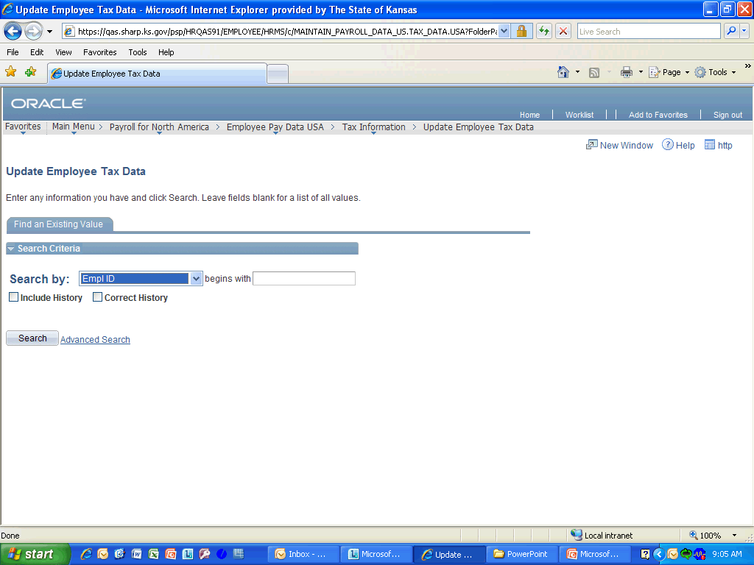

Step | Action
 | Click the Search by list.

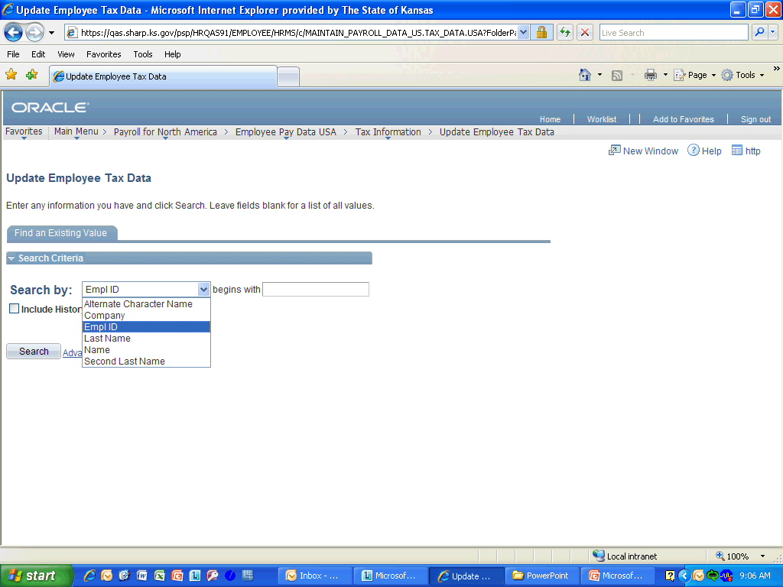

Step | Action
 | See all the options you can search by in Basic Search when you use the drop-down menu. Click anywhere in the Search by selection to continue.

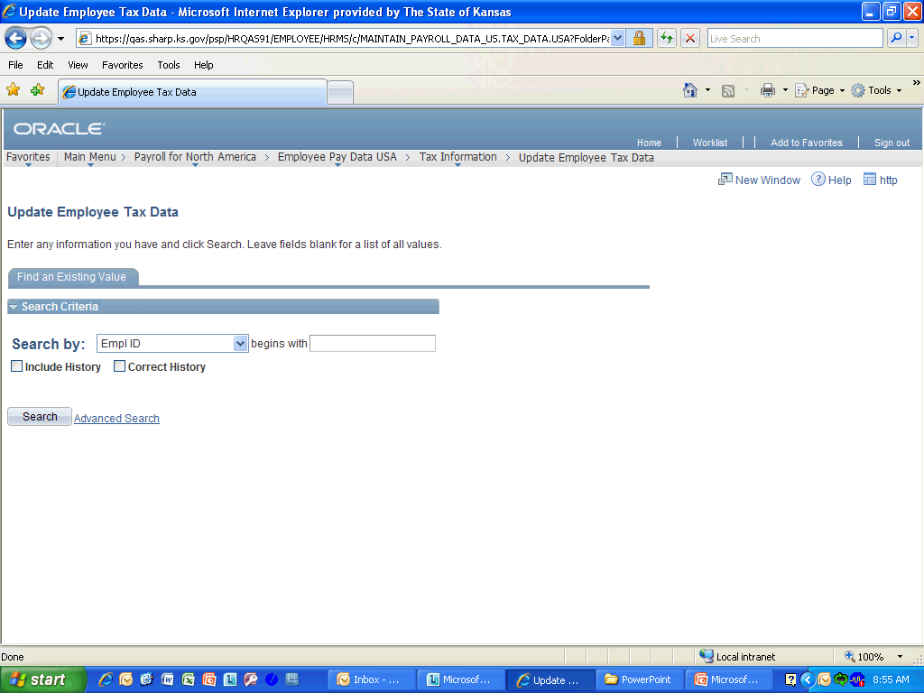

Step | Action
 | Click the Advanced Search link.
Operators are used to narrow search results. By default, when you enter criteria in a search field, all rows of data that "begins with" that criteria are returned. However, you can select from: contains; =; not =; <; <=; >; >=; between; or in. These can help narrow your search results in a variety of ways.

Click anywhere in the Operators section to continue.
Wildcards are characters that substitute for other characters in search criteria. Use a percent sign (%) in your search criteria to replace one or more characters if you are unsure of the exact value in the record you are trying to find.

Click anywhere in the Search Criteria area to continue.
 | Here we will use a Wildcard with the Begins with Operator.Enter the desired information into the Last Name field. Enter "Thumb%".
 | Click the Save Search Criteria object.
 | Enter the desired information into the Name of Search: field. Enter "Tax Updates".
 | Click the Save button.
 | Click the Return to Advanced Search link.
 | Click the Search button.
Notice that this search returned only 1 person whose Last Name begins with Thumb. However, if there was a list of results, you could press Ctrl+F to open the Find dialog box to help narrow your search down more. Once the Find box appears, then you can quickly move through the results with Find Next and Find Previous buttons.

Click the Empl ID link to continue.

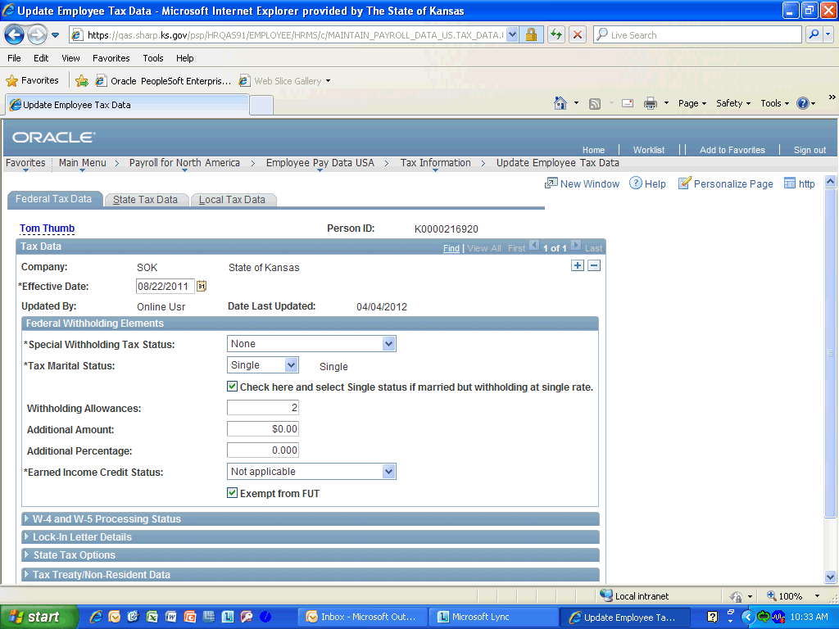

Step | Action
 | This is where the employee tax updates can be made. Click any where in the Selection to continue.

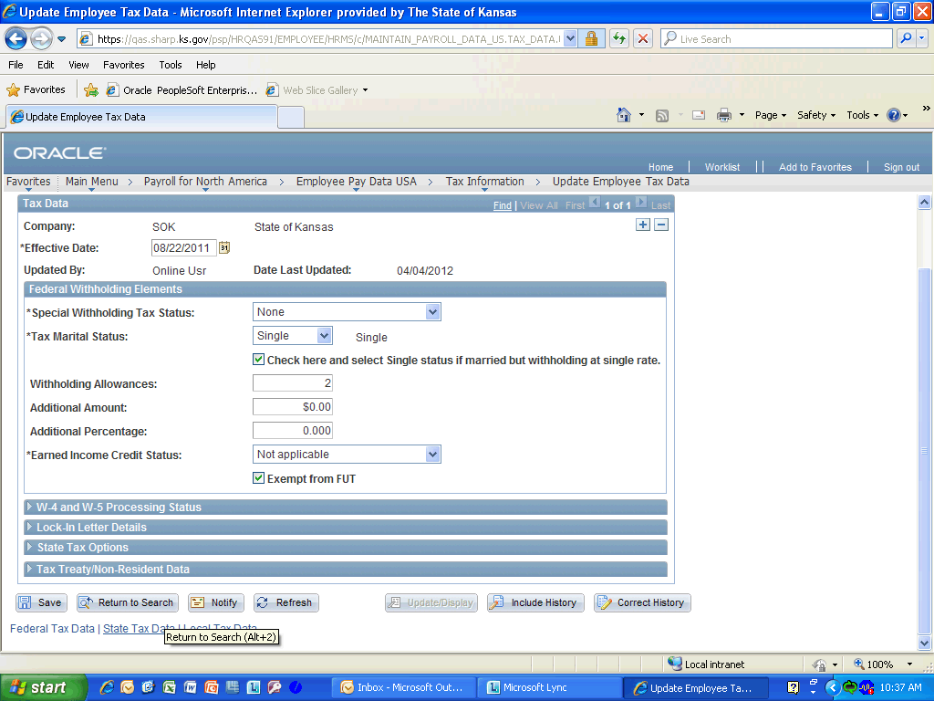

Step | Action
 | Click the Return to Search button.
 | Click the Delete Saved Search link.
 | Click the Delete button.

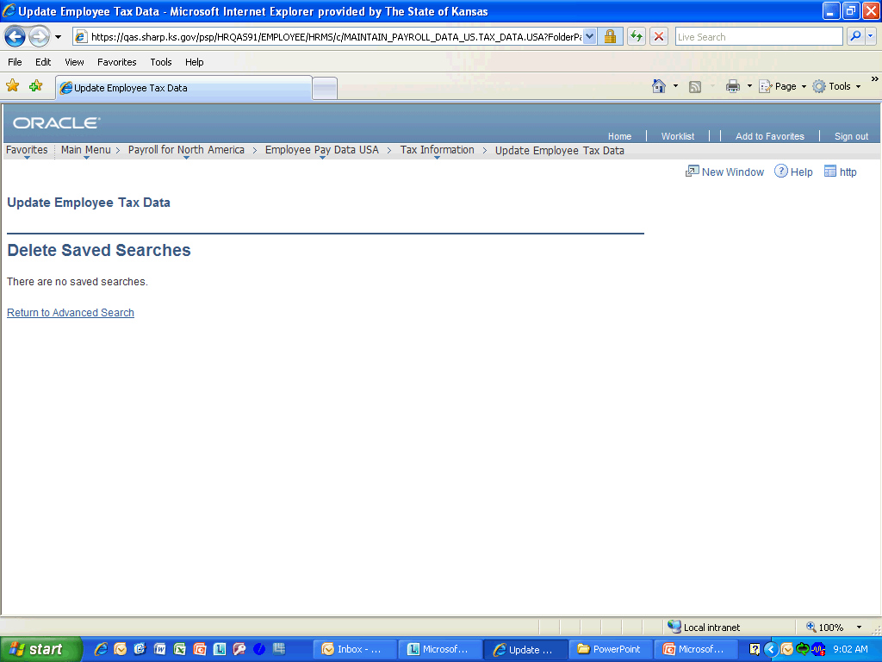

Step | Action
 | Click the Return to Advanced Search link.

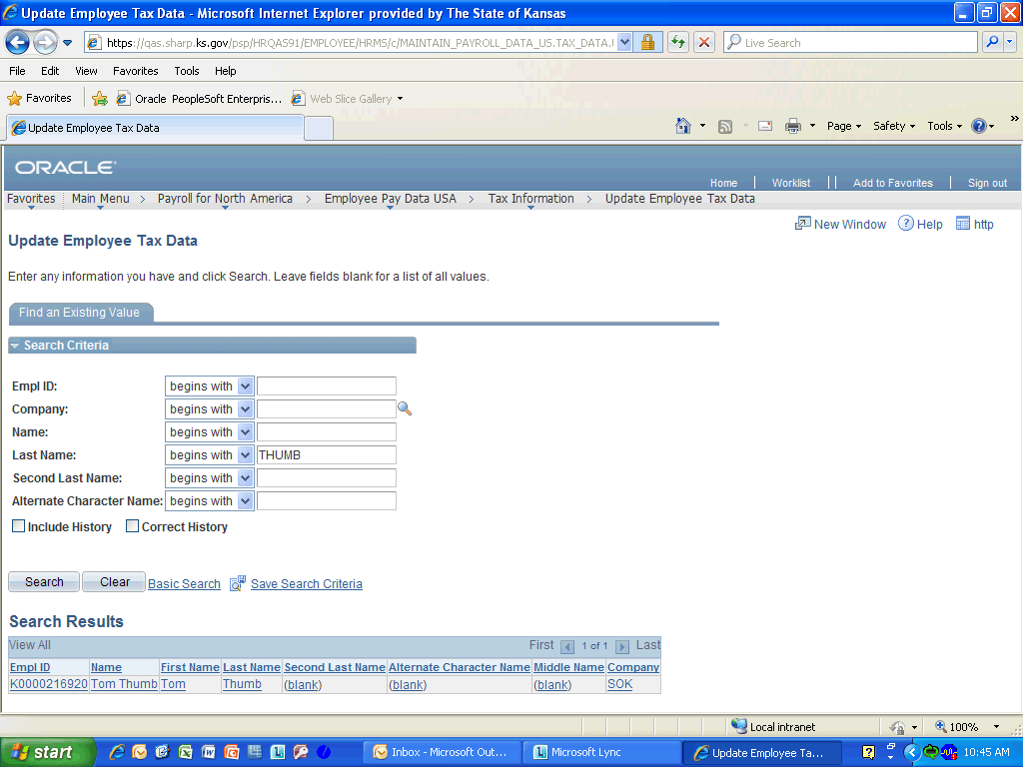

Step | Action
 | Notice that the Delete Saved Search link is now gone. There are no longer any saved searches. Click anywhere in the selection to continue.
Congratulations! You have completed Using Search Pages in SHARP.
End of Procedure.

