Payroll

Viewing a Paycheck in SHARP
Procedure

You are about to enter a simulation that will take you through the steps of viewing a paycheck in the SHARP system.
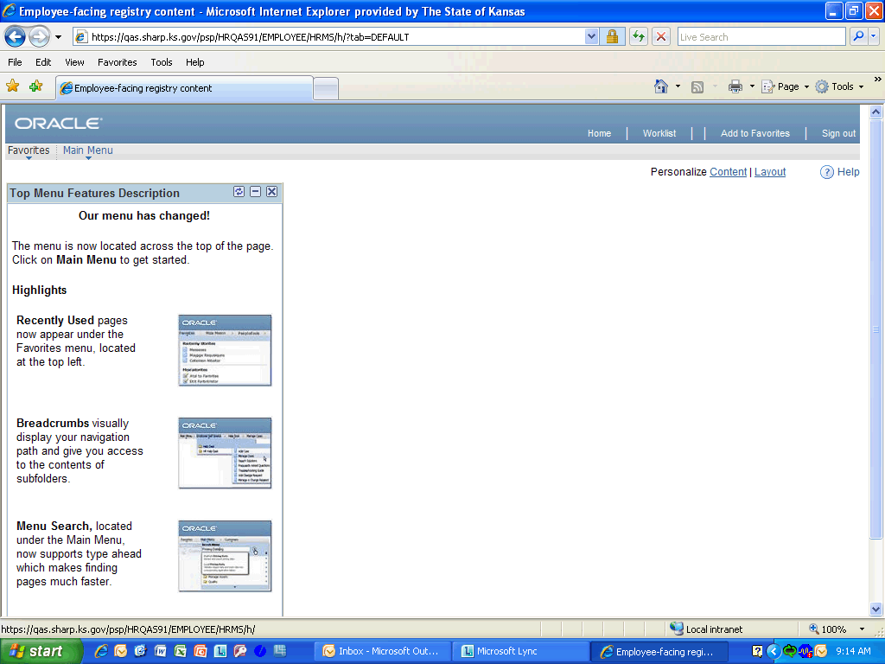

Step | Action
 | Click the Main Menu link.
 | Click the Payroll for North America link.
 | Click the Payroll Processing USA link.
 | Click the Produce Payroll link.
 | Click the Review Paycheck link.

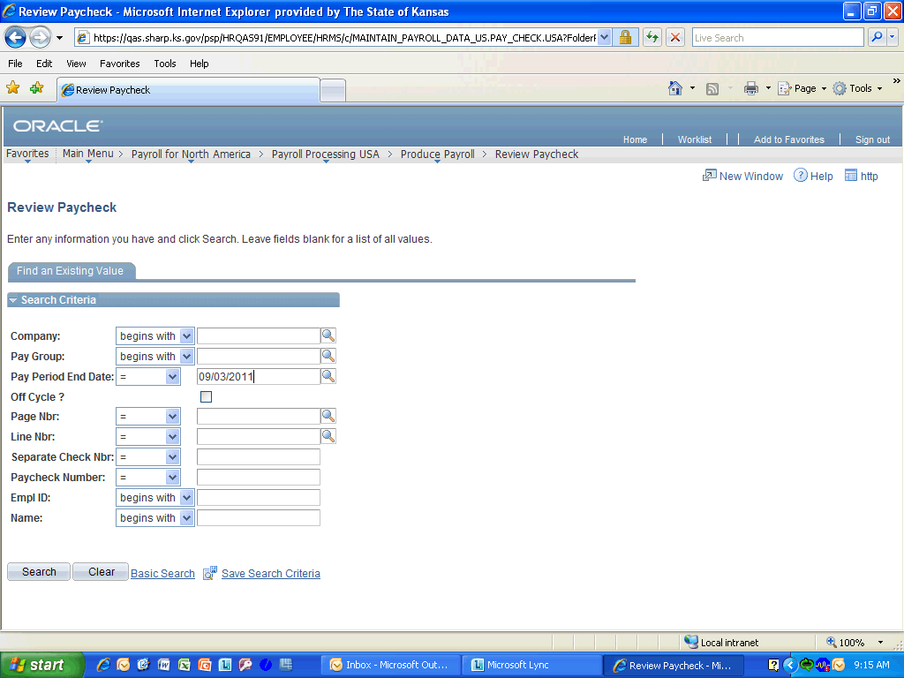

Step | Action
 | Enter the desired information into the Pay Period End Date field. Enter "09/03/2011".
 | Enter the desired information into the Empl ID field. Enter "K0000216920".
 | Click the Search button.
Notice that you are on the Paycheck Earnings Tab.
Click there to continue.
 | Notice that the Paycheck Status is calculated. After the final pay calculation, the status will be confirmed and then a paycheck number will be displayed in the Paycheck Number field. Click either the Paycheck Status or Paycheck Number to continue.
 | Click the View All link to display all the earnings records.

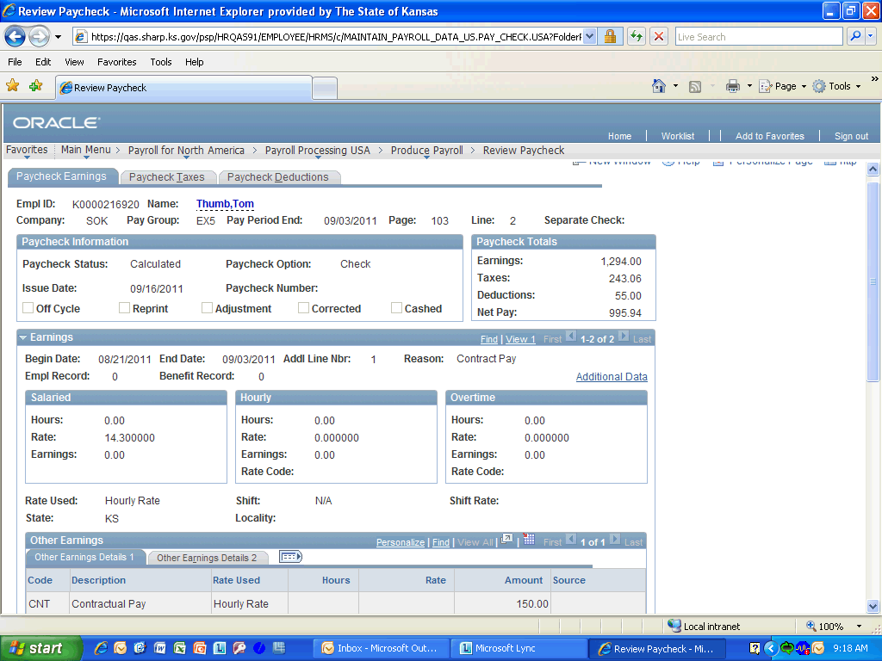

Step | Action
 | Notice that all earnings are now displayed as Other Earnings. This is a change from Time and Leave where Regular pay and Overtime pay were displayed in there perspective boxes. Click the scrollbar and drag it down to continue.

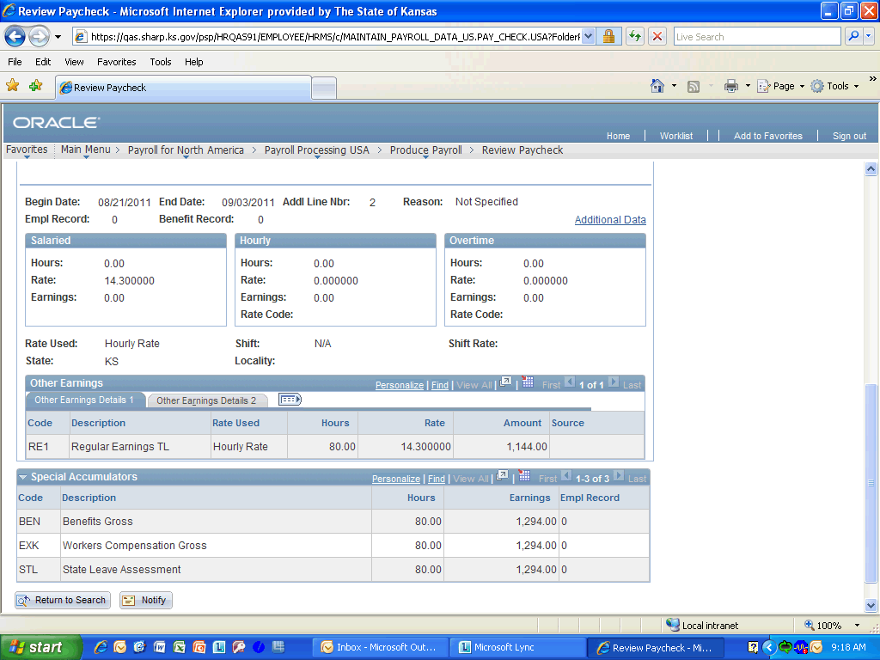

Step | Action
 | Notice the Special Accumulators section that is used for specific earnings codes to calculate some benefit and deduction amounts. Click the scrollbar button and drag it back up to the top when you are finished.
 | Now you will look at the Paycheck taxes. Click the Paycheck Taxes link to continue.
 | Here you can verify both Employee and Employer taxes for the period. Next click the Paycheck Deductions link to continue.
 | Now you can review the deduction for your employee, Thomas Thumb. Click the Return to Search tab when you are finished.
Congratulations! You have completed Viewing a Paycheck in SHARP.
End of Procedure.

