**State of Kansas**

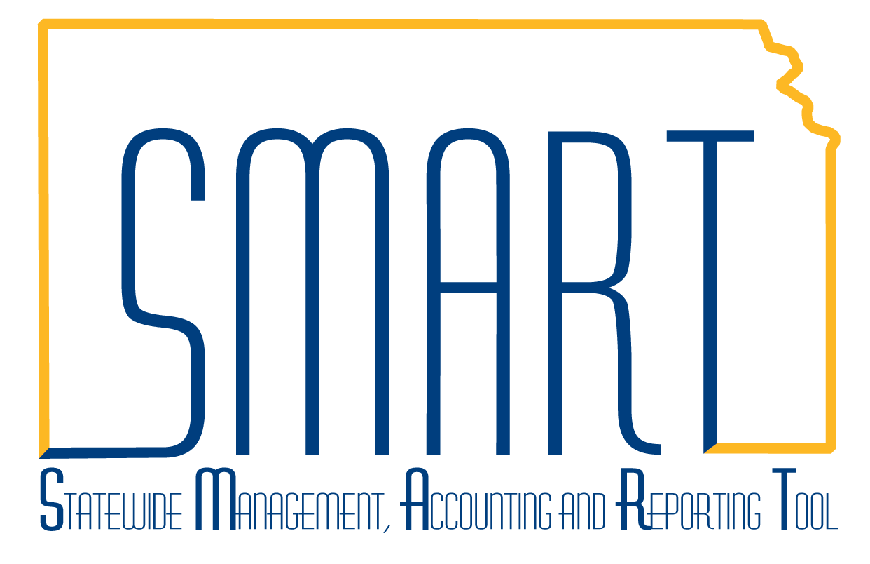

**APY1400/1405 Open Liability**

**Reconciliation Report**

***Statewide Management, Accounting, and Reporting Tool***

**Navigation:** Accounts Payable -> Reports -> Voucher Reconciliation -> Open Liability Reconciliation

**APY 1400 (Summary) Description:** Compares the AP Open Liability balance to the GL Open Liability balance (Account 220100). (Crystal Report)

**APY 1405 (Detail) Description:** Shows all accounting activity for accounts payable transactions for each voucher. Use the detail report to validate the AP Open Liability balance to the General Ledger. (Crystal Report) See APY1400.

**Fields:** GL Business Unit, AP Business Unit; Vendor ID, Vendor Name, Voucher ID, Invoice Date, Accounting Date, Journal ID, Journal Date, Journal Line Number, Amount.

**Output:** PDF Only.

**Note: This report is for Accounts Payable only and does not include Expenses Payable or other non-AP liabilities. This PeopleSoft Delivered report has not been customized or modified. This report does not contain funding information.**

| **Step** | **Action** |
| --- | --- |
| 1 | Navigate to: Accounts Payable -> Reports -> Voucher Reconciliation -> Open Liability Reconciliation  Add a new run control. Enter a Request ID of your choice. Enter the As of Date. Change the Business Unit Option from ALL to Value. Enter your GL Business Unit. Click Run. |
| 2 | Select the APGL Open Liab Recon Data/Rep job. Update/select the Web & PDF report Type and Format, respectively. Click OK. Run Control Screen returns with Process Instance number noted. Click on the Process Monitor link. |
| 3 | Periodically, click on the refresh button until the Run and Distribution statuses are Success and Posted, respectively. **Click on the Process Name link** (APY1400). Larger agencies with high volumes of voucher activity may take more than an hour to complete. |
| 4 | Click on the next to last Process Detail Link (APY1400) for the summary report. |
| 5 | Click on the View Log/Trace link. |
| 6 | Click on the file link with the (.PDF) extension to open the report.You may save or print the report from there. Click Return to navigate to the Process Details page. Click OK to navigate to the Main Job Instance screen so that you can open the detail report. |
| 7 | Click on the last Process Detail Link (APY1405) for the detail report. |
| 8 | Click on the View Log/Trace link. |
| 9 | Click on the file link with the (.PDF) extension to open the report.You may save or print the report from there. |