**State of Kansas**

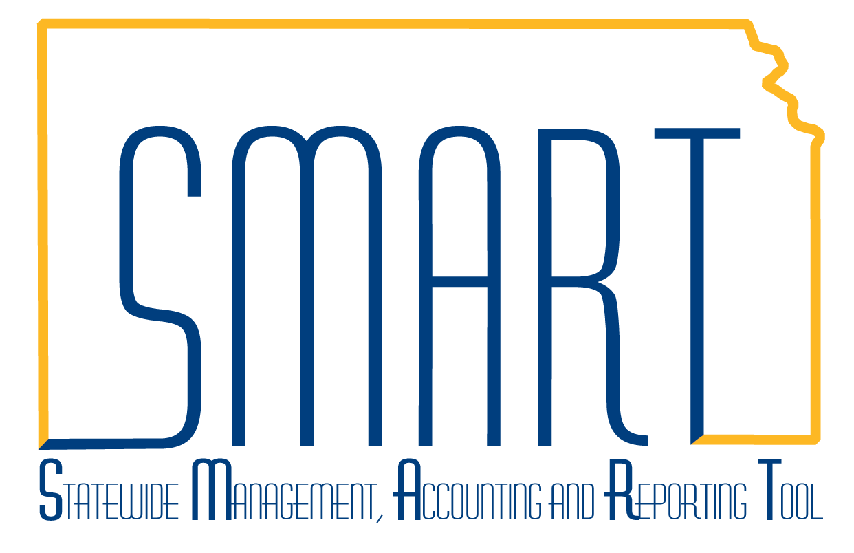

**APY1406 Payables Open Liability Report**

***Statewide Management, Accounting, and Reporting Tool***

**Navigation:** Accounts Payable -> Reports -> Voucher Reconciliation -> Payables Open Liability

**Description:** Lists all open AP liabilities by business unit. (Crystal Report)

**Fields:** AP Business Unit; Vendor ID, Vendor Name, Voucher ID, Invoice ID, Invoice Date; Schedule Date; Accounting Date; Amount

**Output:** PDF Only.

**Note: This report is for Accounts Payable only and does not include Expenses Payable or other non-AP liabilities. This PeopleSoft Delivered report has not been customized or modified. This report does not contain funding information.**

| **Step** | **Action** |
| --- | --- |
| 1 | Navigate to: Accounts Payable -> Reports -> Voucher Reconciliation -> Payables Open Liability  Add a new run control. Enter the As of Date. (Note: Vouchers that have been paid by ACH have payment dates that correspond to the bank settlement date, at least two days in the future. Vouchers that have already been selected in paycycle, but have payment dates greater than the As of Date will show up on this report as an open item. However, the payment activity may already be posted against the General Ledger.) Change the Business Unit Option from ALL to Value. Enter your AP Business Unit(s). Entities with more than one AP Business Unit will need to enter each Unit they wish to include in the report. Select/update the Report Format Options as desired. Note that the Summary report does not contain voucher detail, but provides totals by business unit and vendor. Select the Detail Report Format Option to include voucher level detail. Click Run. |
| 2 | Select the Open Liability Data & Report Options job. Update/select the Web & PDF report Type and Format, respectively. Click OK. After the Data & Reports option has been run initially for a given Unit and date, the Reports Only option can be selected to run reports with different format options. Run Control Screen returns with Process Instance number noted. Click on the Process Monitor link. |
| 3 | Periodically, click on the refresh button until the Run and Distribution statuses are Success and Posted, respectively. **Click on the Process Name link** (APY1406). Larger agencies with high volumes of voucher activity may take more than an hour to complete. |
| 4 | Click on the last Process Detail Link. |
| 5 | Click on the View Log/Trace link. |
| 6 | Click on the file link with the .PDF extension to open the report.You may save or print the report from there. |