

State of Kansas
Create a 1099 Voucher Online
Statewide Management, Accounting, and Reporting Tool
Step | Action
1 | ** If you have already entered voucher lines, please ensure that you have chosen a withholding applicable vendor and skip to step 40.  Click the Accounts Payable link.
2 | Click the Vouchers link.
3 | Click the Add/Update link.
4 | Click the Regular Entry link.
5 | On the Voucher page, you may select to view an existing voucher by clicking the Find an Existing Value tab or you can enter a new voucher by using the Add a New Value tab.  The add/search page allows users to enter the required information when adding a voucher to speed data entry. This process is optional.
6 | Business Unit is a five digit value (your agency number and two zeros).  The Business Unit will default in this field from your user preferences.  Verify the Business Unit field.
7 | The Voucher ID will default to NEXT.  The system assigns the next sequential number for your Business Unit once the voucher is saved.
8 | The Voucher Style you select will determine the type of voucher that will be processed. Click the Voucher Style list.
9 | Click an entry in the list.
10 | To select the vendor for a voucher, you can specify either the Short Vendor Name or the Vendor ID. The remaining vendor selection fields are automatically populated by PeopleSoft based on the vendor defaults.  Click in the Vendor ID field.  
11 | Enter the appropriate information into the Vendor ID field. Please make sure to choose a withholding applicable vendor.
12 | Click in the Invoice Number field.
13 | The Invoice Number is a required field. It holds a maximum of 30 characters. The system uses this number as a reference for duplicate invoice checking.  Enter the appropriate information into the Invoice Number field.
14 | Click in the Invoice Date field.  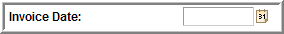
15 | The Invoice Date is a required field. It is used to calculate when the payment is due along with the payment terms. The link beside the Invoice Date field will display a calendar which allows you to select an invoice date.  Enter the appropriate information into the Invoice Date field.
16 | Click in the Gross Invoice Amount field.
17 | Enter the appropriate information into the Gross Invoice Amount field.
18 | Click the Add button.  
19 | The Invoice Information page enables you to enter or view invoice information, including invoice header information and voucher line and distribution information.
20 | Click the scroll bar to view the bottom portion of this page.
21 | Click in the Description field.  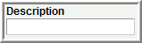
22 | Use the Description field to specify a description of the charges related to this voucher. The description field is a maximum of 30 Characters. Enter the appropriate information into the Description field.
23 | Click in the Extended Amount field.  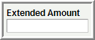
24 | The Extended Amount is the Invoice Line amount and it must equal the sum of the amounts on the Distribution Line(s). Enter the appropriate information into the Extended Amount field.
25 | Click in the Amount field.  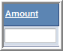
26 | Enter the appropriate information into the Amount field.
27 | Click in the Department field.  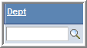
28 | Type the appropriate information into the Department field.
29 | Click in the Fund field.  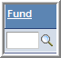
30 | Enter the appropriate information into the Fund field.
31 | Click in the Bud Unit field.  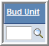
32 | Enter the appropriate information into the Budget Unit field.
33 | Click in the Program field.  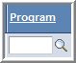
34 | Enter the appropriate information into the Program field.
35 | Click in the Account field.  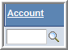
36 | Enter the appropriate information into the Account field.
37 | If desired, enter the appropriate information into the remaining chartfields.
38 | Invoice Line 2  If multiple Invoice Lines or Distribution Lines are needed, click the Add a New Row (+) button. Click the Add a New Row (+) button.    Click the OK button.    Repeat steps 21-37
39 | Click the scroll bar to view the top portion of this page.
40 | Click the Withholding link.  
41 | Click the View All link.  
42 | Click the scroll bar to view the bottom portion of this page.
43 | The Withholding Code is defined in the PeopleSoft setup tables. It defines the values that default in the Withholding Details information such as "Entity, Type, Jurisdiction, and Class." For more detailed information, please reference the Withholding Codes job aid.  The Withholding Code may be changed from this page if necessary. In PeopleSoft v9.0, once the voucher is paid, the Withholding link on the voucher will no longer be available.
44 | The Withholding Applicable checkbox defaults to selected if the vendor was set up as being Withholding applicable. This indicates that the payment for this voucher line will be included on the 1099 statement that is issued for this vendor.  It may be de-selected from this page from either the Withholding Code or the Withholding Details. If de-selected, it will not be included in the amount of the 1099 statement. The Withholding Applicable checkbox should be de-selected only in those cases where the agency has determined the payment to be non-reportable in accordance with IRS regulations.  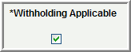
45 | Use the Withholding Class field to change the Withholding Class on the voucher. The Withholding Class field directly corresponds to the boxes listed on the IRS form 1099.  If the appropriate Withholding Class is not available in the look up, contact Accounts & Reports to have the new Withholding Class added to the vendor table.  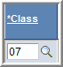
46 | Use the Applicable checkbox to de-select any line of the voucher that should not be included in the amount the vendor receives on a 1099 statement. Information regarding what type of expense should be included on a 1099 statement may be found on the IRS web site. De-select the Applicable checkbox.  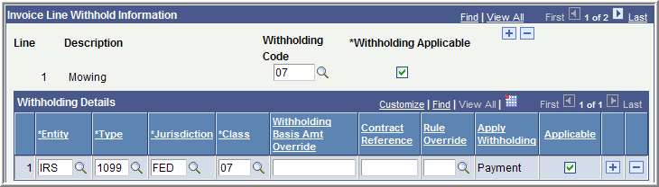  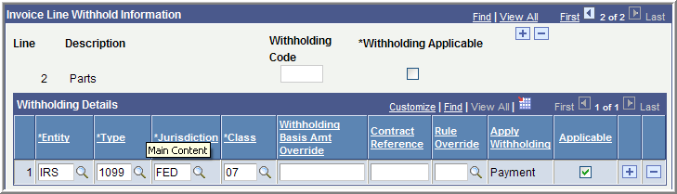
47 | Click the scroll bar to view the top portion of this page.
48 | Click the Back to Invoice link.
49 | Click the Save button.
50 | You have successfully completed the Create a 1099 Voucher topic.

FORM 1099 MISC - EXAMPLES OF REPORTABLE PAYMENTS
RENTS (Form 1099-MISC, Box 1) | NON-EMPLOYEE COMPENSATION
Office Space | (Form 1099-MISC, Box 7)
Parking Lot Space | Accountants/Auditors
Welfare Rental Assistance (to Landlords) | Advertising Services
Equipment | Appraisers
Surface Royalties | Architects
Real Property | Armored Car Services
Other Property | Attorneys* (who are not your employees)
 | (Includes Corporations)*
 | Auto Repair
ROYALTIES (Form 1099-MISC, Box 2) | Board Members
Literary rights | Chaplains
Copyrights | Cleaning Services
Publishing Licensing fees | Commercial Repairs – Hwy Vehicles
 | Computer Programming
 | Computer Repairs
OTHER INCOME (Form 1099-MISC, Box 3) | Construction Services
Awards (Nonemployee) | Consultants
Prizes (Nonemployee) | Contracted Repairs
 | Court Appointed Workers
 | Court Reporters
MEDICAL & HEALTH CARE SERVICES | Custodial / Maintenance
(Form 1099-MISC, Box 6, includes all payments | Design & Testing
to Medical Service Corporations) | Engineers
Ambulance Services | Evaluation Consultant
Dentists/Dental Services | Expert Witnesses
Doctors/Medical Services | Extermination Services
Hospitals** | Graphic Artist
(**except if tax exempt or owned/operated by a | Institution Contracts
governmental entity) | Janitorial Services
Lab Services | Keypunch Services
Optometrists | Landscapers, Locksmiths
Private Duty Nurses | Laundry Services
Psychiatrists, Psychologists | Maintenance Agreements
Rehabilitation Centers | Non-Employee Allowance
Therapists | Occasional Salaries & Wages (to Non-Employees)
Hospitalization | Parcel & Delivery Services
All payments to Medical Service Corporations | Photographers
 | Printing Services
 | Prison Labor Allowance
GROSS PROCEEDS PAID TO AN ATTORNEY | Professional Service Payments
(Form 1099-MISC, Box 14) | Protection Services
Gross proceeds paid to an attorney | Security Services
in connection with legal services. | Teacher/Instructor (Non-Employee)
 | Trash Removal
 | Working Interest - Oil and Gas Payments
FORM 1099-INT, 1099-DIV, 1099-G and 1099-S
EXAMPLES OF REPORTABLE PAYMENTS
INTEREST (Form 1099-INT, Box 1) |  | DIVIDENDS (Form 1099-DIV, Box 1)
Interest income |  | Distributions, such as dividends, capital gain distributions,
 |  | or nontaxable distributions, that were paid on stock,
 |  | and liquidation distributions.
TAXABLE GRANTS (Form 1099-G, Box 6) |  | PROCEEDS FROM REAL ESTATE (Form 1099-S, Box 2)
Taxable Grants |  | Gross Proceeds from the sale or exchange of real estate

