

State of Kansas
Working Errors On the
Sourcing Workbench
Statewide Management, Accounting and Reporting Tool
The Sourcing Workbench in SMART enables you to view the results of the PO Auto Sourcing process, which creates Purchase Orders from approved Requisitions. Using the Sourcing Workbench, you can view all rows, or select subsets of rows within the PO staging tables. You can also view rows that are rejected during the sourcing processes, view detailed error messages, and correct sourcing errors. The Sourcing Workbench records all Requisition lines that process through the sourcing process to a PO. During the day, the Sourcing Workbench will display information concerning each line, including information about any lines that are in error. During the nightly batch, the completed lines are purged with only the lines in error remaining. Users with the Buyer role can navigate to the Sourcing Workbench: Purchasing > Purchase Orders > Stage/Source Requests > Sourcing Workbench.

VENDOR ERRORS: A common error on the Sourcing Workbench is Vendor. When preparing a Requisition, a vendor should be identified on each line. The only exception for not having a vendor is if the line must be bid by Division of Purchases. If a line does not have a vendor identified, that line will error out when the Requisition is sourced to a Purchase Order. For example, a Requisition has 5 lines; two (2) of the lines have a vendor identified; three (3) of the lines do not have a vendor identified. When the batch process runs, the two (2) lines with a vendor will be sourced to a PO. The remaining three (3) lines will error out.
From the “Sourcing Workbench” page, enter search criteria, select the “Search” button, and select the “Sourcing Details” icon:

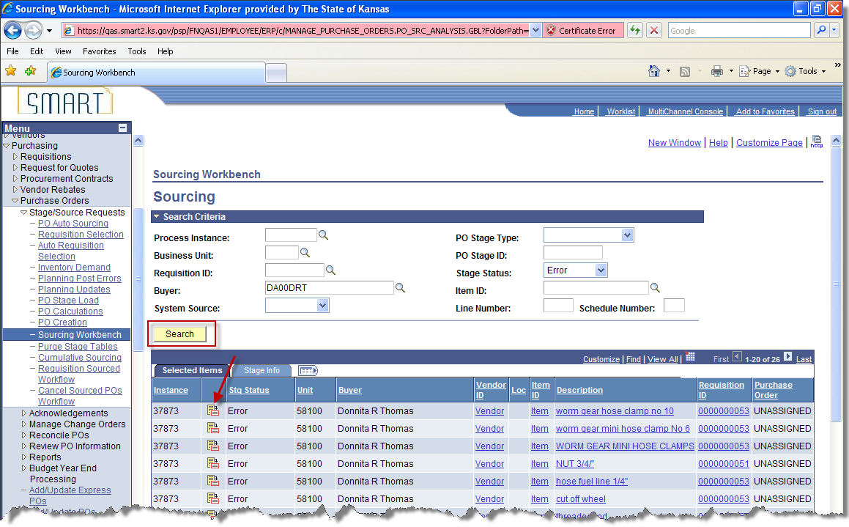

For vendor errors, the Buyer will need to assign a vendor on the Sourcing Workbench so that the PO may be created. On the Sourcing Details page, change the “Stage Status” to “Recycle” and select a “Staged Vendor” using the look up icon. Make sure the “Let POCalc Override Vendor” check box is unchecked, and select the “Save” button.

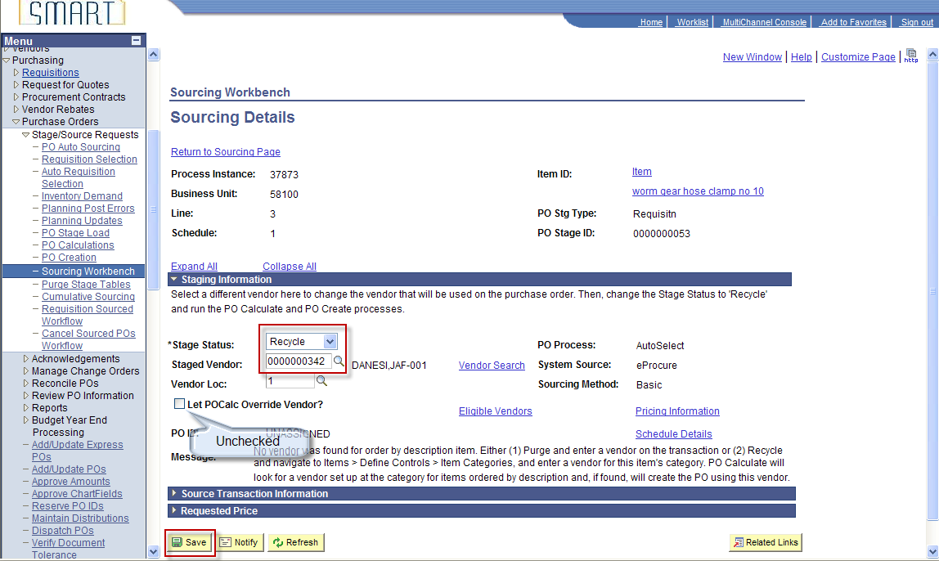

Requisition lines that have a “Stg Status” of “Recycle” will be picked up during the next batch process and sourced to a new Purchase Order. If there were other Requisition lines on the same Requisition that had already sourced to a PO, the Requisition lines that are recycled will not be added to the original PO.

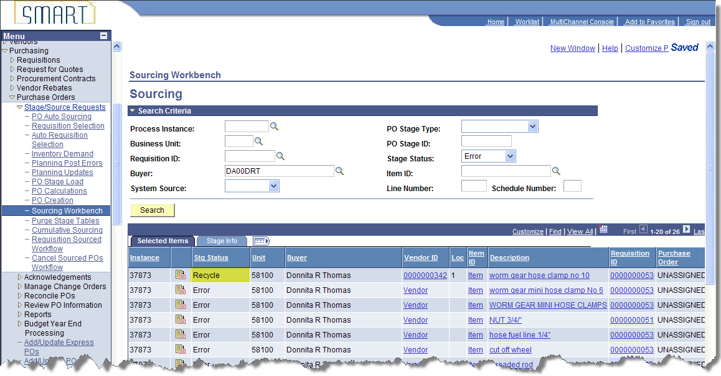

CONTRACT ERRORS: Contract errors are also commonly found on the sourcing workbench. There are a number of reasons that a Requisition could end up on the Sourcing Workbench with a contract error. Possible issues:

- Contract maximums have already been met
- Contract is NOT in “Approved” status
- PO Date (date Requisition sourced to PO) is out of range of the contract begin or expire date
- Requisition Date (date requisition entered in SMART) is out of range of the contract begin or expire date
- Vendor on the Requisition does not match the vendor on the contract

From the “Sourcing Workbench” page, enter search criteria, select the “Search” button, and select the “Sourcing Details” icon:

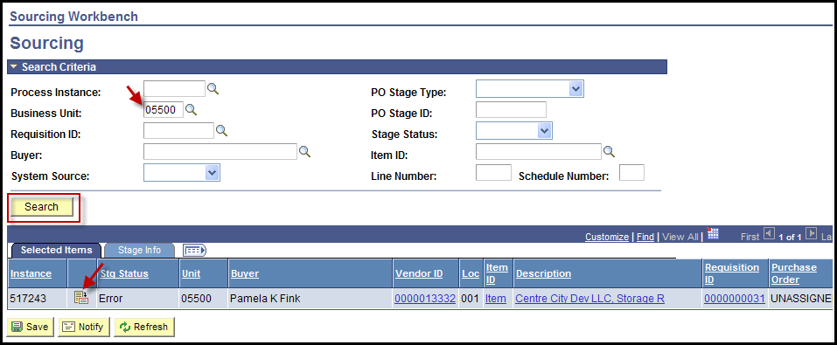

For contract errors, the Buyer will need to identify which contract is involved.

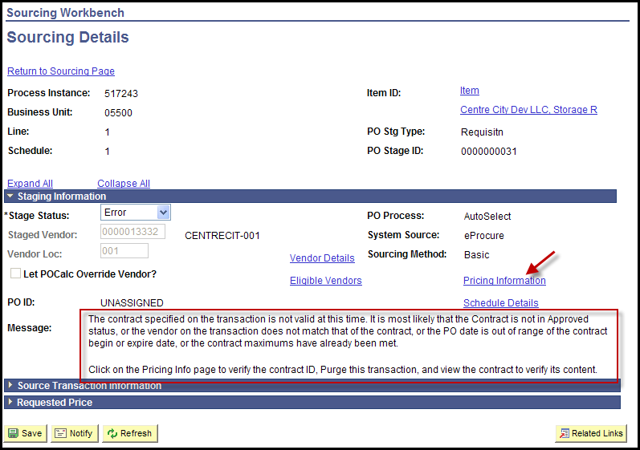

On the Sourcing Details page, select the “Pricing Information” link and go the contract page to identify the contract ID:

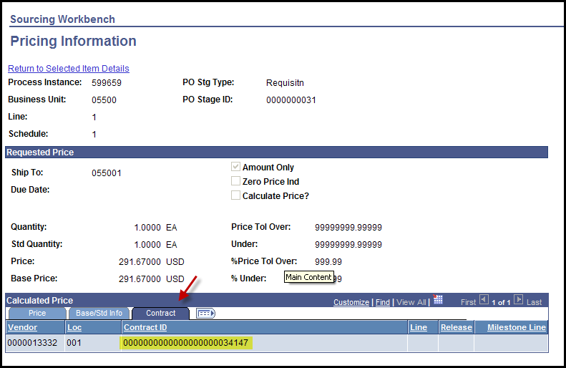

Change the “Stage Status” to “Reset/Purg” and select the “Save” button:

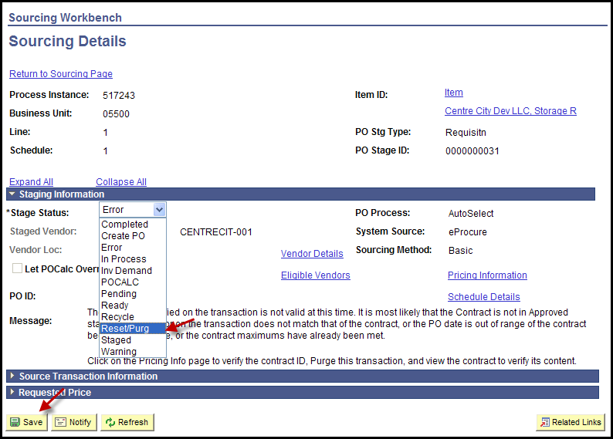

NOTE: If the Stage Status is NOT set to “Reset/Purg”, the following error messages will be received when trying to navigate to the contract or the Requisition:

Navigation: Supplier Contracts > Create Contracts and Documents > Contract Entry

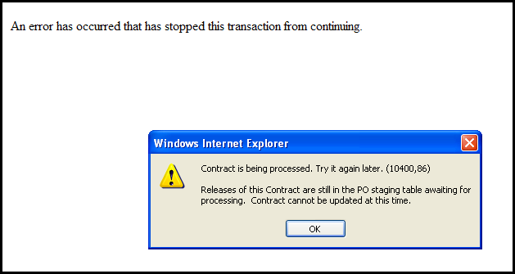

Navigation: eProcurement > Manage Requisitions

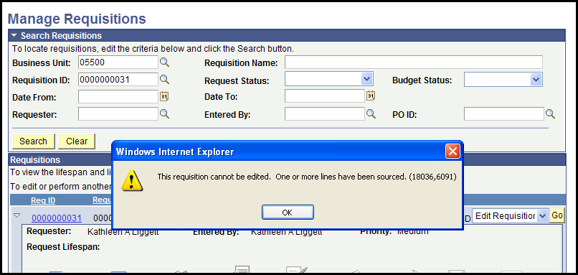

NOTE: Sometimes when you select the “Pricing Information” link, the Contract ID field will be blank. Change the “Stage Status” to “Reset/Purg” and select the “Save” button. Once this is done, navigate to the Purchase Requisition.

Navigation: eProcurement > Manage Requisitions

Select the “Edit Requisition” option from the “<Select Action…>” drop down box and select the “Go” button:

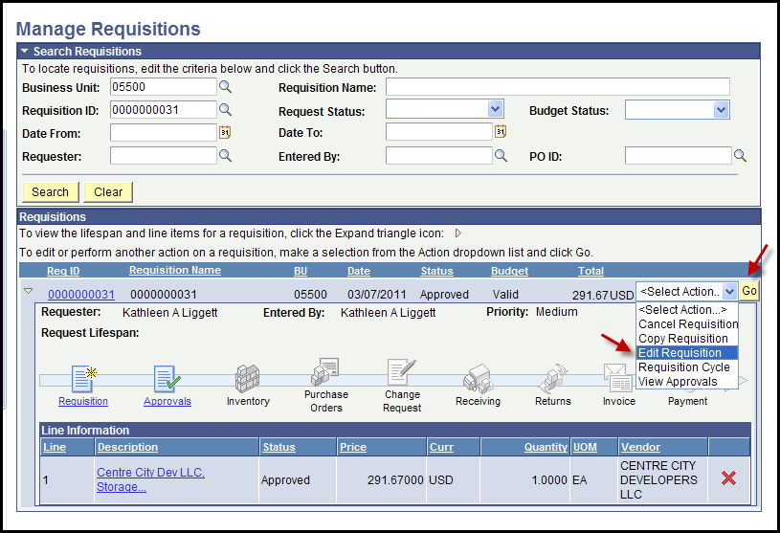

You will receive the message that the approval process will be restarted, select the “OK” button:

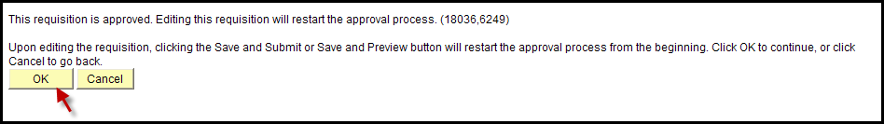

Select the “Line Details” icon:

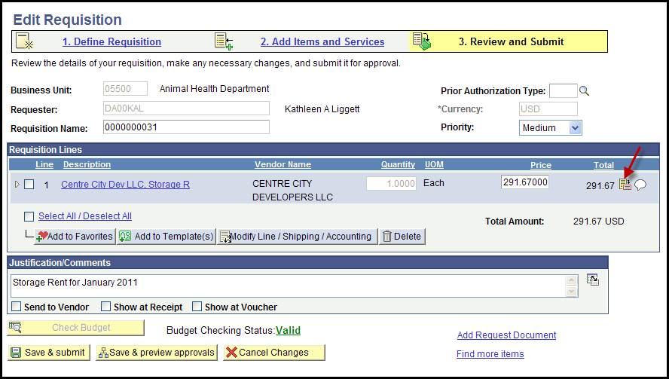

Expand the “Contract” section to see the contract ID:
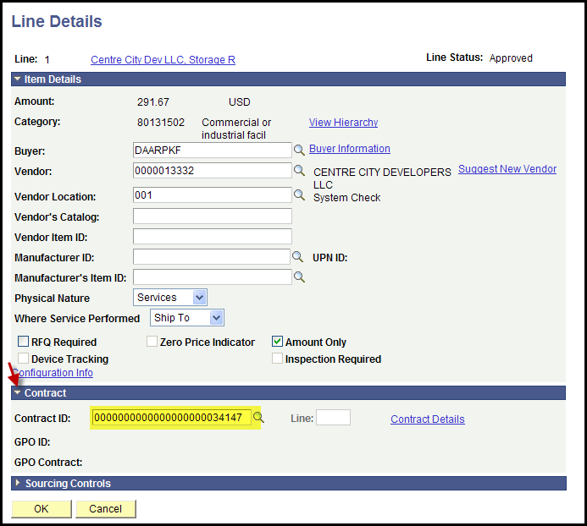

Once you have identified the contract ID, exit out of the Purchase Requisition. The approval process will not be restarted if you navigate away from the Purchase Requisition without saving. Navigate to the contract to determine the issue.

Navigation: Supplier Contracts > Create Contracts and Documents > Contract Entry
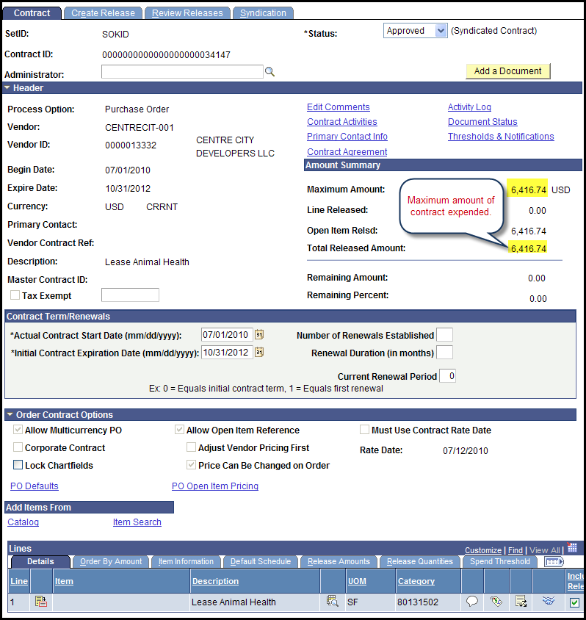

In this example, the contract maximums have already been met.

Resolutions for the possible issues:

Contract maximums have already been met: In some cases it may be appropriate to increase the maximum amount on the Contract. For example, additional services have been negotiated. To increase the contract maximum amount, email a Procurement Officer within the Division of Purchases. Include in the email a justification for increasing the maximum amount and the new maximum amount to be entered.

Contract is NOT in “Approved” status: Check the Division of Purchases web site to verify that the correct contract ID has been entered. If not, update the purchase requisition with the correct contract ID. If the correct contract ID has been used, email the contract administrator for a status update.

PO Date (date Requisition sourced to PO) is out of range of the contract begin or expire date: Check the Division of Purchases web site to verify that the correct contract ID has been entered. If not, update the purchase requisition with the correct contract ID. If the correct contract ID has been used, validate that the date the Requisition was entered is within the Begin Date and Expire Date as noted on the contract in SMART.

Vendor on the Requisition does not match the vendor on the contract: Determine which vendor is correct. If vendor on the Requisition is correct, either locate the correct contract ID for the vendor or remove the contract ID from the Requisition line. If the vendor on the Requisition is correct and the vendor on the applicable contract is incorrect, contact the contract administrator or the Procurement Officer within the Division of Purchases to rectify the incorrect vendor on the contract. If vendor on the contract is correct, update the purchase requisition with the correct vendor id.

NOTE: The PO Auto Sourcing process runs every hour daily from 9 AM to 4 PM and once during the nightly batch cycle. If a contract issue has not been resolved prior to the next PO Auto Sourcing process running, the “Stage Status” will need to be re-set to “Reset/Purg” so that the Purchase Requisition and/or the contract can be accessed.

Incorrect Buyer: If the Buyer field on a Requisition line is left blank or more than one (1) Buyer is entered on a single Purchase Requisition, SMART will default the Buyer as Donnita R Thomas. This cannot be changed on the Requisition; it may only be changed on the PO. To change the Buyer on a Purchase Order, submit a help desk ticket requesting the Buyer be changed on the PO. Include the following information: Business Unit, Purchase Order ID and the correct Buyer ID

