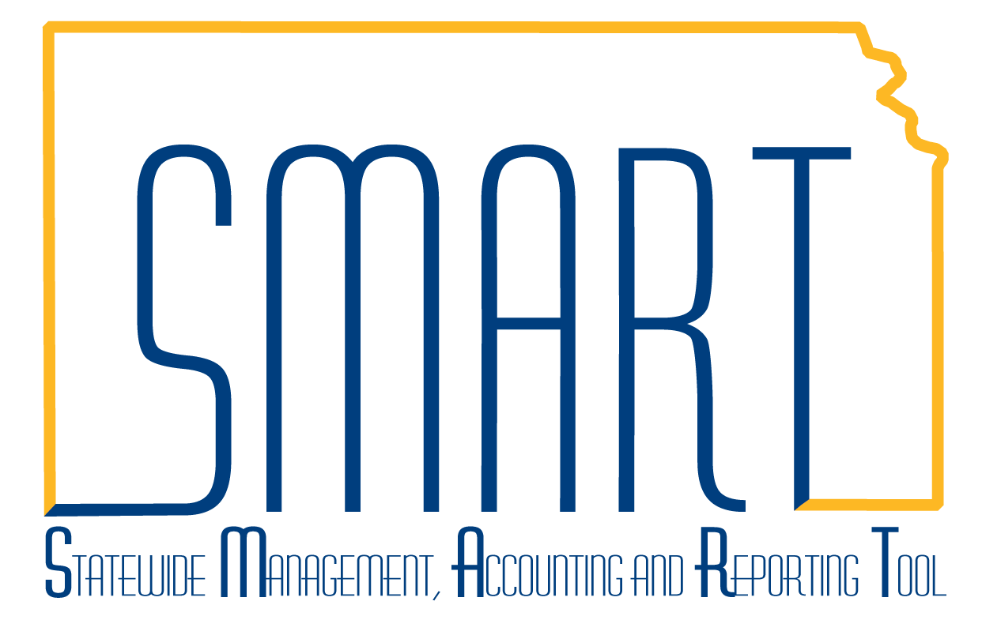

Staples Office Supplies
“Special Orders”
Statewide Management, Accounting and Reporting Tool

The majority of Staples office supply orders will be ordered by browsing their catalog from within SMART and bringing in product to the requisition. On occasion, agencies will need items that are not available from Staples online catalog. These Special Orders require specific order entry steps. Staples refers to special orders as “AAA Specials”.
NOTE: Do not include Staples online catalog items and AAA Specials on the same requisition!
- Agencies will need to communicate with Staples’ Customer Service prior to entering a special order requisition in SMART. Staples’ Customer Service will provide a quote for the AAA Special product(s). Requisitioners must create a new requisition for each AAA Special quote. Multiple products on a single quote may be entered on the same SMART requisition.

- AAA Specials are entered into SMART by navigating to: “2. Add Items and Services”, select the “Special Request” tab and click on “Special Item” request type.
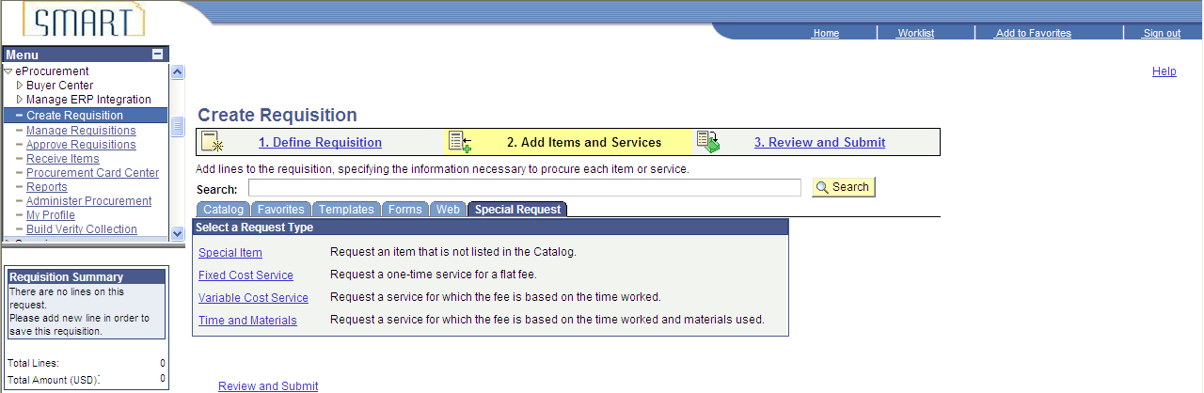

- Values from the Staples’ quote are used to complete the screen/page below:
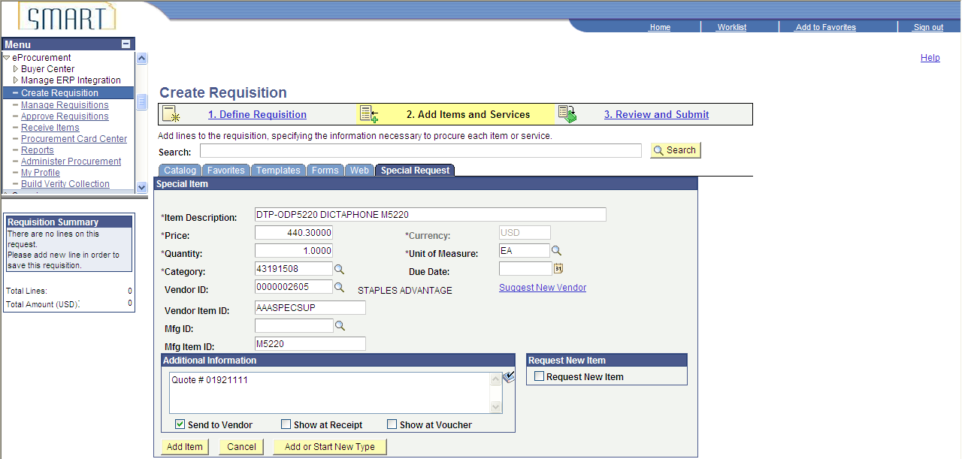
- Item Description: to include information about the item
- Price: Amount quoted from Staples
- Quantity: of the item
- Unit of Measure: varies with item, but most often will be “EA”
- Category: varies with item. Click look up to find applicable category
- Due Date: Optional
- Vendor ID: Staples ID: 0000002571
- Vendor Item ID: This field must include the AAASPECxxx value provided by Staples Customer Service; some values are: AAASPECSUP, AAASPECSTAMP, AAASPECPROMO.
- Mfg ID: Leave this field blank.
- Mfg Item ID: Enter applicable Mfg Item ID, if provided by Staples.
- Additional Information: Enter quote or case number for the AAA Special
- Send to Vendor: Checked
- Request New Item: Leave blank

- Click the “Add Item” button after above fields are completed. The user will see a blank “Special Item” page and may enter another AAA Special item if included on the quote. If this was the last item to enter, click “3. Review and Submit” at top RH area of page.

- The user is able to review the requisition and modify it as necessary. The AAA Special item can be edited by clicking on the item description (circled in red below). Doing so returns the user to the Special Request/ Special Item page.
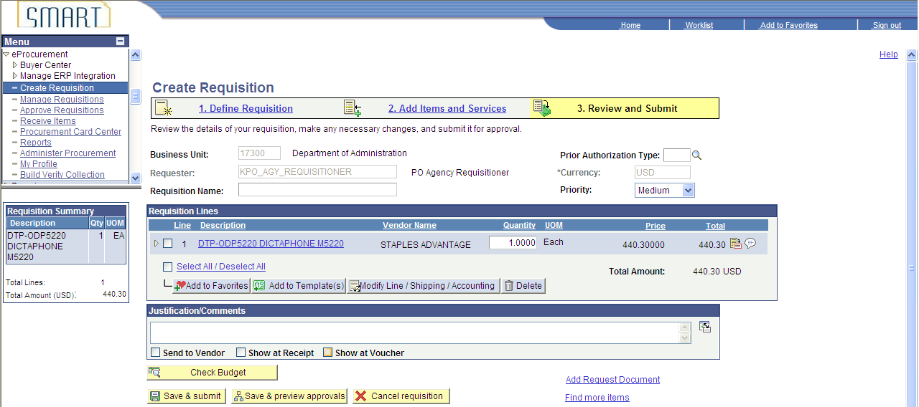

- User will need to associate the Staples contract number to the item by clicking the Line Details icon (circled in orange above). Open the “Contract” section, look up and select the contract number (see below)

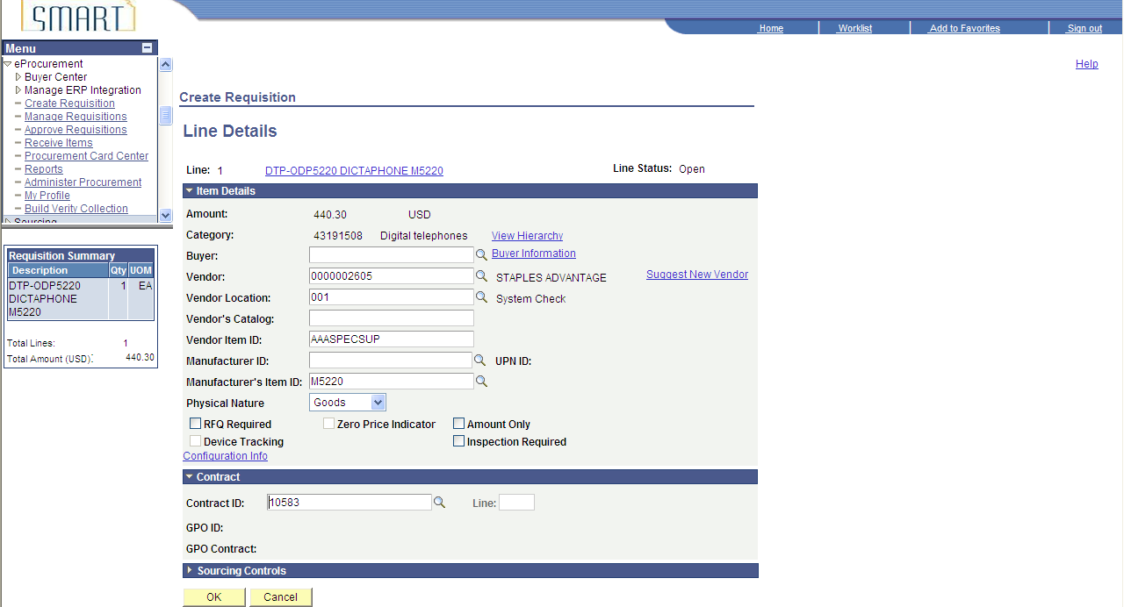

- Click “OK”, finalize the requisition and click the “Save and Submit” button. The requisition is routed for approvals, if OK, a PO is created and transmitted to Staples.

