
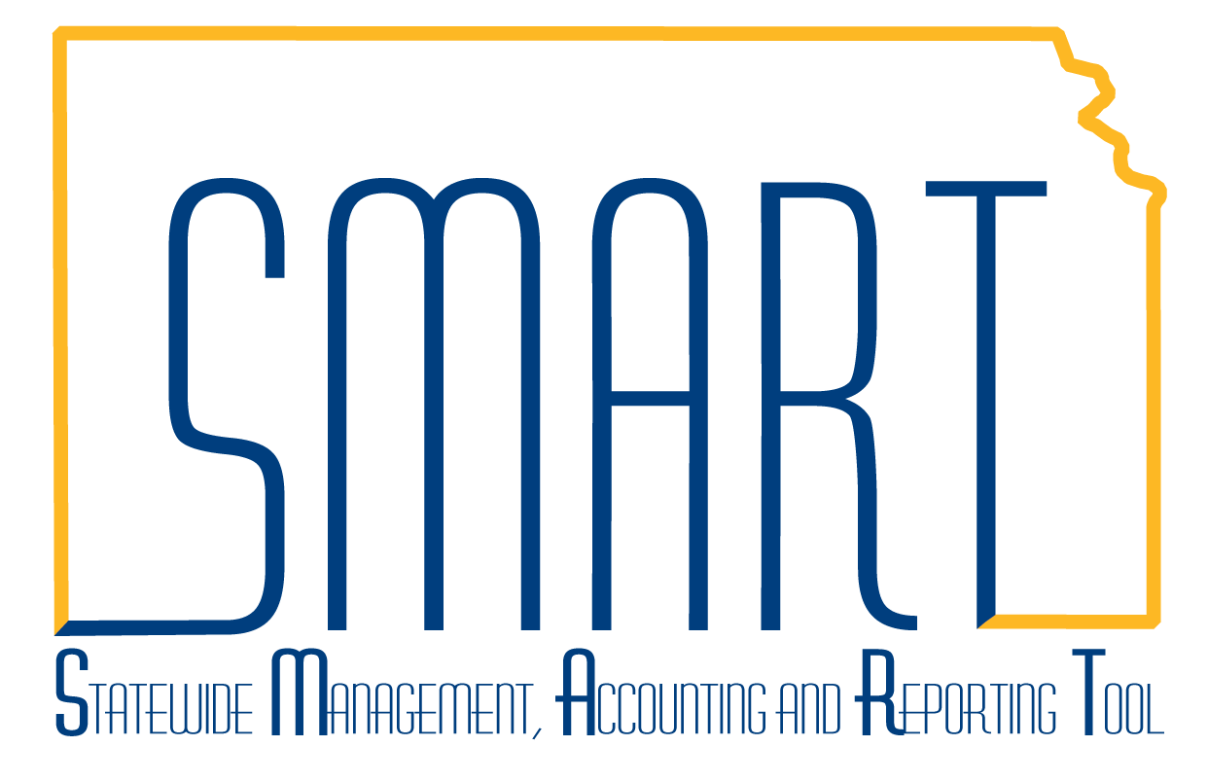
Job Aid
Updating Deposit
Statewide Management, Accounting and Reporting Tool
This job aid is to assist agencies that need to update a deposit after accounting entries are complete.
Roles that can update a deposit are: Deposit Approver and Deposit Processor. Deposit Approver will need to complete steps 1-3.
Modify Accounting Entries
- Navigate to: Accounts Receivable > Payments > Direct Journal Payments > Modify Accounting Entries.
- Enter your Agency Deposit Unit and Deposit ID.
- On the Modify Accounting Entries page, uncheck the ‘Complete’ box. You will get a warning message. Click ‘Ok’
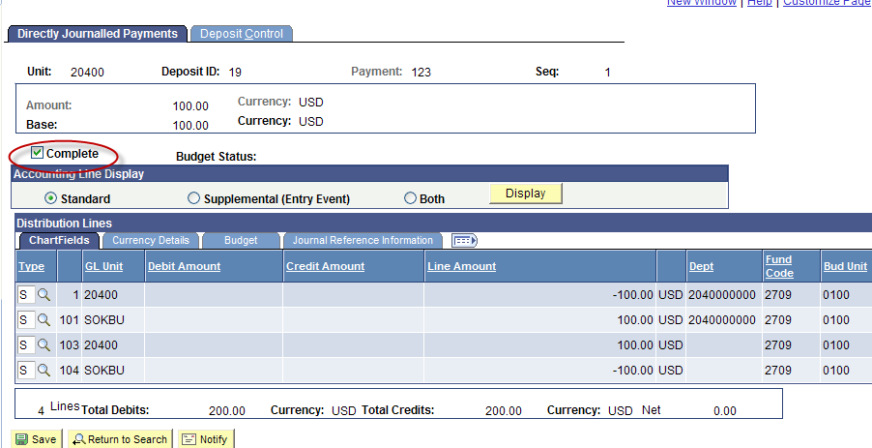
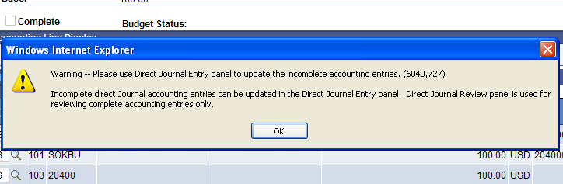
- Navigate to Accounts Receivable > Payments > Direct Journal Payments > Create Accounting Entries.
- Enter your agency Deposit Unit and Deposit ID
- Next to the Lightning Bolt (create) is a White Box with a Red ‘X’ (delete), click it

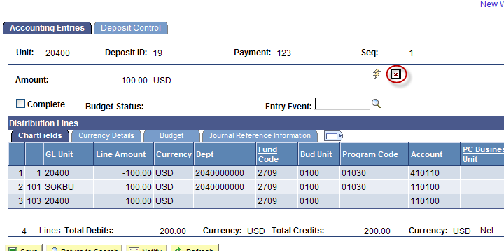

- If you need to update accounting entries you can now do so.
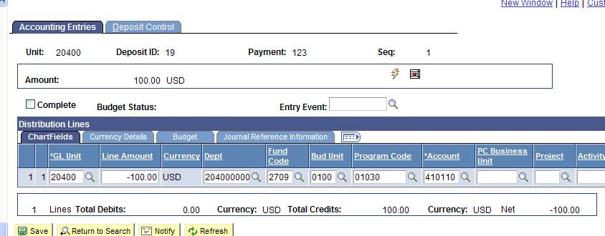

- If you need to update the payment page or deposit totals page: Scroll to the far right and click the blue (-) sign next to each row of Accounting. Click Ok on the error message
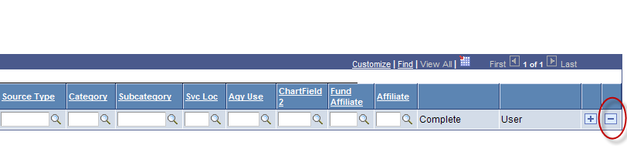
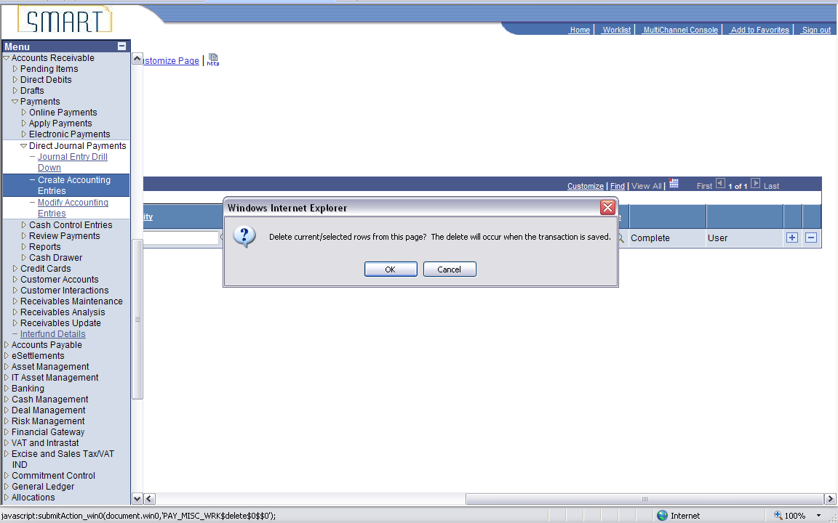
- Click the Save button
- Repeat Steps 1-9 for each payment in the deposit.
- Navigate to Accounts Receivable > Payments > Online Payments > Regular Deposits>Find an Existing Value
- Enter your Deposit Unit and Deposit ID
- Click Search
- The Totals Page and Payment Page can now be updated.

