Situation - Vendor address contains “alternate payee” that is hard to find.
SMART
TIP
This can cause the check to go to the wrong vendor or be misapplied.

Vendor Look-Up:
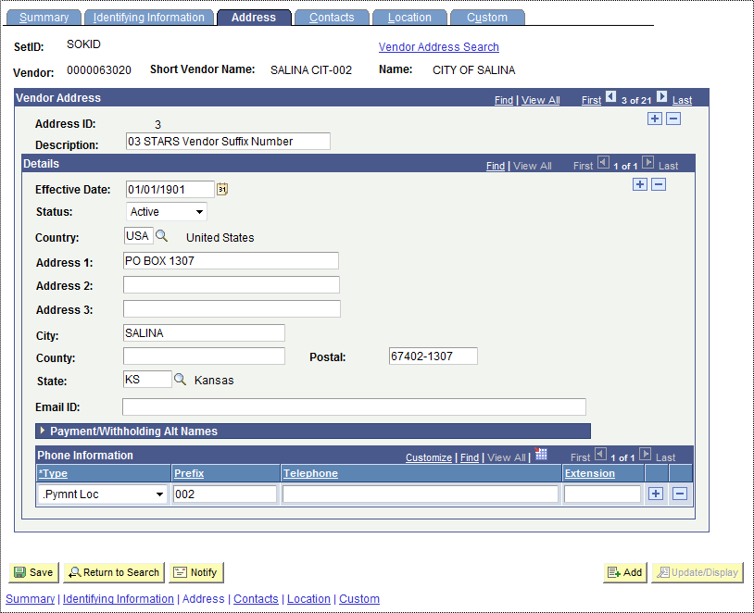
It appears that the check will be made payable to the City of Salina.

Expanded “Payment/Withholding Alt Names”:
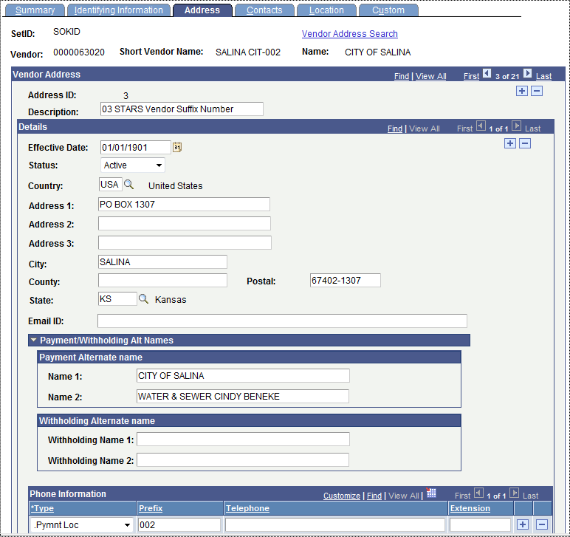
Once the alternate name is expanded you can see that it will in fact be made payable to City of Salina, Water and Sewer with a name added.

The Voucher only displays the primary vendor name:
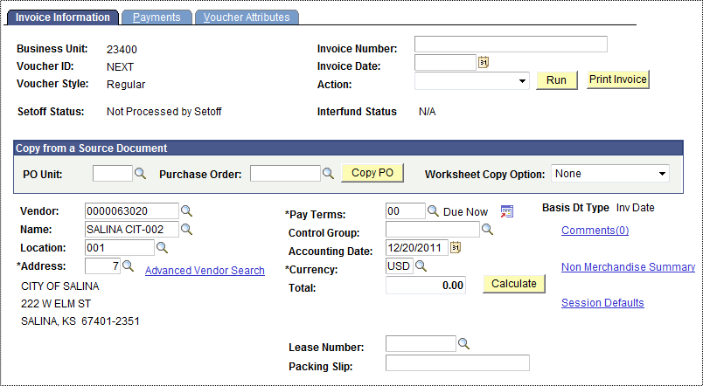
Regardless of which address it always shows City of Salina.

Alternate Way – From the payments tab of the voucher you can see the alternate payee and change if needed.

To see from the voucher click on the button by the remit to box:
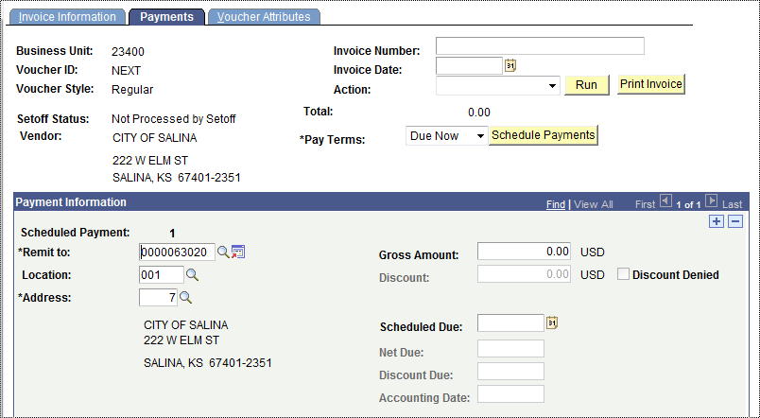

Here is the one for #7:
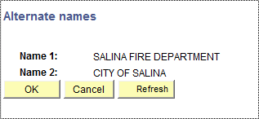

You can even go back and change the address to see a different one, here is address #5:
