Situation – The payment ID field is not long enough to make notes on a deposit.
SMART
TIP

Vendor Look-Up:
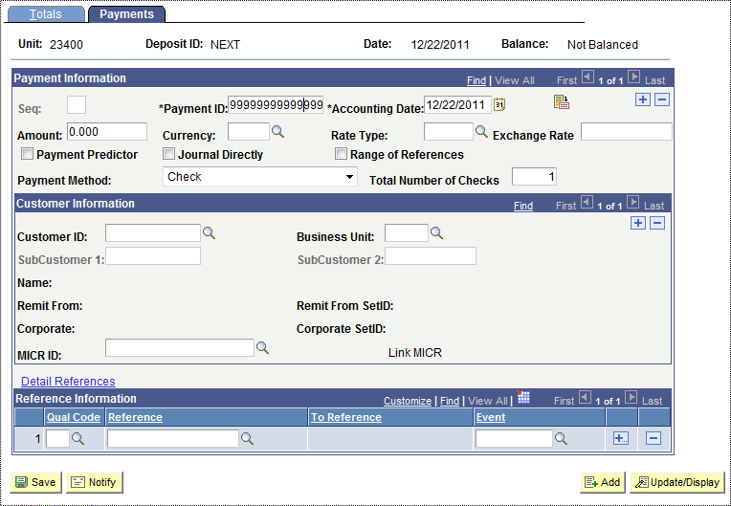
The MICR ID field is 25 characters and while it looks like a look-up field it is not.
The Payment ID Field is only 15 characters long.

Example of how it was used to show more information:
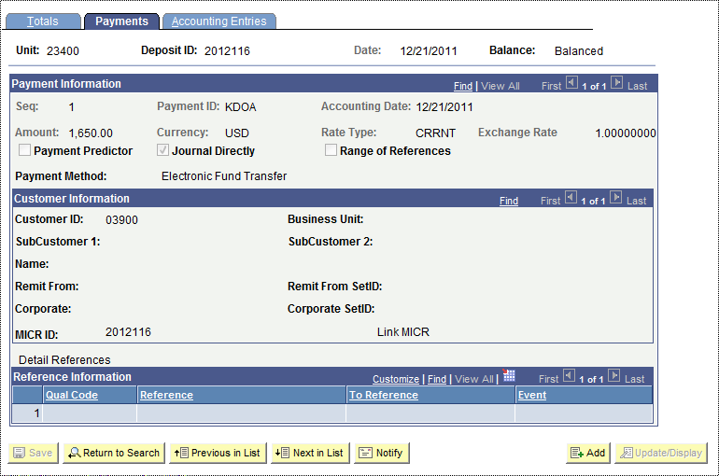
Here we put the program/payee information in the Payment ID field and the invoice number in the MICR ID field.

In the past the Invoice number was put in the Deposit ID field to track payments, which created manual tracking of deposit numbers.

The MICR ID shows on the KS_AR_DIRECT_JOURNAL_GL_BU query:

